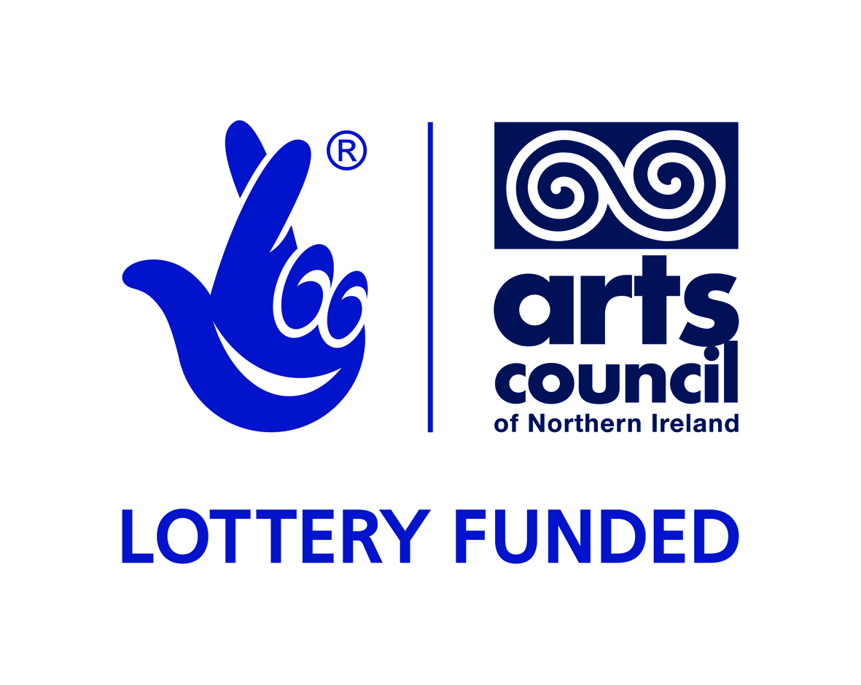 |  |  | 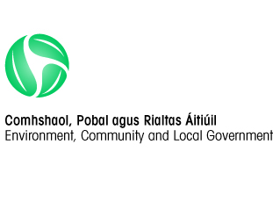

This project is part-financed by the European Union’s Programme for Peace and Reconciliation (PEACEIII) managed by the Special EU Programmes Body; the Arts Council of Northern Ireland; and the International Fund for Ireland.
Suffolk Lenadoon Interface Group
124 Stewartstown Road, Belfast
BT11 9JQ.

Building Peace through the Arts –Peace Walls ProgrammePublic Art Commission

Tender to commission the appointment of an artist to design, produce and install an artwork in the public realm.

Suffolk Lenadoon Interface Groupseeks expressions of interest from experienced and suitably qualified artists or design teams in developing a new public artwork. The total budget available for the artwork is up to £30,000 (inclusive of VAT)
The deadline for expressions of interest is 5th December 2014 at 12pm
Late submissions will not be accepted.
Applicants are requested to read the full content of this document carefully as it contains important information pertaining to all stages of the commission.
Please note that all submissions should be posted in hard copy.

Contents
- Application process
- Background
- Artist’s Brief
- Public Art selection panel/Steering Group
- Stage 1 Expression of interest submissions
- Budgets, fees and expenses for shortlisted artists
- Arts/Design Team responsibilities
- SLIG’sresponsibilities
- Project Timeline
- Ownership
- Contractual Arrangements
- Submitting an Expression of Interest
- Further information
Appendices

1. APPLICATION PROCESS

Stage 1 Expressions of Interest
Expressions of Interest are sought from artists (or a team of collaborating artists) to deliver a piece of Public Art. Shortlisting will be based on the information provided (see Appendix A) using the Evaluation Criteria set out in Appendix B. Please read Appendix A carefully and comply fully with the requirements.

The deadline for receipt of applications is 5th December 2014.You can receive the full brief on request by email to Suzanne@slig.co.uk. The selection panel will consider submissions received by this deadline and select up to three artists to go forward to Stage 2 of this process.

Stage 2 Proposal
£500 will be made available to up to three artists / teams who will be invited to present their proposals to the selection panel. The proposal must include; sketch designs, visualisations and/or a maquette as well as an explanation of the concept for the artwork, how it relates to our theme and how the artist/artist team would approach its design, fabrication and installation. Details of maintenance requirements and lifespan expectations should also form part of the presentation.
The artist/artist team must demonstrate how the work can be implemented within the allocated budget and details of the anticipated duration of the project with timescale broken down into research, production and delivery. The selection panel aims to select one artist / team to undertake the commission.
The SLIG Peace Walls Programmewill be at the heart of this project and the selected artist/artist team must demonstrate how they will work with the community to develop a sense of ownership / pride in the piece& the environment and most importantly help create a shared space for all. Therefore the artist/artist team must also outline the approach they will take to engage and work with the local community and showcase the successful project.
Selected artists /teams must submit their presentations to Suzanne Lavery, Suffolk Lenadoon Interface Group, 124 Stewartstown Road, Belfast, BT11 9JQ.
2. BACKGROUND
The project seeks to develop a legacy artwork reflecting the group’sjourney towards peace.
The Building Peace through the Arts – Re-Imaging Communities Programme themes are community cohesion, regeneration through the arts, positive relations at the local level, peace and reconciliation, connecting communities.
The SLIG Peace Walls Programme strategic objectives of the are to:
• Encourage contact, dialogue and reconciliation between Unionists and Nationalists in interface areas.
• Facilitate dialogue (including conversations on dealing with the past), and/or mediation within and between interface communities to build greater cross-community cohesion and confidence.
• Build relationships and trust for peace building activities and establish a cross-community visioning process to build a shared future within and between interface communities.
• Engage with individuals and communities that have not previously participated in community development or peace building activities.
• Underpin the Peace Process and promote economic prosperity by creating the conditions where interface communities are content to proceed with the physical transformation and ultimate removal of Peace Walls in their area.
• Help interface communities to leverage additional funding for the physical transformation/ removal of Peace Walls and any associated infrastructure and community regeneration needs when the required levels of confidence have been established.
• Improve the wellbeing and safety of local residents in interface areas by promoting economic and social advance.
• Provide a template for this type of intervention, which if successful could be used by others to deliver similar interventions when the Fund ceases to exist.
As a first phase of the project the group developed a local steering group to help manage the process. An Artist was recruited to carry outcreative community consultation with a wide range of stakeholders in the community. (S)he presented a report containinghis/her findings to the steering group including possible themes and potential site locations for the proposed artwork. The steering group agreed ‘Above the Divide’ as the theme most open to artistic interpretation.
The preferred location agreed by the group for the public art is at the entrance of the Stewartstown Road Building (images and map are available on request email, Suzanne@slig.co.uk), this was agreed as the location as both communities have access to the site and as it is the only site in the locality of the Interface that is perceived by both communities as shared space with shared access the residents felt it was the best site for the artwork.
In the Building Peace through the Arts consultation process the participants reflected upon the theme reflected upon the theme and shared their views of why it is important for the community to look above the divide here are some quotes from the participants involved in the consultation process:
“We Want to Be United”
“Leave the Past Where It Belongs”

“We don’t want to be separate”

“We are always going to be different but the difference is you can get past it”

“Communicate” – “When people communicate, they find their similarities, rather than their differences”

“You can be a proud Irish Protestant”

“I’m a Traitor” – “because I cross the divide to see my friends”

3. ARTIST’S BRIEF

Theme :Above the Divide
Suffolk Lenadoon Interface Grouphas achieved relative peace brought about through the balancing act that is the peace process and the desire of local people to accommodate differences for the sake of providing a safe environment for their children and grandchildren. The artwork will look to the future rather than the past suggesting the metaphorical journey that has been taken by SLIG since it was known as area of high levels of interface violence to reach the relative stability enjoyed today. This theme of above the divide shows that there has been a journey as a balancing act from its troubled history to now where so many people are still living with the trauma inflicted during that time has other several aspects: Suffolk is an enclave PUL community in West Belfast, Suffolk is in the centre of large CNR communities and the residents in the area live behind 5 different interfaces with peace lines all around;the artwork may suggest the physical journeys taken by the many people passing through the Interface at Stewartstown Road however should also be relating to the core theme above the divide and the views of the participants.
Project Specific Constraints:It is part of the artists brief to contact utilities companies and statutory agencies for advice in regard to nearby services i.e. electricity and water supply for any artist wishing to incorporate light or water as part of the art works, although this is not a pre-requisite of the brief. Any work involved in extending the services to the site will be part of the overall budget. The site is on a road junction so, consequently, the artist will need to ensure that materials used take road safety into consideration.
Materials: The brief does not specify the materials to be used, but the artwork is intended to be permanent and of high quality. Therefore should be made of high quality, durable materials which require minimum maintenance.
Other Considerations:The successful artist / team will be expected to provide satisfactorydrawings and elevations to satisfy planning procedures. On completion of the project, the successful artist will be required to provide an engineer’s certificate to satisfy the groups Steering Panel that the artwork has been designed, constructed and installed in accordance with current standards and judgments.

4. PUBLIC ART SELECTION PANEL/STEERING GROUP

The selection panel is comprised of representation from local stakeholders and the Arts Council of Northern Ireland.This panel will be responsible for all short-listing and selection procedures as well as overall management of the project.

5. STAGE 1. - EXPRESSION OF INTEREST SUBMISSIONS
Submissions for Stage1 will be assessed against the following criteria:

Section | Scoring
1. Organisation Details | N/A
2. Insurance | N/A
3. Health & Safety | N/A
4. Experience | Pass / Fail
5. Requirement Specific Questions  - 5.1 Artistic Quality  - 5.2 Approach  - 5.3 Community engagement  - 5.4 Stakeholder engagement | 50%  30%  10%  10%
*Please refer to Appendix A Format of Submission for Stage 1.
6. BUDGETS, FEES AND EXPENSES FOR SHORTLISTED ARTISTS
6.1 Each of the 3 artists / teams short-listed to undertake Stage Twowill be paid £500to cover the costs of developing a detailed design proposal including sketch designs, visualisations andmaquette. This fee will include any postage or courier costs involved in transporting the maquette. Payment will be made on submission of an invoice. All travel costs to facilitate expenses associated with site visit(s) and presentation to the selection panel are included in this fee.
6.2 The successful artist/design team will be responsible for the design and creation of the artwork including foundations and final installation within the budget.The budgetis inclusive of VAT and will include any further artists design fees, expenses, foundation costs, materials, insurances, production and manufacturing, engineer’s reports, any relevant consultations and installation fees, transport costs, and other necessary fees in order to finalise the installation of the public art piece. The successful artist/design team will be required to sub-contract and project manage all associated work for the public art piece, and to liaise with the group or their appointed representative in providing information required to secure all required statutory approvals such as planning and technical approval.
6.3 The overall fee also must include any re-landscaping of the site and additional lighting that the artwork may require.
6.4 Short-listed artists/ design teams will be expected to submit an itemised project budget that identifies all costs. It must cover all expenditure, design, documentation, materials, foundation costs, manufacturing, delivery to the site and installation of the finished art work, including all health and safety requirements.

7. ARTIST/DESIGN TEAM’S RESPONSIBILITIES:
The successful artist/design team will be responsible for:

7.1 Liaising with the groupon all aspects of the project.
7.2 Providing all necessary drawings, elevations etc. required to secure statutory planning approvals.

7.3 Providing a detailed timetable/schedule of work

7.4 Documenting the project design and specifications

7.5 Supplying and funding all materials required for the project, including foundations, artwork materials, as well as all transport and works safety requirements

7.6 Ensuring appropriate work site safety procedures are undertaken throughout the preparation of the foundations and installation of the public art.

7.7 The fabrication and installation of the works;

7.8 The provision of a structural engineer report for foundations and final installation, satisfying planners and the Council that the foundations and artwork comply with current engineering standards;
7.9 Completing the project within the timeframe and budget provided;
7.10 Contributing to marketing activities such as photo shoots, allowing use of concept drawings, providing artist statements and any other reasonable activity requested by the groupto promote the project;
7.11 Contributing to reporting and evaluation at the conclusion of the commission;

7.12 Attending Public Art Steering Group as required and updating the group on project development;
7.13 Providing the groupwith operating and maintenance instructions and costs;

7.14 Provision of an integrated artist’s statement as part of completed art work;

7.15 A Lifecycle maintenance budget for the commission.

8. Organisation (the group)responsibilities:

The groupis responsible for:
8.1 Monitoring the project through the Public Art Steering Group;
8.2 Providing the artist/design team with support through SLIG Peace Walls Programmeand the Public Art Steering Committee;
8.3 Overall Project Management and supervision;
8.4 Drafting the Commission Agreement and Contracts;
8.5 Primary artist/team contact;
8.6 Providing community contacts;
8.7 Project marketing and reporting;

8.8 Advising the artist/team if in the future the art work needs to be relocated or intentionally
modified, or decommissioned;
8.9 Facilitating community relationships as requested and as suitable;

8.10Overseeing the budget for the project;

8.11 Obtaining planning permission.

9. PROJECT TIMELINE

Event | Day &Date
Advert for expression of interest | - 7th November 2014
Deadline for receipt of Expression of interest | - 5th December 2014
Shortlisting of artists based onexpressions of interest | - ASAP after deadline (normally within 1 week)
Invitation letters to shortlisted artists to move toStage 2(and letters to unsuccessful artists) | - Within 2 days of shortlisting
Deadline for detailed design phase of short listed artists | - 4 weeks from notifying shortlisted artists
Presentation of detailed design proposals e.g.maquettes to selection panel& artist interviews | - ASAP after deadline (normally within 1 week)
Anticipated delivery of project(normally 6 months) | - Starting February 2015

10. OWNERSHIP
The Public Artwork becomes the property of the landowner after installation by artist/design team. A contract for this project will provide for the appropriate care and maintenance of the work, artist’s copyright and acknowledgement.

11. CONTRACTUAL ARRANGEMENTS
The successful artist will be engaged by the groupand the payment schedule will be in the form of staged payments to be agreed prior to the development of contract.

12. SUBMITTING AN EXPRESSION OF INTEREST (EoI)
The group invitesthe submission of a completed EoIfrom suitably qualified and experienced artists for undertaking the provision of a public artwork. Please note if arts organisations or design teams are applying you must submit relevant information on the experience of the artists to be involved in the project including their CVs.

The available funds of £30,000 (including VAT) are also to allow for all necessary design, treatment of surfaces, installation, the erection and all fixings to secure the feature and all making good to the surrounding surfaces and artwork disturbed during installation or development of the works.

The artist shall be deemed to have satisfied him/herself before submitting their response as to the accuracy and sufficiency of the information contained therein.

Submission requirements for Stage 1 are detailed in Appendix A please read these carefully. All submissions are to be sent to:
Suzanne Lavery, Suffolk Lenadoon Interface Group, 124 Stewartstown Road, Belfast, BT11 9JQ.
The application must be submitted no later than 12pm on 5th December2014
Applications must be in English and prices in £Sterling, inclusive of VAT

Information submitted shall be checked for completeness and compliance with the instructions before evaluation.

It is the responsibility of applicants to obtain for themselves, at their own expense, any additional information necessary for the preparation of their submissions.

13. Further Information

13.1 Requests for clarification
All requests for clarification or further information in respect of this EoI, or any questions about the procurement, should be submitted by email to the nominated person from the group dealing with the project(this information will be included in the advertisement). No approach of any kind in connection with this commission should be made to any other person within, or associated with the group or by any other means.

If the group considers any question or request for clarification to be of material significance, both the question and the response will be communicated, in a suitably anonymous form, to all artists/ artist teams who have responded or have expressed an interest, or those that show an interest before the EoI return date and time.

Any such communication from applicants must be received no later than two days before the closing date and time. Communications shall be treated in confidence, but shall be subject to this paragraph.

Both successful and unsuccessful applicants will be notified in writing by the group.
13.2 Right to Issue Further Instructions
During the procurement period, the group reserves the right to make changes to the EoI documentation and any such changes shall be accepted by the applicants and incorporated into the finalised submission.

13.3 Expenses and Losses
The Group shall not be responsible for, or pay for, any expenses or losses that may be incurred by any applicant in preparing their submissions or abiding by the conditions outlined herein.

13.4 Confidentiality
All information supplied by the group in connection with this competition shall be treated as confidential by applicants, except that such information may be disclosed so far as is necessary for the purpose of obtaining sureties, guarantees and tenders necessary for the preparation and submission of the EoI or by operation of law.

13.5 Ownership of application documents
The documents comprising this application shall remain the property of the group. All Public Art Work and publications become the property of the group after installation/completion.

13.6 Return of specified documents
Failure to return all specified documentation by the closing date, or such subsequent date as may be prescribed, may result in the submission not being considered.

13.7 Qualified submissions
No amendments to the EOI documents issued will be considered valid, except as shall be explicitly required or admitted (in writing) by the group, qualification of submissions may result in rejection thereof.

13.8 Right to request additional information
The Group reserves the right to require any applicant to provide additional information supplementing or clarifying any of the information provided in response to the requests set out in this EOI. SLIGmay also seek independent financial and market advice to validate information declared, or to assist in the evaluation of the submission.

13.9 Evaluation Criteria
Evaluation criteria and scoring mechanism are set out below at Appendix B.
Only those applicants who achieve a minimum quality score of 60% may proceed to the tender stage.

13.10 Conflict of Interest
Artists will be required at all times to adhere to high standards of propriety, including impartiality, integrity and objectivity. This means that any private, voluntary, charitable or political interest that might be material or relevant to the work of the project should be declared. Both real and perceived conflicts of interest must be declared, as the appearance of conflict could be as damaging as the existence of actual conflict.

It is important that all potential conflicts of interest are declared at the beginning of the appointment process. All submissions will be assessed on merit and not treated more or less advantageously because of an actual or perceived conflict of interest.

13.11 Equality
The groupis committed to equal opportunities for all and the submissions will be judged as seen, purely on merit and without prejudice.

Appendix A - Format of Submission
Interested artists are invited to submit an Expression of Interestin hard copy to SLIG, by no later than 12 pm on 5th December 2014
 | ARTIST/ ORGANISATION DETAILS
 | Name of Applicant (or organisation)
 | Contact name for enquiries about this EOI:
 | Job Title:
Address:
Post Code:
 | Telephone number:
 | Fax number:
 | E-mail address: (if available)
 | Website address (if any):
 | Company Registration number (if this applies):
 | Date of Registration: (if this applies)
Registered address if different from the above:
Post Code:
Are you registered for VAT?
If so, please provide Registration number:
 | Are you: | i) a limited company?
 |  | ii)a partnership/ team?
 |  | iii) a self- employed sole trader
1.13b | Are you acting as the lead artist in the partnership/ artist team? | Yes/No

 | Experience
 | Experience of Working in the Public Realm  Demonstrate a full understanding of problems which may be encountered whilst working in a busy operational public area and the approach to minimising the impact on operation of traffic and residents when carrying out the works. Outline relevant lessons learnt from other projects to this commission that demonstrate your understanding of public area working. | Please limit your response to 600 words
 | Relevant Experience and Past Clients  Provide a list of up to 5 examples (maximum) of work in the public realm which has been undertaken in the last 10 years. Include the commissioner’s name and contact details, site location, the commission period and value.One of your examples should relate to a commission worth at least £10k.– Clarify with ACNI | Complete and submit Appendix C.  Do not include generic lists or projects which are not for similar works.  Please include 2 images per project (see below 3.1)

 | Requirement specific questions
 | Artistic Quality  Artistic quality will be judged on images provided for 5 examples of relevant past work. (see 2.2 above) | Please include 2 images per project on 5 examples listed in 2.2 (see above). Maximum size per image is 1 x A4 page.
Approach
Provide a document outlining the approach taken to the delivery of 3 of the artworks provided in 2.2
 | Community and Stakeholder engagement  With reference to up to 5 completed artworks, please demonstrate how the applicant has worked with and engaged the community and key stakeholders. | Please limit your response to 600 words font size 11.

The successful artist / team will be required to satisfy the panel that adequate safety provision will be made and that appropriate insurance cover will be in place.
 | INSURANCE
4.1 | The minimum amount of Public and Products Liability Insurance required is £1m for each and every claim. Please enclose copy of current certificate. If you do not have this level of indemnity you will be required, upon award of contract, to put this in place. | Information only
4.2 | The minimum amount of Employer's Liability Insurance required (if appropriate) is £5m for each and every claim. Please enclose copy of current certificate. If you do not have this level of indemnity you will be required, upon award of contract, to put this in place. | Information only
4.3 | Please confirm whether you would be willing to take out the appropriate level of insurance cover to comply with above contract conditions if you are successful in winning the contract? | Yes/No

 | HEALTH & SAFETY
 | Does your organisation have a written health and safety at work policy? If “Yes” please enclose policy. | Yes / No
 | If “No”, please explain why:
Appendix B – Evaluation Criteria and Scores

Section | Weighting
1.Organisation / Applicant Details | N/A
2. Insurance | N/A
3. Health & Safety | N/A
4. Experience | Pass / Fail
5. Requirement Specific Questions  - 5.1 Artistic Quality  - 5.2 Approach  - 5.3 Community engagement  - 5.4 Stakeholder engagement | (100% Total)  50%  30%  10%  10%

Assessment | Score | Indicators
Excellent | 5 | The content of the Expression of Interest is excellent and fully addresses the requirements of the brief.
Very Good | 4 | The content of the Expression of Interest is very good and fully addresses the requirements of the brief.
Good | 3 | The content of the Expression of Interest is good and addresses the requirements of the brief.
Satisfactory | 2 | The content of the Expression of Interest is adequate and addresses the requirements of the brief.
Poor | 1 | The content of the Expression of Interest is poor and fails to address the requirements of the brief.
Nil Response / Unacceptable | 0 | No response or unacceptable information provided.

Appendix C - Relevant Experience and Past Customers’ Record
Please list all relevant projects using the format below and include the following information; commissioner, commissioner contact name and telephone number, commission period, value, site location and commission description. Please limit your response to 1 side of A4 paper (font size 11) per commission. 2 images to be included, maximum size 1 side of A4 per image. SLIGreserves the right to contact the contact names provided.
Commissioner: ________________________________________________
Contact name and phone number: ________________________________
Commission period: ___________________________________________
Commission Value: ___________________________________________
Description of commission including site location of final piece:
__________________________________________________________________________________________________________________________________________________________________________________________________________________________________________________________________________________________________________________________________________________________________________________________________________________________________________________________________________________________________________________________________________________________________________________________________________________________________________________________________________________________________________________________________________________________________________________________________________________________________________________________________________________________________________________________________________________________________________________________________________________________________________________________________________________________________________________________________________________________________________________________________________________________________________________________________________________________________________________________________________________________________________________________________________________________________________________________________________________________________________________

