An Efficient Estimation Method Coping with the Capture Effect for RFID Tags Identification and Application in Remote Learning

*Lvqing Yanga,*, Guoxing Zhanga, Fan Lina, Huiru Zhengb*

a School of software, Xiamen University, Fujian 361005, China

b School of Computing & Mathematics, Ulster University, Newtownabbey, Co. Antrim, BT37 0QB,UK

*Corresponding Author: lqyang@xmu.edu.cn

*Abstract*—In telecommunications, the capture effect is a phenomenon associated with frequency modulation reception in which two strong signals at, or near, the same frequency or channel will be demodulated. In wireless networks, a frame collision does not necessarily result in all the simultaneously transmitted frames being lost. Depending on the relative signal power and the arrival time of the involved frames, one frame can survive the collision and be successfully received by the receiver. Efficient object identification with passive RFID tags. In former works, many researches focus on the RFID anti-collision protocol only, however, less did pay special attention to the capture effect mainly to keep the design simple and cost low. Nonetheless, the capture effect occurs frequently in real deployments. In this paper, we have taken the capture effect into consideration and combined this thought to an efficient RFID anti-collision protocol, then proposed an efficient method to estimate the optimal frame length to adjust the quantity of RFID tags. After setting an optimal frame length by using the proposed method, furthermore, we obtained higher identification efficiency. RFID technology can be used for real-time recording and tracking of the learning process, which comprises real-time records of learners and their partners learning process such as experience, debate, cooperation, competition, problem solving, and other learning experiences.

*Index Terms*—Capture effect; Vogt algorithm; RFID

# INTRODUCTION

W

ith the development of internet of things(IOT), RFID technology has gradually been popular and widespread. Compared to the traditional two-dimensional code and bar code, RFID tags has more advantages in using, like long recognition distance, short time in identification, eliminating manual operation, large amount of treatment, and so on. However, in the process of multi tag identification, it will lead the problem of collision inevitably. That is, the multi tags send a signal to the reader at the same time, and leading the reader blocked in reading, causing the recognition efficiency reduced. Regarding this question, at present, there were much of research works had been done in improving the tag identification collision problem, and also have gradually reduced this problem. The RFID anti-collision algorithm is divided into two major categories: the Aloha anti-collision algorithm and the binary tree anti-collision algorithm. The algorithm based on ALOHA is more common, in order to obtain the maximum recognition efficiency, the improved

algorithm mainly focuses on how to make the frame slots

equal to the number of the current tags.

From the earliest FSA(framed slotted ALOHA) algorithm to the DFSA(dynamic framed slotted ALOHA) algorithm which based on the FSA algorithm have made the adjustment of slots

more flexible. Then, in order to be more accurate to make time slots equal to the number of tags, and the corresponding papers, such as Vogt algorithm, Schout algorithm, Beyesian estimation algorithms proposed. Both of them are aimed at improving the former algorithm[1-7]. In these algorithms, we found that: in order to estimate the number of tags more accurately and more simply, all these algorithms are based on a hypothesis, which is that each tag in the process of recognition has the same signal intensity, and there is no capture effect (The capture effect is defined as the complete suppression of the weaker signal at the [receiver](https://en.wikipedia.org/wiki/Receiver_(radio)) [limiter](https://en.wikipedia.org/wiki/Limiter) where the weaker signal is not [amplified](https://en.wikipedia.org/wiki/Amplifier), but [attenuated](https://en.wikipedia.org/wiki/Attenuate). When both signals are nearly equal in strength, or are [fading](https://en.wikipedia.org/wiki/Fading) independently, the receiver may [switch](https://en.wikipedia.org/wiki/Switch) from one to the other and exhibit )[3], but in fact, in wireless networks, due to the relative signal intensity and the distance between the tag and reader, the collision tags may also be read successfully. Without taking into account the capture effect, the number of tags in the default cannot be matched with the allocated time slots perfectly, so it is unable to obtain the optimal efficiency. Recently, some studies focus on this issue, such as CMEBE algorithm proposed by Xi Yang, CAE algorithm proposed by Yang Wang and Haifeng Wu, etc[8-12]. All these works based on capture effect have improved the rationality and accuracy of identification. In some related works, there are some innovative ideas which used the RFID technology in remote education and leading a great development in the field of Education[13-15]. The application of RFID can provide students with real-time, life-related social and technical problem situations, which would give them the opportunity to explore the understanding of science and technology. At the same time, students‟ learning activities can be recorded through the RFID system in real time, thereby providing them information for inquiry according to their personal needs; this indicates that the context for every student‟s scientific inquiry is personalized. The capability of RFID for real-time recording makes the combination of process evaluation and result evaluation possible. RFID technology is conducive to the conduct of scientific inquiry activities. An example would be kindergarten students combining playing with learning, in which RFID technology provides a visual, auditory, and other multidimensional feel-phase play situations in order for students to gain emotional and intuitive understanding of a phenomenon. With regard to graduate students, scientific inquiry is considered as “students‟ study exploration”, wherein the communication between adaptable partners helps in developing ideas, while RFID technology provides diverse and flexible forms of cooperation[8-12].

# Estimation with consideration of capture effect

In order to get the optimal output efficiency, we need to adjust the number of slots equal to the current tags. So it is important to estimate the number of tags in the current interrogation area accurately. In the case of ignoring the effect capture, each frame time slot will present three states: the empty slot, the successful slot, the collision slot, respectively. However, under the influence of capture effect, when two or more tags in different distance and different signal intensity transmit their signal to the reader simultaneously, the reader may also recognizes successfully. So the number of successful slots and collision slots estimated in the former works are not accurate, actually, sometimes the estimation error is intolerable. So the algorithm which do not take account of capture effect has poor performance in tag identification, and it can not get the optimal identification efficiency. So it is necessary to remove the difference between the observed value of tags and the expected value of tags, the observed value of tags is easy to get by the reader, and the expected value of tags need to calculate according to some functions. In the former works, the Vogt algorithm has a good performance in observing the number of tags in different states. So, in this paper , the Vogt algorithm will be reconstructed by combined former algorithm to the capture effect. From the former works, some definitions have already been provided.

Definition 1: if  denote the  frame size of the dynamic framed slotted ALOHA, the can be defined as



 (1)

Where the denote the number of idle slots, successful slots and collision slots, respectively which observed by reader in th frame.



Definition 2: Let  denote the probability of capture effect and can be defined as



 (2)

Where denotes the number of slots which under the influence of capture effect in th frame. and denotes the expected number of slots in which at least two tags respond in the frame.



Definition 3: Let  denotes tags identification efficiency of the frame, and can be defined as



 (3)

In DFSA algorithm, the information about capture effect is needed to adjust the frame size according to the actual number of tags. Usually, the reader is unable to know the value of capture effect. CMEBE proposed a method for estimating the value:

 (4)

Where  is Euclidean norm





denote the number of idle slots, successful slots and collision slots respectively in  frame when the probability of capture effect is ,and the number of tags is .  denote the search range of probability of capture effect and the number of tags respectively, Vogt algorithm only estimates the number of tags and does not consider the probability of capture effect. It sets the frame length by , so it is not easy to get the optimal identification efficiency without consideration of capture effect .



According to the expect value of tags in different states, and it is necessary to know the actual value of tags first, from the definition 2, we get three equations as follows



 (5)

Where denote the expected number of idle slots, successful slots and collision slots, respectively in th frame.



Considering that tags are to be read and a read cycle with a frame length of time slots. Given one of the time slots, the number of tags allocated in the slot is a binomial distribution withBernoulli experiments andoccupied probability. The probability of finding  tags in the slot is therefore given by



 (7)

Therefore, according to (5) and (7), we obtain the , and then we can obtain the expectation of identification efficiency according to definition 3 and (7)



 (8)

According to the derivative ,we obtain the optimal frame length

 (9)

Since capture effect has no effect on the idle slot, the number of tags is calculated from the idle slot, according to (5) and (7), we obtain , then substituting into the equation, then the number of tags in th frame can be obtained



 (10)

Then the value of capture effect is calculated by the equation (5)

 (11)

Where , are obtained by substituting the estimated number of tags  into (7)



 which denotes an error vector.

Therefore, the capture effect can be calculated by the following equation

 (12)

Where denotes the pseudo inverse of 

Setting the optimal frame length after obtained the number of tags and the value of capture effect. Assuming that the capture effect  is related to the function about , and in the next circle, the number of tags change to . According to (9), the optimal length of  frame can be obtained:

 (13)

In order to simplify the analysis, and obtain the optimal frame length, the simplified model is adopted [2-4],  That is, the value of capture effect is the same in any slots, we give the flow chart of overall algorithm implementation process here, as shown in Figure. 1.



Fig.1 Figure of algorithm flow

# Simulation results and analysis

According to the process of the proposed algorithm, we made the simulation of the improved algorithm under the environment of MATLAB R2012a, the simulation results are based on the average results of 1000 times independent simulation. The experimental scheme is designed as follows:

One single reader and a large number of passive tags are used, the tag number is increased from 0 to 1000, tags can exit interrogation area until all tags have recognized successfully.

The initial frame length the set of the number of tags is and the set of the probability of capture effect is , refer to EPC C1 Gen2[14], we set the time delay of idle slot, successful slot and the collision slot as  respectively. The results of the proposed algorithm has been shown in simulation.

Firstly, it is necessary to prove that whether the reconstructed Vogt algorithm under capture effect has better performance than the former Vogt algorithm. Figure 2 has shown the simulation results of throughput efficiency, the Vogt algorithm which under the capture effect has a better performance in estimating the number of tags than the old Vogt algorithm. In comparison with the actual number of tags, the throughput efficiency of reconstructed Vogt algorithm is between 0.35-0.4, and the accuracy has been significantly improved. The efficiency of old Vogt algorithm is about 0.3, and the error rate is high and the prediction is not stable. During the large number of tags recognition, the old Vogt algorithm has poor performance efficiency. In the range of 0-400 tags, the throughput efficiency of reconstructed Vogt algorithm has even 0.1 more than old Vogt algorithm, and the overall improvement of efficiency and accuracy is obvious.

Figure 3 which shows performances of the Vogt algorithm and the new Vogt algorithm in tags prediction, the red base line represent the actual number of tags, and the blue line represent the new Vogt algorithm’s prediction, it is clearly shows that the new algorithm has better performance in accuracy.

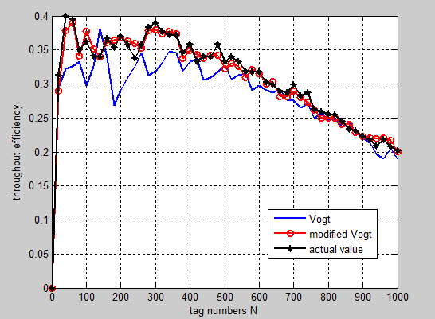

Fig.2 Simulation result of throughput efficiency

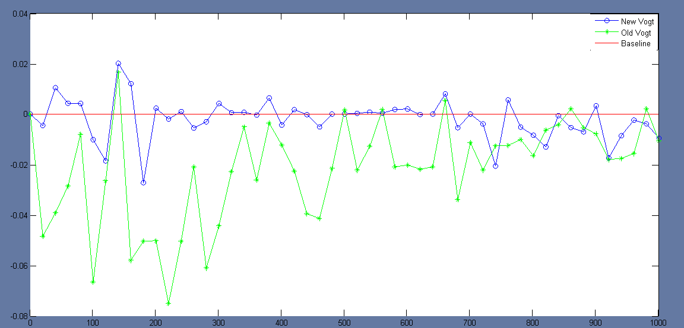

Fig.3 The accuracy of the new Vogt and the old

Vogt algorithm

Figure 4 and Figure 5 show the estimation error of three algorithms, LowerBound algorithm, Schout algorithm and Vogt algorithm, respectively, which under the different value of capture effect, and the function of estimation error defined by

 (14)

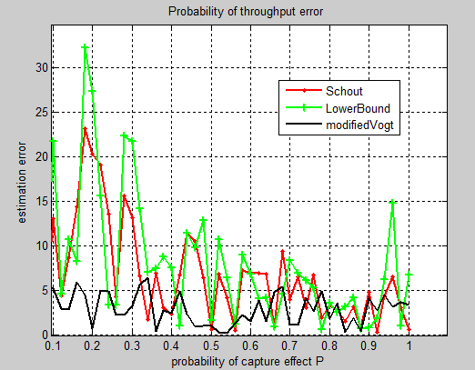

Fig.4 Simulation of estimation error

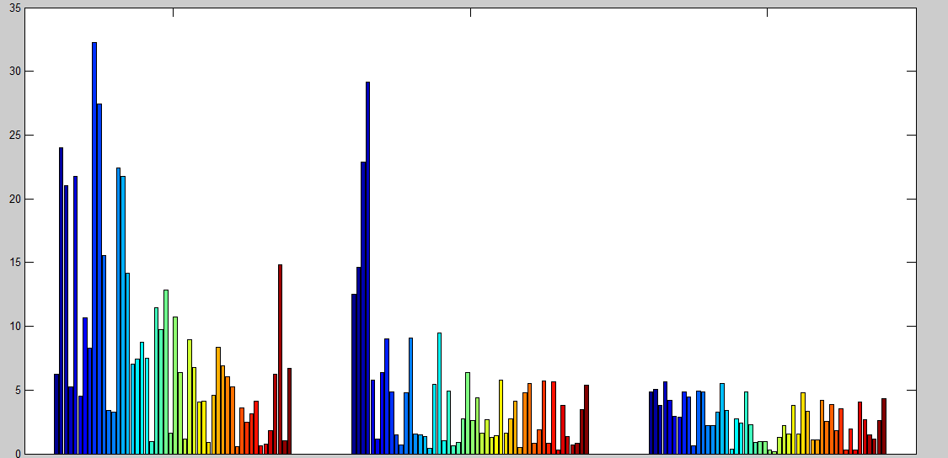

Fig.5 Estimation error.

The whole figure in Figure 5 has three parts, the first part shows the performance of LowerBound algorithm, the second part shows the performance of Schout algorithm, and the third part shows the performance of new Vogt algorithm.

Where  denotes the ratio of the number of unrecognized tags to the total number of slots in the  frame. Where the set of capture effect , ,and . Through the experimental results we can see that the estimation error of Schout algorithm and LowerBound algorithm are both more than 10% when the value of capture effect  is between 0.1 and 0.5, and fluctuation occurs so often, the instability is obvious. However, when the value of capture effect is between 0.5 and 1.0, the estimation error is less than 5%. As for the reconstructed Vogt algorithm, it has a better performance. The overall error is less than 5%, and the fluctuation is more stable, which shows that our work has achieved the expectation.



# Conclusion

As an important factor during the RFID recognition, capture effect has a nonnegligible impact on the process. In this paper, a new algorithm combined old Vogt algorithm with the capture effect has proposed. From the analysis of the experimental results, it can be seen that the new algorithm has a better performance in efficiency and accuracy compared with other algorithms. The overall error is less than 5%, and the fluctuation is more stable. The rationality of the Vogt algorithm is improved also. Because of the limitation of the research condition, the paper should be further studied. First, the performance among the large number of tags need to adapt to the real environment; second, trying to combine the capture effect with other algorithms in good performance, maybe could get more new discoveries in solving RFID tags collision problems. Based on the former work we think that RFID technology can be used for remote education in real-time recording and tracking of the learning process, which comprises real-time records of learners and their partners‟ learning process such as experience, debate, cooperation, competition, problem solving, and other learning experiences. It is helpful to objectively evaluate the students using experimental apparatus, such as the accuracy of laboratory equipment selection and the specification of using the apparatus. It also helps to evaluate students based on their active participation and cooperation, such as exploring whether the problem is clear or the program is reasonable.

.

References

1. Haifeng Wu and Yu Zeng,”Bayesian Tag Estimate and Optimal Frame Length for Anti-Collision Aloha RFID System,”IEEE Transactions on Automation Science and Engineering, vol. 7, no. 4, pp. 963-969, 2010.
2. J. R. Cha and J. H. Kim, “Novel anti-collision algorithms for fast object identification in RFID system,” in Proc. Int. Conf. Parallel Distrib. Syst. Comput., Japan, 2005, pp. 63–67.
3. S. R. Lee, S. D. Joo, and C. W. Lee, “An enhanced dynamic framed ALOHA algorithm for RFID tag identification,” in Proc. Int. Conf. Mobile and Ubiquitous Systems: Networking and Services, 2005, pp.166–174.
4. Tao Cheng, Li Jin,”Analysis and Simulation of RFID Anti-collision Algorithms,”[Advanced Communication Technology, The 9th International Conference](http://ieeexplore.ieee.org/xpl/mostRecentIssue.jsp?punumber=4195058), vol. 1,12-14 Feb. pp. 697 - 701, 2007
5. Yang J, Zhou J, Lv Z, et al. A real-time monitoring system of industry carbon monoxide based on wireless sensor networks[J]. Sensors, 2015, 15(11): 29535-29546.
6. M. A. Bonuccelli, F. Lonetti, and F. Martelli, “Tree slotted ALOHA: A new protocol for tag identification in RFID networks,” in Proc. Int. Symp. World of Wireless, Mobile and Multimedia Networks, 2006, pp.603–608.
7. W. T. Chen, “An accurate tag estimate method for improving the performance of an RFID anticollision algorithm based on dynamic frame length ALOHA,” IEEE Trans. Autom. Sci. Eng., vol. 6, no. 1, pp. 9–15,2009.
8. Xi Yang, Haifeng Wu, Yu Zeng, and Fei Gao,”Capture-Aware Estimation for the Number of RFID Tags with Lower Complexity,”IEEE Comunications Lett, vol. 17, no. 10, pp.1873-1875, 2013
9. Lv Z, Chirivella J, Gagliardo P. Bigdata Oriented Multimedia Mobile Health Applications[J]. Journal of Medical Systems, 2016, 40(5): 1-10. MLA
10. Y.-C. Lai and L. Y. Hsiao, “General binary tree protocol for coping with he capture effect in RFID tag identification,” IEEE Commun. Lett., vol.14, no. 3, pp. 208–210, 2010.
11. Jiang D, Ying X, Han Y, et al. Collaborative multi-hop routing in cognitive wireless networks[J]. Wireless Personal Communications, 2016, 86(2): 901-923.
12. Yang Wang, Haifeng Wu, and Yu Zeng,”Capture-Aware Estimation for Large-Scale RFID Tags Identification,”IEEE Signal Processing Let, vol. 22, no. 9,pp.1274-1277 2015
13. Lv Z, Halawani A, Feng S, et al. Multimodal hand and foot gesture interaction for handheld devices[J]. ACM Transactions on Multimedia Computing, Communications, and Applications (TOMM), 2014, 11(1s): 10.
14. B. Li and J. Y. Wang, “Efficient anti-collision algorithm utilizing the capture effect for ISO18000-6C RFID Protocol,” IEEE Commun. Lett.,vol. 15, no. 3, pp. 352–354, 2011.
15. X. Yang, H. Wu, Y. Zeng, and F. Gao, “Capture-aware estimation for the number of RFIDtagswith lower complexity,” IEEE Commun. Lett.,vol. 17, no. 10, pp. 1873–1876, 2013.
16. Qi Jing Teoh and Nemai Karmakar,“A Performance Evaluation and Analysis of Capture Effect in RFID System,”[Microwave Conference,2008. ampc 2008. Asia-Pacific](http://ieeexplore.ieee.org/xpl/mostRecentIssue.jsp?punumber=4913660),16-20 Dec. Pp.1-4,2008
17. H. Vogt, “Efficient object identification with passive RFID tags,” in Proc.2002 International Conf. on Pervasive Computing, pp. 98–113.
18. Lv Z, Yin T, Han Y, Chen Y, et al. WebVR——web virtual reality engine based on P2P network[J]. Journal of Networks, 2011, 6(7): 990-998.
19. EPC radio-frequency identification protocols class-1 generation-2 UHF RFID protocol for communications at 860 MHz-960 MHz Version 1.1.0 Draft1, EPC global Inc 2005.
20. Lv Z, Tek A, Da Silva F, et al. Game on, science-how video game technology may help biologists tackle visualization challenges[J]. PloS one, 2013, 8(3): e57990.