Corresponding Author:
Kristian M. Jones, Sport and Exercise Sciences Research Institute, Ulster University, Newtownabbey, UK
Email: jones-k11@ulster.ac.uk
Differences in the structure of variability in ground reaction force trajectories provide additional information about variability in the golf swing
Kristian M. Jones^{1,2}, Eric S. Wallace¹, Steve R. Otto²
¹Sport and Exercise Sciences Research Institute, Ulster University, Newtownabbey, UK
²Research and Testing, The R&A, St. Andrews, Fife, UK
Abstract
The study presents a novel application of measures of the structure of variability to ground reaction force (GRF) trajectories and highlights the use of such measures to provide valuable information about coordination of the golf swing. The variability and regularity of GRF trajectories were quantified for iron and driver shots from three participants with different skill levels. Pointwise Median Absolute Deviation (p-MAD) was used to indicate the variability of GRF trajectories across their length and two alternative methodologies, Sample Entropy (SampEn) and Cross-Sample Entropy (Cross-SampEn), were used to determine their regularity. For both driver and iron shots, results showed that whilst there was no difference in the magnitude of variability between any of the participants, there were differences in the structure of this variability. In general, the GRF of the highest skilled participant was significantly more regular than that of the lesser skilled golfers. However, differences occurred across the various components of GRF. Thus, entropy measures can provide additional valuable information concerning dissimilarities among golfers of various skill levels and may indicate differences in neuromuscular system coordination during the golf swing. This study highlights the importance of considering the structure of variability, as well as its magnitude, and describes methods which could be applied to further investigations.
Keywords:
golf, ground reaction forces, variability, sample entropy, cross-sample entropy
1. Introduction
Variability in human motor performance is an inherent feature of movement and reflects the complexity of the human movement system. Repetitive attempts at a motor task are synonymous with kinematic and kinetic variability. Trial-to-trial differences in movement are characteristic of all human movement and occur both within and between individuals and at all levels of task familiarity and skill^{1,2,3}. Bernstein⁴ described the process by which the multiple degrees of freedom of the body can combine with external forces to produce many patterns or strategies with equivalent outcomes. This motor abundance⁵ allows for equivalent task outcomes in the presence of different movement strategies. Kinematic and kinetic variability in the human movement system can present as the result of changing perturbations and constraints across different task attempts, but is not necessarily linked to variability in task outcome or endpoint variability⁶.
It is now generally accepted that variability is not necessarily a negative property of a motor system, rather its interpretation is more complex³. The total variability may be composed of both random fluctuations and functional changes associated with properties of the motor system. These random fluctuations can be associated with the biological noise in the neuromuscular system, measurement noise and other external sources of variation, such as changes in the environment or task^{6,7}. Measured variability combines information about error and the underlying dynamics of the movement system. Increased variability could have positive, negative or neutral implications for the task performance.
To extract the maximum information about the underlying system dynamics, it is not sufficient to quantify only the magnitude of variability in a signal. Rather, the temporal organisation or structure of the variability in a signal should also be considered. Depending on the amplitude of the signals, a sine wave and random noise may display the same standard deviation. However, the signals clearly have different structures, which is not acknowledged by examining the magnitude of variability. Other measures are required to examine the structure of variability^{8,9}. There is growing recognition that quantifying the magnitude of variability does not sufficiently describe the variation in a biomechanical system and the use of tools designed to quantify the structure of variability is growing in popularity.
Whilst there are many different nonlinear methods which can be employed to quantify the structure of variability, this investigation focusses on entropy measures. Entropy refers to the predictability or randomness of the system being studied, and there are several algorithms which have been used to estimate the entropy of time series data⁹. These entropy measures provide a measure of pattern recurrence or regularity. The measures are used to indicate the complexity of a system, and are considered suitable for biological systems whose variability derives from both deterministic and stochastic sources^{9,10}. Entropy measures have been used to investigate changes in motor strategies and differences in skill level within other sports, such as race walking¹⁰.
The requirement of long input signals, which capture a system over many cycles, has mainly restricted the use of nonlinear tools to movements where these signals are readily available, such as gait or heart rate⁹. However, there are many discrete movements in the biomechanical domain with limited research demonstrating the value of such statistics in these movements. For example, Preatoni et al.¹⁰ investigated the stance phase in differently skilled race walkers, utilising an alignment process to join discrete stance phases into a single pseudo-periodic time series with discontinuities at the junctions between signals. Preatoni et al.¹⁰ suggested that these discontinuities would have negligible effect on the results due to the small percentage of the signal in which they occurred. This investigation utilized two related measures, Sample Entropy (SampEn) and Cross-Sample Entropy (Cross-SampEn). The second of these measures requires no alignment process and thus the use of these two related measures should provide evidence to judge whether the presence of discontinuities presents an issue.
The golf swing is a high energy, full body movement which places a high demand on coordination to produce both speed and accuracy of the resulting shot. Whilst outcome consistency is clearly desirable, it is still unclear how movement variability and outcome variability are related in the golf swing. Research has focussed on outcome variability¹¹ or measurements of club movement¹², and has not provided a link between these two types of variability. There has also been little research interest in the variability of GRF and moreover, nonlinear tools of the type proposed in this investigation have yet to be applied to investigations of the golf swing. The presence of external forces is necessary to generate an impulse which affects the motion of the body. The primary method in which this is achieved during the golf swing is through the golfers’ interaction with the ground. Thus, the GRF is important in understanding the mechanics of a successful swing¹³. The high coordinative demands and apparent advantage of consistency makes the golf swing an intriguing subject for the investigation of variability.
This paper presents a multiple case study of the variability of GRF’s of three differently skilled golfers with two different clubs. The aims of the study were: (1) to examine both the structure and magnitude of GRF variability during the golf swing and consider the differences compared to an examination of only the magnitude of variability; (2) to compare two non-linear tools which assess the structure of variability and their application to discrete movements.

2. Methods
2. 1. Participants
Three right-handed male golfers, with different skill levels as determined by handicap category, participated in the investigation. The participants had the following attributes: age: 53, 49, and 23 yr; mass: 89.2, 78.6, and 62.7 kg; height: 1.80, 1.68, and 1.59 m; and handicap: 4, 18, and 22 for Participants 1, 2 and 3, respectively. Participants provided written informed consent and were free from injury at the time of testing. All procedures complied with the ethical approval granted by the University’s institutional review board prior to the commencement of the investigation.
2. 2. Apparatus
A Doppler radar based launch monitor (Trackman 3, Trackman Golf, Vedbaek, Denmark) was used to measure shot outcomes and initial launch conditions, including ball speed, launch angles and ball spin. A three-camera motion capture system (Oqus 300, Qualisys, Gothenburg, Sweden), recording at 1000 Hz and utilising previously reported algorithms¹¹, was used to calculate clubhead presentation variables for all shots. Launch and clubhead variables were defined according to previous work¹⁴. Carry distance, distance travelled during ball flight, was used in place of total distance to avoid the utilisation of a model of ball roll (Fig. 1).
Figure 1. Schematic representation of shot outcome, initial launch and clubhead presentation variables. Amended with permission from Taylor and Francis Ltd. (www.tandfonline.com)¹¹.
A separate eight-camera 500 Hz motion capture system and Qualisys Track Manager (QTM) software (Oqus 300, Qualysis, Gothenburg, Sweden) were used to collect three-dimensional coordinate data of four retroreflective markers attached to the shaft. Ground reaction forces were measured using two force platforms (OR6-6-OP-2000, AMTI, Watertown, MA) sampling at a frequency of 500 Hz. The global coordinate system was defined with its origin at the anterior intersection of the force platforms with the X axis pointing left-right, the Y axis pointing posterior-anterior and the Z axis vertical for the golfer at address. Force data were synchronised with the eight-camera motion capture system and collected using the QTM software. An acoustic trigger was used to jointly trigger both motion capture systems and the force platforms on ball impact. Data were collected for a period of four seconds, including two seconds of pre-trigger data, for each swing.
2. 3. Data collection
Participants undertook one testing session at an indoor driving range bay at The R&A’s equipment test centre. Participants were situated inside the testing bay and shots directed through a 3 m x 3 m doorway onto a driving range. After an opportunity for self-directed warm up, participants hit 20 shots at a self-selected pace. The shots were ten driver shots and ten 5-iron shots in the order five drivers, five irons, five drivers, and five irons. For both clubs, participants were directed to hit a straight shot towards a target placed 250 yards downrange. For each swing, data for launch conditions, clubhead presentation kinematics, club motion and ground reaction force were collected. Miss-hit shots, as determined by the participant, or those not captured by the measuring equipment were discarded and the shot repeated. The three participants discarded three, two and one shots, respectively.
2. 4. Data analysis
Three-dimensional coordinates of the club shaft markers were used to calculate the global club angle using Visual 3D (C-Motion, Germantown, MD) and swing events were defined and calculated according to the definitions of Ball and Best¹⁵. All further analysis was conducted using MATLAB (Mathworks, Natick, MA). GRF trajectories were normalised between participants by dividing by the participants’ bodyweights in Newtons.
Time series are required to be of equal length for the entropy analysis. This was achieved using a two-step process. First, the timings of swing events were used to create GRF trajectories which began at takeaway and finished at impact. Data were then removed from the start of the signal so that all signals were the length of the shortest signal on a participant-by-participant and club-by-club basis. The maximum amount removed from the start of a signal was 89 frames. This equated to 13.8% of the signal, but only a small movement (<5 cm) of the clubhead. However, this was preferred over normalising all signals to a given number of points, as this process creates new signals with distorted velocity characteristics. Other methods for creating equal length signals were tested, and no clear effect was observed between this trimming and the results of the entropy calculations. The Median Absolute Deviation (MAD) statistic was chosen to quantify variability in the clubhead and launch data, as it is robust to outliers¹¹. Variability in the trajectories was assessed using pointwise Median Absolute Deviation (p-MAD), where the MAD of the trajectories was calculated for each time point consecutively.
SampEn measures the regularity of a signal¹⁶ and has been well utilised in biomechanics research^{10,17,18}. The algorithm gauges the presence of similar patterns in a time series by calculating the logarithmic probability that two sequences of m points remain similar for incremental sequences of m+1 points. Cross-SampEn only differs from SampEn in that it estimates the repeatability of two discrete time series rather than one long time series and can thus be applied to the separate biomechanical time series derived from discrete movements without an alignment process⁹ (see appendix for full descriptions). Both measures tend to zero for regular or periodic time series and increase with increasing unpredictability. Whilst not a strict measure of complexity, as predictability is assessed over just one scale and not several⁹, regularity relates to the complexity of the system generating the signal and a decrease in entropy may indicate a loss of complexity^{10,19}.
For the SampEn calculation, new signals were created by joining together the equal length GRF signals to create new signals, which included all ten swings for each participant and club. The time series derived presented discontinuities at the junctions between signal. However, these discontinuities accounted for a small percentage of the overall signal. SampEn was then calculated for each of the 12 signals created, two feet by two clubs by three components of GRF. Cross-SampEn was calculated for all possible comparisons within participant and club. As there were 10 shots with each club, there were 45 unique pairwise comparisons per condition and the median of these comparisons was used to compare to SampEn.
The selection of the parameters, template length m and tolerance r, is highly important in entropy calculations. SampEn and Cross-SampEn were calculated with a range of template lengths m = 1, 2, …, 6 points and tolerances r = 0.001, 0.002, …, 0.020 bodyweights (BW’s). The SampEn score and the median and MAD of Cross-SampEn pairwise comparisons were inspected to determine the effect of changing these parameters on the results of the entropy analyses. Whilst different tolerances produced different entropy values, the pattern of scores from different participants was consistent across a range of parameter values. Parameter values, which gave results reflecting these consistent patterns, include template length m = 3 and tolerance r = 0.004 BW.
Cross-SampEn scores were grouped into 12 categories based on the club used (driver or iron) and component of GRF for each foot (left or right foot and X, Y or Z component). Kolmogorov-Smirnov tests indicated that Cross-SampEn scores were significantly non-normal which was confirmed through inspection of the quartile-quartile plots and histograms. Therefore, non-parametric hypothesis tests were used. For each category, Kruskal-Wallis tests (α=0.05) and pairwise Wilcoxon comparisons with Bonferroni post-hoc adjustment were used to detect differences between the participants. Wilcoxon rank sum tests were used to investigate differences in SampEn and Cross-SampEn scores between the two clubs and the left and right feet. Cohen’s d effect sizes (d) were estimated to gauge the size of differences. Cohen’s d values of greater than 0.2, 0.5 and 0.8 denoted small, medium and large effects, respectively²⁰. All statistical analysis was performed using SPSS (SPSS v.23, IBM, Armonk, NY).

3. Results
Tables 1 and 2 present the median (± MAD) values for shot outcome, ball launch, clubhead presentation, impact location and swing timing variables. Jointly examining the shot outcome variables, carry distance and carry side, gives an indication of task success and shows that Participant 1 had the highest task success, followed by Participants 2 and 3, respectively. However, Participants 2 and 3 appeared to be more closely matched in skill to each other than Participant 1. In most variables, MAD values showed a general trend, whereby Participant 1 had the lowest variability followed by Participants 2 and 3, respectively. However, as might be expected with the multiple single subject methodology, these patterns are subject to inter-individual variation and exceptions are evident.
Table 1. Median ± MAD of outcome and launch variables
Table 2. Median ± MAD of clubhead presentation, impact location and swing timing variables
Variability in GRF during the swing, shown with p-MAD, was uniformly low for all participants with both clubs (Fig. 2). However, most participants displayed higher p-MAD in the vertical component of GRF with a slight increase in p-MAD during the downswing in all cases. Regarding entropy, Participant 1 displayed the highest SampEn and Cross-SampEn scores, and thus lower regularity in GRF in almost all conditions. An exception was the vertical (Z) component of left foot GRF in which Participant 3 showed the highest entropy values out of all participants. Comparing Participant 2 and 3 showed no clear pattern, with one individual having higher entropy values in some components of GRF and the other having higher entropy values in others (Figs. 3 and 4). SampEn and Cross-SampEn scores were higher, denoting lower regularity, in the Z component of GRF for both feet for all participants and clubs and displayed similar patterns for all participants.
Figure 2. Median left and right foot GRF trajectories for each participant with driver and iron clubs. Shaded region indicates 3 MAD’s as calculated using p-MAD. Median MAD values are shown on each graph.
Figure 3. SampEn with r = 0.004 for left and right foot GRF during driver and iron swings
Figure 4. Median (± one MAD error bars) Cross-SampEn with r = 0.004 for left and right foot GRF during driver and iron swings
A Kruskal-Wallis test revealed statistically significant differences in Cross-SampEn scores between participants for all 12 categories (Table 3). Post-hoc pairwise Wilcoxon tests with Bonferroni adjustment revealed statistically significant differences between the participants in all but five cases. In these cases, there was no statistically significant difference between two participants, but there was between these two participants and the third participant. In the exception to the trend highlighted above, where Participant 3 had the highest Cross-SampEn value, the difference between Participant 1 and Participant 3 had a small effect size and was not statistically significant. Effect sizes ranged from no effect to a large effect.
Table 3. Cross-SampEn results including Kruskal-Wallis tests (Test statistic, H(df), and alpha level, α) and post-hoc pairwise Wilcoxon tests with Bonferroni adjustment (test statistic, U, z-score, z, alpha level, α and effect size, d). Statistically significant hypothesis tests (α < 0.005) are highlighted in grey. Asterisks indicate small (* - d > 0.20), medium (** - d > 0.50) and large (*** - d > 0.80) effect sizes
Wilcoxon rank-sum tests revealed that there was a statistically significant difference in Cross-SampEn between the left and right feet (W_{s} = 707558, z = 5.42, α <0.001, d = 0.13) However, Cohen’s effect size descriptors suggested no effect between the two feet. Conversely, there was no significant difference between SampEn scores between the left and right feet (W_{s} = 361, z = 0.89, α =0.389, d = 0.15). Regarding the driver and the iron clubs, there was no significant difference in Cross-SampEn values (W_{s} = 673022, z = 1.76, α = 0.079, d = 0.04) or SampEn scores (W_{s} = 347, z = 0.44, α = 0.673, d = 0.07) between the two clubs.
4. Discussion
The aims of the present study were to demonstrate the use of measures of the structure of variability in the study and interpretation of variability. This was achieved through the utilization of measures of both structure and magnitude of variability in the investigation of GRF variability in three differently skilled golfers with two different clubs. This investigation utilised two related methods for estimating the entropy of a group of discrete signals, SampEn and Cross-SampEn.
The outcome variables, carry distance and carry side, were an indicator of task success which allowed the participants skill levels to be more accurately assessed rather than using their handicap. It should be noted that with all other things remaining constant, a higher carry distance will result in a higher carry side. Thus, to estimate skill, both variables must be considered jointly. The variability in shot outcome, launch variables and clubhead presentation was broadly similar to that reported by Betzler et al.¹¹ who investigated the driver shots of 285 male and female golfers. In that investigation, Betzler et al.¹¹ reported that low-handicap golfers exhibited significantly lower variability in several clubhead presentation variables. Similarly, in this investigation, the lowest variability in outcome, launch and clubhead presentation variables was displayed by Participant 1, the lowest handicap and highest performing golfer. Whilst Participant 1 was the highest performing golfer, Participants 2 and 3 were closer in skill level to each other than to Participant 1. However, as might be expected due to the multiple single subject study design, there was inter-individual variation in both outcome and variability measures.
A linear measure of the variability in GRF, p-MAD, showed no difference between the golfers. All three golfers displayed similar patterns where the variability in GRF was uniformly low throughout the backswing. A slight increase in p-MAD occurred during the downswing for all golfers, but considering the number of participants, it is not appropriate to speculate on the meaningfulness of this effect. However, this result differs from previous investigations of the variability of the clubhead during the golf swing, where previous researchers have found a decrease in variability of the clubhead during the downswing¹². The differences between clubhead variability and GRF variability may suggest compensatory variation, where variability in one subsystem can facilitate consistency in the desired outcome. This may be worthy of further investigation with a larger group of golfers.
Whilst the magnitude of variability in GRF was similar amongst the differently skilled participants, there appeared to be differences in the structure of variability in the GRF between the golfers. Both SampEn and Cross-SampEn showed decreased regularity in the GRF of Participant 1 in most of the components studied. That is, the highest skilled golfer was varying their GRF in a less regular manner, whilst the golfers with lower skill displayed more regular variations. Participant 2 and 3’s SampEn and Cross-SampEn scores were generally similar, reflecting the similarity in skill observed from the outcome variables. However, there was an exception in that Participant 3 had the highest SampEn value for the vertical (Z) component of left foot GRF with the driver club and the highest Cross-SampEn for the vertical (Z) component of the left foot GRF with both clubs. This could be a feature of Participant 3’s individual strategy, but it is difficult to speculate further.
In the scope of this investigation, the pertinent finding was that a measure of the structure of variability could, in most cases, differentiate between golfers of different abilities where the magnitude of variability showed no difference. This study has described a methodology to investigate the structure of variability in the GRF during the golf swing and further research could look to test the robustness of this finding and establish the potential patterns in groups of differently skilled golfers.
Entropy measures were higher in the vertical component of GRF than the medio-lateral and anterior-posterior components, but as a single tolerance value was used for all variables, this is more likely to be an indicator of greater absolute differences due to the increased magnitude of the vertical component. SampEn and similar measures are sensitive to the parameter values used in the calculations⁹. The larger overall magnitude results in a higher magnitude of differences between signals and thus, a vector which is similar with a length equal to m is less likely to be similar with a length of m+1 (see appendix for details). The trends, both between and within participants, were consistent across a range of template lengths and tolerances. The differences in entropy measures among the golfers, in the presence of no clear differences in the magnitude of variability, suggest that this type of nonlinear measure could provide additional valuable information regarding the study of the golf swing.
Aside from the expected differences in outcome, launch and clubhead presentation variables caused by differences in club properties, there were no clear differences between the iron and driver clubs in any of the variability measures. Furthermore, there were no differences in the variability or entropy between shots performed with the two clubs. It was hypothesised that differences would present due to the different properties of the clubs and their different uses during competitive golfing. However, it is possible that the task set to the golfers, which was the same with both clubs, did not adequately reflect these differences. In the future, more ecologically valid tasks, such as the inclusion of a distance control element, should be investigated.
Cross-SampEn was used as an alternative to SampEn, which has been widely applied to topics where long continuous signals are more prevalent, such as gait and posture^{21,22}. Whilst this measure has also been applied to discrete signals, through a process of joining these signals into a single pseudo-periodic signal¹⁰, the effect of discontinuities present in this new signal was not well understood. The SampEn provides a single estimate of entropy for a group of discrete signals, whereas Cross-SampEn must be applied to a pair of signals at a time, and thus generates a group of scores. In this investigation, there was agreement between the two methods and both methods facilitated the investigation of the structure of GRF variability during the golf swing.
5. Conclusion
This investigation demonstrated that entropy measures, as measures of regularity, can provide useful information regarding the structure of GRF variability in the golf swing. In the extant literature, higher entropy values have been associated with less rigid control over the body’s degrees of freedom and greater flexibility and adaptability in changing environmental conditions⁸. Greater entropy, generally displayed by the highest skilled golfer in this study, has been found in higher skilled race walkers¹⁰ and in healthy compared to pathological individuals²³. Thus, this investigation broadly agrees with existing literature, although this certainly warrants further research in a large group of golfers. This paper presents the methodology for performing those investigations. The finding of increased entropy has been used to suggest that variability is not simply the product of random noise in the system and can thus be valuable in the performance of repeated tasks. Whilst these methodologies might appear complex, their application and interpretation provide a novel index of neuromuscular coordination, which could add value to future sports biomechanics research.
6. Funding statement
This research was made possible through a studentship from the Department for Employment and Learning Co-operative Awards in Science and Technology in collaboration with The R&A Rules Ltd.
7. Declaration of conflicting interests
The authors declare that there is no conflict of interest.
8. References
(1) Newell KM, Deutsch KM, Slifkin AB. Variability in motor output as noise: A default and erroneous proposition? In: Davids K, Bennett S, Newell KM, editors. Movement system variability Champaign, IL: Human Kinetics; 2006. p. 3-23.
(2) Bartlett RM, Wheat J, Robins M. Is movement variability important for sports biomechanists? SPORT BIOMECH 2007;6(2):224-243.
(3) Preatoni E, Hamill J, Harrison AJ, Hayes K, van Emmerik RE, Wilson C, et al. Movement variability and skills monitoring in sports. SPORT BIOMECH 2013;12(2):69-92.
(4) Bernstein NA. The coordination and regulation of movements. Oxford: Pergamon Press; 1967.
(5) Latash ML. The Bliss of Motor Abundance. EXP BRAIN RES 2012;217(1):1-5.
(6) van Emmerik RE, Ducharme SW, Amado AC, Hamill J. Comparing dynamical systems concepts and techniques for biomechanical analysis. J SPORT HEALTH SCI 2016;5:3-13.
(7) Hamill J, van Emmerik RE, Heiderscheit BC, Li L. A dynamical systems approach to lower extremity runnning injuries. CLIN BIOMECH 1999;14:297-308.
(8) Harbourne RT, Stergiou N. Movement variability and the use of nonlinear tools: Principles to guide physical therapist practise. PHYS THER 2009;89(3):267-282.
(9) Stergiou N. Nonlinear analysis for human movement variability. Boca Raton, FL: CRC Press; 2016.
(10) Preatoni E, Ferrario M, Dona G, Hamill J, Rodano R. Motor variability in sports: A non-linear analysis of race walking. J SPORT SCI 2010;28(12):1327-1336.
(11) Betzler NF, Monk SA, Wallace ES, Otto SR. Variability in clubhead presentation characteristics and ball impact location for golfers’ drives. J SPORT SCI 2012;30(5):439-448.
(12) Morrison A, McGrath D, Wallace ES. Motor abundance and control structure in the golf swing. HUM MOVEMENT SCI 2016;46:129-147.
(13) Barrentine, SW, Fleisig, GS, Johnson, H. Ground reaction forces and torques of professional and amateur golfers. In: Farrally MR, Cochran AJ, editors. Science and Golf II: Procedings of the World Scientific Congress of Golf; 1994; St Andrews. London: E & FN Spon.
(14) Betzler NF, Monk SA, Wallace ES, Otto SR. The relationships between driver clubhead presentation characteristics, ball launch conditions and golf shot outcomes. Proceedings of the Institution of Mechanical Engineers, Part P: Journal of Sports Engineering and Technology 2014;228(4):242-249.
(15) Ball KA, Best RJ. Different centre of pressure patterns within the golf stroke I: Cluster analysis. J SPORT SCI 2007;25(7):757-770.
(16) Richman JS, Moorman JR. Physiological time-series analysis using approximate entropy and sample entropy. AM J PHYSIOL-HEART C 2000;278:H2039-H2049.
(17) Decker LM, Cignetti F, Stergiou N. Wearing a safety harness during treadmill walking influences lower extremity kinematics mainly through changes in ankle regularity and local stability. J NEUROENG REHABIL 2012;9(8).
(18) Mei Z, Zhao G, Ivanov K, Guo Y, Zhu Q, Zhou Y, et al. Sample entropy characteristics of movement for four foot types based on platar centre of pressure during stance phase. BIOMED ENG ONLINE 2013;12(1).
(19) Pincus SM, Singer BH. Randomness and degrees of irregularity. P NATL ACAD SCI USA 1995;93:2083-2088.
(20) Cohen J. Statistical power analysis for the behavioral sciences. 2nd Edition ed. Lawrence Erlbaum: Hillsdale; 1988.
(21) Lamoth CJ, van Deudekom FJ, van Campen JP, Appels BA, de Vries OJ, Pijnappels M. Gait stability and variability measures show effects of impaired cognition and dual tasking in frail people. J NEUROENG REHABIL 2011;8(2).
(22) Lamoth CJ, Heuvelen MJ. Sports activities are reflected in the local stability and regularity of body sway: Older ice-skaters have better postural control than inactive elderly. GAIT POSTURE 2012;35(3):489-493.
(23) Vaillancourt DE, Slifkin AB, Newell KM. Regularity of force tremor in Parkinson's disease. CLIN NEUROPHYSIOL 2001;112(9):1594-1603.
List of Abbreviations:
Cross-Sample Entropy (Cross-SampEn)
Ground reaction force (GRF)
Median Absolute Deviation (MAD)
Pointwise Median Absolute Deviation (p-MAD)
Sample Entropy (SampEn)

List of Figures:
Figure 1. Schematic representation of shot outcome, initial launch and clubhead presentation variables. Amended with permission from Taylor and Francis Ltd. (www.tandfonline.com)¹¹.
Figure 2. Median left and right foot GRF trajectories for each participant with driver and iron clubs. Shaded region indicates 3 MAD’s as calculated using p-MAD. Median MAD values are shown on each graph.
Figure 3. SampEn with r = 0.004 for left and right foot GRF during driver and iron swings
Figure 4. Median (± one MAD error bars) Cross-SampEn with r = 0.004 for left and right foot GRF during driver and iron swings
List of Tables:
Table 1. Median ± MAD of outcome and launch variables
Table 2. Median ± MAD of clubhead presentation, impact location and swing timing variables
Table 3. Cross-SampEn results including Kruskal-Wallis tests (Test statistic, H(df), and alpha level, α) and post-hoc pairwise Wilcoxon tests with Bonferroni adjustment (test statistic, U, z-score, z, alpha level, α and effect size, d). Statistically significant hypothesis tests (α < 0.005) are highlighted in grey. Asterisks indicate small (* - d > 0.20), medium (** - d > 0.50) and large (*** - d > 0.80) effect sizes

Table 1. Median ± MAD of outcome and launch variables

 |  |  | Shot outcome variables |  |  | Ball launch variables
 |  |  | Carry length | Carry Side |  | Ball Speed | Launch Angle | Launch Direction | Spin Rate | Spin Axis
 |  |  | (m) | (m)  (+ve = right) |  | (m·s⁻¹) | (°)  (+ve = up) | (°)  (+ve = right) | (°·s⁻¹) | (°)  (+ve = right)
Driver | Participant 1 |  | 198 ± 4.7 | 4.4 ± 7.66 |  | 62.9 ± 0.53 | 11.6 ± 0.99 | 4.4 ± 1.64 | 14480 ± 1186 | -6.2 ± 6.52
 | Participant 2 |  | 177 ± 7.0 | 4.6± 12.01 |  | 58.5 ± 0.79 | 14.4 ± 1.54 | 0.8 ± 1.33 | 20450 ± 1962 | 0.4 ± 4.67
 | Participant 3 |  | 147 ± 9.2 | 7.5 ± 8.94 |  | 52.2 ± 1.17 | 14.1 ± 2.05 | -3.3 ± 2.05 | 22270 ± 3293 | 15.9 ± 3.72
Iron | Participant 1 |  | 158 ± 4.1 | 1.0 ± 8.92 |  | 53.8 ± 1.14 | 12.7 ± 0.89 | 5.4 ± 1.69 | 25030 ± 1553 | -8.2 ± 4.78
 | Participant 2 |  | 132 ± 4.3 | -3.8 ± 12.85 |  | 49.4 ± 0.61 | 20.3 ± 1.09 | 2.8 ± 1.72 | 27910 ± 2176 | -5.1 ± 5.51
 | Participant 3 |  | 128 ± 4.7 | 8.0 ± 10.07 |  | 46.0 ± 0.93 | 21.5 ± 1.76 | -1.0 ± 2.26 | 31280 ± 3429 | 7.7 ± 4.02

Table 2. Median ± MAD of clubhead presentation, impact location and swing timing variables

 |  |  | Clubhead presentation |  |  |  |  |  | Impact location |  |  | Swing timing
 |  |  | Clubhead speed | Face Angle | Effective Loft | Effective Lie | Path Angle | Attack Angle |  | X position | Y position |  |  | Backswing  duration | Downswing duration
 |  |  | (m·s⁻¹) | (°)  (+ve=open) | (°)  (+ve = back) | (°)  (+ve=toe-up) | (°)  (+ve = left) | (°)  (+ve = up) |  | (mm)  (+ve=heel) | (mm)  (+ve = up) |  |  | (s) | (s)
Driver | Participant 1 |  | 42.6 ± 0.19 | 3.3 ± 1.05 | 12.5 ± 0.92 | 0.7 ± 0.46 | 5.7 ± 1.12 | 5.6 ± 0.59 |  | -4.4 ± 8.32 | -4.7 ± 3.26 |  |  | 0.82 ± 0.050 | 0.28 ± 0.005
 | Participant 2 |  | 40.6 ± 0.26 | 5.3 ± 2.11 | 18.5 ± 1.64 | 5.7 ± 0.79 | 4.4 ± 0.42 | 7.6 ± 0.65 |  | 6.5 ± 5.26 | -9.6 ± 4.27 |  |  | 0.93 ± 0.032 | 0.29 ± 0.006
 | Participant 3 |  | 38.4 ± 0.25 | 5.3 ± 2.50 | 15.7 ± 1.56 | 7.1 ± 0.60 | -3.2 ± 0.96 | -0.1 ± 0.49 |  | 21.1 ± 9.47 | 8.1 ± 7.66 |  |  | 0.78 ± 0.021 | 0.31 ± 0.004
Iron | Participant 1 |  | 36.8 ± 0.26 | 3.7 ± 1.63 | 18.1 ± 1.72 | -4.3 ± 1.09 | 6.6 ± 0.99 | -3.0 ± 0.49 |  | 0.4 ± 6.20 | -7.1 ± 3.17 |  |  | 0.80 ± 0.010 | 0.26 ± 0.005
 | Participant 2 |  | 34.6 ± 0.29 | 3.9 ± 1.95 | 25.7 ± 1.81 | -1.9 ± 0.87 | 6.3 ± 0.80 | 2.6 ± 0.58 |  | 5.6 ± 5.10 | -5.0 ± 3.20 |  |  | 0.89 ± 0.011 | 0.30 ± 0.007
 | Participant 3 |  | 33.7 ± 0.31 | 1.0 ± 2.63 | 28.0 ± 2.04 | -0.4 ± 0.96 | -5.2 ± 0.78 | -0.4 ± 0.49 |  | 7.2 ± 5.17 | -4.1 ± 4.36 |  |  | 0.75 ± 0.025 | 0.30 ± 0.008

Table 3. Cross-SampEn results including Kruskal-Wallis tests (Test statistic, H(df), and alpha level, α) and post-hoc pairwise Wilcoxon tests with Bonferroni adjustment (test statistic, U, z-score, z, alpha level, α and effect size, d). Statistically significant hypothesis tests (α < 0.005) are highlighted in grey. Asterisks indicate small (* - d > 0.20), medium (** - d > 0.50) and large (*** - d > 0.80) effect sizes
 |  |  |  | Cross-SampEn Median ± MAD |  |  |  | Kruskal-Wallis test |  | Post-hoc pairwise Wilcoxon tests
 |  |  |  |  |  |  |  |  |  |  | 1 vs 2 |  |  |  |  |  | 1 vs 3 |  |  |  |  |  |  | 2 vs 3
 |  |  |  | Participant 1 | Participant 2 | Participant 3 |  | H (2) | α |  | U | z | α | d |  |  | U | z | α | d |  |  | U |  | z | α | d
Driver | Left Foot | X |  | 0.07 ± 0.009 | 0.05 ± 0.016 | 0.04 ± 0.011 |  | 71.41 | <0.001 |  | 29.27 | 3.55 | 0.001 | 0.37 | * |  | 69.40 | 8.42 | <0.001 | 0.89 | *** |  | 40.13 |  | 4.87 | <0.001 | 0.51 | **
 |  | Y |  | 0.11 ± 0.011 | 0.04 ± 0.003 | 0.05 ± 0.015 |  | 94.34 | <0.001 |  | 78.40 | 9.51 | <0.001 | 1.00 | *** |  | 53.40 | 6.48 | <0.001 | 0.68 | ** |  | -25.00 |  | -3.03 | 0.007 | -0.32 | *
 |  | Z |  | 0.17 ± 0.035 | 0.13 ± 0.049 | 0.18 ± 0.017 |  | 28.35 | <0.001 |  | 31.49 | 3.82 | <0.001 | 0.40 | * |  | -10.76 | -1.30 | 0.576 | -0.14 |  |  | -42.24 |  | -5.12 | <0.001 | -0.54 | **
 | Right Foot | X |  | 0.10 ± 0.010 | 0.05 ± 0.004 | 0.05 ± 0.008 |  | 88.80 | <0.001 |  | 63.13 | 7.66 | <0.001 | 0.81 | *** |  | 70.80 | 8.59 | <0.001 | 0.91 | *** |  | 7.67 |  | 0.93 | 1.000 | 0.10
 |  | Y |  | 0.12 ± 0.009 | 0.06 ± 0.005 | 0.06 ± 0.011 |  | 83.05 | <0.001 |  | 67.20 | 8.15 | <0.001 | 0.86 | *** |  | 62.73 | 7.61 | <0.001 | 0.80 | *** |  | -4.47 |  | -0.54 | 1.000 | -0.06
 |  | Z |  | 0.31 ± 0.055 | 0.25 ± 0.030 | 0.22 ± 0.027 |  | 57.29 | <0.001 |  | 37.82 | 4.59 | <0.001 | 0.48 | * |  | 61.91 | 7.51 | <0.001 | 0.79 | ** |  | 24.09 |  | 2.92 | 0.010 | 0.31 | *
Iron | Left Foot | X |  | 0.09 ± 0.010 | 0.07 ± 0.010 | 0.03 ± 0.010 |  | 98.08 | <0.001 |  | 37.49 | 4.55 | <0.001 | 0.48 | * |  | 81.58 | 9.89 | <0.001 | 1.04 | *** |  | 44.09 |  | 5.35 | <0.001 | 0.56 | **
 |  | Y |  | 0.11 ± 0.009 | 0.04 ± 0.003 | 0.06 ± 0.019 |  | 102.94 | <0.001 |  | 83.13 | 10.08 | <0.001 | 1.06 | *** |  | 49.73 | 6.03 | <0.001 | 0.64 | ** |  | -33.40 |  | -4.05 | <0.001 | -0.43 | *
 |  | Z |  | 0.19 ± 0.045 | 0.15 ± 0.021 | 0.21 ± 0.024 |  | 66.55 | <0.001 |  | 61.49 | 7.46 | <0.001 | 0.79 | ** |  | 7.11 | 0.86 | 1.000 | 0.09 |  |  | -54.38 |  | -6.59 | <0.001 | -0.70 | **
 | Right Foot | X |  | 0.10 ± 0.011 | 0.05 ± 0.006 | 0.06 ± 0.012 |  | 87.72 | <0.001 |  | 76.62 | 9.29 | <0.001 | 0.98 | *** |  | 46.71 | 5.67 | <0.001 | 0.60 | ** |  | -29.91 |  | -3.63 | 0.001 | -0.38 | *
 |  | Y |  | 0.10 ± 0.010 | 0.06 ± 0.005 | 0.06 ± 0.010 |  | 93.38 | <0.001 |  | 77.11 | 9.35 | <0.001 | 0.99 | *** |  | 55.96 | 6.79 | <0.001 | 0.72 | ** |  | -21.16 |  | -2.57 | 0.031 | -0.27 | *
 |  | Z |  | 0.30 ± 0.034 | 0.21 ± 0.021 | 0.23 ± 0.035 |  | 51.94 | <0.001 |  | 58.40 | 7.08 | <0.001 | 0.75 | ** |  | 38.73 | 4.70 | <0.001 | 0.50 | ** |  | -19.67 |  | -2.39 | 0.051 | -0.25 | *

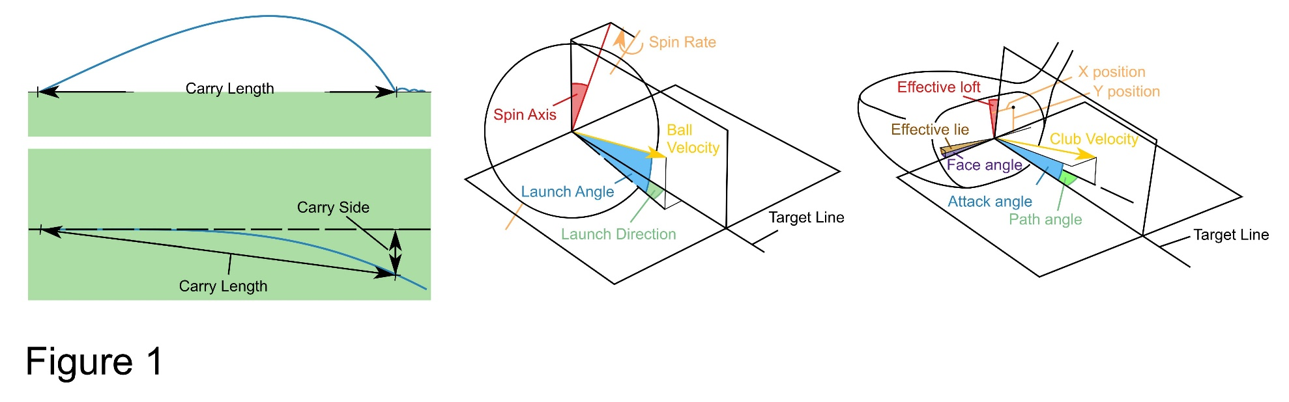
Figure 1. Schematic representation of shot outcome, initial launch and clubhead presentation variables. Amended with permission from Taylor and Francis Ltd. (www.tandfonline.com)¹¹.
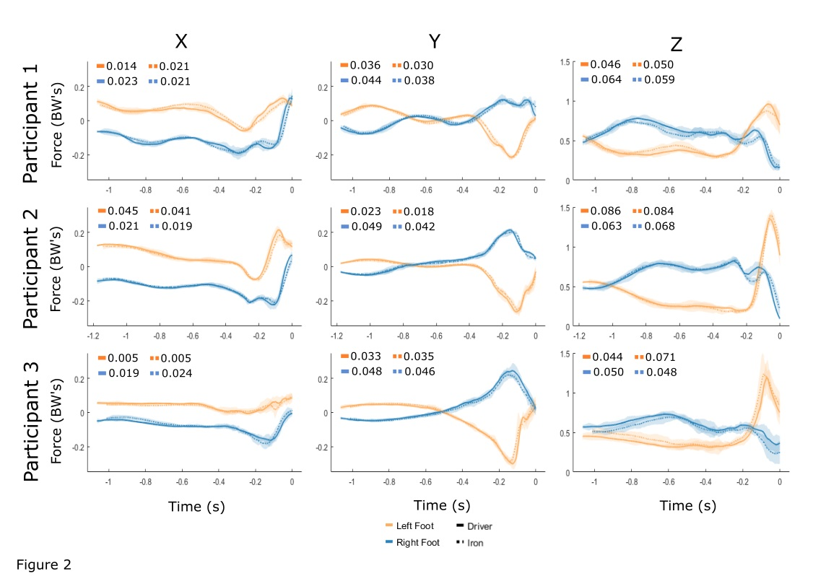
Figure 2. Median left and right foot GRF trajectories for each participant with driver and iron clubs. Shaded region indicates 3 MAD’s as calculated using p-MAD. Median MAD values are shown on each graph.
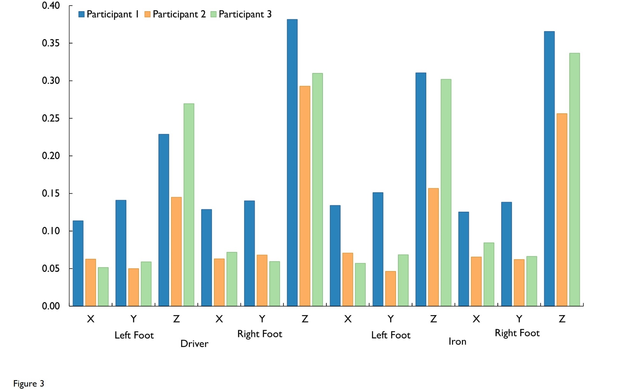
Figure 3. SampEn with r = 0.004 for left and right foot GRF during driver and iron swings
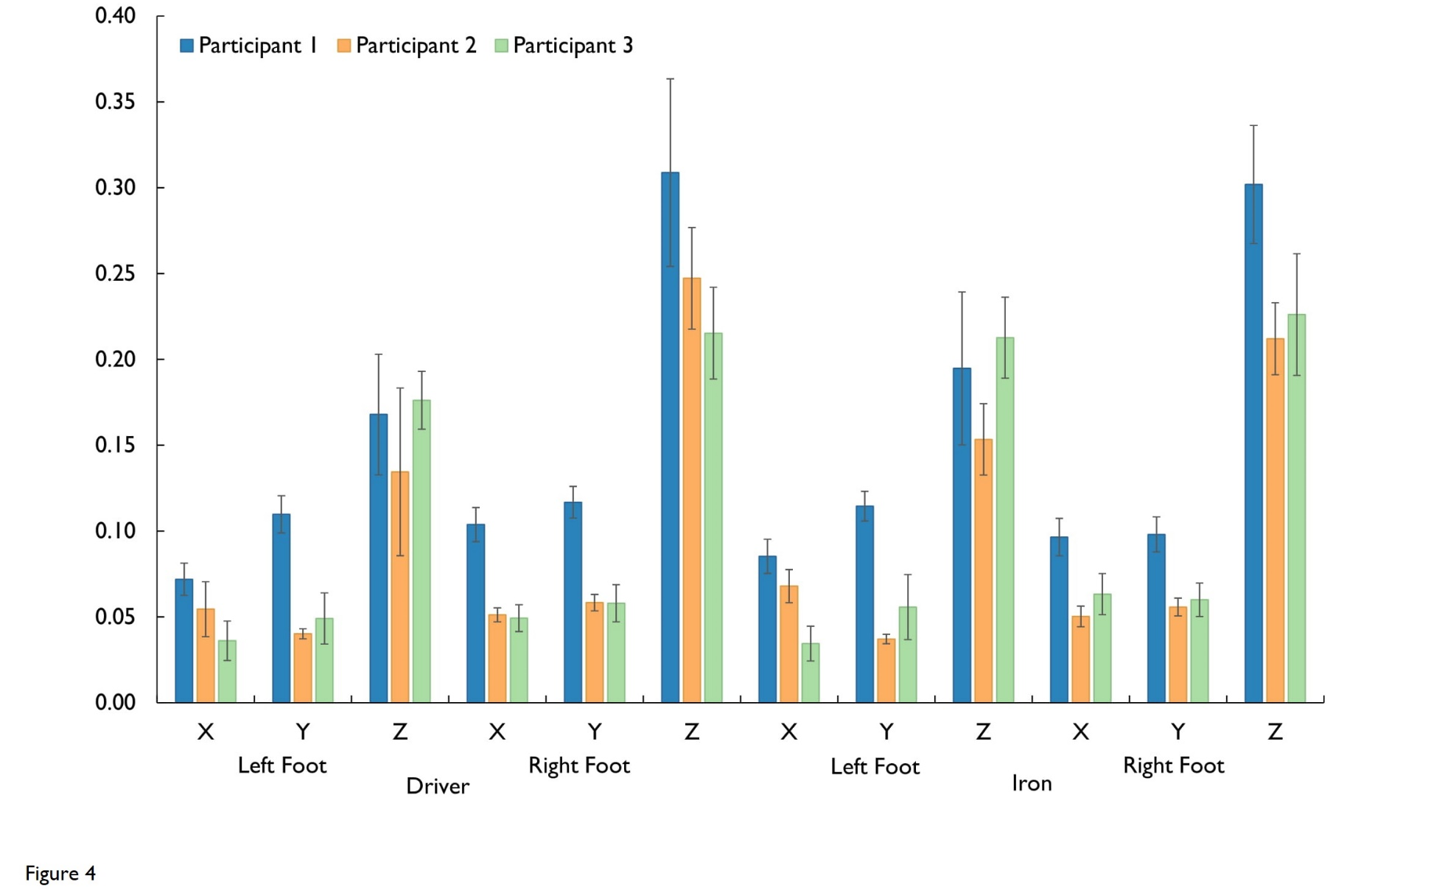
Figure 4. Median (± one MAD error bars) Cross-SampEn with r = 0.004 for left and right foot GRF during driver and iron swings

Appendix
Richman and Moorman¹⁶ developed the SampEn algorithm as a modification of Approximate Entropy (ApEn) proposed by Pincus¹⁹. SampEn displays more consistent behaviour for different parameter choices than ApEn and is largely independent of time series length¹⁶. The algorithm for calculating SampEn is as follows:
(1) Form a time series, u = u(1), u(2), … u(N), which consists of N evenly spaced measurements
(2) Fix m, the vector length, as an integer value and r, the tolerance, as a positive real number
(3) Form the sequence of vectors x_{m} = x_{m}⁽¹⁾, x_{m}⁽²⁾, … x_{m}^{(N-m+1)} defined by x^{(i)} = [u^{(i)}, … u^{(i+m-1)}]
(4) Define the distance between two vectors as d[x,x*] = max|u^{(a)} - u*^{(a)}| where u^{(a)} are the m scalar components of x
(5) For each 1 ≤ i ≤ N-m+1, use the sequence x_{m} to construct:
$$C_{i}^{m}=\frac{(number of x^{(j)} such that d[x^{(i)},x^{(j)}] ≤ r) }{(N-m)}$$
where 1 ≤ j ≤ N-m+1 and i ≠ j
(6) Calculate, $B_{i}=\frac{\sum_{i}{{(C}_{i}^{m})}}{(N-m)}$
(7) Form the sequence of vectors x_{m+1}
(8) Calculate, $A_{i}=\frac{\sum_{i}{{(C}_{i}^{m+1})}}{\left(N-m\right)}$
(9) SampEn is defined as $\lim_{N→∞}\left\{-ln⁡\left(\frac{A_{i}}{B_{i}}\right)\right\}$, however to resolve the limit SampEn is calculated as:
$$SampEn= -\ln\left(\frac{A}{B}\right)$$
where $A= \frac{(N-m-1)(N-m)}{2}A_{i}$ and $B= \frac{\left(N-m-1\right)\left(N-m\right)}{2}B_{i}$
Cross-SampEn is an application of the SampEn algorithm to two discrete time series of equal length, where the template x(i) is taken from a time series and the comparison vectors y(j) from the other time series⁹. Explicitly:
(1) Form two time series, u = u⁽¹⁾, u⁽²⁾, … u^{(N)} and v = v⁽¹⁾, v⁽²⁾, … v^{(N)} which consist of N evenly spaced measurements
(2) Fix m, the vector length, as an integer value and r, the tolerance, as a positive real number
(3) Form the sequence of vectors x_{m} = x_{m}⁽¹⁾, x_{m}⁽²⁾, … x_{m}^{(N-m+1)} and y_{m} = y_{m}⁽¹⁾, y_{m}⁽²⁾, … y_{m}^{(N-m+1)} defined by x^{(i)} = [u^{(i)}, … u^{(i+m-1)}] and y^{(i)} = [v^{(i)}, … v^{(i+m-1)}] likewise
(4) Define the distance between two vectors as d[x,y*] = max|u^{(a)} - v*^{(a)}| where u^{(a)} and v^{(a)} are the m scalar components of x and y respectively
(5) For each 1 ≤ i ≤ N-m+1, use the sequence x_{m} to construct:
$$C_{i}^{m}=\frac{(number of x^{(j)} such that d[x^{(i)},y^{(j)}] ≤ r) }{(N-m)}$$
where 1 ≤ j ≤ N-m+1 and i ≠ j
(6) Calculate, $B_{i}=\frac{\sum_{i}{{(C}_{i}^{m})}}{(N-m)}$
(7) Form the sequence of vectors x_{m+1} and y_{m+1}
(8) Calculate, $A_{i}=\frac{\sum_{i}{{(C}_{i}^{m+1})}}{\left(N-m\right)}$
(9) Cross-SampEn is defined as $\lim_{N→∞}\left\{-ln⁡\left(\frac{A_{i}}{B_{i}}\right)\right\}$, however to resolve the limit Cross-SampEn is calculated as:
$$Cross SampEn= -\ln\left(\frac{A}{B}\right)$$
where $A= \frac{(N-m-1)(N-m)}{2}A_{i}$ and $B= \frac{\left(N-m-1\right)\left(N-m\right)}{2}B_{i}$

Both measures have no units, are undefined in cases where there are no similar vectors and neither method is direction dependent⁹.

