Rapid Paper Based Colorimetric Detection of Glucose using a Hollow Microneedle Device

Dean Nicholas¹, Keiran A. Logan¹, Yingjie Sheng¹, Jinhui Gao¹, Sian Farrell¹, Dorian Dixon², Bridgeen Callan¹, Anthony P. McHale¹ and John F. Callan*¹.

- Biomedical Sciences Research Institute, University of Ulster, Coleraine, Northern Ireland, U.K. BT52 1SA.
- NIBEC, University of Ulster, Shore Road Belfast, BT37 0QB, U.K
- To whom correspondence should be addressed: j.callan@ulster.ac.uk: Ph: 00442870123059
Abstract
The monitoring of blood glucose is a key aspect of diabetes care in limiting the negative effects of hyperglycaemia to both the microvasculature and macrovasculature. Self-monitoring of blood glucose (SMBG) gives an indication of blood glucose at a specific point in time and is recommended to be carried out four times daily. However, due to the inconvenience and associated pain of blood withdrawal, SMBG is often carried out less frequently than recommended or not at all. Extraction and subsequent determination of glucose in interstitial fluid (ISF) using microneedles (MNs) is an emerging area of research due to their minimally invasive nature and lack of associated pain. In this manuscript, a novel method for the fabrication of a hollow microneedle device is reported. The microneedle produced had a sharp bevelled edge and was 400 µm in length. Additionally, a paper backplate embedded with a colorimetric system for the rapid visual determination of glucose in simulated ISF was developed and paired with the hollow MN. This device rapidly extracted simulated ISF within five seconds and its ability to produce a glucose concentration dependent colour change within 30 seconds was demonstrated. Using this approach, it was possible to discriminate between glucose concentrations in normal glycaemia (4-7 mM) and hyperglycaemia (>7 mM) ranges using the naked eye. While further development is required, the results herein highlight the potential of this device to be used as a blood-free minimally invasive approach to glucose monitoring.
Keywords: Microneedle, glucose, monitoring, minimally invasive, colorimetric.

1.0 Introduction: Strict blood glucose control is of vital importance in limiting the progression of long-term adverse effects associated with Type 1 and Type 2 diabetes. Intensive control of blood glucose levels has been shown to decrease diabetes related complications and reduce all-cause mortality (1, 2). Glycated haemoglobin levels are used to determine the average blood glucose level over an extended time-period (i.e. the previous two to three months), (3) while the self-monitoring of blood glucose (SMBG) is used to indicate the concentration of glucose at a specific point in time and plays a critical role in diabetes care. A large portion of SMBG is carried out through capillary blood monitoring facilitated by lancet finger prick blood sampling and companion electronic glucometers. Healthcare guidelines recommend SMBG to be carried out four times daily with this increasing to as high as ten times daily in periods of illness or poor control (4). However, several reports have concluded that approximately 40%-50% of all diabetics either do not adhere to guidelines or do not carry out routine SMBG at all (5, 6), with pain attributed as a contributing factor (7).
Microneedle (MN) mediated sampling of interstitial fluid (ISF) is emerging as an attractive alternative to blood sampling for a range of analytes, with glucose being a prime target (8). MNs provide a minimally invasive method of extraction due to their short length (9) (below 1000 µm), allowing them to penetrate through the stratum corneum and gain access to the ISF in the viable epidermis and upper layers of the dermis, without stimulating nociceptors or reaching blood vessels (10). As it has been demonstrated that the glucose concentration in ISF correlates well to its blood concentration (11), MNs may provide a painless, minimally invasive method of indirectly determining blood glucose levels.
MNs can be prepared from various types of materials to enable the withdrawal of ISF such as swellable hydrogel microneedles (12, 13) or those with hollow microneedle projections that draw fluid through microchannels via capillary action (14, 15). However, one of the main limitations when using swellable hydrogel microneedles is the slow rate of ISF extraction, resulting in long administration times of up to one hour (13). To improve on these extraction times, polymeric MNs prepared from crosslinked hyaluronic acid demonstrated a more rapid ISF extraction with adequate amounts being removed after 10 min (12). Furthermore, MNs created from crosslinked hyaluronic acid have been developed into glucose responsive insulin delivery devices that can tailor the rate of insulin delivery depending on the concentration of glucose within the ISF (16). Nonetheless, such a time scale may still not be practical for a repetitive monitoring technique such as SMBG. In addition, the method of detection for ISF analytes in these studies required centrifugation of the MN and subsequent off-line analysis, further limiting their use as point-of-care devices for SMBG. In contrast, hollow MNs remove the need for swelling induced extraction and offer the possibility for a more rapid removal of ISF.
Current advancements in hollow MNs have shown success in vitro and in both animal and human subjects. MN arrays synthesised from single crystal silicon was shown to extract ISF from human skin using capillary action (17). The presence of glucose in the ISF was confirmed however an integrated sensor with this MN array has not been reported. An electrode linked hollow MN array has demonstrated the in vitro detection of hydrogen peroxide which is a mediator in the enzymatic detection of glucose using glucose oxidase, however studies using simulated ISF and further animal work has not yet been reported (18).
In this manuscript, we report the development of a single hollow MN device containing an integrated enzyme based colorimetric glucose sensor for the rapid determination of physiologically relevant concentrations of glucose in simulated ISF. The glucose sensor was incorporated within a paper matrix and attached as a backplate to the hollow MN. The change of colour intensity with response to varying glucose concentration was assessed using chromaticity measurements and using visual naked eye comparisons.

2.0 Experimental
2.1 Reagents and Materials: D-(+)-glucose, glucose oxidase/peroxidase reagent (containing 500 units of glucose oxidase (Aspergillus niger), 100 Purpurogallin units of peroxidase (horseradish peroxidase)), 3,3′,5,5′-tetramethylbenzidine, sodium acetate, trimethylolpropane trimethacrylate, triethylene glycol dimethacrylate, glycidyl methacrylate, 2-methoxyethanol, 1-hydroxycyclohexyl phenyl ketone and Whatman No.1 paper were purchased from Sigma Aldrich. BD Microlance 30G were purchased from Appleton Woods Ltd. Addition RTV Silicone v13 was purchased from TOMPS online. Photographs were taken using a Canon EOS 100D with an attached 18-55mm IS STM lens. Photographs taken rapidly every second were controlled using a standard intervalometer timer shutter release. UV/Vis spectroscopy was obtained using a Varian Cary 50 Bio spectrometer. 3D printing was carried out using a Form 1+ printer by Formlabs with clear resin. 3D models were drawn using CAD programs SketchUp (Trimble) and NettFab Basic (Autodesk). Chromaticity values were calculated from digital photographs using an open source program ImageJ with the RGB Measure Plugin.
Methods
2.2 Fabrication of Hollow Microneedle Moulds: Using CAD modelling programs, the master mould was created from Formlabs clear resin using a Form 1+ printer. A 30G hypodermic needle was inserted into the mould, set to the required length (400 µm) and fixed in place with adhesive. RTV silicone was prepared following the manufacturer’s instructions. Briefly, equal parts catalyst and base silicones were mixed thoroughly before degassing in a vacuum chamber. The silicone was pushed through the hypodermic needle using a syringe and then poured into the master mould before allowing to set overnight at room temperature. The cured silicone negative mould was released from the master, carefully removing the thin length of silicone that had formed inside the bore of the hypodermic needle. The negative mould was then washed with water and methanol and allowed to dry.
2.3 Fabrication of hollow microneedle device: The photopolymer mix was composed of glycidyl methacrylate (10 % w/w), trimethylolpropane trimethacrylate (6.0 % w/w), triethylene glycol dimethacrylate (15.7 % w/w), 1-hydroxycyclohexyl phenyl ketone (0.01 % w/w) in 2-methoxyethanol. (19). This solution was added to the negative silicone mould and placed under vacuum for 15 min to ensure complete filling of the mould. Subsequently, the moulds were placed under a UV lamp (365 nm) for 30 min to enable polymerisation. The MNs were then removed from the moulds, washed with distilled water and dried. To confirm the ability of the hollow MN device to extract solution, it was pierced through a parafilm membrane and a blank paper backplate attached to the upper side. This was placed on the surface of an aqueous solution containing 1 mM methylene blue. Photographs of the backplate were taken every second for 5 seconds.
2.4 Axial load fracture test of microneedle
The force required to mechanically fracture the microneedle was measured under an axial load test station (Instron® 3344, Buckinghamshire, UK) using a 50 N load cell. A round metal rod with a diameter of 4 mm was driven into the microneedle at a rate of 0.01 mm/s until fracture occurred. Microneedle was fixed to the bottom plate using adhesive tape and fracture was confirmed through observation with an optical microscope throughout experiment.
2.5 Validation of chromaticity measurements through methylene blue uptake. Stock solutions of methylene blue (0-1 mM) in distilled water were prepared. Blank paper backplates were submerged in each solution and allowed to dry at room temperature. Photographs of each backplate were taken and the blue chromaticity values were calculated. This was achieved by obtaining the red (R), green (G) and blue (B) values from the photograph of the backplate using ImageJ with the RGB measure plugin. The blue chromaticity was calculated by dividing the B value by the sum of the R, G and B values.
2.6 Preparation of glucose responsive colorimetric backplates. Paper squares were submerged in an aqueous 3.5 ml solution containing GOx/HRP (625 U/L) and TMB (3.33 mM) for 5 min. The backplates were then removed and allowed to dry at room temperature for 2 h. To test the colour response to glucose, an aliquot of glucose (1 µl) was pipetted onto each backplate and photographs were taken every second for 15 sec.
2.7 Extraction and determination of glucose in simulated interstitial fluid using the MN-backplate assembly. Hollow MN devices integrated with glucose responsive backplates were pierced through parafilm membranes and placed on the surface of glucose solutions (0 – 10 mM) in phosphate buffered saline. A photograph of the backplate was taken after 30 sec and the chromaticity of each backplate was calculated.
3.0 Results and Discussion: The hollow MNs were prepared following polymerisation of the monomers glycidyl methacrylate, trimethylolpropane trimethacrylate and triethylene glycol dimethacrylate, under the assistance of the free-radical initiator 1-hydroxycyclohexyl phenyl ketone. The polymerisation process was undertaken in a “negative” silicon mould prepared from an initial master mould. The latter was fabricated by 3D printing a housing to enable a 30 gauge hypodermic needle to be inserted through the centre. (Fig 1a). This housing enabled the tip of the hypodermic needle to protrude to the exact length needed before it was fixed in place. To create a negative mould from the master, a low viscosity silicone was poured into the top of the master, with silicone also being forced through the hypodermic needle with a syringe (Fig 1b). This ensured the negative mould not only replicated the outer facets of the bevelled needle but also the inner hollow bore. After curing, the negative mould was removed, taking care to remove the silicone that had been inside the hypodermic needle. This yielded a negative hollow microneedle mould (Fig 1c) that was then filled with the monomers / photoinitator matrix and polymerised under UV light (365 nm) for 30 min (Fig 1d). After removal from the negative mould, the MN device was washed with distilled water and dried (Fig 1e), ready for attachment of the paper backplate comprising the glucose sensor (Fig 1f). This novel approach to the preparation of hollow MNs was developed as it represents a cheap, facile method for their preparation and one that is amenable to scale-up if necessary.
A photograph, showing a representative example of a hollow MN prepared using the approach described above is shown in Fig 2a and reveals a relatively flat base-plate with a single needle projection protruding from the lower surface. To confirm the needle was hollow, a thin wire was successfully inserted through the needle bore as demonstrated in Fig 2a. An optical micrograph image of the same hollow MN (Fig 2b) clearly illustrates the successful formation of a sharp bevelled edged microneedle (400 µm length) with a well formed opening at the tip to enable the passage of fluid.
To reliably penetrate the skin, the MN must be adequately robust to withstand the force necessary to penetrate without fracture. The mean axial force required to fracture the MN was measured to be 0.27 N ± 0.04 N (n = 4) by driving a steel rod on to the MN tip using an axial load test station (Fig 3). Previous reports have shown forces ranging between 0.028 N – 0.030 N per MN to be sufficient to penetrate the skin (20). These values are approximately one order of magnitude lower than the mean fracture force of the hollow MN device.

To confirm the capability of the hollow MN to withdraw fluid rapidly, a blank paper backplate was attached to the upper side of the MN baseplate (Fig 4). The needle end of the device was then pierced through a waterproof membrane and the assembly placed onto a solution containing methylene blue dye. The rate of methylene blue uptake was followed visually over the course of 5 seconds. As observed in Fig 4, the first appearance of the dye occurred within two seconds and the backplate was completely saturated within five seconds. Importantly, it was also observed that the blue solution moved up through the hollow bore and into the centre of the paper backplate from where it then migrated toward the outer edges. This confirms that the fluid is only transported though the hollow bore of the needle and not through the baseplate itself. The timescale over which this rapid withdrawal of fluid takes place is superior to the aforementioned swellable hydrogel MNs (12, 13) and compares favourably with those prepared from single crystal silicon (17).
Having demonstrated the rapid extraction of fluid using the hollow MN and methylene blue as a surrogate for glucose, the next step was to develop a suitable chromogenic method for the detection of glucose itself. Paper backplates provide an ideal matrix for the incorporation of a sensor system as they are cheap, highly reproducible with an excellent transfer rate of aqueous fluids and can be readily fixed to a range of materials such as the polymeric baseplate of the hollow MN. To ensure that the intensity of colour changes resulting from any change in glucose concentration could be discriminated on the paper matrix, a series of paper backplates were immersed in solutions of increasing methylene blue concentration and photographed using a digital camera. The blue chromaticity value was then calculated after obtaining the RGB values from the respective images (21). Chromaticity is a measure of the intensity of colour that is independent of luminance thus controlling for small variations in external lighting. A plot of blue chromaticity against methylene blue concentration is shown in Fig 5 and reveals good linearity (R²=0.95) in the 0 - 1.0 mM range. It was also possible to visually identify differences between low methylene blue concentrations (i.e. 0.1 or 0.2 mM) and higher concentrations (i.e. 0.6 or 0.8 mM) using the naked eye, indicating the white coloured paper also enabled sufficient colour contrast to discriminate different intensities of blue colour.
Our interest in the identifying the linearity of blue chromaticity with increasing methylene blue concentration was as a consequence of the method chosen for glucose detection. The glucose oxidase (GOx), horseradish peroxidase (HRP) and 3,3',5,5'-Tetramethylbenzidine (TMB) enzyme/dye combination is commonly used in commercially available colorimetric assays (22). As outlined in Scheme 1, GOx uses glucose as a substrate to produce gluconolactone and hydrogen peroxide. The hydrogen peroxide then facilitates oxidation of TMB in combination with HRP causing a colour change (23). The oxidation of TMB occurs in two distinct steps, with a blue charge transfer complex forming initially that is then further oxidised to the yellow coloured diimine. However, when analysed in the paper matrix and in the short time-scales of analysis required for a practical point-of-care diagnostic, the formation of the blue charge-transfer complex dominates. Therefore, the next step was to determine how paper backplates incorporating a GOx/HRP/TMB sensor would respond to different glucose concentrations by measuring the formation of the blue coloured charge transfer complex. The glucose concentrations chosen were in the 0–10 mM range, consistent with concentrations found in ISF. 1 µl of glucose solution was added to each backplate and the colour change monitored by taking a photograph every second for 15 seconds. The blue chromaticity at each time-point was then determined and plotted as a function of time for each glucose concentration. The results are shown in Fig 6 and reveals an increase in chromaticity at each time point which was also found to be concentration dependent. When the colour intensity 15 sec post glucose addition was plotted as a function of concentration, good linearity (R² = 0.95) was also observed over the 0-10 mM range (Fig. 7).
The final step of development was to demonstrate as proof-of-concept that the hollow MN when interfaced with a sensor loaded paper backplate, was capable of withdrawing simulated ISF spiked with physiologically relevant glucose concentrations and capable of discriminating between different concentrations by the intensity of blue colour produced. Of course, an added requirement is that this fluid extraction and colour change must also be fast enough for potential use in a point-of-care diagnostic. To demonstrate this, the sensor loaded backplate was attached to the upper side of the hollow MN baseplate (Fig 1f) by simply wetting the backplate in deionised water. The needle end of the MN-backplate assembly was then pierced through a waterproof membrane to simulate the skin, with the tip of the needle coming into contact with a glucose spiked PBS solution as a surrogate for ISF. Again, the concentrations of glucose used were consistent with those found in ISF. In each case, a photograph of the backplate end of the MN-backplate assembly was taken 30 sec post-immersion in the glucose spiked solution and the blue chromaticity calculated in each case. As was the case for the methylene blue study, the MN-backplate assembly again rapidly withdrew the glucose solution as evidenced by a dampening of the paper backplate (Figure 8). In addition, the intensity of the blue colour generated 30 seconds following immersion was dependent on the concentration of glucose with excellent linearity (R² = 0.99) observed over the 0–10 mM range. Representative images of the hollow MN-backplate assembly at each concentration demonstrated it was also possible to discriminate between the low and high glucose concentrations tested. Indeed, the difference in colour intensity produced from normal glycaemia (4-7 mM) and hyperglycaemia (>7 mM) (4) was visually apparent. Further work will involve the evaluation of the ability of this device to penetrate skin as only a surrogate membrane (Parafilm) has been used to date. Consequently, the extraction of ISF from animal subjects and quantification of the glucose within must be demonstrated.
In conclusion, the results presented above illustrate a novel method to manufacture a single hollow MN integrated with a colorimetric detection method for glucose. The hollow MN was formed with a sharp bevelled tip to aid skin penetration and demonstrated extremely rapid fluid uptake through capillary action within 5 seconds. The colorimetric paper based backplate provides a rapid and facile method to detect glucose after 30 seconds that enables discrimination between normal glycaemia (4-7 mM) and hyperglycaemia (>7 mM) with the naked eye. This integrated device obviates the need for extraction and further processing of the simulated ISF from the MN to obtain a glucose level and thus represents an important step towards the goal of an easy to use, minimally invasive, point-of-care device as an alternative to fingertip blood sampling for SMBG. However, further studies must be carried out to test the potential use of this device in animal models through the determination of ISF glucose concentrations.
Acknowledgements: DN thanks Norbrook Laboratories Ltd and the Department for the Economy (DfE) in Northern Ireland for a DFE-CAST studentship. JC thanks Norbrook Laboratories Ltd for an endowed chair.
References
1. King P, Peacock I, Donnelly R. 1999. The UK Prospective Diabetes Study (UKPDS): clinical and therapeutic implications for type 2 diabetes. Br J Clin Pharmacol. 48,643-8.
2. Holman R, Paul S, Bethel M, Matthews D, Neil H. 2008. 10-year follow-up of intensive glucose control in type 2 diabetes. N Engl J Med. 359,1577-1589.
3. American DA. 2010. Standards of Medical Care in Diabetes. Diabetes Care. 34,S11-61.
4. National Institute for Health and Care Excellence (NICE). 2015. Type 1 diabetes in adults: diagnosis and management [NG17]
5. Farhan SA, Shaikh AT, Zia M, Kahara BR, Muneer R, Fatima K. 2017. Prevalence and Predictors of Home Use of Glucometers in Diabetic Patients. Cureus. 9.
6. Centers for Disease Control and Prevention (CDC). 2007. Self-monitoring of blood glucose among adults with diabetes-United States, 1997-2006. MMWR Morb Mortal Wkly Rep. 56, 1133-7.
7. Vincze G, Barner J, Lopez D. 2005. Factors Associated With Adherence to Self-Monitoring of Blood Glucose Among Persons With Diabetes. Diabetes Educ. 30,112-5.
8. Bruen D, Delaney C, Florea L, Diamond D. 2017. Glucose Sensing for Diabetes Monitoring: Recent Developments. Sensors. 17, 1866.
9. Donnelly RF, Mooney K, Caffarel-Salvador E, Torrisi BM, Eltayib E, McElnay JC. 2014 Microneedle-mediated minimally invasive patient monitoring. Ther Drug Monit. 36, 10-7.
10. Ventrelli L, Marsilio Strambini L, Barillaro G. 2015. Microneedles for Transdermal Biosensing: Current Picture and Future Direction. Adv Healthc Mater. 4.
11. Koschinsky T, Jungheim K, Heinemann L. 2003. Glucose sensors and the alternate site testing-like phenomenon: relationship between rapid blood glucose changes and glucose sensor signals. Diabetes Technol Ther. 5, 829-42.
12. Chang H, Zheng M, Yu X, Than A, Seeni RZ, Kang R, et al. 2017. A Swellable Microneedle Patch to Rapidly Extract Skin Interstitial Fluid for Timely Metabolic Analysis. Adv Mater. 29.
13. Caffarel-Salvador E, Brady AJ, Eltayib E, Meng T, Alonso-Vicente A, Gonzalez-Vazquez P, et al. 2015. Hydrogel-Forming Microneedle Arrays Allow Detection of Drugs and Glucose In Vivo: Potential for Use in Diagnosis and Therapeutic Drug Monitoring. PLoS ONE. 10.
14. Ranamukhaarachchi SA, Padeste C, Dübner M, Häfeli UO, Stoeber B, Cadarso VJ. 2016. Integrated hollow microneedle-optofluidic biosensor for therapeutic drug monitoring in sub-nanoliter volumes. Scientific reports. 6, 29075.
15. Miller PR, Narayan RJ, Polsky R. 2016. Microneedle-based sensors for medical diagnosis. J. Mater. Chem. B. 4, 1379-83.
16. Yu J, Zhang Y, Ye Y, DiSanto R, Sun W, Ranson D, Ligler F, Buse J, Gu Zhen. 2015. Microneedle-array patches loaded with hypoxia-sensitive vesicles provide fast glucose-responsive insulin delivery. PNAS. 112 (27) 8260-8265.
17. Mukerjee E, Collins S, Isseroff R, Smith R. 2004. Microneedle array for transdermal biological fluid extraction and in situ analysis. Sensors and Actuators A: Physical. 114(2):267-75.
18. Miller PR, Gittard SD, Edwards TL, Lopez DM, Xiao X, Wheeler DR, et al. 2011. Integrated carbon fiber electrodes within hollow polymer microneedles for transdermal electrochemical sensing. Biomicrofluidics. 5(1):013415.
19. Liu L, Kai H, Nagamine K, Ogawa Y, Nishizawa M. 2016. Porous polymer microneedles with interconnecting microchannels for rapid fluid transport. RSC Adv. 6(54):48630-5.
20. Olatunji O, Das D, Garland M, Belaid L, Donnelly R. 2013.Influence of Array Interspacing on the Force Required for Successful Microneedle Skin Penetration: Theoretical and Practical Approaches. J. Pharm. Sci. 102, 1209-1221.
21. Shen L, Hagen JA, Papautsky I. 2012 Point-of-care colorimetric detection with a smartphone. Lab Chip. 12(21):4240-3.
22. Josephy PD, Eling T, Mason RP. 1982. The horseradish peroxidase-catalyzed oxidation of 3,5,3',5'-tetramethylbenzidine. Free radical and charge-transfer complex intermediates. J Biol Chem. 257(7):3669-75.
23. Marquez LA, Dunford HB. 1997. Mechanism of the oxidation of 3, 5, 3 ‘, 5 ‘-tetramethylbenzidine by myeloperoxidase determined by transient-and steady-state kinetics. Biochemistry (NY). 36(31):9349-55.

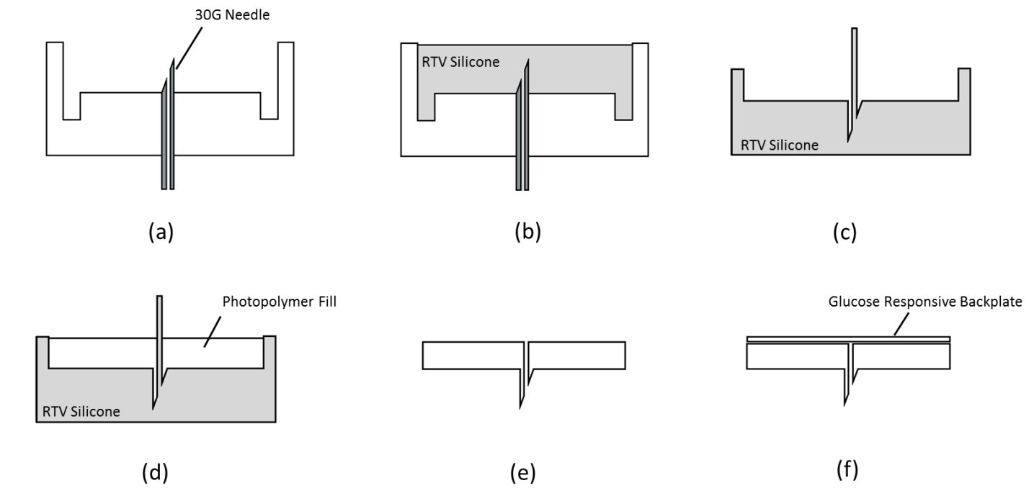
Figures & Diagrams

Figure 1 Manufacture of hollow polymer microneedle with colorimetric glucose responsive backplate. (a) 3D printed polymer mould with 30G hypodermic needle inserted to correct length. (b) RTV silicone added to produce negative mould of hollow MN. (c) Flexible silicone negative mould. (d) Photopolymer fill of negative mould. UV exposure causes polymerisation of liquid polymer to yield solid hollow microneedle. (e) Fully polymerised baseplate with hollow microneedle with bevelled edge. (f) Integration of colorimetric backplate with hollow microneedle

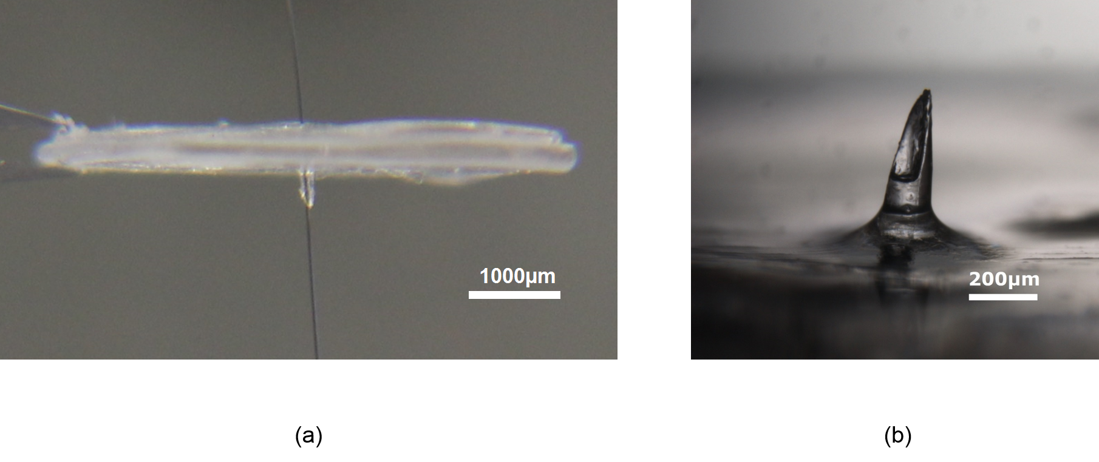
Figure 2 Photographs of polymerised hollow microneedle devices. (a) Polymer microneedle with metal wire through hollow bore. (b) Micrograph image of hollow microneedle tip.

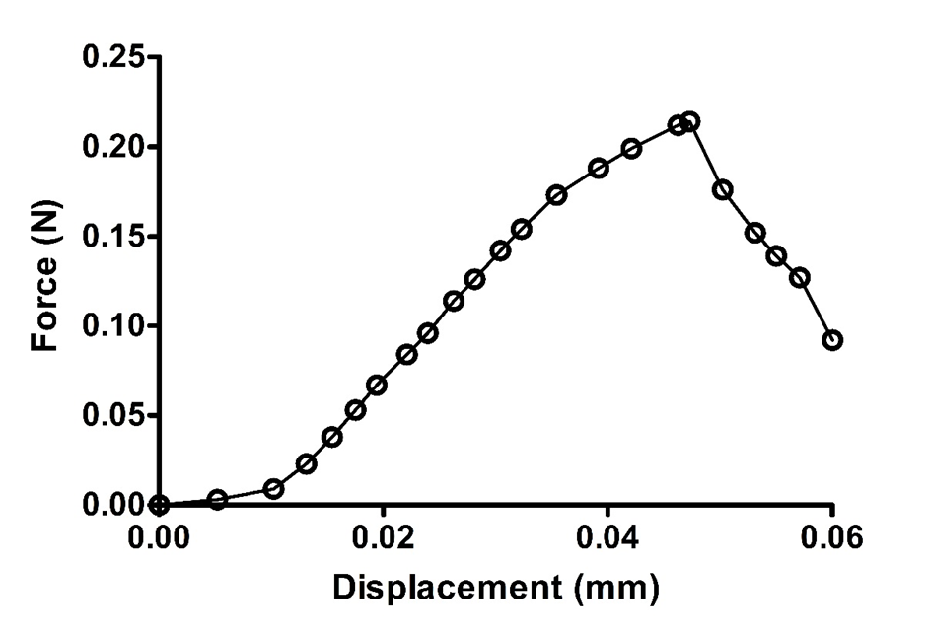
Figure 3 Representative plot of force against displacement of axial load fracture test of microneedle. Sharp decrease shows force required to fracture microneedle.

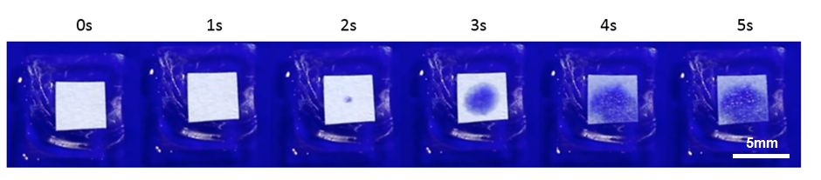
Figure 4 Photographs of paper backplate absorbing methylene blue after extraction of fluid through hollow MN.

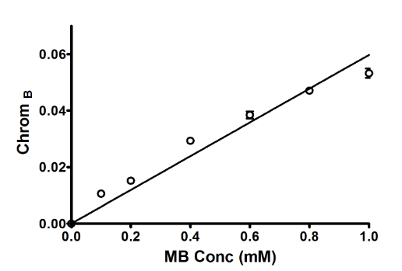
Figure 5 Plot of blue Chromaticity (Chrom _{B}) against methylene blue concentration illustrating a linear increase in proportion to methylene blue concentration in paper backplates. Paper backplates were submerged in increasing concentrations of MB aqueous solution and photographed after drying. Chrom _{B} values were calculated using ImageJ. Representative images of paper squares (right). n = 3. Error bars are standard error of the mean.
R² = 0.95

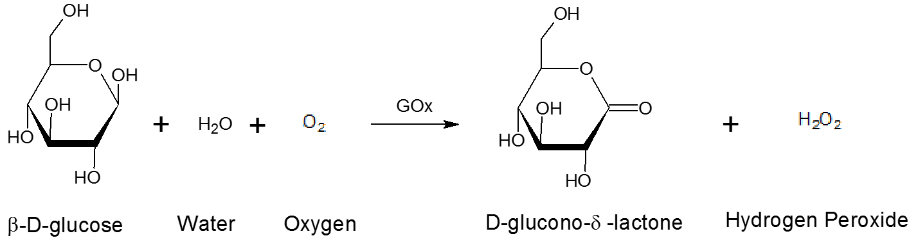
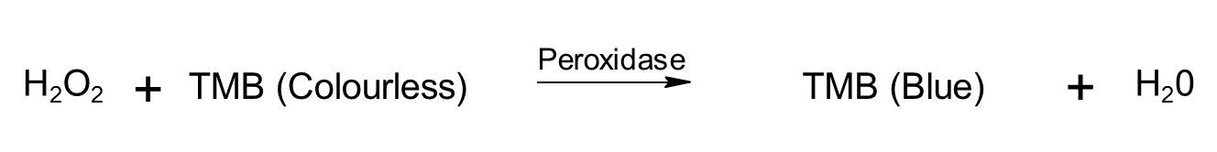

Scheme 1 Colorimetric detection of glucose using glucose oxidase, horseradish peroxidase and chromogenic dye 3,3',5,5'-tetramethylbenzidine.

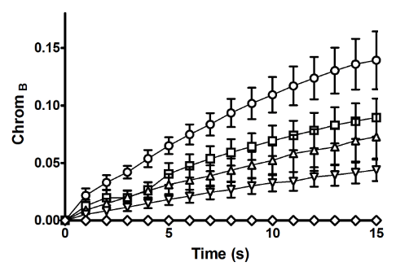
Figure 6 Plot of blue chromaticity against time for glucose responsive backplates following addition of increasing glucose concentrations 10mM (Circle) 7.5mM (Square) 5mM (Triangle) 2.5mM (Inverted triangle) 0mM (Diamond). n = 3. Error bars are standard error of the mean.

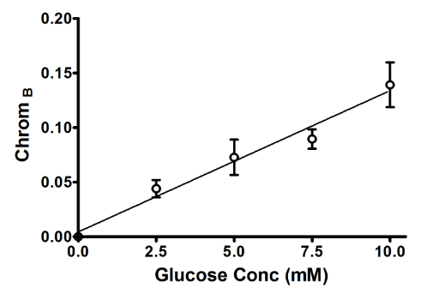
R² = 0.95
Figure 7 Plot of blue chromaticity against glucose concentration observed in glucose responsive paper backplates 15 sec following direct addition of 1µl of aqueous glucose solution. n = 3. Error bars are standard error of the mean.

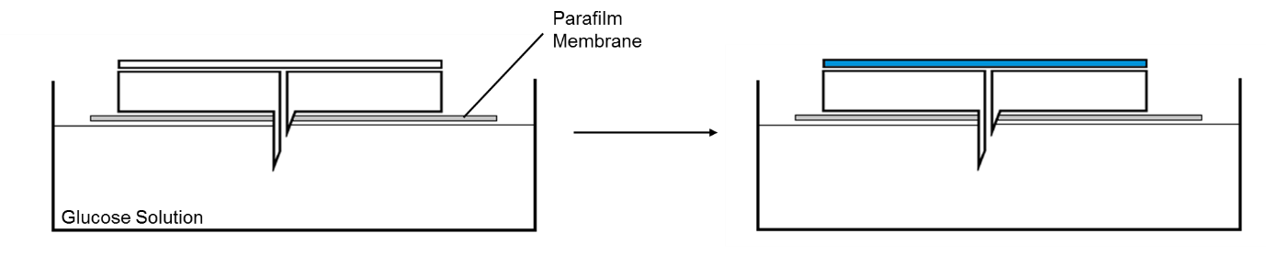
(a)

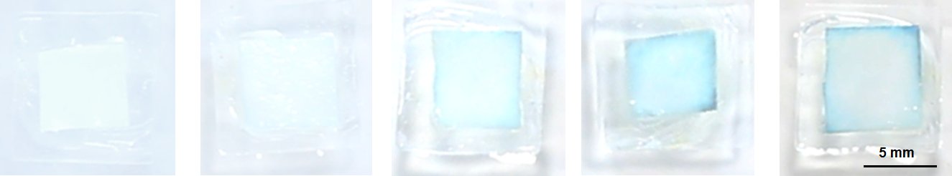
0mM 2.5mM 5mM 7.5mM 10mM
(b)
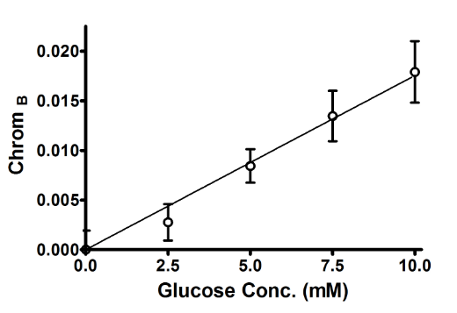
(c)
R² = 0.99
Figure 8 (a) Illustration of glucose solution extraction in vitro. (b) Digital photographs of backplates (c) Linear colorimetric response of glucose responsive backplates integrated with the hollow microneedle device. Colour change photographed after 30 seconds. n = 3. Error bars are standard error of the mean.

