Network analysis of posttraumatic stress experiences of adults seeking psychological treatment for childhood sexual abuse (CSA)

Orla McBride¹, Philip Hyland², Jamie Murphy¹, & Ask Elklit³

¹ School of Psychology, Ulster University, Northland Road, Londonderry, Northern Ireland, United Kingdom
² National College of Ireland, Dublin, Ireland
³ National Centre for Psychotraumatology, Department of Psychology, University of Southern Denmark, Denmark

Correspondence concerning this article should be addressed to: Orla McBride, PhD School of Psychology, Ulster University, Northland Road, Londonderry, Northern Ireland, BT48 7JL, United Kingdom. Email: o.mcbride@ulster.ac.uk, Tel: +44 (0)28 71675341

Abstract
Network analysis proposes that mental disorders may best be construed as causal systems embodied in networks of functionally interconnected symptoms. In this study, network analysis was used to test how adult survivors of childhood sexual abuse (CSA) experienced symptoms of posttraumatic stress, using alternative conceptualisations of PTSD. Given the characteristics of the sample (i.e. the nature of and duration since trauma) it was hypothesised that: (1) symptoms relating to arousal were not expected to be prominent in the networks; and (2) symptoms relating to negative alternations in cognition and mood (NACM) would be core components in the network. Danish adults seeking psychological treatment for CSA (n=473) completed the Harvard Trauma Questionnaire and Trauma Symptom Checklist. Three alternative models (DSM-5; DSM-5 with dissociation; and ICD-11 Complex PTSD) were estimated using state-of-the-art regularized partial correlation models. In the DSM-5 network, strong associations emerged for experiences of NACM (e.g. blame, guilt) and intrusions (thoughts and flashbacks). Adding ‘depersonalisation’ and ‘derealisation’ to the DSM-5 model produced a strong association, although these experiences were largely unrelated to other PTSD clusters. In the CPTSD network, interpersonal problems and negative self-concept were central to the survivors’ experiences. For this highly-specific survivor group who experienced traumatic CSA many years ago, experiences relating to NACM appeared to be more central to the post-trauma experience than those of arousal. If replicated elsewhere, these findings could help inform treatment plans for specific groups of survivors. Methodological implications as to the usefulness of network models in the psychopathological research literature are discussed.
Keywords: PTSD; network analysis; ICD-11; complex PTSD; sexual abuse

Network analysis of posttraumatic stress experiences of adults seeking psychological treatment for childhood sexual abuse (CSA)
The disease model of psychopathology, which proposes that ‘disorders’ such as posttraumatic stress disorder (PTSD) are manifested by ‘symptoms’ such as avoidance, hyperarousal, and recurrent nightmares (Borsboom, Cramer, Schmittmann, Epskamp, & Waldorp, 2011), is inherently problematic. First, for this model to hold, it should be possible to separate conceptually the condition (e.g. PTSD) from its symptoms (e.g. hyperarousal). In the absence of robust evidence (e.g. key genetic markers or neural abnormalities) as to the root cause of mental disorders (Kendler, 2005), the main indicators of psychological distress are a list of ‘symptoms’ outlined in psychiatric classification systems. It is not possible to be diagnosed with PTSD independently of intrusive or cognitive-related symptoms, which are core symptoms for a diagnosis in the DSM or ICD. Second, in a latent variable modelling framework, the assumption of local independence must be satisfied; that is, observed variables are assumed to be statistically independent conditional on the latent variable (Borsboom, 2008). This assumption means that symptoms such as difficultly sleeping, hyperarousal, and recurrent nightmares co-occur with an individual only because they are all caused by a condition called PTSD and not because they are casually related. For many disorders, including PTSD, this seems an implausible assumption (Cramer et al., 2012).
If it is assumed that the associations between the observable components of psychological constructs such as PTSD are real (Cramer et al., 2012), then mental disorders may best be construed as causal systems embodied in networks of functionally interconnected symptoms (McNally et al., 2014). Network analysis, which conceptualises symptoms as constitutive of the mental disorder rather than reflecting a latent entity, (Robinaugh, LeBlanc, Vuletich, & McNally, 2014), has gained attention in recent years (see Cramer et al. (2012)).
McNally et al. (2014) generated a network model of PTSD using data from a sample of Chinese earthquake survivors with a probable PTSD diagnosis (n=362; 73% women). The results identified that: (1) hypervigilance was central to the network, meaning it was a core feature of the survivors’ experience; (2) ‘feelings that one’s future will be cut short’ acted as a bridge between both hypervigilance and intrusive memories with emotional numbness, and in turn, with feelings of social disconnection and anhedonia; (3) there was bi-directionality between experiences (i.e. hypervigilant survivors were prone to startle, which served to promote continued hypervigilance, thus increasing the chronicity of the disorder); (4) irritability/anger was linked to sleep and concentration problems; and (5) intrusive thoughts, flashbacks, and nightmares were all connected, but physiological and emotion reactions to reminders of the trauma were not. Studies following this pioneering work have produced varying results. For example, Sullivan, Smith, Lewis, and Jones (2016) found less support for the centrality of hypervigilance in a network of post-trauma experiences among university students who had witnessed a mass shooting on-campus, but stronger evidence for the role of intrusive thoughts and anger. In a sample of US veterans diagnosed with probable PTSD, Armour, Fried, Deserno, Tsai, and Pietrzak (2017) reported that experiences related to guilt, shame, flashbacks, and reactivity to trauma reminders were central to the network.
Although recent work indicates that structure of PTSD networks across heterogeneous treatment-seeking samples have patterns of symptoms in common (Fried et al., 2018), it is plausible that the configuration of a post-trauma network may depend on the type of trauma experienced and duration since the trauma (Roberts, Gilman, Breslau, Breslau, & Koenen, 2011). Much evidence has alluded to the role of arousal in the short-term aftermath of a violent trauma, in increasing the likelihood for PTSD (Schell, Marshall, & Jaycox, 2004). Symptoms from other clusters, mainly avoidance, tend to occur following periods of excessive arousal and re-experiencing (O’Donnell, Elliott, Lau, & Creamer, 2007) in an attempt to establish cognitive equilibrium, which may be maladaptive and promote dysfunction (Clark & Beck, 2011). Negative alterations in cognition and mood (NACM), including guilt, might be particularly prevalent among individuals who were sexually abused (Kubany & Manke, 1995), perhaps partly due to the personally invasive nature of this trauma. In this study, we assessed the PTSD experiences of adults seeking psychological treatment for CSA using network analysis. We modelled alternative conceptualisations of PTSD as per the DSM-5, and the proposed ICD-11 Complex PTSD (CPTSD), which acknowledges that ‘disturbances in self-organisation’ (DSO), are evident among individuals who have experienced chronic and repeated trauma (Cloitre, Garvert, Brewin, Bryant, & Maercker, 2013), to test two hypotheses: (1) symptoms relating to arousal would not be prominent in the networks; and (2) symptoms of NACM would be central components of the networks.
Method
Participants and Procedure
Data were collected from adult attendees (N=484) at four Danish treatment centres that provide psychological treatment for CSA victims. Further details on the study are available elsewhere (Elklit, Christiansen, Palic, Karsberg, & Eriksen, 2014). Briefly, the treatment centres are supported by the Ministry of Social Affairs. Treatment exclusion criteria were: (1) a current alcohol or drug problem, (2) a psychotic or personality disorder, (3) self-harming behaviour, and (4) engagement in treatment elsewhere. Clients who met the exclusion criteria were referred either to specialized institutions or to voluntary help groups. Approval for the use of this data was obtained from the relevant ethical boards [removed]. Gender was recorded for 98.1% of the sample (407 women; 84.1%); age for 97.3% ($\overline{X}$ =36.4 years, SD=10.6 years), and years since abuse ended for 59.3% ($\overline{X}$ =22.5 years, SD=11.8 years).
Measures
Harvard Trauma Questionnaire-Part III (HTQ) (Mollica et al., 1992). The 30-item HTQ assess the occurrence of symptoms on a four-point Likert scale (1 = not at all; 4 = mostly); 20 items were used to assess the occurrence of DSM-5 PTSD symptoms in the past month. The Danish version of the HTQ produces reliable and valid scores (Bach, 2003). HTQ ratings according to the DSM-III-R diagnostic criteria of PTSD showed an 88% concordance with interview-based estimates of PTSD (Mollica et al., 1992).
Trauma Symptom Checklist (TSC) (Briere & Runtz, 1989). TSC is a 33-item questionnaire that assesses general psychological distress on a four-point Likert scale (1=never; 4=always). The Danish version of the TSC has been used in a wide range of trauma populations with reports of good reliability and validity (Elklit, 1990).
Data analysis
Adults with complete missing data on all questionnaire items (n=11; 2.3% of the sample) were excluded. Three alternative PTSD networks were estimated in stages, using items from across the HTQ/TSC (see Table 1): (1) Network 1 DSM-5 (21 items); (2) Network 2 DSM-5 with dissociation (23 items; as per Hansen, Műllerová, Elklit, and Armour (2016); and (3) Network 3 ICD-11 CPTSD (12 items; as per Cloitre et al. (2013).
Stage 1: Network estimation and visualisation. Edges (the association between two symptoms) were calculated by computing polychoric correlations between nodes (questionnaire items) using the state-of-the-art Pairwise Markov Random Field (PMRF) (Epskamp, Borsboom, & Fried, 2016b; Epskamp & Fried, 2016) for ordinal data -the Gaussian graphical model (GGM) (Costantini et al., 2015; Lauritzen, 1996). GGM networks estimate a large number of parameters (e.g. 20 nodes require the estimation of 210 parameters: 20 threshold parameters and 20 x 19/2=190 pairwise association parameters) that likely result in some false-positive edges. Epskamp, Borsboom, and Fried (2016a) direct that the ‘least absolute shrinkage and selection operator’ (LASSO; Tibshirani (1996)) – a form of regularization which causes small connections to shrink to be exactly zero – is applied to construct a simple, parsimonious model. A well-established and fast algorithm for estimating LASSO regularization is the graphical LASSO (glasso; Friedman, Hastie, and Tibshirani (2008), which is implemented in the R package qgraph (Epskamp, Cramer, Waldorp, Schmittmann, & Borsboom, 2012) (Friedman, Hastie, & Tibshirani, 2014). Qgraph utilises glasso in combination with the Extended Bayesian Information Criterion (EBIC; Chen and Chen (2008)) model selection to estimate a regularised GGM. The absence of an edge in this network indicates that two nodes are conditionally independent given all other nodes in the network (Costantini et al., 2015). For network visualisation in grayscale, positive associations are full lines and negative associations are dashed. Thicker lines represent stronger connections and thinner lines represent weaker connections. Associations between PTSD indicators estimated in the networks are weighted but not directed, reflecting the magnitude of the association only. Qgraph implements the Fruchterman and Reingold (1991) algorithm, which positions strongly correlated nodes together.
Stage 2: Centrality estimation. Centrality, which reflects how connected a symptom is in a network, is indicated by three indices of node: strength, closeness, and betweenness (Opsahl, Agneessens, & Skvoretz, 2010). Centrality indices are presented as standardised values. Items high in node strength, a measure of the sum of the weights of the edges (i.e. correlation magnitudes), are likely to exert strong direct influence over other nodes in the network. Closeness represents the average distance between a given node and the remaining nodes in the network; this may determine which PTSD symptoms are likely to be quickly affected by changes in other symptoms. The betweeness index reflects how important that node is for transmitting effects between other nodes in the network. Removal of items with high betweenness from a network increases the distance of other paths in the network (Costantini et al., 2015). High values on the centrality measures, which are presented graphically in qgraph, reflect a node’s greater importance to the network.
Stage 3: Accuracy and stability estimation. We used the bootnet package in R to test the stability and accuracy of the networks (Epskamp et al., 2016a; Fried & Cramer, 2016). This analysis is necessary to determine the certainty with which the rank ordering of the edge weights and centrality indices can be interpreted. Specifically, we investigated the accuracy of the edge weights by constructing 95% confidence intervals (CI) around the edges, and calculated the edge weights difference test that estimates whether edge weights differ from each other significantly. Further, we estimated the stability of the order of the estimation by subsetting bootstrap (i.e. dropping participants and re-estimating the network); if the order of the centrality estimates obtained from a network with substantially fewer participants is highly correlated to those obtained from a network analysis of all participants, the centrality estimates are viewed as stable. The centrality stability coefficient (CS-coefficient) should be at a minimum 0.25, but preferably ≥ 0.5 (Epskamp et al., 2016a).
Results
Preliminary analyses
The distributions of HTQ and TSC items satisfied skewness criteria for normality. As presented in Table 1, experiences of arousal (e.g. hypervigilance) occurred frequently, whereas experiences relating to self-destructive behaviour occurred less so.
Network 1: DSM-5
Visual inspection (Fig.1, Panel A) revealed several strong positive correlations between ‘Thoughts’, ‘Flashbacks’, and ‘Physical_Psychological’ reactions, and between these items and experiences of ‘Shame’ and ‘Avoid activities’. ‘Guilt survived and Future’ and ‘Guilt not doing and Blame’ were strongly related to each other, but not to other experiences in the NACM cluster. Weaker associations emerged between ‘Guard and Jumpy’ and ‘Sleep and Concentrate’. ‘Remember’ was positively associated with ‘Emotions’. Results of the accuracy and stability testing for this network (see Supplementary material) indicated substantial interrelatedness (correlation of .75 between node strength and closeness, .73 between node strength and betweenness, and .80 between closeness and betweenness). Moreover, CS-coefficients for node strength, closeness and betweenness were .51, .36, and .21 respectively. Both of these findings combined justify a focus on the stable estimates of node strength and closeness in the main report, with the findings relating to betweeness relegated to the supplementary material. Fig.2 (Panel A) presents standardised centrality estimates; the five nodes with the highest centrality indices were: Flashbacks, Future, Guilt survived, Detached, and Nightmares. Nightmares (Node 2) had a strong strength index, but also had the highest closeness estimate (across all experiences). ‘Irritable’ and ‘Remember’ produced the lowest estimates across both centrality indices.
Network 2: DSM-5 (with dissociation)
The strongest (positive) associations emerged between ‘Depersonalisation’ and ‘Derealisation’, with weaker associations evident between these items with other experiences (Fig. 1 Panel B). ‘Depersonalisation’ was associated mainly with experiences ‘Nightmares’ and ‘Flashbacks’, whereas ‘Derealisation’ was mainly associated with experiences in the Arousal and NACM clusters (e.g. ‘Concentrate’ and ‘Remember’). As outlined in the Supplementary material, the CS-coefficients for node strength, closeness and betweenness were .52, .28, and .21 respectively. The rank ordering of the strongest edges changed from Network 1 to Network 2; specifically, the edge weight between ‘Derealisation’ and ‘Depersonlisation’ was ranked 1st, followed by ‘Future’ and ‘Guilt survived’ (2nd; 1st in Network 1), ‘Blame’ and ‘Guilt not doing’ (3rd; 2nd in Network 2) and ‘Thoughts’ and ‘Flashbacks’ (4th; 3rd in Network 1). Of the pair, ‘Depersonalisation’ had the strongest strength index, but was weaker than the top five nodes in Network l (Fig. 2 Panel B).
Network 3: ICD-11 Complex PTSD
Strongest associations emerged between ‘Rely on and Isolated’ and ‘Insecure and Blame’; the relationship between ‘Temper’ and ‘Cry’ was weaker (Fig. 1, Panel C). CS-coefficients for node strength, closeness and betweenness were .59, .28, and .13 respectively (see Supplementary material). Nodes reflecting affect regulation had the lowest strength estimates, which raises concerns about their importance in the network. Alternatively, Rely on was the most important experience in this network (Fig. 2, Panel C).
Discussion
The findings from this study, which sought to understand and explain the core experiences of adult survivors of CSA trauma from a network perspective, can be summarised succinctly. Strong associations emerged between the three pairs of experiences: ‘Future’ and ‘Guilt survived’, ‘Blame’ and ‘Guilt not doing’ and ‘Thoughts’ and ‘Flashbacks’. When ‘Depersonalisation’ and ‘Derealisation’ were included in the network, the strength of this association outranked the three aforementioned associations. Depersonalisation in particular was an important element of the post-trauma experience. In the CPTSD network, interpersonal problems and negative self-concept (‘DSO’), seemed to be core elements of the post-trauma experience, whereas difficulties regulating mood were less so. Collectively, these findings suggest support for the study’s hypotheses. Before a detailed discussion of the findings, some study limitations are worth mentioning. Survivors were predominantly female, educated, married, in middle adulthood, and free from substance use problems and other mental health difficulties; these characteristics preclude generalisability of this study’s findings to other trauma groups. Experiences of PTSD were assessed at one-time point in adulthood, and (for most individuals) many years after the trauma ended. Although efforts are on-going to develop a measure of ICD-11 CPTSD (e.g. International Trauma Questionnaire; Hyland et al. (2017), this study was limited to approximating CPTSD using items from other measures. Given the cross-sectional study design, we were unable to determine whether the most central experiences activated other experiences, were activated by other experiences, or whether a reciprocal relationship was the most plausible explanation. Finally, the sample size could be perceived as merely adequate for estimating a network with twenty-three nodes.
The findings of this paper, which relate to a highly-specific trauma survivor group, indicated that, many years following traumatic CSA, experiences relating to NACM appear more central to the post-trauma experience than experiences of arousal. If replicated elsewhere, this may have an important clinical implication: in the immediate to short-term aftermath of a trauma, clinical interventions that focus on reducing physiological and psychological arousal may be most effective, whereas in the long-term, clinical interventions that focus of modifying dysfunctional cognitive/emotional factors may be required. The discovery that the two dissociation experiences were highly associated with one another, but relatively isolated from all other PTSD symptoms, is interesting. On one hand this finding could be interpreted as indicating support for the notion of a PTSD subtype (Armour, Karstoft, & Richardson, 2014; Lanius et al., 2014); on the other, it may indicate that these symptoms have little in common with the other PTSD symptoms and therefore their inclusion within a PTSD profile could be questioned. (Cloitre et al., 2013; Maercker et al., 2013).
Finally, we focus our attention on the suitability of network analysis to identify the PTSD experiences of these Danish adults. Despite a mushrooming of studies using this modelling framework (Afzali et al., 2017; Bryant et al., 2017), critics contest the methodology is in its infancy and that there should be legitimate concerns about the approach (Ashton & Lee, 2012). In response, the findings of the current (and past) network models suggest a considerable degree of similarity to traditional latent variable models of PTSD. For example, in each of the current networks, the PTSD symptoms cluster in a manner that largely reflects the four-factor model in the DSM-5, the dissociative subtype, and the six-factor model of ICD-11 CPTSD. The network approach offers no obvious explanation for why the intrusions, avoidance, NACM, arousal, and dissociative symptoms are intra- and inter-related in the manner in which they are. Indeed, if latent variable models were incorrect and PTSD symptoms were simply related to one another in a causal network with no underlying latent structure, it would seem improbable that these symptoms should cluster together in a consistent manner across multiple studies, and much less so in a manner similar to what is evidenced in the latent variable modelling literature. Of course, the current results indicate that the symptoms are not clustering in a manner that perfectly reflects the four-factor model of DSM-5 PTSD (e.g. Items 9, 10, and 12 are disconnected from the rest of the NACM symptoms, and some of the arousal symptoms are unconnected to one another). The current, and prior, findings could be used as a potential exploratory approach to identify symptom covariation patterns that could aid in the development of new factorial models of psychiatric disorders. Furthermore, the network approach seems useful in terms of identifying “core symptoms” of a given disorder and thus useful for item/symptom reduction purposes. Consider, for example, two arousal items in this study that were strongly connected (‘Guard’ and ‘Jumpy’), but largely unrelated to the other arousal symptoms. These two items were selected by the ICD-11 Working Group for Trauma and Stress-Related Disorders as the core hyperarousal symptoms to be included within the upcoming ICD-11 model of PTSD (Karatzias et al., 2017). The results of this study, and those of McNally et al. (2014), support the notion that these two items are distinct measures of hyperarousal. Thus, rather than viewing network analysis and latent variable models as competing methodologies for understanding psychopathology, it may be possible instead to consider both as complimentary techniques that achieve and reveal more together than they do separately.

References
Afzali, M. H., Sunderland, M., Teesson, M., Carragher, N., Mills, K., & Slade, T. (2017). A network approach to the comorbidity between posttraumatic stress disorder and major depressive disorder: The role of overlapping symptoms. Journal of Affective Disorders, 208, 490-496. doi:10.1016/j.jad.2016.10.037
Armour, C., Fried, E. I., Deserno, M. K., Tsai, J., & Pietrzak, R. H. (2017). A network analysis of DSM-5 posttraumatic stress disorder symptoms and correlates in US military veterans. Journal of anxiety disorders, 45, 49-59.
Armour, C., Karstoft, K.-I., & Richardson, J. D. (2014). The co-occurrence of PTSD and dissociation: differentiating severe PTSD from dissociative-PTSD. Social Psychiatry and Psychiatric Epidemiology, 49(8), 1297-1306.
Ashton, M. C., & Lee, K. (2012). On Models of Personality Structure. European Journal of Personality, 26(4), 433-434.
Bach, M. E. (2003). En empirisk belysning og analyse af “Emotional Numbing” som eventuel selvstændig faktor i PTSD [An empirical investigation and analysis of “Emotional Numbing” as a possible independent factor in PTSD]. Psykologisk Tidsskriftserie, 5(1), 1-199.
Borsboom, D. (2008). Latent variable theory. Measurement, 6, 25-53.
Borsboom, D., Cramer, A. O., Schmittmann, V. D., Epskamp, S., & Waldorp, L. J. (2011). The small world of psychopathology. PloS one, 6(11), e27407.
Briere, J., & Runtz, M. (1989). The Trauma Symptom Checklist (TSC-33) early data on a new scale. Journal of interpersonal violence, 4(2), 151-163.
Bryant, R. A., Creamer, M., O’Donnell, M., Forbes, D., McFarlane, A. C., Silove, D., & Hadzi-Pavlovic, D. (2017). Acute and Chronic Posttraumatic Stress Symptoms in the Emergence of Posttraumatic Stress Disorder: A Network Analysis. JAMA psychiatry, 74, 135-142. doi:10.1001/jamapsychiatry.2016.3470
Chen, J., & Chen, Z. (2008). Extended Bayesian information criteria for model selection with large model spaces. Biometrika, 95(3), 759-771.
Clark, D. A., & Beck, A. T. (2011). Cognitive therapy of anxiety disorders: Science and practice: Guilford Press.
Cloitre, M., Garvert, D. W., Brewin, C. R., Bryant, R. A., & Maercker, A. (2013). Evidence for proposed ICD-11 PTSD and complex PTSD: A latent profile analysis. European journal of psychotraumatology, 4. doi:doi: 10.3402/ejpt.v4i0.20706
Costantini, G., Epskamp, S., Borsboom, D., Perugini, M., Mõttus, R., Waldorp, L. J., & Cramer, A. O. (2015). State of the aRt personality research: A tutorial on network analysis of personality data in R. Journal of Research in Personality, 54, 13-29.
Cramer, A. O., Sluis, S., Noordhof, A., Wichers, M., Geschwind, N., Aggen, S. H., . . . Borsboom, D. (2012). Dimensions of normal personality as networks in search of equilibrium: You can't like parties if you don't like people. European Journal of Personality, 26(4), 414-431.
Elklit, A. (1990). Måling af belastninger efter voldeligt overfald med TSC-33 traume symptom checkliste [Measuring distress after violent assault with TSC-33]. Nordisk Psykologi 42, 281–289.
Elklit, A., Christiansen, D., Palic, S., Karsberg, S., & Eriksen, S. (2014). Impact of traumatic events on posttraumatic stress disorder among Danish survivors of sexual abuse in childhood. Journal of child sexual abuse, 23(8), 918-934.
Epskamp, S., Borsboom, D., & Fried, E. I. (2016a). Estimating psychological networks and their accuracy: a tutorial paper. ArXiv Preprint, 501, 1-25.
Epskamp, S., Borsboom, D., & Fried, E. I. (2016b). Estimating Psychological Networks and their Stability: a Tutorial Paper. arXiv preprint arXiv:1604.08462.
Epskamp, S., Cramer, A. O., Waldorp, L. J., Schmittmann, V. D., & Borsboom, D. (2012). Qgraph: Network visualizations of relationships in psychometric data. Journal of Statistical Software, 48(4), 1-18.
Epskamp, S., & Fried, E. I. (2016). A Primer on estimating regularized psychological networks. arXiv preprint arXiv:1607.01367.
Fried, E. I., & Cramer, A. O. (2016). Moving forward: challenges and directions for psychopathological network theory and methodology. Perspectives on Psychological Science, 10.
Fried, E. I., Eidhof, M. B., Palic, S., Costantini, G., Huisman-van Dijk, H. M., Bockting, C. L., . . . Karstoft, K.-I. (2018). Replicability and Generalizability of Posttraumatic Stress Disorder (PTSD) Networks: A Cross-Cultural Multisite Study of PTSD Symptoms in Four Trauma Patient Samples. Clinical Psychological Science, 2167702617745092.
Friedman, J., Hastie, T., & Tibshirani, R. (2008). Sparse inverse covariance estimation with the graphical lasso. Biostatistics, 9(3), 432-441.
Friedman, J., Hastie, T., & Tibshirani, R. (2014). glasso: Graphical lasso- estimation of Gaussian graphical models. R package version 1.8.
Fruchterman, T. M., & Reingold, E. M. (1991). Graph drawing by force‐directed placement. Software: Practice and experience, 21(11), 1129-1164.
Hansen, M., Műllerová, J., Elklit, A., & Armour, C. (2016). Can the dissociative PTSD subtype be identified across two distinct trauma samples meeting caseness for PTSD? Social psychiatry and psychiatric epidemiology, 1-11.
Hyland, P., Shevlin, M., Brewin, C., Cloitre, M., Downes, A., Jumbe, S., . . . Roberts, N. (2017). Validation of post‐traumatic stress disorder (PTSD) and complex PTSD using the International Trauma Questionnaire. Acta Psychiatrica Scandinavica, 136(3), 313-322.
Karatzias, T., Shevlin, M., Fyvie, C., Hyland, P., Efthymiadou, E., Wilson, D., . . . Cloitre, M. (2017). Evidence of distinct profiles of Posttraumatic Stress Disorder (PTSD) and Complex Posttraumatic Stress Disorder (CPTSD) based on the new ICD-11 Trauma Questionnaire (ICD-TQ). Journal of affective disorders, 207, 181-187.
Kendler, K. S. (2005). “A gene for...”: the nature of gene action in psychiatric disorders. American Journal of Psychiatry, 162, 1243-1252.
Kubany, E. S., & Manke, F. P. (1995). Cognitive therapy for trauma-related guilt: Conceptual bases and treatment outlines. Cognitive and Behavioral Practice, 2(1), 27-61.
Lanius, R., Wolf, E., Miller, M., Frewen, P., Vermetten, E., Brand, B., . . . Resick, P. (2014). The dissociative subtype of PTSD. Handbook of PTSD: Science and practice, 234-250.
Lauritzen, S. L. (1996). Graphical models. . Oxford, UK: Clarendon Press.
Maercker, A., Brewin, C. R., Bryant, R. A., Cloitre, M., Reed, G. M., van Ommeren, M., . . . Llosa, A. E. (2013). Proposals for mental disorders specifically associated with stress in the International Classification of Diseases-11. The Lancet, 381(9878), 1683-1685.
McNally, R. J., Robinaugh, D. J., Wu, G. W., Wang, L., Deserno, M. K., & Borsboom, D. (2014). Mental Disorders as Causal Systems A Network Approach to Posttraumatic Stress Disorder. Clinical Psychological Science, 2167702614553230.
Mollica, R. F., Caspi-Yavin, Y., Bollini, P., Truong, T., Tor, S., & Lavelle, J. (1992). The Harvard Trauma Questionnaire: Validating a cross-cultural instrument for measuring torture, trauma, and posttraumatic stress disorder in Indochinese refugees. The Journal of nervous and mental disease, 180(2), 111-116.
O’Donnell, M. L., Elliott, P., Lau, W., & Creamer, M. (2007). PTSD symptom trajectories: From early to chronic response. Behaviour research and therapy, 45(3), 601-606.
Opsahl, T., Agneessens, F., & Skvoretz, J. (2010). Node centrality in weighted networks: Generalizing degree and shortest paths. Social networks, 32(3), 245-251.
Roberts, A. L., Gilman, S. E., Breslau, J., Breslau, N., & Koenen, K. C. (2011). Race/ethnic differences in exposure to traumatic events, development of post-traumatic stress disorder, and treatment-seeking for post-traumatic stress disorder in the United States. Psychological medicine, 41(01), 71-83.
Robinaugh, D. J., LeBlanc, N. J., Vuletich, H. A., & McNally, R. J. (2014). Network analysis of persistent complex bereavement disorder in conjugally bereaved adults. Journal of abnormal psychology, 123(3), 510.
Schell, T. L., Marshall, G. N., & Jaycox, L. H. (2004). All symptoms are not created equal: the prominent role of hyperarousal in the natural course of posttraumatic psychological distress. Journal of abnormal psychology, 113(2), 189.
Sullivan, C. P., Smith, A. J., Lewis, M., & Jones, R. T. (2016). Network analysis of ptsd symptoms following mass violence. Psychological Trauma. doi:10.1037/tra0000237
Tibshirani, R. (1996). Regression shrinkage and selection via the lasso. Journal of the Royal Statistical Society. Series B (Methodological), 267-288.

Table 1. Items from the Harvard Trauma Questionnaire (HTQ) and the Trauma Symptom Checklist (TSC) mapped to the DSM-5 and ICD-11 conceptualisation of PTSD and associated response frequencies for Danish treatment-seeking adult survivors of childhood sexual abuse

Node label | PTSD experience (Questionnaire item) | ¹Frequencies- analytic sample (n=473)
 |  | Not at all |  | Rarely |  | Sometimes |  | Mostly
Thoughts ^{ab} | Recurrent thoughts (HTQ1) | 32 | 6.8% | 84 | 17.9% | 246 | 52.5% | 107 | 22.8%
Nightmare ^{abc} | Recurrent nightmares (HTQ3) | 134 | 28.8% | 127 | 27.3% | 124 | 26.7% | 80 | 17.2%
Flashback ^{abc} | Feel event happening again (HTQ2) | 124 | 26.4% | 146 | 31.1% | 161 | 34.3% | 39 | 8.3%
Physical_  Psychological ^{ab} | Sudden physical/psychological reaction (HTQ16) | 25 | 5.3% | 91 | 19.4% | 175 | 37.3% | 178 | 38.0%
Avoid feelings ^{abc} | Avoid thoughts or feelings of trauma (HTQ15) | 49 | 10.5% | 76 | 16.3% | 165 | 35.5% | 175 | 37.6%
Avoid activities ^{abc} | Avoid activities that remind of trauma (HTQ11) | 85 | 18.5% | 88 | 19.1% | 102 | 22.2% | 185 | 40.2%
Remember ^{ab} | Inability to remember parts of trauma (HTQ12) | 64 | 13.9% | 69 | 15.0% | 139 | 30.2% | 189 | 41.0%
Future ^{ab} | Feeling as if don’t have future (HTQ14) | 93 | 19.9% | 94 | 20.1% | 160 | 34.3% | 120 | 25.7%
Blame ^{ab} | Blame yourself for things that happened(HTQ19) | 135 | 29.1% | 91 | 19.6% | 137 | 29.5% | 101 | 21.8%
Shame ^{ab*} | Feel ashamed about things that happened (HTQ23) | 73 | 15.6% | 116 | 24.7% | 191 | 40.7% | 89 | 19.0%
Guilt survived ^{ab*} | Feel guilt for having survived (HTQ21) | 48 | 10.4% | 92 | 19.9% | 208 | 44.9% | 115 | 24.8%
Guilt not doing ^{ab*} | Feel guilt not doing enough (HTQ31) | 90 | 19.4% | 88 | 18.9% | 145 | 31.2% | 142 | 30.5%
Interest ^{ab} | Less interest in daily activities (HTQ13) | 51 | 10.9% | 129 | 27.7% | 199 | 42.7% | 87 | 18.7%
Detached ^{ab} | Feel detached or withdrawn from people (HTQ4) | 48 | 10.3% | 73 | 15.6% | 190 | 40.7% | 156 | 33.4%
Emotion ^{ab} | Unable show emotions (HTQ5) | 90 | 19.1% | 122 | 26.0% | 195 | 41.5% | 63 | 13.4%
Irritable ^{ab} | Feeling irritable or outbursts of anger (HTQ10) | 25 | 5.3% | 78 | 16.7% | 210 | 44.9% | 155 | 33.1%
Reckless ^{ab} | Want to harm yourself physically (TSC21) | 290 | 62.2% | 125 | 26.8% | 29 | 6.2% | 22 | 4.7%
Guard ^{abc} | Feeing on guard (HTQ9) | 24 | 5.1% | 54 | 11.6% | 163 | 4.9% | 226 | 48.4%
Jumpy ^{abc} | Feeling jumpy (HTQ6) | 51 | 10.9% | 106 | 22.6% | 135 | 28.8% | 177 | 37.7%
Concentrate ^{ab} | Difficulty concentrating (HTQ7) | 19 | 4.0% | 65 | 13.8% | 202 | 43.0% | 184 | 39.1%
Sleep ^{ab} | Trouble sleeping (HTQ8) | 58 | 12.3% | 70 | 14.9% | 129 | 27.4% | 214 | 45.4%
Depersonalization ^{b} | Feel as if you are outside your body (TSC32) | 172 | 37.3% | 160 | 34.7% | 76 | 16.5% | 53 | 11.5%
Derealization ^{b} | A sense of unreality (TSC30) | 120 | 25.9% | 173 | 37.4% | 105 | 22.7% | 65 | 14.0%
Temper ^{c} | Temper outburst you could not control (TSC16) | 143 | 30.4% | 195 | 41.5% | 67 | 14.3% | 65 | 13.8%
Cry ^{c} | Crying easily (TSC14) | 95 | 20.2% | 201 | 42.8% | 102 | 21.7% | 72 | 15.3%
Isolated ^{c} | Feelings of inferiority or insecurity (TSC28) | 43 | 9.2% | 167 | 35.9% | 131 | 28.2% | 124 | 6.7%
Blame ^{c} | Blaming yourself (TSC29) | 53 | 11.5% | 142 | 30.7% | 147 | 31.8% | 120 | 26.0%
Insecure ^{c} | Feeling isolated from others (TSC6) | 72 | 15.4% | 181 | 38.6% | 129 | 27.5% | 87 | 18.6%
Rely on ^{c} | Feeling that you have no on to rely upon (HTQ27) | 67 | 14.3% | 100 | 21.4% | 172 | 36.8% | 129 | 27.6%

Note. HTQ=Harvard Trauma Questionnaire; TSC=Trauma Symptom Checklist. ¹Corresponding response categories for TSC: ‘never’, ‘yes, sometimes’, ‘yes, often’, ‘yes, very often’. Minimal levels of missing data across response categories; valid percentage reported.
ª Network 1= DSM-5 PTSD; ^{b} Network 2 = DSM-5 PTSD with dissociative experiences; ^{c} Network 3 = ICD-11 Complex PTSD
* In DSM-5, these items are combined to reflect a single criterion ‘negative emotional state’; for the purposes of this study, these items were modelled as separate experiences

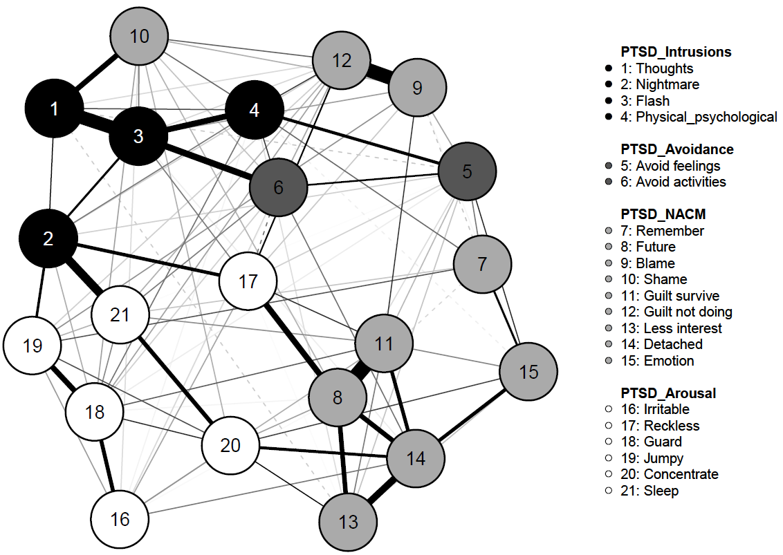
Panel B
Panel A

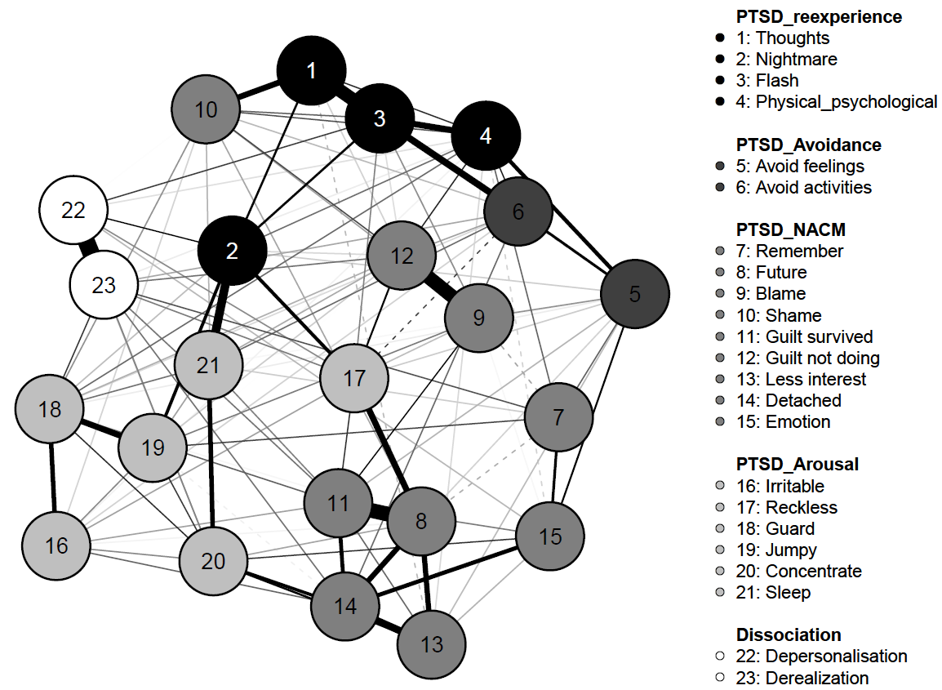

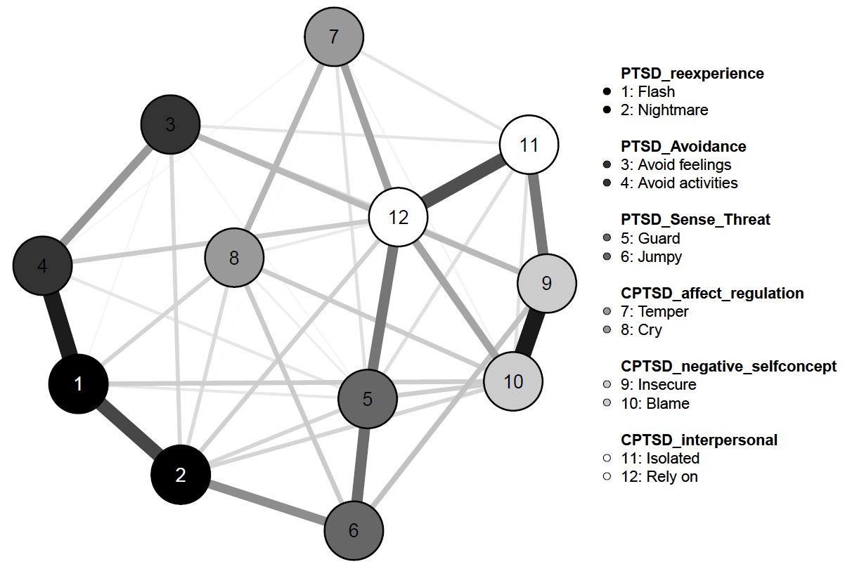
Panel C

Figure 1. Gaussian graphical model (GGM) networks of HTQ and TSC items depicting a DSM-5 (Panel A), DSM-5 with dissociation (Panel B) and ICD-11 CPTSD (Panel C) experiences among adult survivors of childhood sexual abuse (n=473).
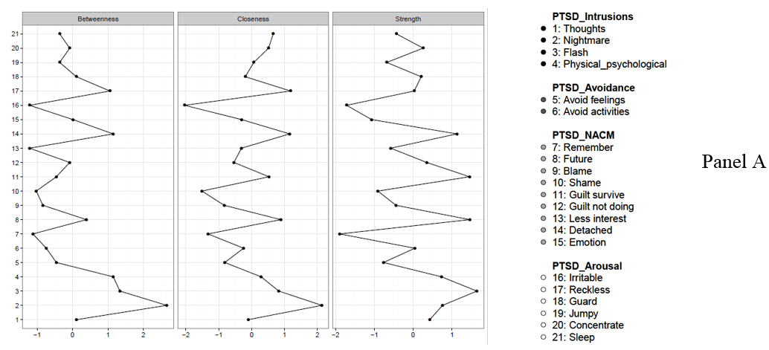
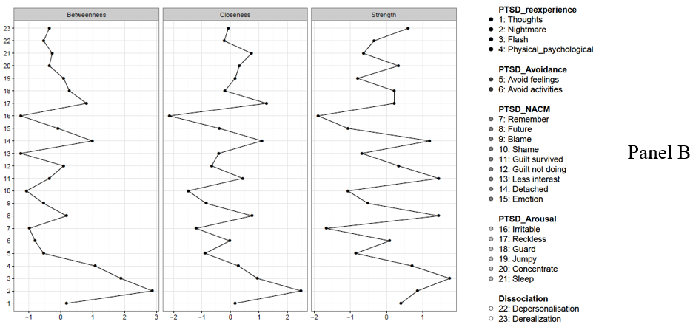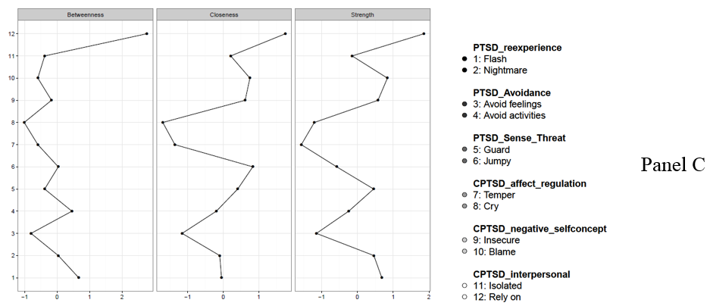

Figure 2. Centrality estimates from Gaussian graphical model (GGM) network of HTQ and TSC items depicting a DSM-5 (Panel A), DSM-5 with dissociation (Panel B) and ICD-11 CPTSD (Panel C) experiences among adult survivors of childhood sexual abuse (n=473).

