An observational study of clinician’s gaze behaviour in simulated emergencies
Authors:
Dr Ben McNaughten¹, Dr Caroline Hart¹, Dr Stephen Gallagher², Carol Junk¹, Patricia Coulter¹, Dr Andrew Thompson¹, Dr Thomas Bourke³
- Royal Belfast Hospital for Sick Children
- Ulster University
- Centre for medical education, QUB
Abstract:
Aim:
Eye tracking technology has been used in aviation and surgery to describe differences in the gaze behaviour between experts and novices. The aim of this study was to describe the gaze behaviour of clinicians from different training backgrounds during a simulated paediatric emergency.
Methods:
Twenty-seven clinicians from different clinical areas within a tertiary children’s hospital undertook a standardised, six minute, high fidelity simulated paediatric emergency. Participants wore SMI Eye Tracking Glasses®. We measured the fixation count and dwell time on four key areas of interest. The time taken to key clinical interventions was also recorded.
Results:
Participants from all groups looked more often and for longer at the patient (chest and airway) than any of the other key areas of interests. Paediatric Intensive Care (PICU) consultants focused longer on the chest and airway than any other groups. The gaze behaviour of paediatric consultants and trainees was similar. Both groups spent longer looking at the defibrillator and algorithm (51,180ms and 50,551ms respectively) than the PICU consultants and consultants in Paediatric Emergency Medicine (19,804ms and 28,095ms respectively). The PICU consultants were quickest to all key clinical interventions.
Conclusions:
This study is the first to describe differences in the gaze behaviour between clinicians from different backgrounds during a simulated paediatric emergency. The findings compliment literature in the fields of aviation and surgery by identifying differences in gaze behaviour between experts and novices. Further research is needed to evaluate the potential use as an educational tool in the resuscitation setting.
Introduction:
The human eye moves approximately three to five times per second.¹ These movements enable us to examine and process complex visual information.² In the clinical environment clinicians collect, prioritise and respond to visual cues when making decisions about patient care. This is of particular importance in the resuscitation environment where clinicians are required to absorb and process large volumes of complex visual information in a time critical manner. Eye tracking technology allows for the measurement of an observer’s point of gaze based on where their pupil is focused.^{3,4} Mobile eye tracking systems now allow subjects to interact with their environment in a realistic manner. ^{5,6}
We performed a literature search relating to eye tracking technology using Pubmed in September 2016 and again in July 2017 (Figure 1). After reviewing the titles and abstracts we identified 49 relevant articles. Three main fields of research where eye tracking technology has been used extensively were identified; aviation, autistic spectrum disorder (ASD) and surgery (Figure 1).

Figure 1:

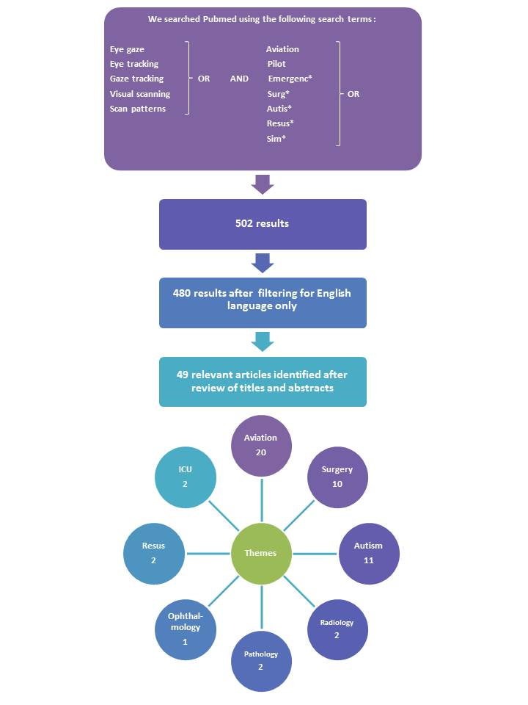

Visual strategies are clearly defined in the aviation industry and are an integral part of pilot training.^{7,8} Differences in the gaze behaviour between experienced pilots and novices are clearly described.^{8,9,10} These differences exist across a variety of gaze-based measurements such the number of times participants looked at key areas (fixation count) and the duration of time spent looking at each of these areas (dwell time). Differences have also been noted in the sequence in which gaze occurs. Experts display shorter fixation times and more active visits to most instruments. They continue to look at key flight variables, including those not being manipulated, even during an emergency.^{11,12}
The use of eye tracking technology within healthcare has focused predominantly on research in ASD and surgery. Autism is a pervasive developmental disorder characterised by a triad of social communication problems, difficulties with reciprocal social interactions and unusual patterns of repetitive behaviour.¹³ Point-of-View (POV) cameras have been used to measure eye gaze in children with ASD and have demonstrated differences in gaze targets between children with ASD and typically developing children.^{14,15} The potential use of eye tracking technology as an aid for early identification of atypical learning and behaviour in preverbal populations has been described.¹⁶
Eye tracking research in surgery largely focuses on the field of laparoscopic procedures. One recent literature review identified differences in gaze behaviours between experts and novices and the potential to use eye tracking technology as an educational tool.⁴
Our literature review identified two studies assessing the use of eye tracking technology in the resuscitation setting.^{5,6} (Table 1) One observational study explores the potential of mobile eye tracking in undergraduate nursing and paramedic students as a tool to enhance debriefing.⁵ The second describes a technical feasibility study considering the combined use of first-person video and gaze tracking in medical simulation.⁶

Table 1:  Citation | Study group | Study type | Outcome | Key results
Browning M, Cooper S, Cant R, Sparkes L, Bogossian F, Williams B, O'Meara P, Ross L, Munro G, Black B. The use and limits of eye-tracking in high-fidelity clinical scenarios: A pilot study. International emergency nursing. 2016 Mar 31;25:43-7. | 39 undergraduate degree students  (19 paramedic students and 20 nursing students). | Observational study. | 1)Mean total gaze on designated areas of interest.  2)Performance rated using an observational structured clinical examination (OSCE). | 1)Participants focused on three main areas of interest: the head (34%), trunk (24%) and their clinical assistant (5%) with differences noted between disciplines.  2) Objectively rated performance improved by the third scenario.
Szulewski A, Howes D. Combining first-person video and gaze-tracking in medical simulation: a technical feasibility study. The Scientific World Journal. 2014 Feb 19;2014. | 5 participants  (1 medical student, 3 emergency medicine residents, 1 experienced emergency medicine consultant). | Technical feasibility study. | 1)Quality, clarity and utility of the audio/video and gaze indicators rated using Likert scales.  2)Advantages and limitations of the gaze tracking technology. | 1) Gaze-tracking equipment did not limit behaviour.  2) Fitting and calibrating the equipment was easy and efficient.  3) The quality, clarity and utility of the recordings were very good (8/10) or better.  4) The device was able to discriminate participants’ gaze as they looked at relatively small areas of interest.  5) Limitations: Some participants reported discomfort. In addition the eye tracker was unable to pick up information from the peripheral field of view if the participants looked outside of the lenses.

In the resuscitation environment clinicians are required to absorb and process large volumes of complex visual information in a time critical manner. There are no studies assessing expert clinicians’ gaze behaviours in the resuscitation setting.
We hypothesised that the gaze behaviour of clinicians during resuscitations may differ based on specialty training and experience. Knowledge of these differences could potentially enable development of educational strategies to improve resuscitation training and ultimately clinical outcomes for critically ill children.
Methods:
We designed an observational cohort study to explore gaze behaviour and performance of clinicians in a simulated paediatric emergency. Governance approval was obtained from the Belfast Health and Social Care Trust.
Sample:
A convenience sample of 28 clinicians was recruited. This sample consisted of eight consultant paediatricians, eight paediatric intensive care unit (PICU) consultants, six consultants in paediatric emergency medicine (PEM) and six paediatric trainees.
Procedures:
The study took place in the simulation suite in the Royal Belfast Hospital for Sick Children on two consecutive days in October 2016. The simulation suite contains a Laerdal SimJunior® and is designed to mimic the clinical areas within the hospital. Recognised algorithms for treatment of common paediatric emergencies were available.
On arrival participants received an orientation to the simulation suite. Written consent was obtained. The eye tracking equipment was fitted and calibrated. The participants each undertook the same, standardised six minute scenario based on a four year old boy in ventricular fibrillation cardiac arrest following a tricyclic antidepressant overdose. Participants were blinded to the scenario.
They were invited to lead the resuscitation and provided with two staff nurses and one paediatric trainee to assist. The assistants received training in the scenario and were advised to act on instruction and avoid prompting. The same personnel were used throughout all of the scenarios to ensure consistency. Following the scenario participants undertook a structured debrief with an experienced clinician.
Data Collection:
- Gaze behaviour:
Participant’s eye movements were recorded using SMI Eye Tracking Glasses ®. These allowed the participant’s pupil fixation to be overlaid on a simultaneous point-of-view recording. The glasses use infrared light reflected on the cornea to accurately measure gaze behaviour. During data analysis the eye gaze fixations were represented by coloured dots on the video [Figure 2]. The glasses have a temporal accuracy of 30Hz and a spatial accuracy of 0.5 degrees.
Figure 2
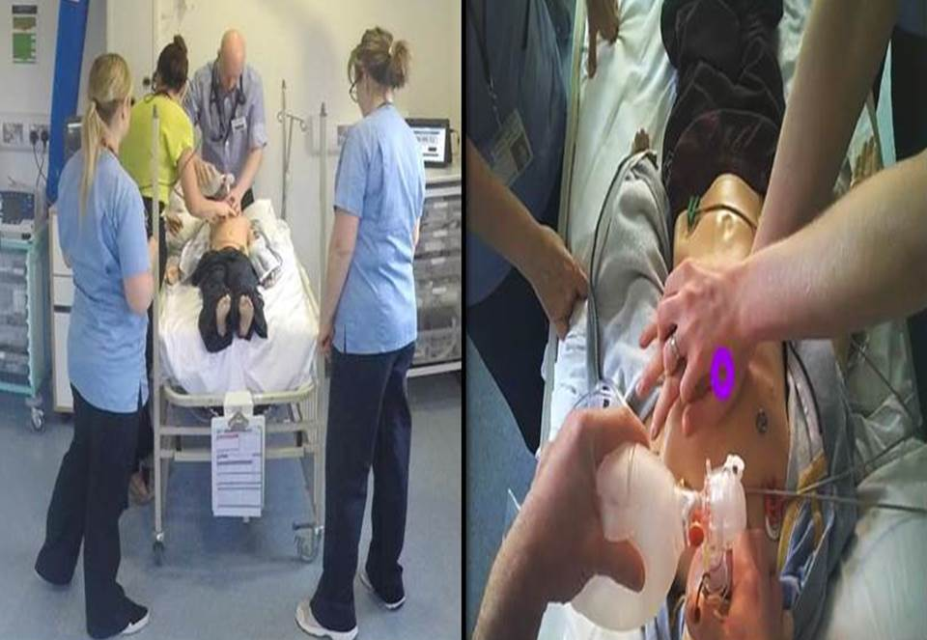

The equipment was run using ‘iView ETG’ software. All software was located on a designated ETG laptop and portable data recording unit. Data was analysed using ‘BeGaze 3.4’.
We identified four key areas of interest before the study based on our clinical experience:
  - The patient’s airway
  - The cardiac arrest algorithm
  - The patient’s chest
  - The defibrillator
We analysed the number of times participants looked at each of these key areas (fixation count) and the duration of time spent looking at each of these areas (dwell time in milliseconds).
- Time to key clinical interventions:
The fixed video recordings were reviewed to assess the time taken in seconds for participants to perform three pre-defined key clinical interventions – commence bag and mask ventilation, commence chest compressions and administer the first shock.
Results:
We recruited 28 participants. We were unable to calibrate the eye tracking equipment for one participant. 27 participants were included: eight consultant paediatricians, seven PICU consultants, six consultants in PEM and six paediatric trainees.
Gaze Behaviour:
The mean fixation count and dwell time of the participants in each group are shown in Figure 3. Participants from all groups looked more often and for longer at the patient (chest and airway) than any of the other key areas of interests. However, the mean fixation count (396) and dwell time (96,286ms) on the patient’s chest and airway was noticeably longer for PICU consultants. The gaze behaviour of the paediatric consultants and trainees was similar. They looked more often and longer at the defibrillator and algorithm than the other groups. The combined total dwell time on the defibrillator and algorithm for the paediatric consultants and paediatric trainees was 51,180ms and 50,551ms. This compares to 28,095ms for the consultants in PEM and 19,804ms for the PICU consultants.

Figure 3:
Fixation Count

Number of fixations

Area of interest
Dwell Time

Time spent looking at area of interest (ms)

Area of interest
The Binning charts displayed in Figure 4 provide a visual representation of the gaze patterns of one paediatric consultant and one consultant in PICU. Each line represents a period of two seconds. The colour of the line represents the area of interest which the participant was looking at during that period. The height of the line represents the duration of the gaze with a shorter line representing a shorter glance. These charts show a marked difference in gaze behaviour. Both participants begin by assessing the patient and focusing on the airway and chest. Participant 1, a consultant paediatrician, then spends a large proportion of time looking at the defibrillator and algorithm. The PICU consultant continues to look at all areas of interest for shorter periods of time. The chart is noticeably less densely populated. This reflects greater proportions of time when the participant is not looking at one of the key areas of interest. Review of the corresponding POV recordings shows that much of this time is spent communicating with team members and surveying the wider resuscitation area.

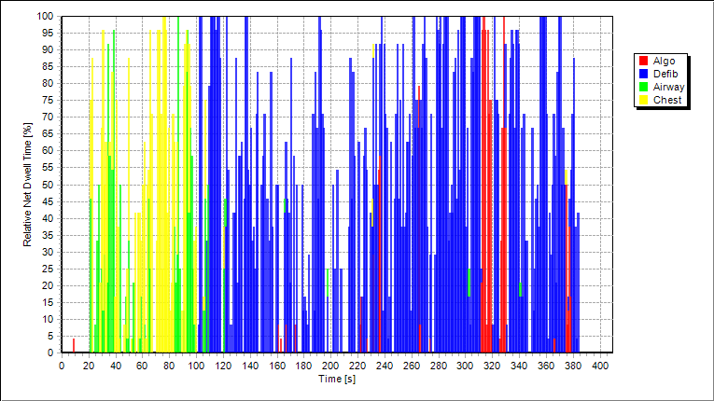
Figure 4:

Participant 1 – Consultant Paediatrician
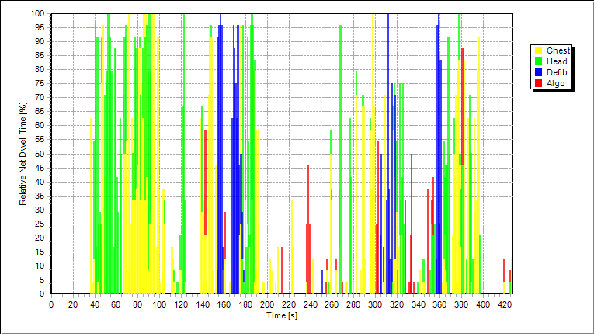

Participant 15 – PICU consultant

Time to key interventions:
Table 2 shows the median time taken for each of the groups to perform key clinical interventions.
Table 2 | Median time in seconds
 | Bag and mask ventilation | Chest compressions | 1st Shock
Trainees | 29.5 | 47 | 129
Paediatricians | 34 | 60.5 | 142
PEM | 34.5 | 43.5 | 123.5
PICU | 27 | 32 | 105

Discussion:
Our study is the first to describe the gaze behaviour of clinicians in simulated emergencies. PICU consultants were fastest to all key clinical interventions and displayed different gaze behaviour to clinicians in the other groups. The most noticeable difference was the high mean fixation count and dwell time on the patient’s chest and airway. Consultant paediatricians were slowest to key clinical interventions. They looked more frequently and for longer at the algorithm and defibrillator than clinicians in the other groups.
The Binning charts shown demonstrate a paediatric consultant focusing mainly on the defibrillator and algorithm. This type of ‘perceptual narrowing’ in situations of high cognitive load has been described in novice drivers and increases the risk of missing key visual cues.¹⁷ The PICU consultant pays more attention to all areas of interest for shorter periods of time. They also spent a greater proportion of time surveying the wider resuscitation area.
The gaze behaviour of PICU consultants is very similar to that observed in experienced pilots who make shorter fixations, more active visits to important instruments and more checks on flight variables not being manipulated.^{8,11} Although potentially perceived as experts, consultant paediatricians performed worst and had a similar gaze pattern to true novices [trainees]. PICU consultants are more likely to encounter time critical emergencies in their practice. Long haul pilots are commonly perceived to be experts and yet display similar gaze behaviour to novices.⁸ Pilots on short-haul flights perform up to five times more landings than those on long-haul flights and demonstrate superior gaze behaviour.¹²
We found that the use of eye tracking technology in simulated resuscitations is technically feasible. Recordings were accurate and of good quality. Participants found the glasses comfortable and advised that they soon forgot they were wearing them. We did not have difficulty with participants gaze dropping below the glasses described elswhere.^{4,5}
The small size and convenience nature of the study is a limitation. We attempted to ensure consistency by using a standardised scenario with the same personnel throughout. Participants were blinded to the scenario. This was a simulated emergency and it is impossible to know if an individual’s performance reflects their normal practice. We did not assess visual scan patterns which may have provided additional useful information in relation to clinician’s gaze behaviour.

Conclusion:
Good practice in gaze behaviour is clearly defined in the aviation industry and taught to novice pilots. There is evidence from aviation, transport and surgery that it can be used as a targeted intervention to improve trainee’s performance. ^{9,17,18,19} Our study demonstrates a difference in gaze behaviour between those who performed best and those who performed poorest. The use of eye tracking technology in simulated scenarios is technically feasible. Further multicentre study is needed to better define expert gaze behaviour during resuscitation and evaluate if behaviour during simulation is similar to behaviour during a real emergency. Once this has been defined further research is needed to develop and evaluate how this could be used as an educational tool to teach novices. This may improve training and ultimately enhance the quality of care offered to patients in the resuscitation setting.
What is already known:
- Research in the aviation industry and surgery has demonstrated differences in the gaze behaviour between experts and novices.
- It can be used as a part of a targeted intervention to improve performance
What this study adds:
- The use of eye tracking technology during simulated resuscitations is feasible
- There is a difference in gaze behaviour between those who performed best and those who performed poorest during a simulated emergency
- This technology has real potential as an educational tool

References:
- Holmqvist K, Nyström M, Andersson R, Dewhurst R, Jarodzka H, Van de Weijer J. Eye tracking: A comprehensive guide to methods and measures. OUP Oxford; 2011 Sep 22.

- Broadbent M, Horsley M, Birks M, Persaud N. Comparing novice and expert nurses in analysing electrocardiographs (ECGs) containing critical diagnostic information: an eye tracking study of the development of complex nursing visual cognitive skills. In Current Trends in Eye Tracking Research 2014 (pp. 297-315). Springer International Publishing.

- Jacob RJ, Karn KS. Eye tracking in human-computer interaction and usability research: Ready to deliver the promises. Mind. 2003;2(3):4.

- Hermens F, Flin R, Ahmed I. Eye movements in surgery: A literature review. Journal of Eye Movement Research. 2013 Nov 8;6(4).

- Browning M, Cooper S, Cant R, Sparkes L, Bogossian F, Williams B, O'Meara P, Ross L, Munro G, Black B. The use and limits of eye-tracking in high-fidelity clinical scenarios: A pilot study. International emergency nursing. 2016 Mar 31;25:43-7.

- Szulewski A, Howes D. Combining first-person video and gaze-tracking in medical simulation: a technical feasibility study. The Scientific World Journal. 2014 Feb 19;2014.

- Hess EH. Attitude and pupils size. Scientific American, vol 212, pp. 46-54, 1965.

- Haslbeck A, Zhang B. I spy with my little eye: Analysis of airline pilots’ gaze patterns in a manual instrument flight scenario. Applied ergonomics. 2017 Sep 30;63:62-71.

- Yu CS, Wang EM, Li WC, Braithwaite G. Pilots’ visual scan patterns and situation awareness in flight operations. Aviation, space, and environmental medicine. 2014 Jul 1;85(7):708-14.

- Yu CS, Wang EM, Li WC, Braithwaite G. Pilots’ visual scan patterns and situation awareness in flight operations. Aviation, space, and environmental medicine. 2014 Jul 1;85(7):708-14.

- Bellenkes AH, Wickens CD, Kramer AF. Visual scanning and pilot expertise: the role of attentional flexibility and mental model development. Aviation, Space, and Environmental Medicine. 1997 Jul.

- Haslbeck A, Bengler K. Pilots’ gaze strategies and manual control performance using occlusion as a measurement technique during a simulated manual flight task. Cognition, Technology & Work. 2016;3(18):529-40.

- Boraston Z, Blakemore SJ. The application of eye‐tracking technology in the study of autism. The Journal of physiology. 2007 Jun 15;581(3):893-8.

- Edmunds SR, Rozga A, Li Y, Karp EA, Ibanez LV, Rehg JM, Stone WL. Brief Report: Using a Point-of-View Camera to Measure Eye Gaze in Young Children with Autism Spectrum Disorder During Naturalistic Social Interactions: A Pilot Study. Journal of autism and developmental disorders. 2017 Mar;47(3):898-904.

- Leekam SR, Hunnisett E, Moore C. Targets and cues: Gaze-following in children with autism. The Journal of Child Psychology and Psychiatry and Allied Disciplines. 1998 Oct;39(7):951-62.

- Boardman JP, Fletcher-Watson S. What can eye-tracking tell us? Archives of Disease in Childhood. 2017; 102:301-302

- Van Leeuwen PM, Happee R, De Winter JC. Changes of driving performance and gaze behavior of novice drivers during a 30-min simulator-based training. Procedia Manufacturing. 2015 Jan 1;3:3325-32.

- Vine SJ, Masters RS, McGrath JS, Bright E, Wilson MR. Cheating experience: Guiding novices to adopt the gaze strategies of experts expedites the learning of technical laparoscopic skills. Surgery. 2012 Jul 31;152(1):32-40.

- Vine SJ, Chaytor RJ, McGrath JS, Rich S, Masters W, Wilson MR. Gaze training improves the retention and transfer of laparoscopic technical skills in novices. Surgical endoscopy. 2013 Sep 1;27(9):3205.

Law, Benjamin, et al. "Eye gaze patterns differentiate novice and experts in a virtual laparoscopic surgery training environment." Proceedings of the 2004 symposium on Eye tracking research & applications. ACM, 2004.

Gegenfurtner, Andreas, Erno Lehtinen, and Roger Säljö. "Expertise differences in the comprehension of visualizations: A meta-analysis of eye-tracking research in professional domains." Educational Psychology Review 23.4 (2011): 523-552.

