The Craft of Making. Flowerfield Arts Centre Publicity, 2019.
https://www.flowerfield.org/exhibition/n-i-p-a-print-exhibition-2019

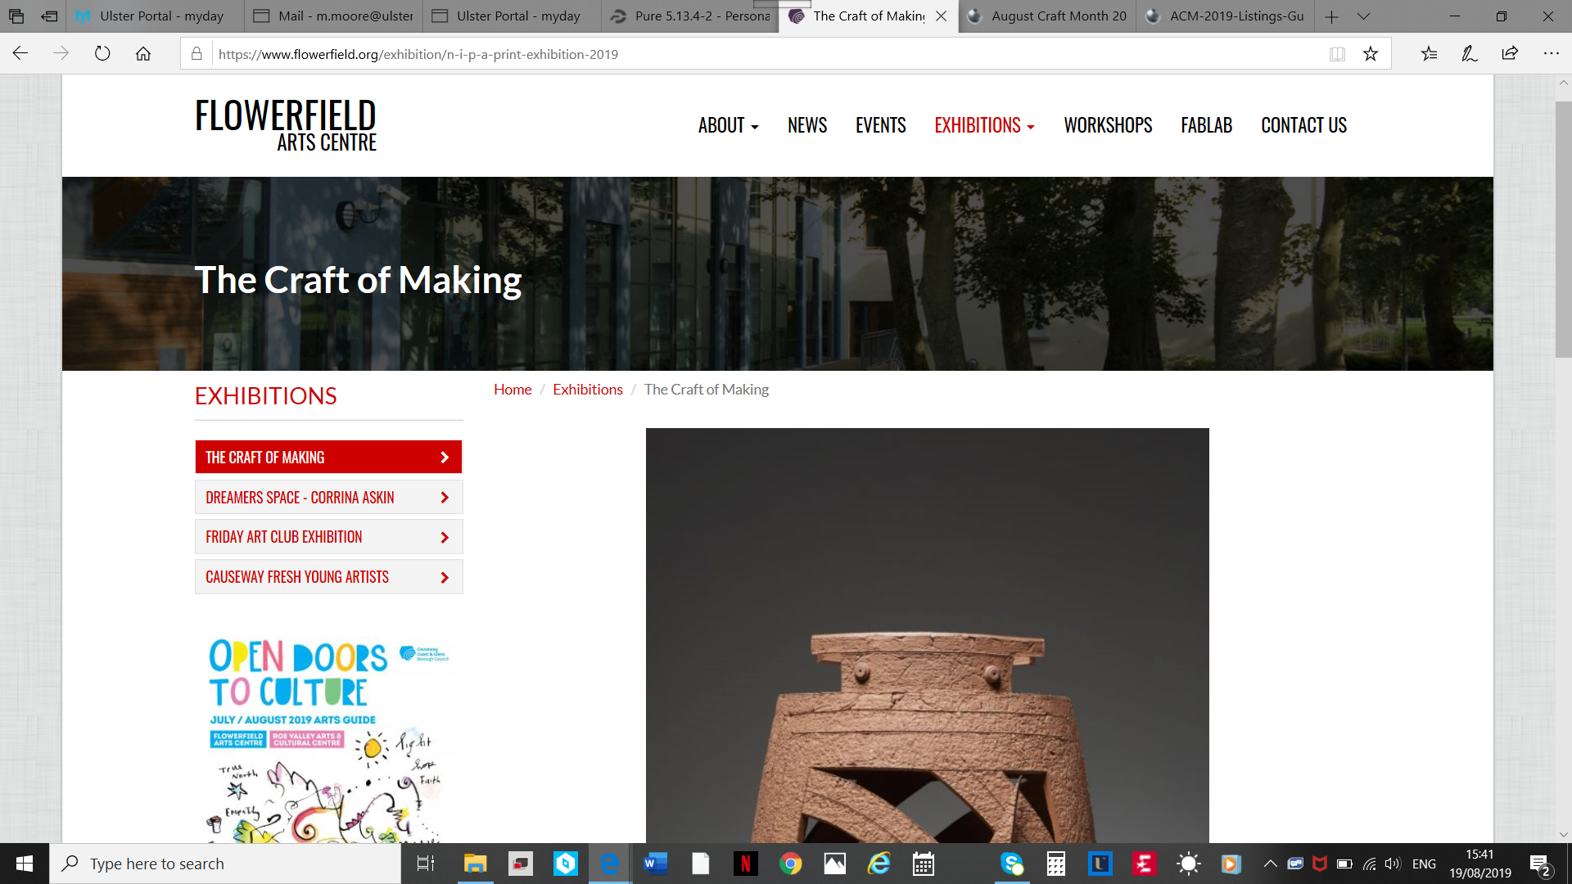
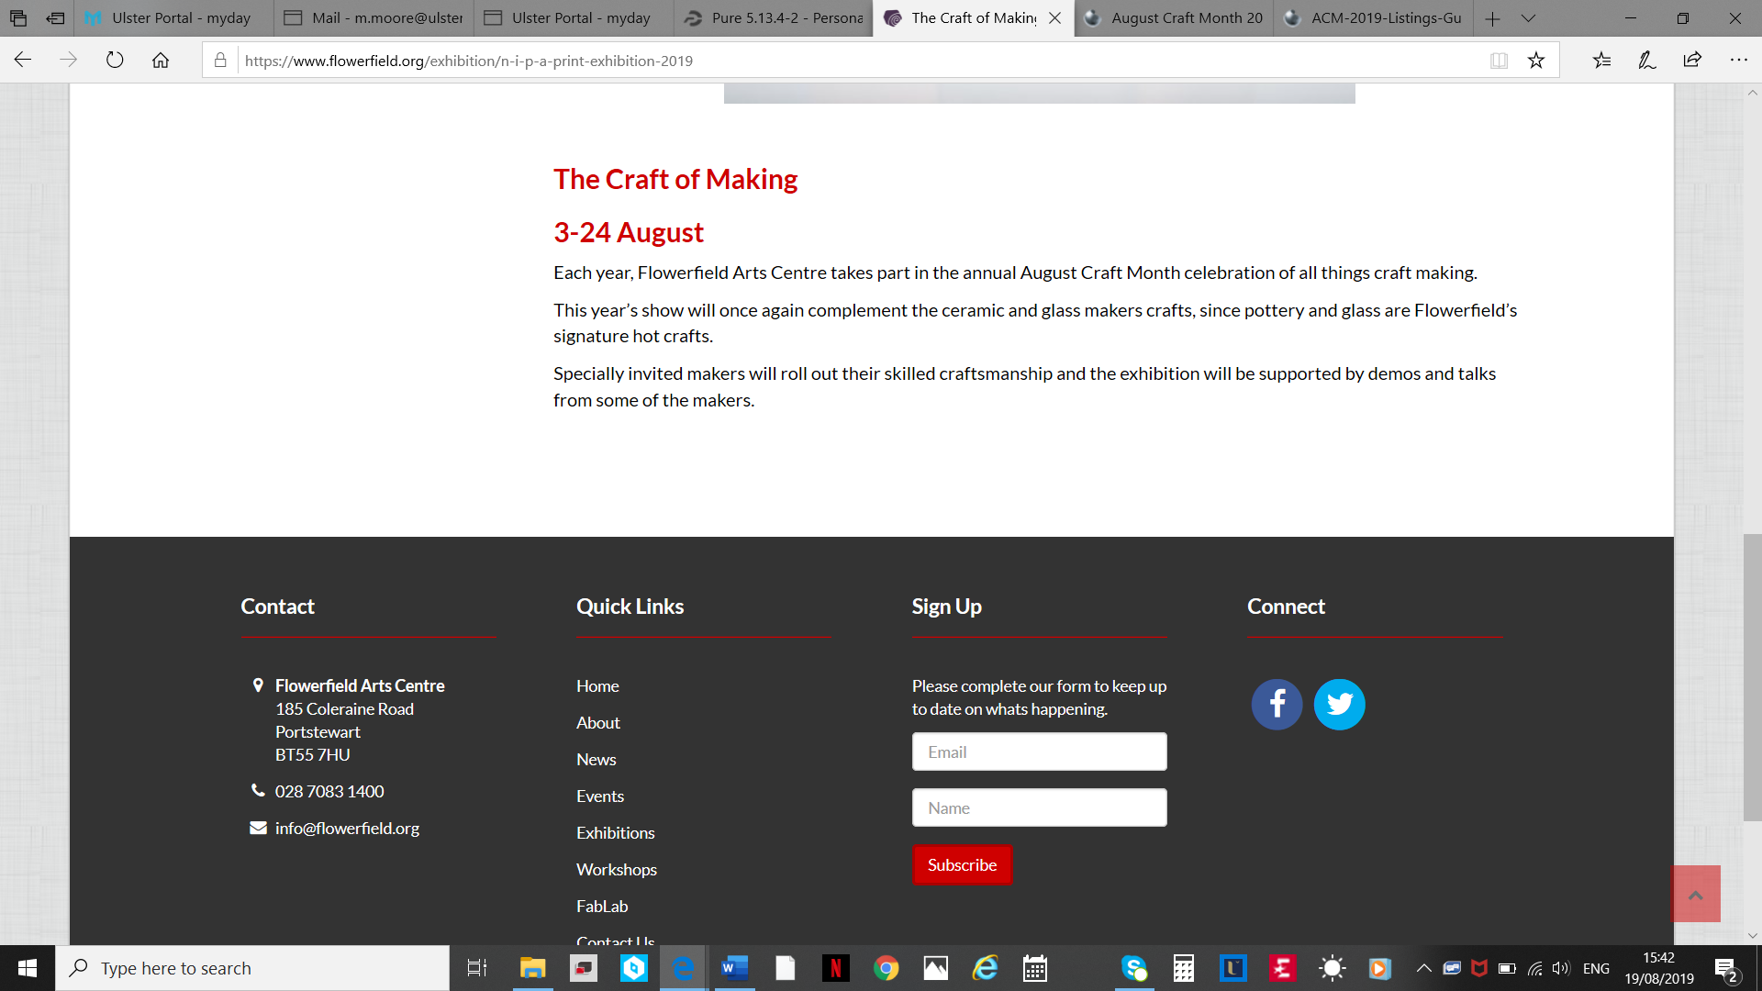

https://www.flowerfield.org/news-page
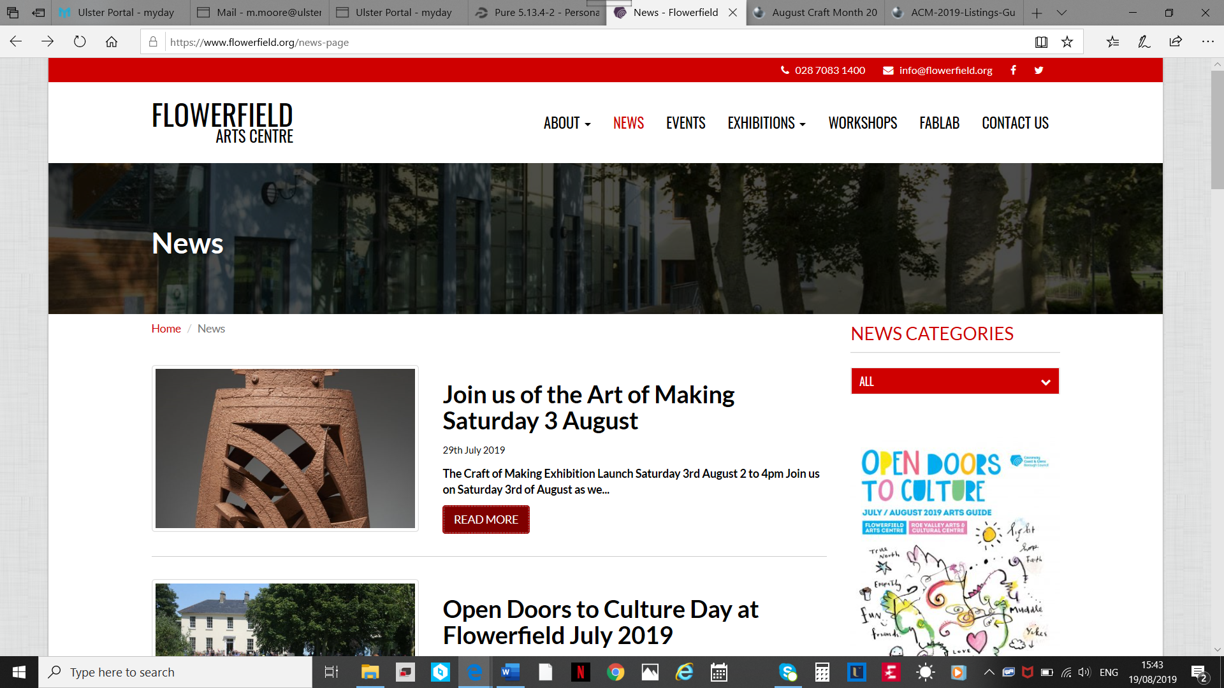
https://www.flowerfield.org/news/join-us-of-the-art-of-making-saturday-3-august
