Gold-coated plant virus as computed tomography imaging contrast agent
Alaa A. A. Aljabali*¹, Mazhar S. Al Zoubi², Khalid M. Al-Batanyeh³, Ali Al-Radaideh⁴, Mohammad A. Obeid¹, Abeer Al Sharabi⁵, Walhan Alshaer⁶, Bayan AbuFares³,
Tasnim Al-Zanati¹, Murtaza M. Tambuwala⁷, Naveed Akbar⁸, David J. Evans⁹
¹Yarmouk University - Faculty of Pharmacy, Department of Pharmaceutical Sciences, Irbid, Jordan
²Yarmouk University - Faculty of Medicine, Department of Basic Medical Sciences, Irbid, Jordan
³Yarmouk University - Faculty of Science, Department of Biological Sciences, Irbid, Jordan
⁴Hashemite University - Department of Medical Imaging, Zarqa, Jordan
⁵National Agricultural Research Center, Amman, Jordan
⁶University of Jordan - Cell Therapy Center, Amman, Jordan
⁷SAAD Centre for Pharmacy and Diabetes, School of Pharmacy and Pharmaceutical Science Ulster University, Coleraine, UK
⁸ University of Oxford - Cardiovascular Medicine, John Radcliffe Hospital, Oxford, UK
⁹ John Innes Centre, Norwich Research Park, Norwich, UK

*Corresponding author:
Dr. Alaa A Aljabali
Faculty of Pharmacy
Department of Pharmaceutical Sciences
Yarmouk University, Irbid, Jordan,
alaaj@yu.edu.jo

Abstract
Biologically derived nanoparticles, such as proteins and viruses, provide unique platforms that allow the incorporation of novel properties due to their surface composition, their amenability for chemical and genetic engineering, monodispersity and biodegradability. Chemical modification of the virus surface, both the interior and the exterior, imparts new functionalities, that have potential applications in nanomedicine. In this study, we developed novel virus-based nanomaterials as a contrast agent for computed tomography (CT) imaging in vitro. The gold-coated cowpea mosaic virus (Au-CPMV) particles were generated by the electrostatic adsorption of positively charged electrolyte on the virus capsid with the subsequent incubation and reduction of anionic gold complexes to generate Au-CPMV particles. Au-CPMV particles as a CT contrast agent offer a fast scan time (less than 2 minutes) method, low cost, biocompatibility and a high-resolution image with ~ 150 Hounsfield Units (HU). The Au-CPMV surface was further modified allowing the incorporation of targeting molecules of specific cell types for imaging diseased cells.
Keywords: Gold, Computed Tomography, Viruses, Biomedical Imaging, Targeting, Nanotechnology
Introduction
Numerous types of nanomaterials are currently under investigation in medicine, including dendrimers, polymeric nanoparticles (NPs), liposomes and protein-based NPs. Each system has advantages and disadvantages in terms of its toxicity, biocompatibility, immunogenicity, distribution and the payload being carried.
Modified protein cages are robust systems that combine imaging capabilities and target selectivity on the same platform. One application is the development of magnetic resonance imaging (MRI) contrast agents. Current contrast agents achieve their effect by increasing the relaxation rates (longitudinal relaxation rate (R₁), transverse relaxation rate (R₂), and pseudo-transverse relaxation rate (R₂*)) of water protons in tissues through the catalysis of alignment of nuclear spins [1], thus manipulating the MR image contrast. This effect is known as paramagnetic relaxation enhancement [2], and is common among contrast agents containing gadolinium [3] and iron oxide nanoparticles [4]. However, CT is a non-invasive, diagnostic imaging tools that allow for 3-D visual reconstruction and tissue segmentation. It relies on the use of X-rays with wavelengths between 0.01 nm and 10 nm as a source of electromagnetic radiation [5]. The CT image is generated from the 360⁰ rotation of the X-ray beam source around the object, with a detector positioned opposite the radiation source. The obtained attenuation profiles are processed mathematically by algorithms to create a 3-D image reconstructed from the dataset of the scanned object and expressed in Hounsfield Units [6]. X-ray attenuation and the image contrast results from the scattering (differential) of the X-ray by tissue. Tissue and bones absorb X-rays more strongly than air [7].
NPs hold great potential as molecular imaging tools for various reasons [8]. In general, NPs carry high contrast agent payloads in comparison to smaller moieties [9]. Semiconductor quantum dots (QD) are nano-sized crystals, a photostable fluorophore with a broad excitation spectrum but narrow emission at wavelengths dependent on the size and chemical composition of the core [10]. NPs, such as QDs and magnetic NPs, generate a contrast signal that is unmatched by smaller chemical counterparts [11]. Although iodine-based contrast agents are the most commonly used CT contrast agents nowadays [12], a variety of materials have been used as CT contrast agents including gold nanoparticles (AuNPs) [13], bromine [14], platinum [15], ytterbium [16], gadolinium [4], tungsten [15] and many others. Many of the systems are made up of a core that is coated with a polymeric material such as liposomes [17], micelles [13], lipoproteins or polymeric nanoparticles [18]. One of the first examples of such NP-based systems was reported by Caride et al using brominated phospholipids packaged into liposomes and administered to dogs. Contrast enhancement signals of 40 Hounsfield units (HU) were observed in the liver of imaged animals [14]. Micelles loaded with iodine of 17.7 % by weight at a dose of 170 mg of iodine per kg after 2 hours post-injection were able to show an attenuation of 150 HU in the heart [19], 57 HU in the liver and 90 HU in the spleen [20].
The development of AuNPs as imaging agents were invigorated after Hainfeld reported the formulation of a 1.9 nm contrast X-ray imaging agent after the injection of rats with 2.7 g gold/kg with no observable toxic effects [21]. Further, Cai et al (2007) synthesized AuNPs coated with PEG-2000 with a hydrodynamic radius of 38 nm and a 10 nm core [22] that generated a 100 HU signal in the aorta at a dose of 493 mg of gold/kg with a mean circulation half-life of 14.6 hours [23]. Furthermore, von Maltzahan et al (2009) developed PEGylated gold nanorods (13 x 47 nm) as CT contrast agents and for photothermal tumor therapy [13], the study resulted in tumor elimination and mice survival over 50 days [23]. van Schooneveld et al (2010), reported micelle-based AuNPs by generating 66 nm AuNPs coated with an 11 nm layer of silica and showed that for mice injected with these particles a contrast signal was observed [13], Popvtzer et al (2008) reported successful CT imaging of squamous cell carcinoma using gold nanorods coated with anti-antigen A9 [24].
The low sensitivity of contrast media represents a major challenge in the targeted CT imaging approach [23]. The minimum detectable signal was defined by Krause [25] to be 30 HU [26], with an attenuation rate of gold being 5.1 HU and with a concentration difference of 5.9 mM between the target and the background noise [27]. The accumulation of such concentration of the contrast agent is very difficult [28]. Therefore, the need to develop different forms on nanoparticles that are densely loaded with CT contrast agents for use in clinical settings will be of great value. The work reported here explores the development of a plant virus-based NP as a CT imaging agent.
In this study, the plant Cowpea mosaic virus (CPMV) was coated with a gold shell and their use as a CT contrast agent evaluated. Although a few publications reported the decoration of the surface of virus capsids with preformed AuNPs in specific patterns [29], to the best of our knowledge, this is the first time that modified plant virus particles have been used for CT imaging in vitro; the generated particles have potential for clinical imaging applications.
Results and Discussion
Characterization of Au-CPMV
The colloidal solution of Au-CPMV was synthesized based on the previously described method [30], by the adsorption of positively charged polymer on the CPMV virus capsid followed by subsequent reduction of gold ions onto the virus capsid. The approach allowed control of the size and generated a highly monodisperse distribution with limited coalescence. Au-CPMV assemblies were freely suspended as no aggregation was observed by NTA or DLS analysis. The successful coating of CPMV particles with gold was confirmed by TEM, representative images are shown in Figure 1. Nearly spherical NPs were observed with average diameter as shown in Table 1: Au-CPMV particles imaged by TEM appeared relatively smaller in size in comparison to when measured by other methods (NTA & DLS) as this technique measured the solid cores of the particles. Three different sizes of NPs were generated (50 nm, 70 nm and 100 nm) by varying the amount of gold hydroxide. The Au-CPMV particles were dark-red in colour. A characteristic SPR band of Au-CPMV was observed in the UV-vis spectrum at λ=535 nm for particles with a diameter of 50 nm, λ= 552 nm for particles with a diameter of 70 nm and λ=572 nm for particles with a diameter of 100 nm as shown in (Figure 3C). This confirms the formation of spherical particles for all three sizes of modified virus. The surface plasmon resonance phenomenon depends on the shape and the size of the NPs. For instance, ellipsoid shapes with three different axes have three different dipole modes. Furthermore, when the size of the spherical AuNPs increases, their SPR does not red-shift significantly. However, when the spectrum of rod-shaped particles is recorded the SPR shifts dramatically. The central resonance peak around ca. 520-530 nm represents the transverse SPR, which corresponds to the electron oscillation vertically to the long axis and it coincides spectrophotometrically with the SPR spectrum of spherical nanoparticles [31].
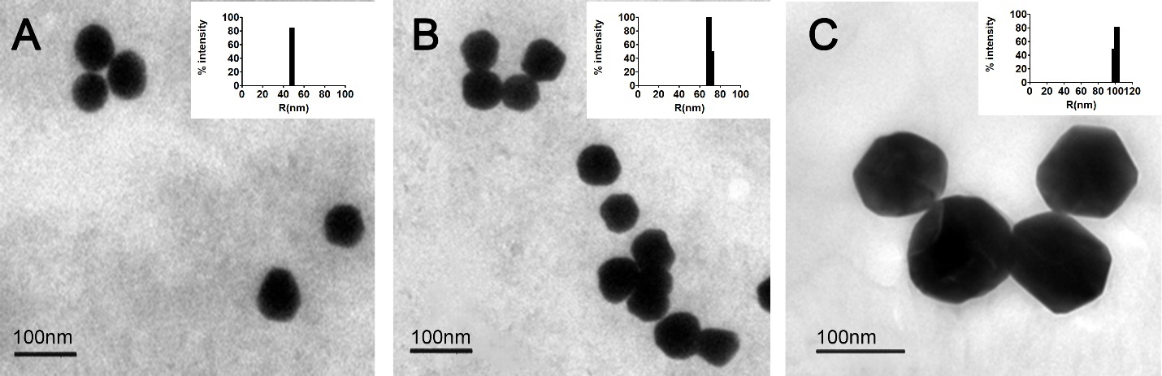
Figure 1: Size distribution of unstained TEM images of Au-CPMV with the corresponding DLS histogram size distribution (inset). (A) 50 nm Au-CPMV particles; (B) 70 nm Au-CPMV particles; (C) 100 nm Au-CPMV.

The hydrodynamic diameter and the polydispersity of the Au-CPMV suspended colloidal particles were measured by DLS and NTA. The Au-CPMV bare (unfunctionalized) particles showed a hydrodynamic diameter and polydispersity index as listed in Table 1, which is in accordance with the size observed from the TEM images and further confirms the narrow size distribution of the three types of Au-CPMV particles. The particles’ size measured by DLS is influenced by the substances adsorbed on the NPs surfaces, it is also influenced by the electrical double layer (solvation shell). Therefore, the size measured in DLS instruments appears to be slightly bigger in comparison to the particles measured under TEM images [32]. The polydispersity index (PDI) of the DLS data represents the intensity of light scattered by various fractions of the NPs differing in their sizes and calculated by (width/mean)² for each peak. Particles with PDI values of ≤ 0.1 are considered highly monodisperse [32]. Furthermore, to confirm the monodispersity of the particles the Cumulants fit correlogram generated by the DLS instruments, that measures the time at which the correlation starts to significantly decay, gave a slope of 85.3⁰ consistent with a monodisperse distribution. The steeper the line (closer to 90⁰) the more monodisperse the particles are.

Table 1: The average size Z-average (Z-Ave) of the bare (unfunctionalized particles), functionalized NPs polydispersity index (PdI); Zeta Potential (ζ) mV; concentration of the Au-CPMV particles as ~ 0.5 mg/ml for all three particle sizes; articles count (number of particles per ml) E9/ml as measured by NTA, n= 6 measurements.
Particles | TEM  (nm) | DLS |  | NTA  (nm) | Particles count (E9/ml) | Zeta Potential (ζ) mV
 |  | Z-ave  (nm) | PdI  (nm)
CPMV | 27 ± 2.0 | 30 ± 1.1 | 0.05 ± 0.01 | 28.9 ± 1 | 3.56 | -13
^{PEG 5000}Au-CPMV | - | 50.2 ± 3.2 | 0.12 ± 0.07 | - | - | -30.2 ± 2.1
^{VCAM1-PEG5000}Au-CPMV | - | 56.1 ± 2.4 | 0.16 ± 0.02 | - | - | -20.5 ± 1.2
Au-CPMV (50 nm) | 44.5 ± 4.2 | 50.2 ± 3.2 | 0.04 ± 0.01 | 51 ± 2 | 2.32 | -45.9 ± 3.1
Au-CPMV (70 nm) | 63.5 ± 4.0 | 68.0 ± 2.0 | 0.13 ± 0.03 | 71 ± 3 | 1.87 | -48.2 ± 1.8
Au-CPMV (100 nm) | 92.0 ± 3.8 | 96.0 ± 4.1 | 0.15 ± 0.08 | 100 ± 5 | 1.08 | -43.7 ± 2.1

The ζ-potential cannot be measured directly, rather it is deduced from the electrophoretic mobility of the charged NPs under an applied electric field. The electrophoretic mobility toward which electrode within the instrument determines the ζ-potential values as negative or positive. The mean of ζ-potential values for Au-CPMV particles of different suspensions are summarized in Table 1. The ζ-potential is consistent, in each case, with the formation of a similar layer deposited on the surface of the Au-CPMV particles [33] . The ζ-potential of the unfunctionalized Au-CPMV agree with previously reported values [34] ranging between -43.7 ± 2.1 to -48.2 ± 1.8 mV [35]. The ζ-potential of ^{VCAM1-PEG5000}Au-CPMV has a surface charge value of -20.5 ± 1.2 mV and for ^{PEG 5000}Au-CPMV -30.2 ± 2.1 mV. One of the values of the ζ- principle is the ability to classify NP stability based on their surface charge values. Values in the range of ± 30 mV are considered highly stable [36]. The high values of ζ-potential observed confirm electrostatic repulsion between the NPs that increases their stability and extends their shelf life. The ζ-potential of the particles measured after 10 months storage at 4 ⁰C gave similar values.
Further analyses of Au-CPMV size, size distribution and concentration used Nanotracking (NTA). NTA analysis of the Brownian motion of the Au-CPMV on a particle-by-particle basis and the subsequent employment of the Stokes-Einstein equation allows the derivation of NPs size and concentration. Au-CPMV with a concentration of ~ 0.5 mg/ml gold contains roughly10⁹ to 10¹⁰ of Au-CPMV particles per ml as determined by NTA. This concentration corresponds to 3500 NPs present in the quartz cuvette (300 μl) of the instruments under laminar flow, of which ~ 100-200 NPs are illuminated at any given time as determined from still images of the recorded video using ImageJ software. NTA enables sample visualization with approximation of the particle concentration and confirmed a relatively narrow monodisperse size distribution for all three samples with no aggregation. Furthermore, the particle size distribution obtained from NTA analysis (Figure 2B) showed a peak of 51 ± 2 nm, 71 ± 3 nm and 100 ± 5 nm, respectively, with over 90% of the particles being within the measured size thus confirming the narrow size distribution. CPMV (uncoated particles) have an average diameter of 28 nm and surface charge of ~ 13 mV [37].

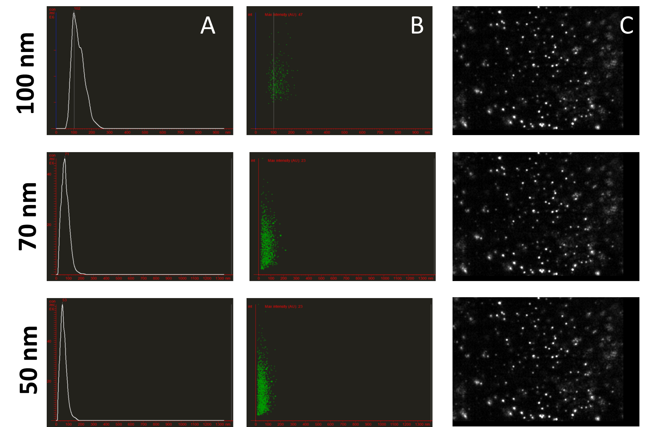
Figure 2: NTA measurement of Au-CPMV at 25 ⁰C recorded from three consecutive 60s runs for each sample. (A) particle size (concentration particles/ml vs size); (B) representative NTA scattering distributions of each population (size vs intensity) showing compact clustering intensity and indicating particles are highly monodisperse with no aggregation, each dot represents a single particle; (C) representative NTA video frame. Data was recorded from six independent experiments.
Surface Functionalization and UV-Visible Studies
One of the objectives of the present work was the development of a smart cell-specific contrast agent based on surface modification of Au-CPMV with specific antibodies to target desired cells. Quantification of the amount of antibody attached to the ^{VCAM1-PEG 5000}Au-CPMV was determined spectrophotometrically at λ=565 nm using BCA reagent and found to be 1.95 ± 0.18 mg/ml gold. Further, the hydrodynamic radius of the ^{VCAM1-PEG 5000}Au-CPMV increases from 50.2 ± 3.2 to 56.1 ± 2.4 nm after rigorous purification of the antibody labelled particles suggesting successful modification of their exterior surface. This observed increase in the hydrodynamic radius is consistent with the previous report of particles coated with proteins [38]. In addition, the UV-vis spectrum was used to evaluate the surface functionalization of Au-CPMV. The localized surface plasmon resonance (LSPR) spectrum shifted by almost 4 nm (Figure 3-A). This shift of the extinction maximum from 534 nm to 538 nm is a result of an increase in the local refractive index at the Au-CPMV surface as reported in the literature following surface modification with proteins [39] and indicates that the surface of the Au-CPMV particles are “smooth”. The shift would be greater if the surface had an uneven shape. In addition, the 4 nm red-shift of the LSPR peak suggests that the modification of the Au-CPMV surface with antibody has been successful. This increase in the absorbance shift is expected as the SPR of the AuNPs is sensitive to their interparticle distance and surface state [40]. Furthermore, the LSPR band of Au-CPMV is dependent on the size of the particles. The peak absorbance wavelength increases with the increase of the particles diameter as shown in (Figure 3-C). The UV-visible spectrum was used to calculate the concentration of Au-CPMV particles using Beer-Lamberts law with lambda max of λ= 535 nm and extinction coefficient (ε) = 1.8 × 10¹⁰ M⁻¹cm⁻¹ for a particle diameter of 50 nm, SPR wavelength of λ=552 nm and ε = 6.70 × 10¹⁰ M⁻¹ cm⁻¹ for a particle diameter of 70 nm, and from SPR peak wavelength λ= 572 nm using ε = 1.57 × 10¹¹ M⁻¹cm⁻¹ for particles with a diameter ca. 100 nm. In addition, the EDX spectrum of ^{VCAM1-PEG 5000}Au-CPMV clearly confirms the presence of gold with a signal at 2.120 keV and 9.712 keV as indicated by the white arrows (Figure 3-B) and a strong signal for sulfur from the linker on the surface of the Au-CPMV particles.

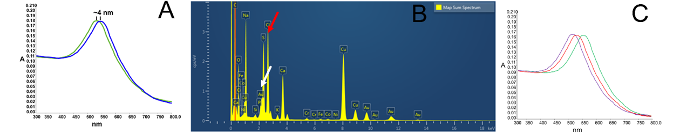
Figure 3: (A) UV-vis spectrum of 50 nm unconjugated Au-CPMV (green) and antibody labelled Au-CPMV particles (blue). The spectrum shows a 4 nm red-shift peak, while preserving the overall shape and intensity of the spectrum, confirming successful coupling of the antibody to the Au-CPMV surface. (B) EDX analysis with a scanning electron microscope (SEM) confirms the presence of gold (white arrows) and sulfur (red arrow), Si and Cr signals are from the sample holder. (C) UV-vis spectrum of the SPR bands of Au-CPMV at λ=535 nm for particles with a diameter of 50 nm (blue line), λ= 552 nm for particles with a diameter of 70 nm (red line) and λ=572 nm for particles with a diameter of 100 nm (green line).
In vitro Fluorescent Cell Imaging
To confirm successful modification of the Au-CPMV with antibodies the ζ-potential was utilized [38]. The ζ-potential of the 50 nm Au-CPMV particles decreased from -45.9 ± 3.1 mV to -53.8 ± 2.4 mV upon antibody coating of the particles and the ^{VCAM1-PEG 5000}Au-CPMV becomes more negative [37] ,which is consistent with the literature [41].
Confocal fluorescence microscopy was performed on the cell lines to demonstrate the specificity and the distribution of the labelled NPs. As shown in Figure 4-B, green-fluorescent labelled ^{VCAM1-PEG5000}Au-CPMV particles incubated with RAW264.7 cells showed significant and specific binding of the fluorescently labeled antibody on the exterior of Au-CPMV to the surface of the RAW264.7 cells. Fluorescent microscopy confirmed that the ^{VCAM1-PEG5000}Au-CPMV can selectively bind to their target, whereas, the ^{IgG-PEG5000}Au-CPMV control did not show any fluorescent signal indicative of no binding to the surface of the cells Figure 4-A. The merged confocal microscopy image demonstrates the successful attachment of the ^{VCAM1-PEG5000}Au-CPMV to the surface of the RAW264.7 cells as shown in Figure 4-C: ^{VCAM1-PEG5000}Au-CPMV in green, blue and red fluorescence indicate the cell nucleus and the plasma membrane, respectively, the images represent the overall morphology of the RAW264.7 cells. Thus, we conclude that the prepared ^{VCAM1-PEG5000}Au-CPMV is an acceptable targeting model for further in vivo studies.
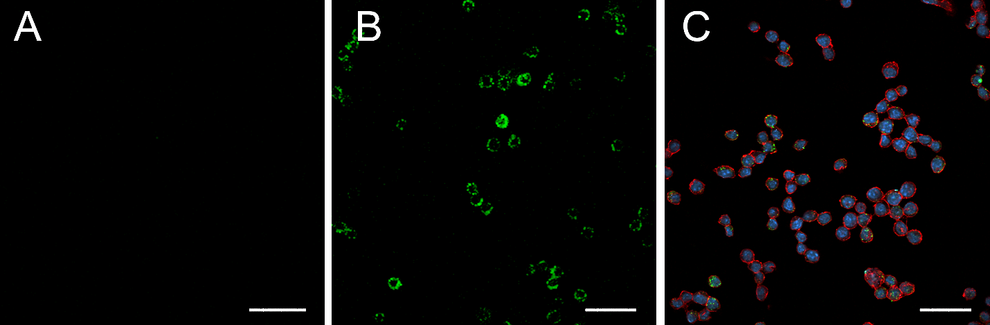
Figure 4: Confocal fluorescence microscope images of fluorescently labelled ^{VCAM1-PEG5000Au-}CPMV particles RAW246.7 Actin filaments were labelled with DY-554 phalloidin (red) and DAPI (blue). (A) ^{IgG-PEG5000}Au-CPMV (B) ^{VCAM1-PEG5000}Au-CPMV showing the binding of the particles to the cells surface and (C) merged image of the cells with the ^{VCAM1-PEG5000}Au-CPMV showing the stained cells and the binding of the particles. Scale bar 100 μm.

STEM−EDX elemental maps
STEM offers a contrast enhancement over the TEM analysis due to lower energy (20-30 kV). Higher electron scattering provides better insight into the morphology of low atomic number materials [42]. In the case of imaging Au-CPMV particles in RAW246.7 cells in vitro, the electron-dense particles appeared to be outside the cell and on the cellular surface as shown in Figure 5-A. The images revealed that Au-CPMV particles maintain their original shape and size, indicating that they are resistant to solubilization or oxidation. The dual STEM and EDX spectra from the ^{Antibody-PEG 5000}Au-CPMV gave useful information from the spatial distribution of gold and sulfur across the cellular surface. The cells are flexible, which may lead to change in their shape. The simultaneously acquired EDX spectrum images confirmed that electron-dense material comprised of gold and sulfur is at the surface as a consequence of modification of Au-CPMV with the antibody-linker. Furthermore, STEM-EDX analysis provided compositional and topographical 3-D elemental distributions as shown in Figure 5.

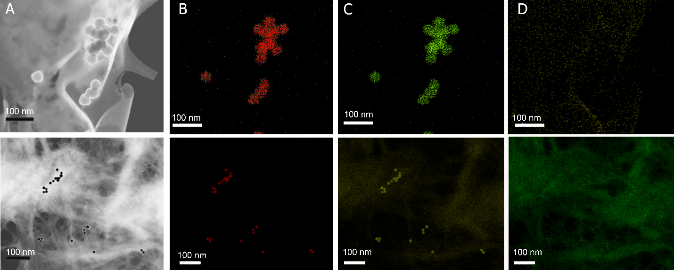
Figure 5: Dark-field STEM image of ^{Antibody-PEG 5000Au-}CPMV as electron-dense particles. (A) High-resolution TEM image of ^{Antibody-PEG 5000Au-}CPMV (B) the elemental EDX map of gold from the gold coating the virus particles distributed almost uniformly on the same position of the electron-dense particles. (C) Sulfur from the linker attachment to the nanoparticles distributed uniformly on the same position of the electron-dense particles. (D) Carbon from the biological matrix of the cells. The electron dose is 20 e-/Å2 per frame (200 kV, probe current of 691 pA). Top and lower panels represent different magnifications of two independent experiments.
CT Imaging
Iodine containing moieties are routinely and clinically used as CT imaging agent [43] due to the high X-ray attenuation of the iodine [44]. It has been shown that gold provides on average three times higher X-ray attenuation per unit weight than iodine [45]. This was the rational to generate AuNPs as CT imaging agents. The Au-CPMV particle sizes of 50, 70 and 100 nm were selected to ensure that the particles will bind specifically to their target tissue without being so small as to induce cell toxicity. This occurs at sizes smaller than 50 nm due to their diffusion properties. The Au-CPMV particles are believed to have suitable sizes for optimal imaging quality and biocompatibility in clinical applications. Herein, we report the size effect of the three Au-CPMV samples on X-ray attenuation as measured by CT. The generated signals are shown in Figure 6. The average CT number from three scans for each sample was 183 HU, 133 HU, and 115 HU for the 50 nm, 70 nm, and 100 nm, respectively. At the same gold concentration, the smaller 50 nm Au-CPMV particles show greater X-ray attenuation than the 100 nm Au-CPMV particles and the CT signal is concentration dependent. This can be attributed to the increase in the surface area of the NPs with the decrease in their particle size. It has been reported that gold with higher atomic number and higher theoretical X-ray attenuation (at 100 keV: gold, 5.16 cm²/g; iodine, 1.94 cm²/g; water, 0.171 cm²/g) can absorb more X-rays at specific energy levels [46].
On this scale the CT scan of soft tissues ranges between minus 100 to 100 HU and for bones ranges from 400 to 1000 HU. Cai et al reported the use of 38 nm AuNPs coated with PEG-2000 with a core of 10 nm and a dose of 493 mg gold/kg with a circulation time of 14.6 hours and a contrast of ~ 100 HU signal from the imaged aorta for up to 24 hours [22]. Furthermore, 66 nm AuNPs coated with a 11 nm layer of silica provided in vivo imaging of the liver with a CT signal of ~ 23-25 HU per gram of gold [13]. Herein, our gold-modified virus NPs with similar sizes to those reported in the literature have higher HU values in vitro. This might be attributed to the generated gold coating leaving the center as a hollow core. The Au-CPMV particles have great potential as contrast agents with excellent attenuation, their surface can be modified with targeting molecules, and they exhibit no toxicity [35].

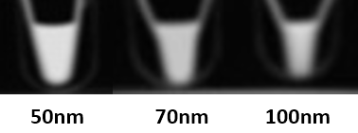
Figure 6: CT images of Au-CPMV particles of different sizes suspended in DD water at, the gold concentration is 200 μg of gold suspended in 200 μl aqueous solution for each sample. The average CT values from three scans for each sample were 183 HU, 133 HU, and 115 HU for the 50 nm, 70 nm, and 100 nm, respectively.

Conclusion:
In conclusion, CT has become an extremely useful tool in imaging research. CT produces non-invasive, three-dimensional and high-resolution images. CT contrast agents have evolved from iodinated molecules to complex nanoparticles. Au-CPMV particles are easy to synthesis, provide control over NPs size, and the ability to tune the surface functionalities allows the use of such particles in biomedical applications. The Au-CPMV particles reported here have excellent stability and dispersion for at least almost a year in that no visible aggregation nor changes in particles size was observed from samples stored at 4 ⁰C. Their surface can be modified with molecules to enhance tissue targeting. Coupling of fluorescently-labelled antibodies to the nanoparticles have enabled cell line studies. As a CT agent, Au-CPMV particles generated on average a 150 HU in a size dependent manner showing contrast enhancement similar to, or better than, other contrast agents. Au-CPMV-labelled cell tracking has great potential for use in clinical studies.
Materials and Methods:
Materials
Poly(allylamine hydrochloride) (PAH, MW∼15,000), gold(III) chloride trihydrate 99.9+%, sodium chloride, 50 and 100 kDa cut-off Millipore filter membranes, potassium carbonate, sucrose, dimethyl sulfoxide (DMSO; 25%), 2-(N-morpholino)ethanesulfonic acid (MES) buffer, isopropanol, tetrachloroauric acid, trypsin, ethylenediaminetetraacetic acid (EDTA), HEPES sodium salt, Triton™ X-100, Phosphate Buffered Saline (PBS) tablets and Bovine Serum Albumin (BSA), were purchased from Sigma-Aldrich; potassium carbonate from BDH; hydroxylamine hydrochloride, 99%, from Lancaster Synthesis; Carboorundum (Fine grade silicon carbide) from Parchem; carboxyl-PEG 5000-SH, (1-ethyl-3-(3-dimethylaminopropyl)carbodiimide hydrochloride) (EDC), (N-hydroxysulfosuccinimide)sulfo-NHS, Bicinchoninic acid (BCA) protein assay kit, RPMI, foetal calf serum, and T125 mm tissue culture flasks from ThermoFisher Scientific; EGM-2 medium from Lonza. Cell culture medium phenol red-free [high glucose Dulbecco modified eagle medium (DMEM) supplemented with 10% (v/v) fetal bovine serum (FBS). 100 units/M1 penicillin, gentamicin antibiotic (50 μg/ml), fungizone (1.3 μg/ml) and 2 mM L-glutamine], anti-VCAM1 (FITC labelled) (EPR17010-83; Abcam) and macrophage cell line (RAW264.7) from American Type Culture Collection (ATCC; Manassas, VA).

Methods
CPMV propagation
CPMV propagation followed our previously published method [37]. Black-eyed peas plant (Vigna unguiculata) were grown from seeds, obtained locally, in a greenhouse for 10 days. Primary leaves were rubbed with Carborundum (Fine grade silicon carbide abrasive) and treated with CPMV (50 μl of 0.1 mg/ml) suspended in 10 mM sodium phosphate buffer pH 7.0. The leaves were sprinkled with tap water to remove the excess Carborundum. 14 days after infection, the infected leaves were harvested and stored at -20 °C prior to use.
CPMV isolation
Infected leaves were homogenized to extract CPMV particles following our previously published protocol [33].

CPMV-poly(allylamine) hydrochloride (^{PAH}CPMV)
^{PAH}CPMV particles were prepared as previously reported [30]. CPMV (1 mg/ml) was suspended in double-distilled (DD) water and added dropwise to freshly prepared aqueous solution of PAH (1 mg/ml; supplemented with 250 mM NaCl) over 5-10 minutes with continuous stirring at 500-800 rpm at ambient temperature. ^{PAH}CPMV particles were washed 4 times with DD water (15 ml each) on 50 kDa cut-off Millipore filter membranes, followed by dialysis with 12400 molecular weight cut off (MWCO) against 10 mM sodium phosphate buffer pH 7.0 for 15 hours.
Gold hydroxide solution
Gold hydroxide solution was prepared following the published protocol [30]. Gold (III) chloride trihydrate (HAuCl₄·3H₂O) (17.4 ml of 25 mM aqueous solution) was diluted with DD water (982.6 ml), and potassium carbonate (249 mg, 1.8 mM) added. The solution was aged for 1–2 days in the dark (foil wrapped) at 4 °C, during which it changed colour from yellow to colorless indicative of gold hydroxide formation
Gold-coated CPMV (Au-CPMV)
Particles were prepared following the published protocol [30]. Freshly prepared ^{PAH}CPMV (approximately 1 mg/ml) was incubated with gold hydroxide solution (0.8 ml to generate 50 nm particles, 1.1 ml to generate 70 nm particles and 1.5 ml to generate 90 nm particles). The reaction was stirred continuously at 500 rpm for 2 hours at ambient temperature. Freshly prepared aqueous solution of hydroxylamine hydrochloride was added to a final concentration of 20 mM. the reaction was left to proceed for a further 30 minutes at ambient temperature. The Au-CPMV particles were centrifuged at 5000g for 20 minutes to remove any large aggregates. The supernatant was layered on sucrose gradients (15 ml 10 - 70 % (w/v) dissolved in 10 mM sodium phosphate buffer pH 7.0). Sucrose fractions containing Au-CPMV (light blue color) were collected and dialyzed against 10 mM sodium phosphate buffer pH 7.0 using 50 kDa MWCO.

^{Carboxyl-PEG 5000}Au-CPMV
Freshly prepared Au-CPMV (1 mg/ml) suspended in PBS buffer (20 mM sodium phosphate, 150 mM NaCl; pH 7.4) was added to a solution of carboxyl-PEG 5000-SH (spacer arm length 15.8 Å, 10 mg) dissolved in DMSO (1 ml). The reaction was stirred for ca. 12 hour at ambient temperature. ^{Carboxyl-PEG 5000}Au-CPMV particles were dialyzed for 24 hours against 100 mM sodium phosphate, 0.15 M NaCl, buffer pH 7.4 using 100 kDa dialysis membranes.
^{VCAM1-PEG 5000}Au-CPMV
^{Carboxyl-PEG 5000}Au-CPMV were buffer exchanged using 14000 kDa dialysis bags in 2-(N-morpholino)ethanesulfonic acid (MES) buffer, pH 6.0 for 12-14 hours. To ^{Carboxyl-PEG 5000}Au-CPMV (100 μl, ~ 1 mg/ml), aqueous EDC (50 μl, 200 mM) and aqueous (N-hydroxysulfosuccinimide)sulfo-NHS (200 μl, 800 mM) was added. The reaction was left to proceed for 1 hour at ambient temperature (25 ºC) then precipitated with isopropanol (500 μl). Activated ^{Esterfied-PEG 5000}Au-CPMV was resuspended in anti-VCAM1 (FITC labelled, 20 μl of 1 mg/ml) antibody solution in PBS, pH 7.4 (EPR17010-83; Abcam) and reacted at 4 ºC overnight (~15 hours). ^{VCAM1-PEG 5000}Au-CPMV was centrifuged at 5000 g and washed 4 times with DD water to remove unbound antibodies. Particles were purified on PD-10 columns pre-equilibrated with 10 mM sodium phosphate buffer pH 7.0. ^{IgG-PEG 5000}Au-CPMV were prepared as a negative control following the same procedure.
Antibody Quantification
Bicinchoninic acid (BCA) protein assay kit from ThermoFisher Scientific was used according to the manufacturer’s instructions [47]. ^{VCAM1-PEG 5000}Au-CPMV and ^{IgG-PEG 5000}Au-CPMV (200 μl of 0.1 mg Au) and BCA reagent (200 μl) were mixed together and incubated at 60 ⁰C for 10 minutes. The samples were left to cool for 30 minutes then centrifuged at 14000 g for 40 minutes (Thermo Scientific CL10 Centrifuge) to pellet the particles. The supernatant BCA dye absorbance was measured at λ= 565 nm using a microplate reader. The change in absorbance is a consequence of the reduction of Cu²⁺ to Cu⁺, an indicator of the presence of protein.
Murine macrophage (RAW264.7)
Cell culture
A mouse monocyte/macrophage cell line (RAW264.7), was purchased from American Type Culture Collection (ATCC; Manassas, VA). RAW264.7 cells were plated in T125 mm tissue culture flasks at 6000 cells/cm² in growth medium phenol red-free following the published protocol [48]. All cells were cultured in a humidified incubator at 95 % humidity and 5 % CO₂ maintained at 37 °C. For experiments cells were seeded the day prior to the incubation with the NPs at 3.5 × 10⁴ cells per cm³ of growth surface and were used between passages 2 and 3. Subculture occurred after 60-70 % confluence after trypsinization (0.025 % trypsin, 0.5 mM EDTA, 10 mM HEPES buffer pH 6.5).
RAW264.7 Cell Labelling and Confocal Microscopy
Cells of a murine endothelial line (RAW264.7, 100 μl of 1x10⁶ cells/ml) were cultured on a glass coverslip, kept in a six-well plate for 10-12 hours prior to the NP addition. ^{VCAM1-PEG 5000}Au-CPMV (100 μg/ml) was incubated with the cells on the coverslip for 2 hours at 4 °C. Coverslips were washed 3 times with 10 mM sodium phosphate buffer pH 7.0 to remove free NPs. Cells were fixed in 4% paraformaldehyde/PBS (pH 7.0) for 15 minutes at ambient temperature (25°C). Cells were rinsed three times for 5 minutes with PBS (10 ml) and incubated in 0.2% Triton X-100 for a further 10 minutes. After three 5-minute rinses with PBS and preincubation with 2% BSA to block nonspecific staining, cells were stained with fluorescein phalloidin (red) (5 to 10 μm/m) for 20 minutes to stain F-actin. After three additional 5-minute PBS (10 ml) washes, nuclei were stained with 4′,6-diamidino-2-phenylindole (DAPI) (1 μg/ml in PBS) for 15 minutes. Samples were washed three times with 10 ml of PBS and analyzed with a fluorescence microscope (Cytation Cell Imager; BioTek Instruments, Inc).
Transmission Electron microscopy (TEM)
TEM images were recorded using Titan Transmission Electron Microscope FEI, operating at 300 kV and fitted with a post-column Gatan Tridiem GIF 863. Samples were dispersed in water at a concentration of 0.01 - 0.05 mg/ml and deposited on 400 mesh carbon grids (SPI supplies), samples were air dried prior to imaging.
Energy-dispersive X-Ray spectroscopy (EDX / EDS)
A FIB Scios system was used combined with a scanning electron microscope (SEM) and a focused ion beam equipped with X-MaxN 50 mm² EDS system to measure 0.3-3 μm with a detection limit of ~1%. The sample was placed at a 52º-degree tilt and at a eucentric height (or WD) of 7-10 mM from the pole piece. The Auger electrons were set to ~1 nm, secondary electrons ~100 nm and inelastically backscattered electrons to 1 μm under vacuum.
The EDX data was processed by Aztec software from Oxford Instruments. Images were recorded on CCD camera with mapping resolution of 2048 x 1600. The beam was selected with accelerating voltage for imaging, beam current 100 pA at 30 kV and a spot size of 5-6, fast scan rate of dwell time (0.1 – 0.3 μs), detector ETD (SE) and a working distance (FWD).
UV-Visible Spectroscopy
The absorption measurements were recorded on a PerkinElmer Lambda 25 spectrometer. CPMV concentration was determined using the Beer Lambert equation with molar extinction coefficient of ε = 8.1 ml mg⁻¹ cm⁻¹ [49]. Au-CPMV concentration was determined from peak SPR wavelength λ= 535 nm using ε = 1.8 × 10¹⁰ M⁻¹cm⁻¹ for a particle diameter of 50 nm, SPR wavelength of λ=552 nm using ε = 6.70 × 10¹⁰ M⁻¹cm⁻¹ for a particle diameter of 70 nm, and from SPR peak wavelength λ= 572 nm using ε = 1.57 × 10¹¹ M⁻¹cm⁻¹ for particles with a diameter ca. 100 nm [35]. Spectroscopic analyses were recorded at ambient temperature (21-28 ºC) using quartz cuvettes with an optical path length of 1 cm.
Dynamic Light Scattering (DLS)
DLS measurements were reported on Wyatt DynaProTM DP-801 system coupled with Dynamics V7.0.0.95 software. Measurements were recorded on the following settings 20 mW He-Ne laser, λ₀ = 780 nm, scattering angle θ = 90º, molar refractive index of 1.33; viscosity of 0.8872 at 25 ºC; attenuator was set up automatically and ranged between 6 to 9. Corresponding quartz cells were flushed with deionized water followed by a 1% (v/v) aqueous Hellmanex solution (strong alkaline cleaning concentrate made of phosphates and surfactants from Helma Analytics) and air dried prior to being filled with sample solution (500 μl). The outer surface of the cells was wiped gently with a sheet of soft lens cleaning tissue. A total of 10 successive DLS measurements were carried out per sample after 2 minutes waiting time to allow the solutions to be at rest. The hydrodynamic radius (intensity particle size distribution was used for all measurement) was calculated by the instrument from the translational diffusion coefficient using Stokes-Einstein equation.
Zeta Potential (ζ)
The zeta potential of the particles was reported on a Zetasizer™ NanoZS-90 (Malvern Instruments) equipped with a 4 mW, λ₀ = 632 nm He‐Ne laser operating at θ = 173°-degree detector angle and cell voltage of the instrument was fixed to 80 V during measurements. The reference beam has intensity within 2000 and 3500 kcps. Zeta values were reported as an average of three measurements from each sample.
Nanoparticle Tracking Analysis
Hydrodynamic diameters of the nanoparticles and their concentration (particle numbers) were measured by nanoparticle tracking analysis (NTA) using a NanoSight LM10 with a laser module LM14 set at a wavelength of 532 nm, NTA 2.3 build 0033 analytical software (Malvern Instruments Ltd, Malvern) and high-sensitivity sCMOS camera. Particles were suspended in PBS buffer pH 7.4. The samples were injected in the sample chamber with sterile syringes until the solution reached the tip of the nozzle. Ten 30s videos using a camera level of 7 and a detection threshold of 5, were recorded for each sample and the software was used to estimate concentration and NP size. Measurements were recorded at ambient temperature with camera setting of 380 gain and shutter speed of 15 ms with auto particle detection settings. The instrument was calibrated with 100 nm standard polystyrene beads with known concentrations prior to sample recordings.
Scanning Transmission Electron Microscopy
A FEI Titan 80-300 TEM/STEM (spherical aberration corrector Cs ≈ 1.2 mm) operating at 300 kV and equipped with EDAX detector for X-ray analysis and elemental mapping was used. The microscope objective lens is a FEI Tecnai “Super Twin”. The CCD Gatan Orius SC200D camera located above the viewing chamber is a 4K (2048 x 2048) pixel cooled CCD. The high-angle annular dark field scanning transmission electron microscopy (HAADF-STEM) images further confirmed the existence of dimeric structures (Figure 1c), composed of a brighter core and a darker attachment. STEM-energy dispersive X-ray (EDX) elemental mapping measurements were conducted to analyze chemical composition.
Fluorescent Imaging of Labelled Cells
^{Antibody-PEG 5000}Au-CPMV particles of concentration 50 μg Au/ml were incubated with cells as described above using 20 x 10³ cells. Images were recorded on Olympus IX 81 Inverted fluorescence microscope using LUC PLAN 40X objective (Numerical Aperture 0.6; Olympus). Images were taken using a back-illuminated electron multiplying charge-coupled camera (Andor Technology, Belfast, Northern Ireland)
Computed Tomography (CT) Scanning
Scanning was performed three times (different days) on a multi-slice GE CT (Optima CT660) scanner (GE MEDICAL SYSTEMS) using clinical settings for helical brain scanning (80 kVp and 330 mAs) in a coronal plane to the tubes-containing nanoparticles with in-plane resolution of 0.5 x 0.5 mm and slice thickness of 5 mm. Images were retrospectively reconstructed into an isotropic voxel of 0.5 mm³ and loaded into the ImageJ software (https://imagej.nih.gov/ij/ ) in analyze format to calculate the average signals (mean CT number) for each sample from the three scans.
Acknowledgments
This work was financially supported by the Deanship of Research and Graduate Studies at Yarmouk University, Irbid, Jordan, Grant Number 18/2017.
Competing interests
The authors declare that they have no competing interests

References:
1. Cole, L. E.; Vargo-Gogola, T.; Roeder, R. K. ACS nano 2015, 9 (9), 8923-32.
2. Tu, C.; Osborne, E. A.; Louie, A. Y. Annals of biomedical engineering 2011, 39, 1335-1348.
3. Uchida, M.; Qazi, S.; Edwards, E.; Douglas, T. Use of Protein Cages as a Template for Confined Synthesis of Inorganic and Organic Nanoparticles. In Protein Cages: Methods and Protocols; Orner, B. P., Ed.; Springer New York: New York, NY, 2015; pp 17-25.
4. Carrascosa, P.; Capunay, C.; Deviggiano, A.; Bettinotti, M.; Goldsmit, A.; Tajer, C.; Carrascosa, J.; Garcia, M. J. Heart 2010, 96, 1543-9.
5. Lusic, H.; Grinstaff, M. W. Chemical reviews 2013, 113, 1641-66.
6. Kalender, W. A. Computed tomography: fundamentals, system technology, image quality, applications; John Wiley & Sons: 2011.
7. Cormode, D. P.; Naha, P. C.; Fayad, Z. A. Contrast media & molecular imaging 2014, 9, 37-52.
8. Cormode, D. P.; Skajaa, T.; Fayad, Z. A.; Mulder, W. J. Arteriosclerosis, thrombosis, and vascular biology 2009, 29, 992-1000.
9. Elrod, D. B.; Partha, R.; Danila, D.; Casscells, S. W.; Conyers, J. L. Nanomedicine : nanotechnology, biology, and medicine 2009, 5, 42-5.
10. Rizvi, S. B.; Ghaderi, S.; Keshtgar, M.; Seifalian, A. M. Nano reviews 2010, 1, 10.3402/nano.v1i0.5161.
11. Gao, Z.; Ma, T.; Zhao, E.; Docter, D.; Yang, W.; Stauber, R. H.; Gao, M. Small 2016, 12, 556-576.
12. Yordanov, A. T.; Lodder, A. L.; Woller, E. K.; Cloninger, M. J.; Patronas, N.; Milenic, D.; Brechbiel, M. W. Nano letters 2002, 2, 595-599.
13. van Schooneveld, M. M.; Cormode, D. P.; Koole, R.; van Wijngaarden, J. T.; Calcagno, C.; Skajaa, T.; Hilhorst, J.; t Hart, D. C.; Fayad, Z. A.; Mulder, W. J.; Meijerink, A. Contrast media & molecular imaging 2010, 5, 231-6.
14. Caride, V. J.; Sostman, H. D.; Twickler, J.; Zacharis, H.; Orphanoudakis, S. C.; Jaffe, C. C. Investigative radiology 1982, 17, 381-5.
15. Yu, S. B.; Watson, A. D. Chemical reviews 1999, 99, 2353-78.
16. Pan, D.; Schirra, C. O.; Senpan, A.; Schmieder, A. H.; Stacy, A. J.; Roessl, E.; Thran, A.; Wickline, S. A.; Proska, R.; Lanza, G. M. ACS nano 2012, 6, 3364-70.
17. Torchilin, V. P.; Frank-Kamenetsky, M. D.; Wolf, G. L. Academic radiology 1999, 6, 61-5.
18. Cormode, D. P.; Skajaa, T.; van Schooneveld, M. M.; Koole, R.; Jarzyna, P.; Lobatto, M. E.; Calcagno, C.; Barazza, A.; Gordon, R. E.; Zanzonico, P.; Fisher, E. A.; Fayad, Z. A.; Mulder, W. J. Nano letters 2008, 8, 3715-23.
19. Rumberger, J. A. Journal of the American College of Cardiology 2008, 52, 1733-5.
20. Sun, I. C.; Eun, D. K.; Na, J. H.; Lee, S.; Kim, I. J.; Youn, I. C.; Ko, C. Y.; Kim, H. S.; Lim, D.; Choi, K.; Messersmith, P. B.; Park, T. G.; Kim, S. Y.; Kwon, I. C.; Kim, K.; Ahn, C. H. Chemistry 2009, 15, 13341-7.
21. Hainfeld, J. F.; Slatkin, D. N.; Focella, T. M.; Smilowitz, H. M. The British journal of radiology 2006, 79, 248-53.
22. Cai, Q.-Y.; Kim, S. H.; Choi, K. S.; Kim, S. Y.; Byun, S. J.; Kim, K. W.; Park, S. H.; Juhng, S. K.; Yoon, K.-H. Investigative radiology 2007, 42, 797-806.
23. von Maltzahn, G.; Park, J. H.; Agrawal, A.; Bandaru, N. K.; Das, S. K.; Sailor, M. J.; Bhatia, S. N. Cancer research 2009, 69, 3892-900.
24. Popovtzer, R.; Agrawal, A.; Kotov, N. A.; Popovtzer, A.; Balter, J.; Carey, T. E.; Kopelman, R. Nano letters 2008, 8, 4593-4596.
25. Krause, W. Advanced drug delivery reviews 1999, 37, 159-173.
26. Regino, C. A.; Walbridge, S.; Bernardo, M.; Wong, K. J.; Johnson, D.; Lonser, R.; Oldfield, E. H.; Choyke, P. L.; Brechbiel, M. W. Contrast media & molecular imaging 2008, 3, 2-8.
27. Galper, M. W.; Saung, M. T.; Fuster, V.; Roessl, E.; Thran, A.; Proksa, R.; Fayad, Z. A.; Cormode, D. P. Investigative radiology 2012, 47, 475-81.
28. Hubbell, J. H. a. S., S. M. . National Institute of Standards and Technology 2004, MD, USA
29. Blum, A. S.; Soto, C. M.; Wilson, C. D.; Cole, J. D.; Kim, M.; Gnade, B.; Chatterji, A.; Ochoa, W. F.; Lin, T.; Johnson, J. E.; Ratna, B. R. Nano letters 2004, 4 (5), 867-870.
30. Aljabali, A. A.; Lomonossoff, G. P.; Evans, D. J. Biomacromolecules 2011, 12, 2723-8.
31. Lee, K. S.; El-Sayed, M. A. The journal of physical chemistry. B 2005, 109, 20331-8; Tabor, C.; Murali, R.; Mahmoud, M.; El-Sayed, M. A. The journal of physical chemistry. A 2009, 113, 1946-53.
32. Bhattacharjee, S. Journal of controlled release : official journal of the Controlled Release Society 2016, 235, 337-351.
33. Aljabali, A. A.; Barclay, J. E.; Lomonossoff, G. P.; Evans, D. J. Nanoscale 2010, 2 (12), 2596-600.
34. Aljabali, A. A.; Evans, D. J. Methods in molecular biology 2014, 1108, 89-95.
35. Aljabali, A. A. A.; Akkam, Y.; Al Zoubi, M. S.; Al-Batayneh, K. M.; Al-Trad, B.; Abo Alrob, O.; Alkilany, A. M.; Benamara, M.; Evans, D. J. Nanomaterials 2018, 8.
36. Patel, V. R.; Agrawal, Y. K. Journal of advanced pharmaceutical technology & research 2011, 2, 81-7.
37. Aljabali, A. A.; Evans, D. J. Methods in molecular biology 2014, 1108, 97-103.
38. Aljabali, A. A.; Barclay, J. E.; Steinmetz, N. F.; Lomonossoff, G. P.; Evans, D. J. Nanoscale 2012, 4, 5640-5.
39. Hafele, V.; Trugler, A.; Hohenester, U.; Hohenau, A.; Leitner, A.; Krenn, J. R. Optics express 2015, 23, 10293-300.
40. Anfossi, L.; Baggiani, C.; Giovannoli, C.; Giraudi, G. Analytical and bioanalytical chemistry 2009, 394, 507-12.
41. tCui, X.; Liu, M.; Li, B. The Analyst 2012, 137, 3293-9.
42. Guise, O.; Strom, C.; Preschilla, N. Microscopy and Microanalysis 2008, 14, 678-679.
43. Hainfeld, J. F.; Slatkin, D. N.; Smilowitz, H. M. Physics in medicine and biology 2004, 49, N309-15.
44. Mironava, T.; Hadjiargyrou, M.; Simon, M.; Jurukovski, V.; Rafailovich, M. H. Nanotoxicology 2010, 4, 120-37.
45. Jackson, P. A.; Rahman, W. N.; Wong, C. J.; Ackerly, T.; Geso, M. European journal of radiology 2010, 75, 104-9.
46. Page, N. P. L. H. National Institute of Standards and Technology https://www.nist.gov/ (accessed 14/4/2019); Cole, L. E.; Ross, R. D.; Tilley, J. M.; Vargo-Gogola, T.; Roeder, R. K. Nanomedicine : nanotechnology, biology, and medicine 2015, 10, 321-341.
47. Aljabali, A. A. A.; Hussein, E.; Aljumaili, O.; Zoubi, M. A.; Altrad, B.; Albatayneh, K.; Abd Al-razaq, M. A. IOP Conference Series: Materials Science and Engineering 2018, 305, 012005.
48. Akbar, N.; Digby, J. E.; Cahill, T. J.; Tavare, A. N.; Corbin, A. L.; Saluja, S.; Dawkins, S.; Edgar, L.; Rawlings, N.; Ziberna, K.; McNeill, E.; Oxford Acute Myocardial Infarction, S.; Johnson, E.; Aljabali, A. A.; Dragovic, R. A.; Rohling, M.; Belgard, T. G.; Udalova, I. A.; Greaves, D. R.; Channon, K. M.; Riley, P. R.; Anthony, D. C.; Choudhury, R. P. JCI insight 2017, 2.
49. Aljabali, A. A.; Sainsbury, F.; Lomonossoff, G. P.; Evans, D. J. Small 2010, 6, 818-21; Aljabali, A. A.; Shah, S. N.; Evans-Gowing, R.; Lomonossoff, G. P.; Evans, D. J. Integrative biology : quantitative biosciences from nano to macro 2011, 3, 119-25; Aljabali, A. A.; Shukla, S.; Lomonossoff, G. P.; Steinmetz, N. F.; Evans, D. J. Molecular pharmaceutics 2013, 10, 3-10.

