Optimization of parameters of micro-plasma transferred arc additive manufacturing process using real coded genetic algorithm
Sagar H. Nikam¹, Neelesh Kumar Jain^{2 @}, Mayur S. Sawant³
¹Research Associate, School of Computing, Engineering and Intelligent Systems,
Ulster University, Derry/Londonderry BT48 7JL, Northern Ireland, UK
²Professor, ³Postdoctoral Fellow, Discipline of Mechanical Engineering
Indian Institute of Technology Indore, Simrol 453 552 (MP) India
@ Corresponding author: nkjain@iiti.ac.in;
Phone: +91 731 2438 700: Ext. 989; Fax: +91 731 2438 721
Abstract Micro-plasma transferred arc additive manufacturing (μ-PTAAM) process developed at IIT Indore has proven be an energy and material efficient additive manufacturing process for various meso-scale ALM applications of high melting point metallic materials. This paper reports on optimization of three most important parameters (i.e. micro-plasma power, worktable travel rate and wire feed rate) of µ-PTAAM process by real coded genetic algorithms so as to minimize the aspect ratio (i.e. ratio of deposition width to deposition height) with an overall objective to increase productivity of this process. Objective function for aspect ratio was formulated using generic theoretical thermal developed in terms of µ-PTAAM process parameters and properties of the substrate and deposition material and models developed using regression analysis and artificial neural networks (ANN). It gave optimized values of micro-plasma power as 370, 355 and 360 W respectively by the thermal model, regression model and ANN model, and that of travel speed of worktable and wire feed rate as 100 mm/min and as 1700 mm/min by all three models. The optimized results were validated experimentally by depositing 0.3 mm diameter wire of P20 on 5 mm thick substrate of the same material. The optimized values of the aspect ratio using objective function based generic thermal model, regression model and ANN model are 1.15; 1.31; and 1.36 respectively with corresponding experimental values being 1.48; 1.5; and 1.48 respectively. Use of optimum process parameters resulted in very good quality and accuracy of the deposition which has excellent bonding with the substrate material and no internal defects.
Keywords: Additive manufacturing; Micro-plasma transferred arc; Optimization; Thermal model; Regression; ANN; Real coded genetic algorithms.

Nomenclature
AR | Aspect ratio of deposition geometry
A_{w} | Cross-section area of the deposition material (mm²)
C_{d} | Specific heat of the deposition material (J/Kg K)
C_{s} | Specific heat of the substrate material (J/Kg K)
D | Dilution i.e. ratio of deposited area to sum of deposited and diluted area (%)
f_{w} | Wire feed rate (mm/s)
F_{AR} | Fitness value of aspect ratio
h | Height of the deposition (mm)
P | Micro-plasma power (W)
T_{i} | Ambient temperature (K)
T_{md} | Melting temperature of the deposition material (K)
T_{ms} | Melting temperature of the substrate material (K)
v | Travel speed of worktable (mm/s)
w | Width of the deposition (mm)
α_{s} | Thermal diffusivity of the substrate material (mm²/s)
Ƞ | Thermal efficiency of micro-plasma transferred arc (%)
ρ_{d} | Density of the deposition material (Kg/mm³)
ρ_{s} | Density of the substrate material (Kg/mm³)

1. Introduction
Additive manufacturing (AM) involves manufacturing of three dimensional real-file components, adding extra features to an existing component, and repairing/remanufacturing of a defective yet very useful component by layered deposition of the selected material in in the form of wire, powdered, both wire and powder, particulate or flakes. Strength and performance of the additive manufactured components are influenced by the size, shape, and quality of the deposition which depends on deposition rate, metallurgical bonding between the successive layers, and AM process parameters. Different AM processes such as beam-based processes (i.e. electron beam, laser beam) and conventional arc-based [i.e. plasma arc (PA), gas metal arc (GMA), gas tungsten arc (GTA)] deposition processes gives different deposition quality and deposition rates. Electron and laser beam-based processes give very good deposition quality but less deposition rate while the conventional arc-based deposition processes give higher deposition rate but yield low deposition quality. Therefore, a wide gap exists between deposition quality, deposition rate, and other capabilities of the beam-based and conventional arc-based deposition processes. These gaps have been attempted to bridge by developing a material efficient, energy efficient, and very economical process named as micro-plasma transferred additive manufacturing (µ-PTAAM) process for metallic materials at IIT Indore. The process has been developed in such a way the deposition material can be used either in wire form [1] or powdered form [2]. In this process, an arc is generated inside the micro-plasma nozzle between a tungsten electrode and copper nozzle rather between the nozzle and the workpiece which happens in conventional arc-based process. This arc then ionizes molecules of an inert gas forming its plasma which provides required thermal energy for material deposition. This feature of µ-PTAAM process minimizes heat-affected zone (HAZ) [2], thermal distortion, and residual stresses in the deposition [3].
Optimization of parameters of an AM process is essential because it directly optimizes deposition quality and quantity which in turn enhance productivity, reduce extensive and expensive experimentations required for the AM of the components [4]. For beam, arc and hybrid AM processes, researchers have used different modeling technique such as regression, artificial neural network (ANN) and mathematical models to develop the objective function required for genetic algorithm (GA). For laser-beam based AM processes, the objective function developed using regression model has been used with genetic programming and non-dominated sorting method for minimizing the surface roughness of the manufactured products [5]. Artificial neural network (ANN) model integrated with GA has been used to predict bead geometry in terms process parameters and to optimize the weld bead appearance [6]. The mathematical models were used with GA to optimize the laser energy consumption and material wastage in selective laser sintering (SLS) process [7]. Dey et al. [8] used GA with regression model to develop relationship between electron beam melting process parameters and bead geometry of Al-1100 plates and to optimize the geometry parameters of the obtained deposition.
For the arc-based AM processes, genetic algorithm (GA) has been used to optimize the process parameters of plasma arc welding, gas metal arc (GMA) welding, GMA based additive manufacturing, flux-cored arc welding, gas tungsten arc (GTA) welding, submerged arc welding (SAW) and shielded metal arc welding (SMAW) process. Siva et al. [9] used GA with an objective to minimize deposition characteristics such as width and height of deposition required for hard-facing of plates of austenitic stainless steel. Researchers have also developed objective function to predict the bead geometry using second order regression [10, 11] and ANN [11] models which have been integrated with GA to optimize the size, quality and accuracy of single bead deposition done by GMA and flux-cored arc welding process [12]. Some researchers have also used Taguchi experimental design approach and grey relational analysis along with ANN to optimize process parameters of GMA process [13] and submerged arc welding (SAW) process [14]. To minimize the depth of penetration and heat affected zone (HAZ), optimization of process parameters of GTA welding process was first reported by Nagaraju et al. [15] using response surface methodology (RSM) and GA. Regression model in terms of process parameters has been used as an objective function with GA to optimize the weld-bead overlap dimension in multi-track deposition by For shielded metal arc (SMA) deposition process [16]. While for similar process, ANN based model was integrated with fuzzy grey relational analysis (FGRA) to predict and optimize the amount of slag, energy consumption, fume generation rate and spatter losses in terms of process parameters [17]. For hybrid deposition process such as CO₂ laser-metal inert gas (MIG) hybrid welding process, Chaki et al. [18] predicted the deposition strength in terms of parameters by developing ANN model. Subsequently, it was combined with GA, simulated annealing and Quasi-Newton line search methods to optimize parameters of the hybrid welding process. Orishich et al. [19] optimized the input energy level to minimize internal defects for laser welding, micro-plasma welding and hybrid of laser and micro-plasma welding processes.
In past work, researchers have either used regression or ANN models as objective functions whose accuracy is completely based on excessive experimentation. No attempt has been made to develop and use generic thermal model as objective function for optimization of process parameters. Consequently, the present paper reports on (i) optimization of three most important parameters (i.e. micro-plasma power, worktable travel rate and wire feed rate) of µ-PTAAM process by real coded genetic algorithms (RCGA) so as to minimize the aspect ratio (i.e. ratio of deposition width to deposition height) with an overall objective to increase productivity of this process, (ii) formulation of objective function for aspect ratio using generic thermal model developed in terms of µ-PTAAM process parameters and properties of the substrate and deposition material and empirical models developed using regression analysis and artificial neural networks (ANN), and (iii) validation of the optimized process parameters experimentally. Since, optimized parameters of μ-PTAAM process have been identified using its generic thermal model to formulate the objective function therefore the objective function can be used any combination of deposition and substrate materials and for any form of the deposition material. Moreover, results of this study will reduce excessive and expensive experimentations required to develop empirical and statistical models which have limited applicability.
2. Formulation of the Objective Function
Objective of the optimization is to identify optimum parametric combinations of a process or system subjected to constraints imposed by limited resources. Aspect ratio of a deposition by an AM process is the deposition width ‘w’ to deposition height ‘h’. Aspect ratio significantly affects deposition quality by an AM process. Its optimum value is desired to obtain dense inter-metallic bonds in multi-track and multi-layer depositions by an AM process. Its optimum value also helps in avoiding inter-run porosity in multi-track depositions and inter-layer and intra-layer porosity in multi-layer depositions by an AM process [18]. Jhavar et al. [20] have mentioned that the depositions produced by the μ-PTAAM process are smooth and regular when the value of aspect ratio lies in the range from 1 to 3. Therefore, aspect ratio (AR given by Eq. 1) has been chosen as objective function to optimize three most important parameters of μ-PTA wire additive manufacturing (μ-PTAWAM) process namely micro-plasma power ‘P’, travel speed of the worktable ‘v’ and wire feed rate ‘f_{w}’
$$\operatorname{AR}{=\frac{w}{h}} (1)$$
Deposition width and deposition height required in above equation of aspect ratio are calculated by different modeling approaches as described in following sections.
2.1 Objective function using thermal model
Thermal model developed by Nikam et al. [21] to predict deposition width and deposition height by micro-plasma transferred arc wire additive manufacturing (µ-PTAWAM) process has been used to formulate objective function for optimization. Value of deposition width ‘w’ and deposition height ‘h’ were obtained using Eq. 2 and Eq. 3 respectively. Values of µ-PTAWAM process parameters and properties of substrate and deposition material required for these equations are given in Table 1 and 2.
$${w=2\left[\frac{ƞP-f_{w}A_{w}ρ_{d}C_{d}(T_{md}-T_{i}) }{17.8ρ_{s}C_{s}^{*}\left(T_{ms} - T_{i}\right)\sqrt{α_{s}v}\left[\text{erfc(1)}- \frac{1}{exp\sqrt{π}}+ \frac{1}{\sqrt{π}}\right]}\right]}^{\frac{2}{3}} (2)$$
$$h=\frac{4\left(1-D\right)f_{w}A_{w}}{ π v } {×\frac{1}{2}\left[\frac{17.8ρ_{s}C_{s}^{*}\left(T_{ms} - T_{i}\right)\sqrt{α_{s}v}\left[\text{erfc(1)}- \frac{1}{exp\sqrt{π}}+ \frac{1}{\sqrt{π}}\right] }{ƞP-f_{w}A_{w}ρ_{d}C_{d}\left(T_{md}-T_{i}\right)}\right]}^{\frac{2}{3}} \left(3\right)$$
Where, ƞ is thermal efficiency micro-plasma transferred arc (%); P is micro-plasma power (W); f_{w} is the wire feed rate (mm/min); A_{w} is the area of the wire (mm²); ρ_{d} is density of deposition material (Kg/mm³); C_{d} specific heat of deposition material (J/kg K); T_{md} is melting temperature of the deposition material (K); T_{i} is ambient temperature (K); ρ_{s} is density of substrate material (Kg/mm³); C_{s}* is the modified specific heat of the substrate material (J/Kg K); T_{ms} is melting temperature of the substrate material (K); $α_{s}$ is thermal diffusivity of the substrate material (mm²/min); v is travel speed of worktable (mm/min); and D is dilution (%).
Table 1 Values of µ-PTAWAM process parameters used in formulation of the objective function on the basis of thermal model.
Parameter name (unit) | Values
Micro-plasma power ‘P’(W)  Travel speed of worktable ‘v’ (mm/min)  Wire feed rate ‘f_{w}’ (mm/min) | 350; 400; 450  40; 50; 63; 80; 100  850; 1275; 1700

Table 2 Properties of the substrate and deposition materials used in formulation of objective function on the basis of thermal model.
Property name | Value (unit)
Thermal efficiency ‘η’ | 0.4
Thermal diffusivity ‘α_{s}’ | 8 mm²/s
Density of substrate ‘ρ_{s}’ and deposition material ‘ρ_{d}’ | 7810 Kg/mm³
Specific heat of substrate ‘C_{s}’ and deposition material ‘C_{d}’ | 460 J/Kg K
Melting temperature of substrate ‘T_{ms}’ and deposition material ‘T_{md}’ | 1700 K
Ambient temperature ‘T_{i}’ | 290 K
Area of wire ‘A_{w}’ | 0. 71 mm²
Dilution ‘D’ | 10 %
Figure 1 graphically presents relationship between the experimental values obtained by Jhavar et al. [1] (presented in Table 3) and theoretical values predicted by the thermal model (i.e. using Eq. 1, 2, 3) of deposition width (Fig. 1a), deposition height (Fig. 1b) and aspect ratio (Fig. 1c) of single-layer single-track deposition of P20 steel wire on substrate of same material by µ-PTAWAM process. These graphs reveal accuracy of the thermal model to predict deposition width, deposition height and aspect ratio to be 85.3% (Fig. 1a), 88.7% (Fig. 1b) and 86.67% (Fig. 1c) respectively.
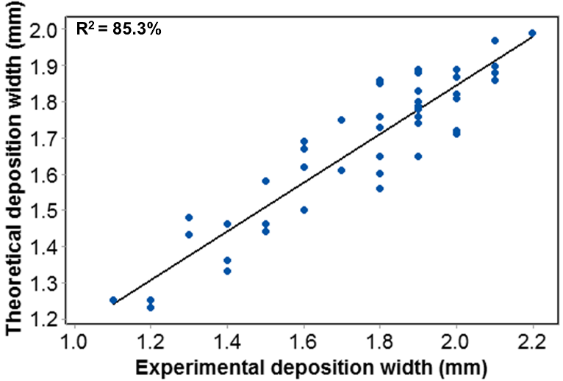
(a)
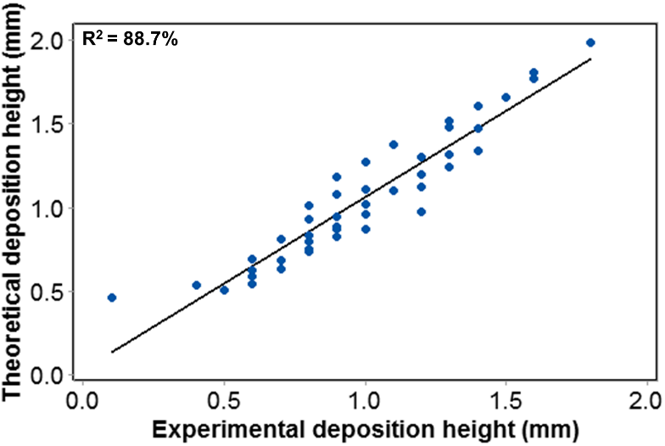
(b)
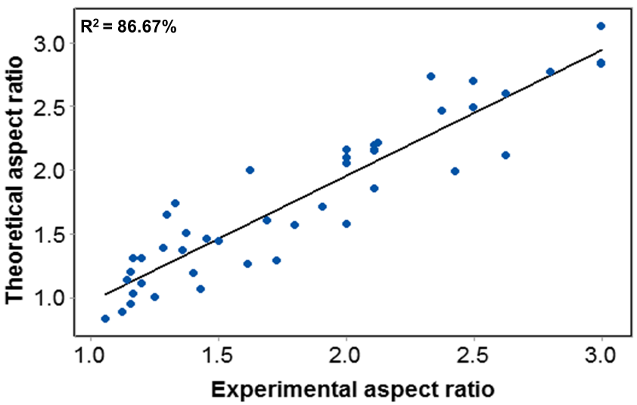
(c)
Fig. 1. Graphical relationship between the experimental values [1] and the theoretical thermal model predicted values of (a) deposition width; (b) deposition height; and (c) aspect ratio of single-layer single-track deposition of P20 steel wire on substrate of same material by µ-PTAWAM process.
2.2 Objective function using regression model
Following regression equations for deposition width ‘w’ (Eq. 4) and deposition height ‘h’ (Eq. 5) were obtained using the experimental values of deposition width and deposition height (as shown in Table 3) for single obtained for µ-PTAWAM process. Regression model was developed considering terms of micro-plasma power ‘P’, travel speed of the worktable ‘v’ and feed rate of wire deposition material ‘f_{w}’ and their interactions:
$$w=0.719+3.67×{10}^{-3}P-2.74×{10}^{-3}v-5.8×{10}^{-5}f_{w}-1.3×{10}^{-5}P v$$
$$-9×{10}^{-9}Pf_{w}+1.1×{10}^{-9}f_{w} v \left(4\right)$$
$$h=0.41-9.76×{10}^{-4} P-6.66×{10}^{-3}v+2.017×{10}^{-3}f_{w}+1.7×{10}^{-5 }P v$$
$$-2×{10}^{-6} Pf_{w}-8×{10}^{-6}f_{w}v (5)$$
Figure 2 shows graphical relationship between the experimental values obtained by Jhavar et al. [1] (given in Table 3) and regression model predicted values of deposition width (Fig. 2a), deposition height (Fig. 2b) and aspect ratio (Fig. 2c) of single-layer deposition of P20 steel wire on substrate of same material by µ-PTAWAM process. These graphs show accuracy of the regression model to predict deposition width, deposition height and aspect ratio as 98.8% (Fig. 2a), 98.88% (Fig. 2b) and 92.84% (Fig. 2c) respectively. Figure 3 depicts the 3D graphs for the experimental values of the deposition width (Fig. 3a), deposition height (Fig. 3b) and aspect ratio (Fig. 3c) of single-layer single-track deposition done for different combinations of µ-PTAWAM process parameters (i.e. P, v and f_{w}).
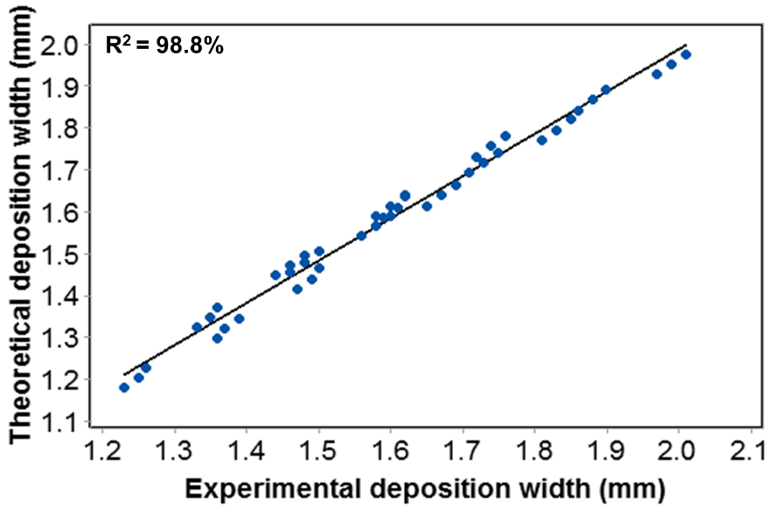
(a)
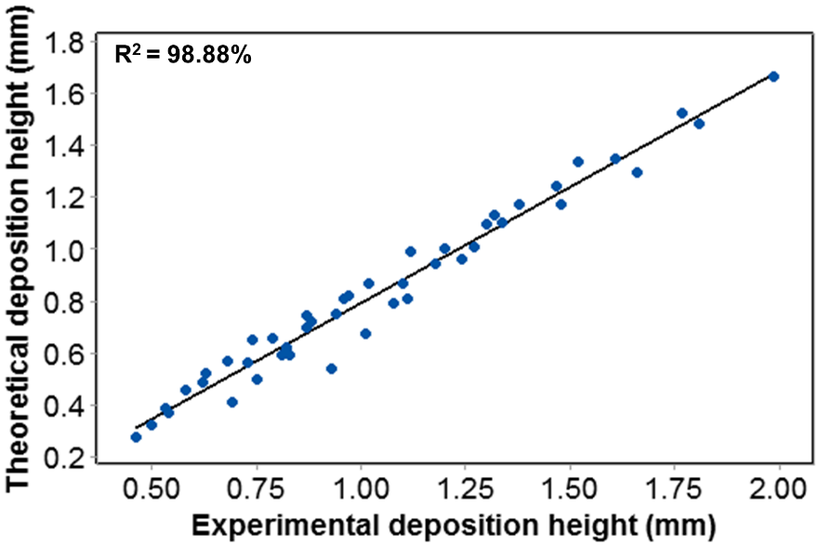
(b)
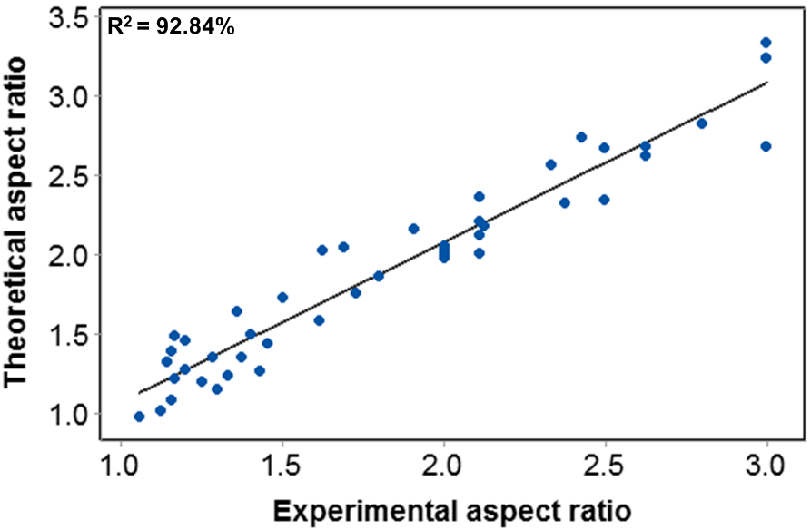
(c)
Fig. 2. Graphical relationship between the experimental values [1] and regression model predicted values of (a) deposition width; (b) deposition height; and (c) aspect ratio of single-layer single-track deposition of P20 steel wire on substrate of same material by µ-PTAWAM process.
Table 3 Experimental and different model predicted values of width and height of single-layer single-track deposition of P20 tool steel wire on same material substrate by µ-PTAWAM process.
Exp no. | Input parameters |  |  | Deposition width 'w' (mm) |  |  |  | Deposition height 'h' (mm)
 | Micro-plasma power 'P' (W) | Work-table travel rate 'v' (mm/min) | Wire feed rate 'fw' (mm/min) | Experi-mental values | Thermal model | Regression model predicted | ANN model predicted | Experi-mental values | Thermal model predicted | Regression model predicted | ANN model predicted
1 | 350 | 80 | 1700 | 1.4 | 1.33 | 1.32 | 1.54 | 1.2 | 1.3 | 1.09 | 1.49
2 | 350 | 80 | 850 | 1.4 | 1.36 | 1.37 | 1.57 | 0.7 | 0.63 | 0.52 | 0.83
3 | 450 | 100 | 1275 | 2 | 1.89 | 1.44 | 2.1 | 0.6 | 0.69 | 0.40 | 0.89
4 | 350 | 40 | 1700 | 1.9 | 1.65 | 1.61 | 1.86 | 1.8 | 1.99 | 1.66 | 2.19
5 | 400 | 40 | 1700 | 2 | 1.81 | 1.77 | 2.02 | 1.6 | 1.81 | 1.48 | 2.01
6 | 350 | 100 | 1275 | 1.1 | 1.25 | 1.20 | 1.46 | 0.8 | 0.83 | 0.59 | 1.03
7 | 450 | 100 | 850 | 1.6 | 1.5 | 1.46 | 1.71 | 1.1 | 0.46 | 0.27 | 0.66
8 | 350 | 40 | 1275 | 1.6 | 1.67 | 1.64 | 1.88 | 1.4 | 1.47 | 1.24 | 1.67
9 | 450 | 40 | 1700 | 2.1 | 1.97 | 1.93 | 2.18 | 1.5 | 1.66 | 1.30 | 1.86
10 | 450 | 50 | 850 | 2.1 | 1.9 | 1.89 | 2.11 | 0.8 | 0.73 | 0.56 | 0.92
11 | 350 | 63 | 1275 | 1.4 | 1.46 | 1.47 | 1.67 | 1.2 | 1.12 | 0.99 | 1.33
12 | 400 | 100 | 850 | 1.9 | 1.89 | 1.34 | 2.1 | 0.5 | 0.5 | 0.32 | 0.55
13 | 450 | 40 | 1275 | 2.2 | 1.99 | 1.95 | 2.2 | 1.3 | 1.24 | 0.96 | 1.44
14 | 400 | 40 | 850 | 1.8 | 1.85 | 1.82 | 2.06 | 0.9 | 0.88 | 0.72 | 1.09
15 | 400 | 50 | 850 | 1.7 | 1.75 | 1.74 | 1.96 | 0.8 | 0.79 | 0.65 | 0.98
16 | 450 | 40 | 850 | 1.9 | 1.8 | 1.98 | 2.01 | 0.9 | 0.82 | 0.62 | 1.02
17 | 400 | 63 | 850 | 1.6 | 1.62 | 1.64 | 1.83 | 0.7 | 0.68 | 0.56 | 0.88
18 | 350 | 63 | 1700 | 1.5 | 1.44 | 1.45 | 1.65 | 1.3 | 1.52 | 1.34 | 1.73
19 | 450 | 100 | 1700 | 2.1 | 1.97 | 1.41 | 2.18 | 0.8 | 0.93 | 0.54 | 1.13
20 | 400 | 100 | 1700 | 1.9 | 1.76 | 1.30 | 1.97 | 0.8 | 1.01 | 0.67 | 1.21
21 | 400 | 63 | 1700 | 1.9 | 1.78 | 1.59 | 1.99 | 1.1 | 1.38 | 1.17 | 1.59
22 | 400 | 100 | 1275 | 2 | 1.87 | 1.32 | 2.08 | 0.8 | 0.75 | 0.50 | 0.95
23 | 350 | 80 | 1275 | 1.2 | 1.25 | 1.35 | 1.46 | 1 | 0.96 | 0.80 | 1.16
24 | 450 | 50 | 1275 | 2.1 | 1.88 | 1.87 | 2.09 | 1.1 | 1.1 | 0.86 | 1.30
25 | 450 | 80 | 850 | 2 | 1.82 | 1.63 | 2.03 | 0.4 | 0.53 | 0.39 | 0.73
26 | 400 | 80 | 1700 | 1.8 | 1.86 | 1.45 | 2.07 | 0.9 | 1.18 | 0.94 | 1.37
27 | 350 | 40 | 850 | 1.6 | 1.69 | 1.66 | 1.9 | 1.2 | 0.97 | 0.82 | 1.18
28 | 400 | 80 | 850 | 1.8 | 1.65 | 1.50 | 1.86 | 0.6 | 0.58 | 0.45 | 0.78
29 | 450 | 63 | 1275 | 1.9 | 1.74 | 1.76 | 1.95 | 0.9 | 0.94 | 0.74 | 1.15
30 | 400 | 50 | 1275 | 1.8 | 1.73 | 1.72 | 1.94 | 1.2 | 1.2 | 1.00 | 1.38
31 | 350 | 100 | 1700 | 1.2 | 1.23 | 1.18 | 1.44 | 1 | 1.11 | 0.81 | 1.31
32 | 450 | 50 | 1700 | 2.1 | 1.86 | 1.84 | 2.07 | 1.3 | 1.48 | 1.17 | 1.67
33 | 400 | 50 | 1700 | 2 | 1.71 | 1.69 | 1.92 | 1.4 | 1.61 | 1.35 | 1.80
34 | 400 | 80 | 1275 | 1.9 | 1.88 | 1.48 | 2.09 | 0.9 | 0.87 | 0.70 | 1.07
35 | 450 | 80 | 1700 | 1.9 | 1.79 | 1.59 | 2 | 0.9 | 1.08 | 0.79 | 1.28
36 | 450 | 63 | 850 | 1.8 | 1.76 | 1.78 | 1.97 | 0.6 | 0.62 | 0.48 | 0.82
37 | 350 | 63 | 850 | 1.3 | 1.48 | 1.50 | 1.69 | 0.8 | 0.74 | 0.64 | 0.94
38 | 450 | 63 | 1700 | 2 | 1.72 | 1.73 | 1.93 | 1 | 1.27 | 1.01 | 1.47
39 | 400 | 40 | 1275 | 1.9 | 1.83 | 1.80 | 2.04 | 1.4 | 1.34 | 1.10 | 1.54
40 | 450 | 80 | 1275 | 1.7 | 1.61 | 1.61 | 1.82 | 0.7 | 0.81 | 0.59 | 1.01
41 | 350 | 100 | 850 | 1.5 | 1.46 | 1.23 | 1.67 | 0.6 | 0.54 | 0.37 | 0.75
42 | 350 | 50 | 1700 | 1.8 | 1.56 | 1.54 | 1.77 | 1.6 | 1.77 | 1.52 | 1.97
43 | 350 | 50 | 850 | 1.3 | 1.43 | 1.59 | 1.64 | 1 | 0.87 | 0.74 | 1.06
44 | 400 | 63 | 1275 | 1.8 | 1.6 | 1.61 | 1.81 | 1 | 1.02 | 0.87 | 1.22
45 | 350 | 50 | 1275 | 1.5 | 1.58 | 1.57 | 1.79 | 1.3 | 1.32 | 1.13 | 1.50
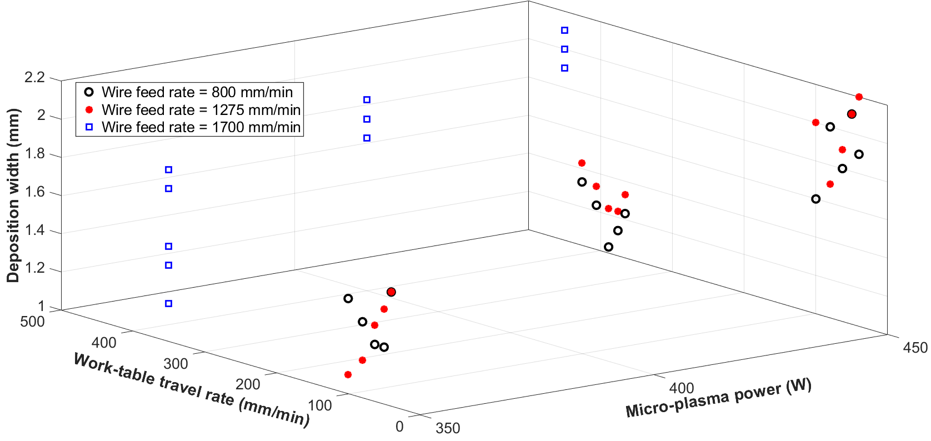
(a)
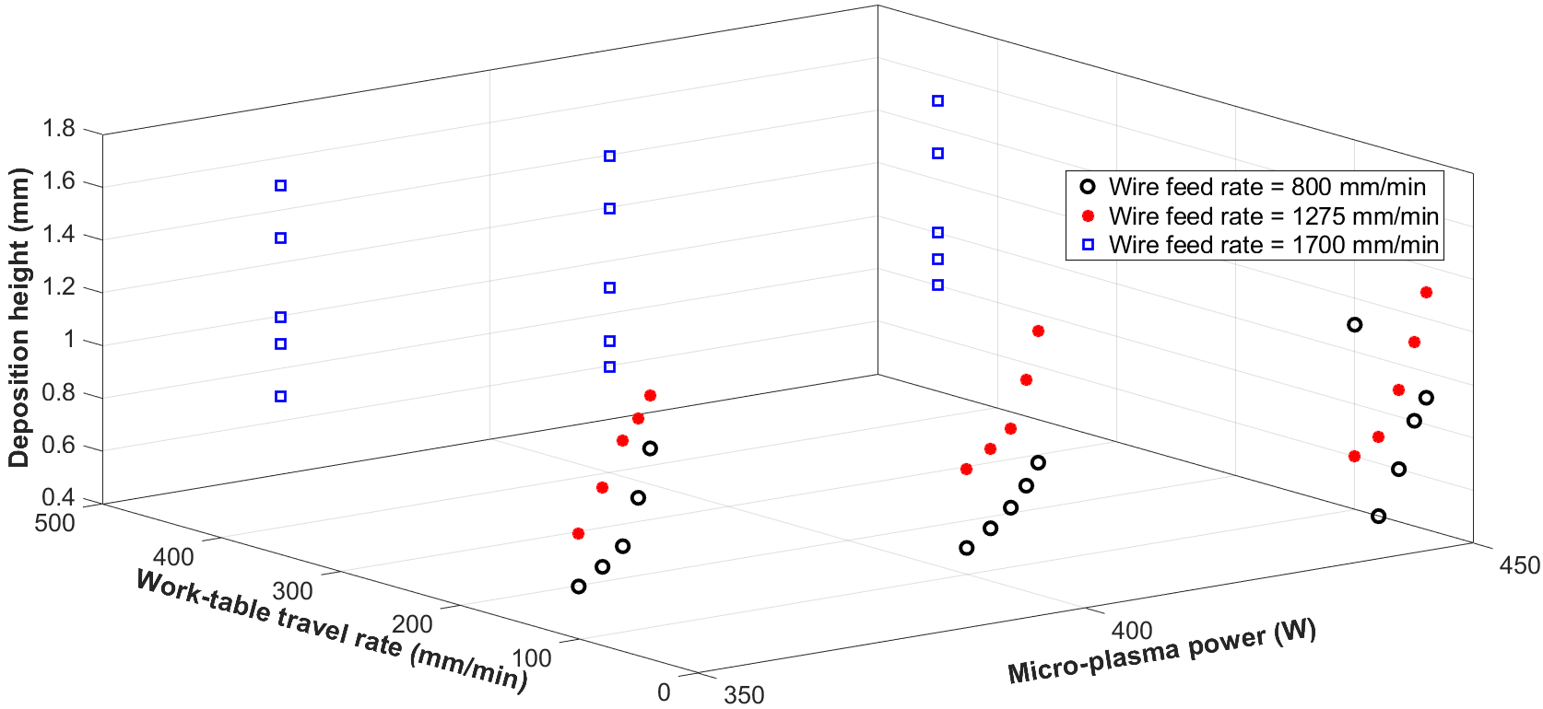
(b)
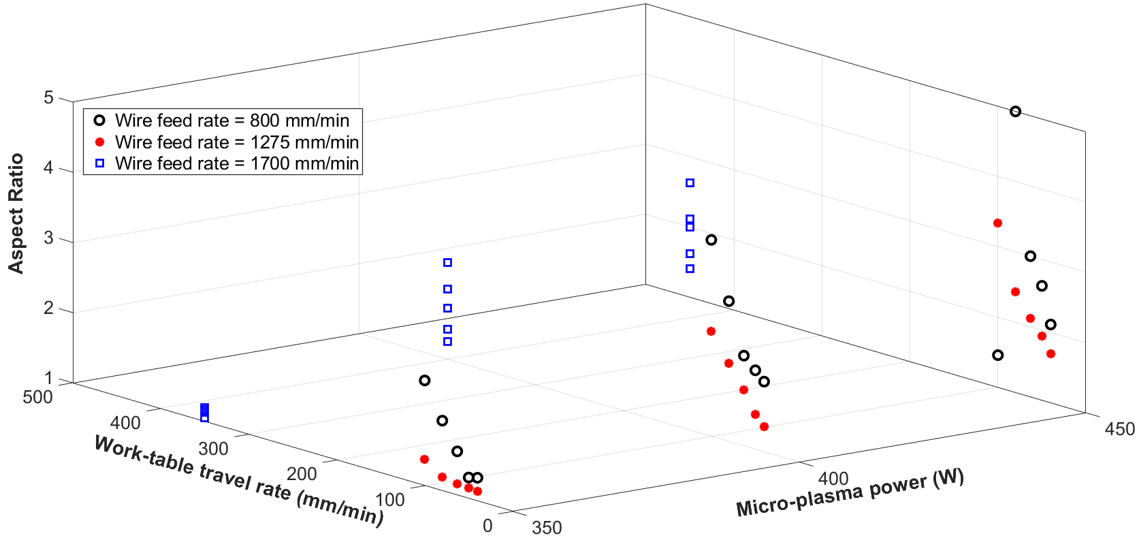
(c)
Fig. 3. 3D graphs for the experimental values of (a) deposition width, (b) deposition height and (c) aspect ratio, of single-layer single-track deposition for different combinations of µ-PTAWAM process parameters.
2.3 Objective function using ANN model
Performance of ANN depends on number of neurons in input layers, hidden layers and output layers used for feed-forward back-propagation network. The ANN model developed for µ-PTAWAM process consists of three neurons (i.e. for P, v and f_{w}) in input layers, one hidden layers and two neurons (i.e. w and h) in output layer. After various trial and error runs, the closest results for output layers were obtained with 10 neurons in hidden layer. The architecture for ANN model has been selected based on the observed linear dependency of the experimental value of the deposition width (Fig. 3a), deposition height (Fig. 3b) and aspect ratio (Fig. 3c) on parameters (i.e. P, v and f_{w}) of µ-PTAWAM process. Figure 4 depicts architecture of the developed ANN model. Logarithmic sigmoidal transfer function was used as the activation function for the hidden and output layers. Network was trained using Levenburg-Marquardt (LM) reduction scheme. Total number of data set used is 45 as mentioned in Table 3 and it was divided for training, validation and testing in the proportion of 60:20:20. Figure 5 depicts the trend of mean square error with respect to number of iterations. Performance of developed neural network have been tested for up to 500 iterations and the least value of mean square error is 4.4552e-05. Figure 6 shows graphical relationship between the experimental values (i.e. from Table 3) and ANN model predicted values of deposition width (Fig. 6a), deposition height (Fig. 6b) and aspect ratio (Fig. 6c) of single-layer single-track deposition of P20 steel wire on substrate of same material by µ-PTAWAM process. These graphs indicate accuracy of the ANN model to predict deposition width, deposition height and aspect ratio as 99.49% (Fig. 6a), 99.89% (Fig. 6b) and 98.36% (Fig. 6c) respectively.
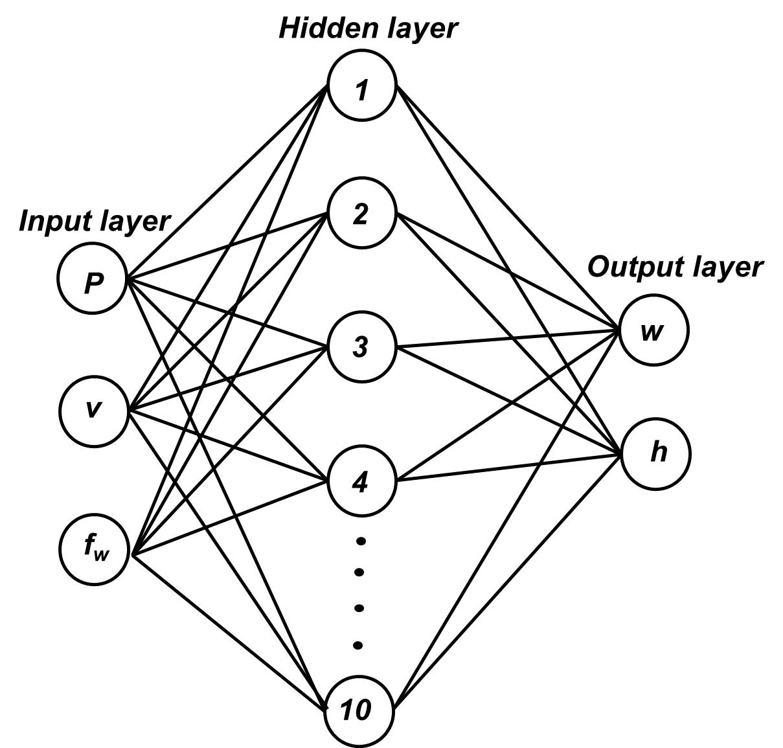
Fig. 4. Architecture of the ANN model developed for optimization of µ-PTAWAM process parameters.
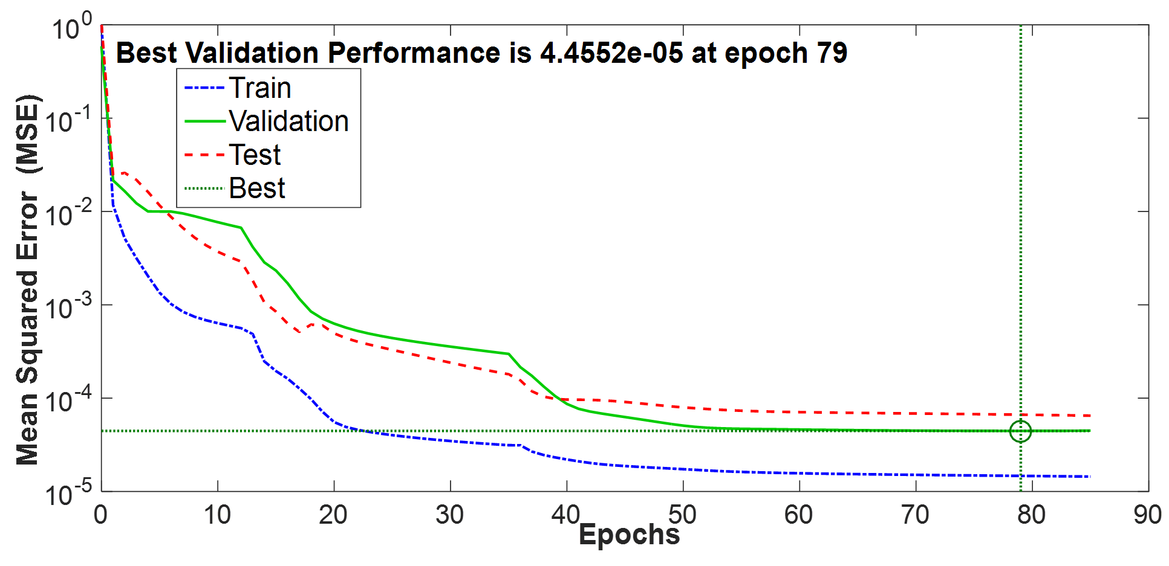
Fig. 5. Performance of the developed ANN model for optimization of µ-PTAWAM process parameters.
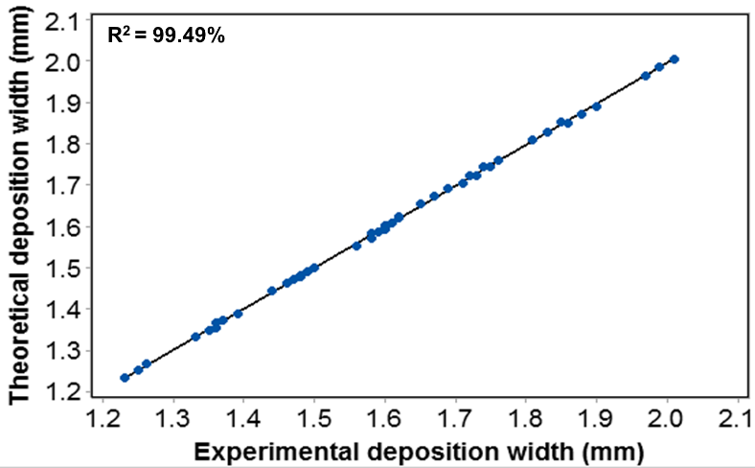
(a)
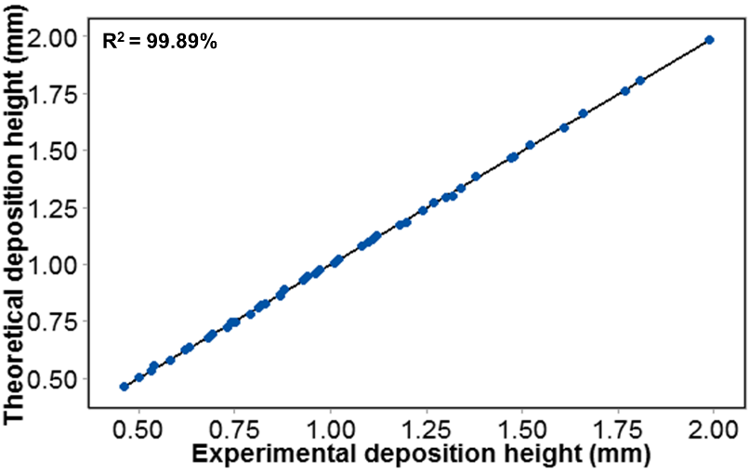
(b)
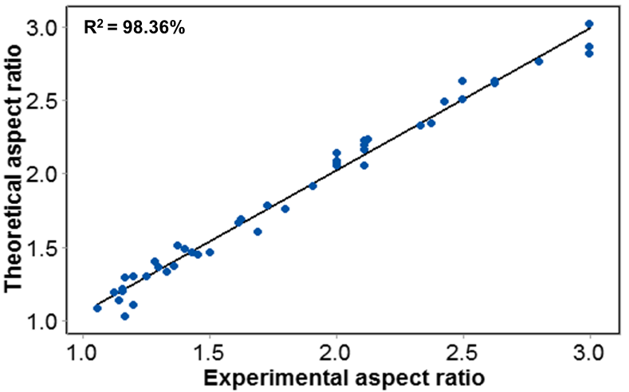
(c)
Fig. 6. Graphical relationship between the experimental values [1] and ANN model predicted values of (a) deposition width; (b) deposition height; and (c) aspect ratio of single-layer single-track deposition of P20 steel wire on substrate of same material by µ-PTAWAM process.
3. Optimization using Real Coded Genetic Algorithms
The objective functions (i.e. aspect ratio in µ-PTAWAM process) formulated using the theoretical thermal model (Eq. 1 to 3) and regression model (Eq. 4 and 5) are non-linear and too complicated to be solved using any traditional optimization method whereas objective function formulated from ANN model is implicit and this also cannot be solved by any traditional optimization method. Genetic algorithms (GA) are very effective tool optimizing such types of objective functions. They do optimization using a set of solution (known as population size) and give set of sub-optimal solution unlike any traditional optimization method which start with only one feasible solution and provide only one optimum solution and sometimes it may not even be global optimum solution. Binary coded GA discretize the search space as per string length of a parameter thereby restricting chances of attaining global optimum solution. Therefore, real coded GA (RCGA) has been used to optimize the parameters of µ-PTAWAM process by minimizing the aspect ratio formulated from theoretical thermal model (using Equations 1, 2 and 3), regression model (using Equations 4 and 5) and ANN model. Generally, GA are used to maximize the objective function [22]. Minimization problems are converted to maximization problems by appropriately modifying the relation for fitness function. In the present work, fitness function for minimizing the aspect ratio ‘F_{AR}’ was expressed by following relation:
$$F_{AR}{=\frac{1}{\left(1+\frac{w}{h}\right)}} (6)$$
Table 4 shows the upper and lower bounds of µ-PTAWAM process parameters and Table 5 presents details of the RCGA parameters used in the optimization.
Table 4 Upper and lower bounds of parameters of µ-PTAWAM process used in optimization.
Micro-plasma power ‘P’ (W) | 350 ≤ P ≤ 450
Travel speed of the worktable ‘v’ (mm/min) | 40 ≤ v ≤ 100
Feed rate of wire deposition material ‘f_{w}’ (mm/min) | 850 ≤ f_{w} ≤ 1700
Table 5 Values of parameters of real coded genetic algorithm used in optimization of µ-PTAWAM process parameters.
Number of variables | 3
Population size | 50
Population type | Double vector
Number of generations | 100
Reproduction operator | Roulette wheel
Crossover function | Single point
Crossover probability | 0.85
Mutation function | Uniform
Mutation probability | 0.05

4 Results of Optimization
Table 6 presents values of the fitness function (Eq. 6) for aspect ratio given by the thermal model, regression model and ANN model for different generations while Fig. 7 depicts them graphically.
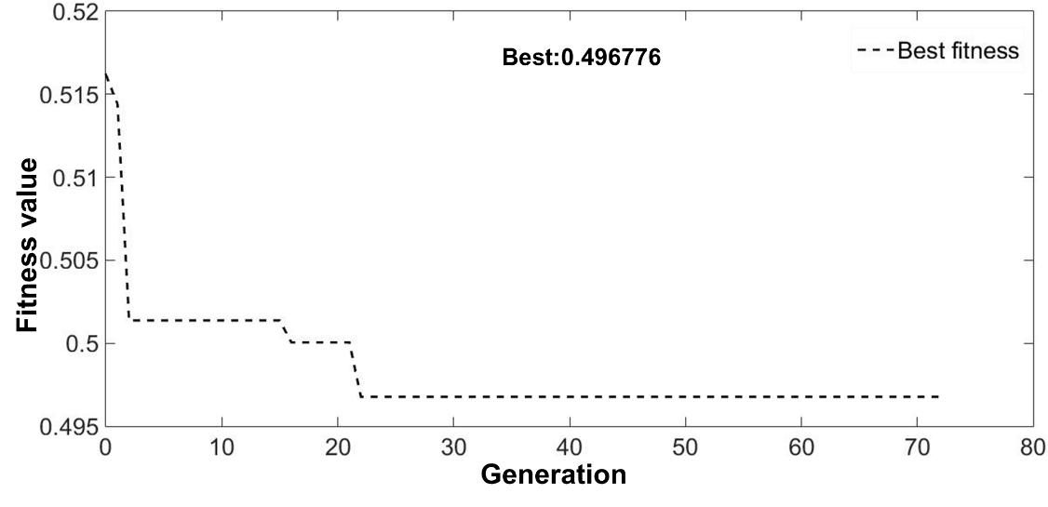
(a)
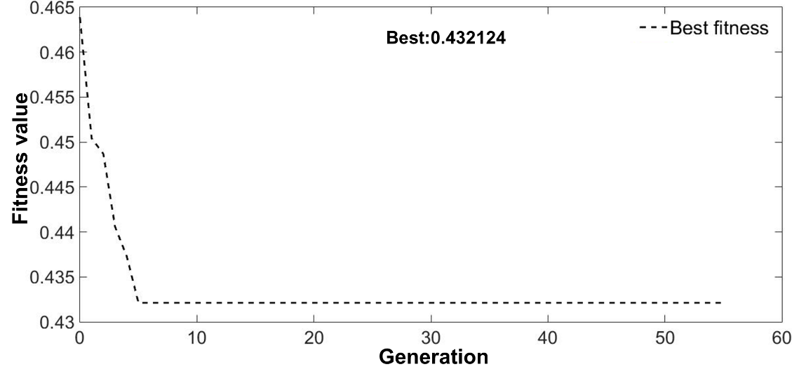
(b)
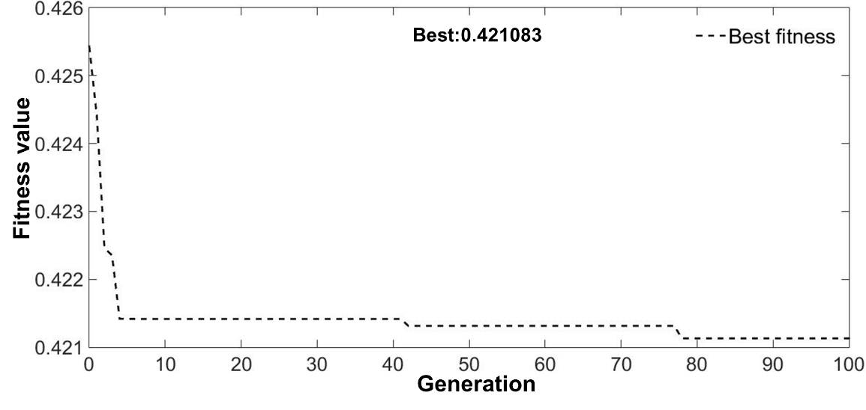
(c)
Fig. 7. Variation of the fitness function for minimizing aspect ratio formulated using the (a) thermal model; (b) regression model; and (c) ANN model.
It can be observed from Fig. 7 that the fitness of the (i) aspect ratio given by the thermal model stabilizes after attaining minimum value of 0.496776 in 22nd generation of RCGA (Table 6 and Fig. 7a) giving optimum values of micro-plasma power, travel speed of the worktable and wire feed rate as 368.91 W; 99.03 mm/min; and 1692.66 mm/min respectively, (ii) aspect ratio given by the regression model attains minimum value of 0.432124 in 5th generation and stabilizes (Table 6 and Fig. 7b) resulting in optimum values of micro-plasma power, travel speed of the worktable and wire feed rate as 354.64 W; 96.17 mm/min.; and 1698.14 mm/min. respectively, and (iii) aspect ratio given by the ANN model attains minimum value of 0.421083 in 78th generation and stabilizes subsequently (Table 6 and Fig. 7c) yielding optimum values of micro-plasma power, travel speed of the worktable and wire feed rate as 358.81 W; 95.07 mm/min; and 1699.08 mm/min, and (iv) aspect ratio given by ANN model converges to its minimum value much faster than thermal model and regression model. Comparison of the optimized values of the aspect ratio using different modeling approaches is presented in Table 7 shows that they lie in the target range of aspects and that aspect ratio given by the thermal model gives its minimum value while that ANN model gives its maximum value.
Table 6 Values of fitness function of aspect ratio given by the thermal model, regression model, and ANN model for different generations.
Generation | Micro-plasma power (W) | Travel speed of worktable (mm/min.) | Feed rate of wire deposition material (mm/min.) | Fitness values
(A) For thermal model
Starting | 387.51 | 95.82 | 1690.17 | 0.51617
1 | 386.88 | 96.95 | 1690.57 | 0.51441
2 | 385.54 | 96.88 | 1690.85 | 0.50138
3 | 385.54 | 96.88 | 1690.85 | 0.50138
4 | 385.54 | 96.88 | 1690.85 | 0.50138
13 | 385.54 | 96.88 | 1690.85 | 0.50138
14 | 385.54 | 96.88 | 1690.85 | 0.50138
15 | 385.54 | 96.88 | 1690.85 | 0.50138
16 | 381.26 | 97.78 | 1691.05 | 0.50005
20 | 381.26 | 97.78 | 1691.05 | 0.50005
21 | 381.26 | 97.78 | 1691.05 | 0.50005
22 | 368.91 | 99.03 | 1692.66 | 0.496776
30 | 368.91 | 99.03 | 1692.66 | 0.496776
55 | 368.91 | 99.03 | 1692.66 | 0.496776
73 | 368.91 | 99.03 | 1692.66 | 0.496776
(B) For regression model
Starting | 352.09 | 94.99 | 1696.57 | 0.46378
1 | 352.34 | 95.17 | 1696.95 | 0.4504
2 | 352.99 | 95.43 | 1697.09 | 0.44868
3 | 353.48 | 95.72 | 1697.83 | 0.44057
4 | 353.81 | 95.91 | 1697.53 | 0.43728
5 | 354.64 | 96.17 | 1698.14 | 0.432124
53 | 354.64 | 96.17 | 1698.14 | 0.432124
54 | 354.64 | 96.17 | 1698.14 | 0.432124
55 | 354.64 | 96.17 | 1698.14 | 0.432124
(C) For ANN model
Starting | 357.53 | 93.75 | 1697.91 | 0.42543
1 | 357.71 | 93.98 | 1698.07 | 0.4244
2 | 357.96 | 94.15 | 1698.35 | 0.42246
3 | 358.04 | 94.35 | 1698.55 | 0.42235
4 | 358.24 | 94.53 | 1698.76 | 0.42142
5 | 358.24 | 94.53 | 1698.76 | 0.42142
48 | 358.63 | 94.89 | 1698.97 | 0.42132
50 | 358.63 | 94.89 | 1698.97 | 0.42132
77 | 358.63 | 94.89 | 1698.97 | 0.42132
78 | 358.81 | 95.07 | 1699.08 | 0.421083
79 | 358.81 | 95.07 | 1699.08 | 0.421083
98 | 358.81 | 95.07 | 1699.08 | 0.421083
100 | 358.81 | 95.07 | 1699.08 | 0.421083

Table 7 Comparison between optimized parameters of µ-PTAWAM process obtained from different models used to formulate objective function for aspect ratio
Type of model used to formulate aspect ratio | Micro-plasma power (W) | Travel speed of worktable (mm/min.) | Wire feed rate (mm/min.) | Best value of the fitness function | Optimized aspect ratio | Targeted range of aspect ratio
Thermal model | 368.91 | 99.03 | 1692.66 | 0.496776 | 1.013 | 1 to 4
Regression model | 354.64 | 96.17 | 1698.14 | 0.432124 | 1.314
ANN model | 358.81 | 95.07 | 1699.08 | 0.421083 | 1.375
5. Experimental Validation of the Optimization Results
The optimization results were validated experimentally by depositing 0.3 mm diameter wire of P20 tool steel on 5 mm thick substrate of the same material using the standard values of µ-PTAWAM process parameters available on its experimental apparatus (shown in Fig. 8) which are nearest to their optimized values. These standard values were: micro-plasma power as 370 W; 355 W; and 360 W for the aspect ratio given by the thermal model, regression model, and ANN model respectively. Travel speed of the worktable and wire feed rate as 100 and 1700 mm/min, respectively for the aspective ratio given by all three models. Figure 9 depicts geometry of single-layer single-track deposition done by using µ-PTAWAM process parameters optimized by the thermal model (Fig. 9a), regression model (Fig. 9b) and ANN model (Fig. 9c). These depositions have good accuracy, smaller dilution of substrate material, HAZ, free from internal defects such as cracks and porosity, and forms good metallurgical bond with the substrate. Figure 10 presents SEM microstructure of single-layer single-track deposition of P20 on substrate of the same material using µ-PTAWAM process. It reveals development of lath martensite microstructure along with primary carbides. It is also evident that no significant directional solidification was observed in P20 deposition. The lath martensite provides a better combination of strength and toughness in P20 deposition.

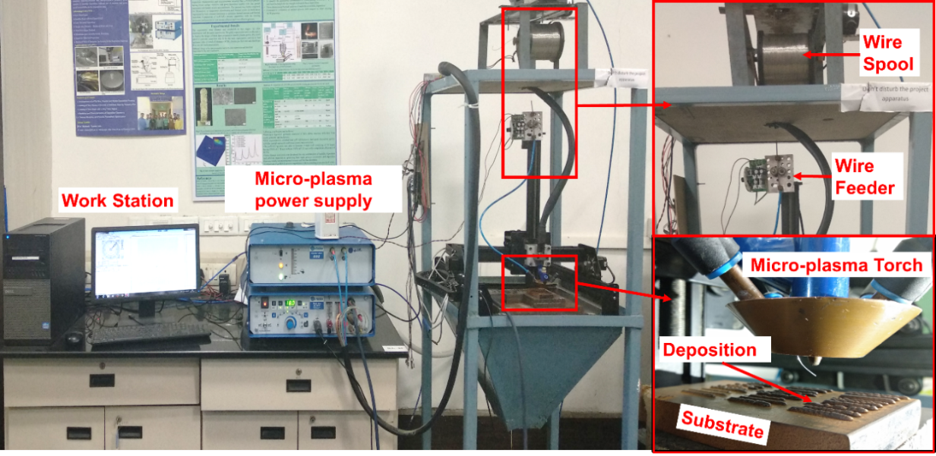
Fig. 8. Apparatus of µ-PTAWAM process used in experimental validation of the optimization results.
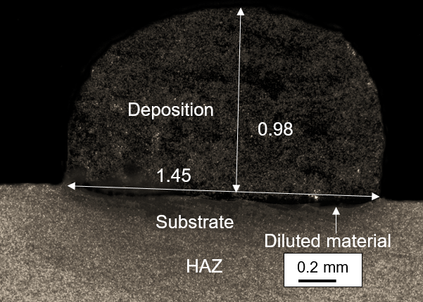
(a)
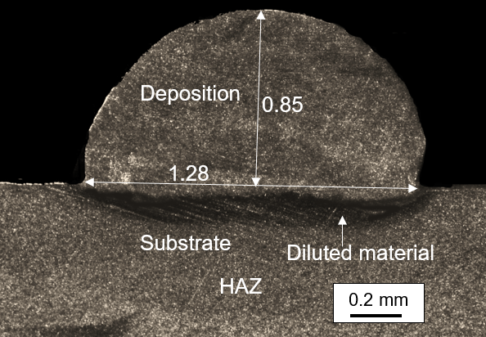
(b)
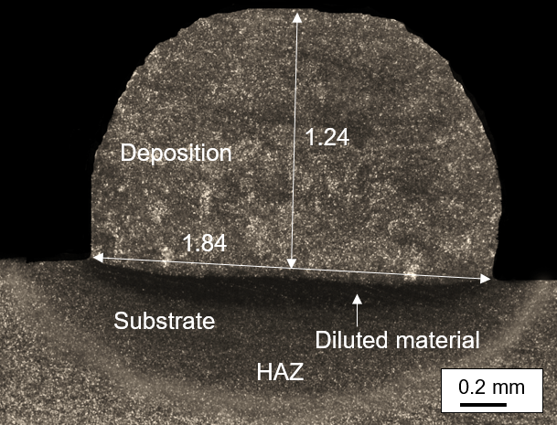
(c)
Fig. 9. Photographs of single-layer single-track depositions obtained using optimized parameters of µ-PTAWAM process by (a) thermal model; (b) regression model; and (c) ANN model.
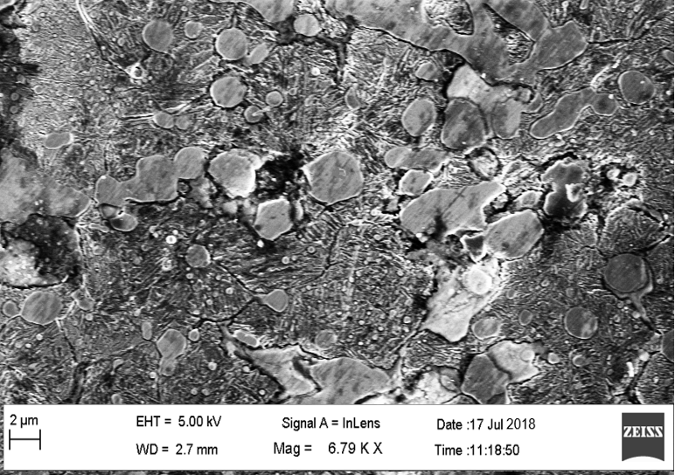
Fig. 10. SEM microstructure of single-layer single-track deposition of P20 on substrate of the material by µ-PTAWAM process.
Table 8 presents energy dispersive X-ray spectroscopy (EDX) analysis of P20 deposition and substrate materials. It shows minor difference in chemical composition of the deposition and substrate materials because the P20 deposition was done by µ-PTAWAM process and P20 substrate made by casting process.
Table 8 Chemical composition (wt. %) of P20 deposition and substrate material.
Elements | C | Cr | Mn | Mo | Si | Cu | Fe
P20 substrate | 0.35 | 1.90 | 1.10 | 0.21 | 0.30 | - | Bal.
P20 Deposition | 0.21 | 1.90 | 0.97 | 0.40 | 0.54 | 0.03 | Bal.
Table 9 shows the combination of deposition process parameters obtained by using different modeling approaches. It reveals that the (i) optimized values for deposition width and deposition height by different modeling approaches are in good agreement with their experimental values and the error between them is 11.5% and 13.3% for thermal model, 5.78% and 7.61% for regression model, and 1.63% and 10.14% for ANN model, respectively, (ii) the thermal model gives minimum value (i.e. 1.15) and the ANN model gives maximum value (i.e. 1.36) of the optimized aspect ratio. This can be explained by the fact that the themal model is genric nature in terms of the µ-PTA process parameters and thermal properties of deposition and substrate materials whereas, other models are completely specific to the experimental values of deposition width and deposition height obtained for different combinations of µ-PTAWAM process parameters, (iii) experimal value of aspect ratio are same for the thermal and ANN models (i.e. 1.48) and very near to that of regression model (i.e. 1.5), and (iv) ANN model gives minimum error between the optimized and experimental values of aspect ratio. It was observed that, the regression model gave maximum value of experimental aspect ratio (i.e. 1.50) as compared to thermal and ANN model (i.e. 1.48). This is due to the fact that the regression model gave optimized value of micro-plasma power as 355 W which is lower than that given by ANN and thermal models i.e. 360 and 370 W respectively. Therefore, low energy available to melt the deposition material has significantly reduced the experimental deposition height and consequently increased the aspect ratio given by the regression model.
Table 9 Comparison between the optimized values of deposition width and height and aspect ratio with their experimental values for different modeling approaches.
Type of model used to formulate aspect ratio | Values of process parameters used in validation of the optimization results |  |  | Deposition width (mm) |  | Deposition height (mm) |  | Aspect ratio
 |  |  |  | Opti-mized | Experi-mental | Opti-mized | Exper-imental | Opti-mized | Experi-mental
 | Micro-plasma power  (W) | Travel speed of worktable (mm/min.) | Wire feed rate (mm/min.)
Thermal model | 370 | 100 | 1700 | 1.3 | 1.45 | 1.13 | 0.98 | 1.15 | 1.48
Regression model | 355 | 100 | 1700 | 1.21 | 1.28 | 0.92 | 0.85 | 1.31 | 1.50
ANN model | 360 | 100 | 1700 | 1.87 | 1.84 | 1.38 | 1.24 | 1.36 | 1.48

4. Conclusions
Present work optimized power of micro-plasma, wire feed rate, and travel speed of the worktable of µ-PTAWAM process by real coded genetic algorithm using minimization of aspect ratio as the objective function so as to improve the quality of deposition. Theoretical thermal model and two empirical models namely regression model and ANN model were used to compute deposition width and deposition height which are required to compute aspect ratio. The optimized results were validated experimentally by single-layer single-track deposition of P20 steel on the substrate of the same material. Following conclusion can be drawn from this work:
- Theoretical thermal model of generic nature i.e. independent of type and form of deposition and substrate materials. Therefore, it has wide applicability and can be used for any combination of substrate and deposition materials and for any form (wire, powder, particulate, flakes, or both wire and powder) of the deposition material. This model has ability to optimize parameters of μ-PTAAM process with good accuracy as compared to the regression and ANN models.
- Thermal model gave minimum value of aspect ratio (i.e. 1.013) while ANN give maximum value of aspect ratio (i.e. 1.375) for the optimized values of micro-plasma power as 368.91 and 358.81 W respectively, travel speed of worktable as 99.03 and 95.07 mm/min respectively, and wire feed rate as 1692.66 and 1699.08 mm/min respectively.
- Experimental validation of the optimization results using the nearest values of the optimized parameters available on the apparat us of μ-PTAAM process gave optimized values of aspect ratio 1.15; 1.31; and 1.36 by the theoretical thermal model, regression model, and ANN model respectively with the corresponding experimental values being 1.48; 1.5; and 1.48 respectively.
- Optimized values for deposition width and deposition height by different modeling approaches are in good agreement with their experimental values and the error between them is 11.5% and 13.3% for thermal model, 5.78% and 7.61% for regression model, and 1.63% and 10.14% for ANN model respectively.
- Optical examinations of the depositions done using the optimized process parameters exhibited good quality and accuracy of deposition with excellent bonding with the substrate material and no internal defects.
- All the modeling approaches used for optimization has ability to give optimum combination of process parameters and to achieve the desired optimized deposition geometry characteristics.
References
- Jhavar S, Jain NK, Paul CP (2014) Development of micro-plasma transferred arc (μ-PTA) wire deposition process for additive layer manufacturing applications. J. Mater. Process. Technol. 214(5): 1102–1110. DOI: 10.1016/j.jmatprotec.2013.12.016
- Sawant MS, Jain NK (2018) Investigations on Additive Manufacturing of Ti-6Al-4V by µ-Plasma Transferred Arc Powder Deposition Process. Trans. ASME: J. of Manuf. Sci. Engg. 140(8): 081014-1-081014-11, DOI: 10.1115/1.4040324
- Nikam SH, Jain NK (2019) Modeling and Prediction of Residual Stresses in Additive Layer Manufacturing by Microplasma Transferred Arc Process Using Finite Element Simulation. Trans. ASME: J. of Manuf. Sci. Engg. 141(6): 061003-1-061003-14, DOI: 10.1115/1.4043264
- Nikam SH, Jain NK (2018) 3D-finite element simulation and image processing based prediction of width and height of single-layer deposition by micro-plasma-transferred arc process. Int. J. Adv. Manuf. Tech. 95(9–12): 3679–3691, DOI: 10.1007/s00170-017-1472-x
- Lestan Z, Klancnik S, Balic J, Brezocnik M (2015) Modeling and design of experiments of laser cladding process by genetic programming and nondominated sorting. Mater. Manuf. Processes 30(4):458–463. DOI:10.1080/10426914.2014.973586
- Yanxi Z, Xiangdong G, Seiji K (2015) Weld appearance prediction with BP neural network improved by genetic algorithm during disk laser welding. J. Manuf. Systems 34(C):53–59. DOI:10.1016/j.jmsy.2014.10.005
- Verma A, Rai R (2016) Sustainability-induced dual-level optimization of additive manufacturing process. Int. J. Adv. Manuf. Technol. 88(5–8):1945–1959. DOI: 10.1007/s00170-016-8905-9
- Dey V, Pratihar DK, Datta GL, Jha MN, Saha TK, Bapat AV (2010) Optimization and prediction of weldment profile in bead-on-plate welding of Al-1100 plates using electron beam. Int. J. Adv. Manuf. Tech., 48(5–8):513–528. DOI:10.1007/s00170-009-2307-1
- Siva K, Murugan N, Logesh R (2009) Optimization of weld bead geometry in plasma transferred arc hardfaced austenitic stainless steel plates using genetic algorithm. Int. J. Adv. Manuf. Tech. 41:24–30. DOI: 10.1007/s00170-008-1451-3
- Kim D, Rhee S (2001) Optimization of arc welding process using a genetic algorithm. Weld. J. Res. Suppl. 184–189.
- Xiong J, Zhang G, Hu J, Wu L (2014) Bead geometry prediction for robotic GMAW-based rapid manufacturing through a neural network and a second-order regression analysis. J. Intell. Manuf. 25(1):157–163. DOI:10.1007/s10845-012-0682-1
- Senthilkumar B, Kannan T, Madesh R (2015) Optimization of flux-cored arc welding process parameters by using genetic algorithm. Int. J. Adv. Manuf. Tech. 93(1–4):35–41. DOI:10.1007/s00170-015-7636-7
- Lin HL (2012) The use of the Taguchi method with grey relational analysis and a neural network to optimize a novel GMA welding process. J. Intell. Manuf. 23(5):1671–1680. DOI:10.1007/s10845-010-0468-2
- Datta S, Bandyopadhyay A, Pal PK (2008) Grey-based taguchi method for optimization of bead geometry in submerged arc bead-on-plate welding. Int. J. Adv. Manuf. Tech. 39: 1136–1143. DOI: 10.1007/s00170-007-1283-6
- Nagaraju S, Vasantharaja P, Chandrasekhar N, Vasudevan M, Jayakumar T (2016) Optimization of welding process parameters for 9Cr-1Mo steel using RSM and GA. Mater. Manuf. Processes 31(3):319–327. DOI:10.1080/10426914.2015.1025974
- Da Silva MM, Batista VR, Maciel TM, Dos Santos MA, Brasileiro TL (2018) Optimization of submerged arc welding process parameters for overlay welding. Welding International 32(2):122¬–129. DOI:10.1080/09507116.2017.1347325
- Vimal KEK, Vinodh S, Raja, A (2017) Optimization of process parameters of SMAW process using NN-FGRA from the sustainability view point. J. Intell. Manuf. 28(6):1459–1480. DOI:10.1007/s10845-015-1061-5
- Chaki S, Shanmugarajan B, Ghosal S, Padmanabham G (2015) Application of integrated soft computing techniques for optimisation of hybrid CO2 laser-MIG welding process. Appl Soft Comput. 30:365–374. DOI:10.1016/j.asoc.2015.01.045
- Orishich AM, Malikov AG, Shelyagin VD, Khaskin VY, Chayka AA (2016) Optimisation of the processes of laser, microplasma and hybrid laser–microplasma welding of aluminium alloys. Welding International 30(12): 957–961. DOI:10.1080/09507116.2016.1157338.
- Jhavar S, Paul CP, Jain, NK (2016) Micro-plasma transferred arc additive manufacturing for die and mold surface remanufacturing, JOM: J. Mine. Meta. Mater. Soc. 68(7): 1801-1809. DOI: 10.1007/s11837-016-1932-z
- Nikam SH, Jain NK Jhavar S (2016) Thermal modeling of geometry of single-track deposition in micro-plasma transferred arc deposition process. J. Mater. Process. Technol. 230:121–130. DOI: 10.1016/j.jmatprotec.2015.11.022
- Kim D, Rhee S, Park H (2002) Modelling and optimization of a GMA welding process by genetic algorithm and response surface methodology. Int. J. Prod. Res. 40(7):1699–1711. DOI:10.1080/00207540110119964

List of Captions for Figures
Fig. 1. Graphical relationship between the experimental values [1] and the theoretical thermal model predicted values of (a) deposition width; (b) deposition height; and (c) aspect ratio of single-layer single-track deposition of P20 steel wire on substrate of same material by µ-PTAWAM process.
Fig. 2. Graphical relationship between the experimental values [1] and regression model predicted values of (a) deposition width; (b) deposition height; and (c) aspect ratio of single-layer single-track deposition of P20 steel wire on substrate of same material by µ-PTAWAM process.
Fig. 3. 3D graphs for the experimental values of (a) deposition width, (b) deposition height and (c) aspect ratio of single-layer single-track deposition done for different combinations of µ-PTAWAM process parameters.
Fig. 4. Architecture of the ANN model developed for optimization of µ-PTAWAM process parameters.
Fig. 5. Performance of the developed ANN model for optimization of µ-PTAWAM process parameters.
Fig. 6. Graphical relationship between the experimental values [1] and ANN model predicted values of (a) deposition width; (b) deposition height; and (c) aspect ratio of single-layer single-track deposition of P20 steel wire on substrate of same material by µ-PTAWAM process.
Fig. 7. Variation of the fitness function for minimizing aspect ratio formulated using the (a) thermal model; (b) regression model; and (c) ANN model.
Fig. 8. Apparatus of µ-PTAWAM process used in experimental validation of the optimization results.
Fig. 9. Photographs of single-layer single-track depositions obtained using optimized parameters of µ-PTAWAM process by (a) thermal model; (b) regression model; and (c) ANN model.
Fig. 10. SEM microstructure of single-layer single-track deposition of P20 on substrate of the material by µ-PTAWAM process.

List of Captions for Tables
Table 1 Values of µ-PTAWAM process parameters used in formulation of the objective function on the basis of thermal model.
Table 2 Properties of the substrate and deposition materials used in formulation of the objective function on the basis of thermal model.
Table 3 Experimental and different model predicted values of width and height of single-layer single-track deposition of P20 tool steel wire on same material substrate by µ-PTAWAM process.
Table 4 Upper and lower bounds of parameters of µ-PTAWAM process used in optimization.
Table 5 Values of parameters of real coded genetic algorithm used in optimization of µ-PTAWAM process parameters.
Table 6 Values of fitness function for aspect ratio given by the thermal model, regression model, and ANN model for different generations.
Table 7 Comparison between optimized parameters of µ-PTAWAM process obtained from different models used to formulate objective function for aspect ratio.
Table 8 Chemical composition (wt. %) of P20 deposition and substrate material.
Table 9 Comparison between the optimized values of deposition width and height and aspect ratio with their experimental values for different modeling approaches.

