Mapping Fuel Poverty Across Northern Ireland – Dr Paul McKenzie
A household in fuel poverty is typically defined as one that spends 10% of household income on energy services, particularly warmth (Boardman, 1991). Fuel poverty is influenced by three main factors. Firstly, household income has a particularly significant impact on fuel poverty and low-income households are at significant risk of experiencing fuel poverty. Secondly, the energy efficiency of the home contributes to the extent of fuel poverty in a home. Buildings with poor loft insulation, inefficient boilers and single glazing are hard to heat and require a significant amount of money to attain a comfortable temperature. While inefficient buildings typically are at risk of fuel poverty, they also contribute to carbon emissions (Jenkins, 2010). The third contributor to fuel poverty is the cost of domestic energy services. Northern Ireland has been traditionally restricted to home heating oil (HHO) and has had limited access to natural gas. In 2008, 80% of homes in Northern Ireland used oil-fire central heating compared to 8% in Scotland. These causes of fuel poverty have led to Northern Ireland experiencing some of the highest rates of fuel poverty within the UK (Table 1). Healy and Clinch (2002) noted that in Northern Europe, the UK and Ireland had high incidences of fuel poverty.

Table 1: Percentage of fuel poverty per UK Country (Source: Regional House Condition Surveys).
Year | NI | Scotland | England
2004 | 23 | 19 | 6
2006 | 34 | 25 | 12
2009 | 44 | 34 | 18
2012 | 42 | 35 | 11

Fuel poverty and health
The World Health Organisation (WHO, 2007) recommended that living spaces in homes should be heated to a minimum of 21 °C while other spaces should be 18 °C. When home owners live in inefficient dwellings and lack the necessary income to heat the home to sufficient levels, a number of health issues may arise. Excess Winter Mortality rates are high in countries with inefficient buildings that are difficult to heat during winter months (Healy, 2003). Living in cold properties has been linked to strokes, heart attacks and an increased risk of infections (Crawford et al., 2003; Howieson and Hogan, 2005) along with respiratory illness and arthritis (WHO, 2007). Homes experiencing fuel poverty are often damp which can have significant impacts not only on physical health but also mental health (Shortt and Rugkåsa, 2007). Khanom (2000) identified a relationship between cold, damp homes and self-reported mental health problems such as depression and anxiety. The effect of living in cold, damp conditions appears to disproportionately affect younger people within the home (Liddell and Morris, 2010). While youth are affected by fuel poverty, elderly people, particularly those in rural locations, are also at risk (Lawlor et al., 2002). It has been suggested that fuel poverty causes abnormal behavioural patterns within homes with families living in one or two heated rooms, a concept known as “spatial shrinkage” (Lawlor et al., 2002; Farrell et al., 2008).

Targeting those most in need
With fuel poverty such a critical issue across the UK and Ireland, there is an urgent need to target interventions to those in greatest need. In the 2011 fuel poverty strategy for Northern Ireland, the Department for Social Development Northern Ireland (DSDNI) aimed to target resources to the most vulnerable households. The Warm Homes scheme was the main home energy scheme in Northern Ireland and provided energy efficiency measures at low or no cost. The scheme also performed benefit entitlement checks and gave energy saving advice to recipient households (Department for Social Development Northern Ireland, 2011). While the scheme was very effective, it did target homes that were not in fuel poverty (Sefton, 2002) and the scheme relied on self-referral which often meant eligible households were not targeted (Armstrong, Winder, Wallis, 2006). Other targeted approaches rely on the data from the National House Condition Surveys (HCS) which relies on a small sample size. There has been a move toward area-based targeting schemes that use large datasets such as the UK Census. By determining variables that infer risk of fuel poverty it is possible to identify and target resources to those in greatest need. For instance, Baker et al (2003) created a fuel poverty indicator for England using socio-economic variables from the UK Census to predict the number of fuel poor households at ward level (approx. 2,500 households). A similar approach was adopted by Morrison and Shortt (2008) in Scotland using additional fine scale household data to refine targeting to Output Area level (approx. 60 households in Scotland). The potential to integrate a range of pertinent datasets in a coherent framework is facilitated by the use of Geographic Information Systems (GIS). GIS is computer-based software designed to collect, store, analyse, visualise and share spatial data. GIS enables a range of data to be integrated and combined into a coherent spatial framework. The ability of GIS to integrate spatial data into one location means it is well placed to integrate socio-economic variables that are potential indicators of fuel poverty (Liddell, Morris, McKenzie, Rae, 2011). To date, area-based targeting using GIS has been highly effective in identifying those in greatest need of assistance. By using an area-based targeting system, policy makers are able to efficiently identify those households in greatest need in order to target funding.

Developing a fuel-poverty risk map for Northern Ireland
The area-based targeting approach for Northern Ireland was focussed on Census Output Areas (COAs) in 2011 with an average of 125 households for each COA. Two groups of data were integrated for each COA in Northern Ireland (N=5,022) relating to housing and poverty (Walker, Liddell, McKenzie, Morris, 2013).

The housing element accounted for a range of household characteristics that were related to fuel poverty. Data from Land and Property Services (LPS, Northern Ireland Mapping Agreement, MOU 203) were used to measure the size, value, type and age of each domestic property. Small, terraced homes that were built more recently were considered to have less energy costs than large, detached homes. In addition to measures on the property, a ‘heating burden’ metric was calculated based on two locational factors. Each household was assigned a value based on its elevation above sea-level and the mean winter temperature for that location. A second measure of heating burden was calculated by determining the cost of 300 litres of home heating oil (HHO) from 131 suppliers. These measures were combined to identify homes that may experience cold winter temperatures and high winter HHO costs (Figure 1). The housing element also took account of the presence of gas in each COA.

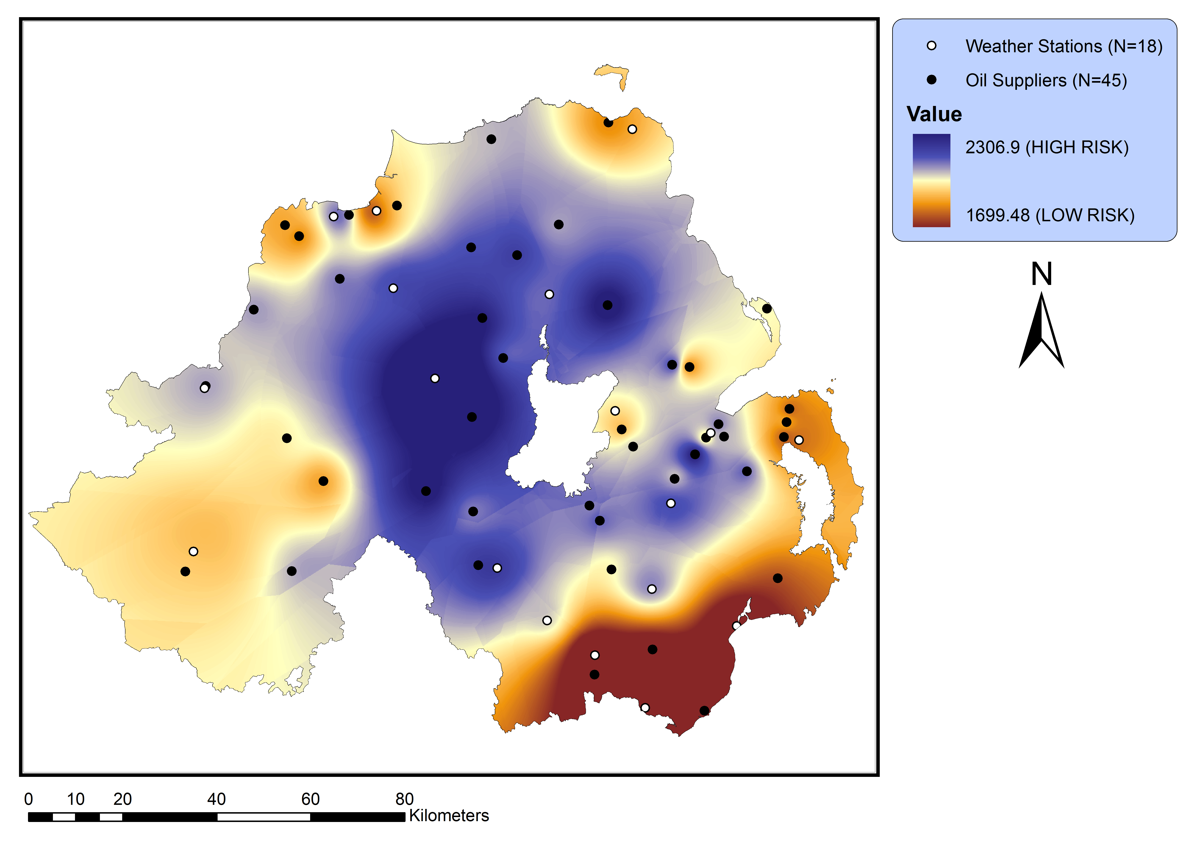
Figure 1: Combined fuel price and temperature metric (Adapted from: Walker, McKenzie, Liddell, Morris, 2012).
Social vulnerability, or the poverty measure, was calculated based on socio-economic datasets. A range of data, such as Housing Benefit or Jobseeker’s Allowance, were obtained from the Northern Ireland Neighbourhood Information Service (NINIS: www.ninis.nisra.gov.uk) and mapped for each COA. Income was determined using the Anderson (2008) poverty measure which identified the proportion of households with an income below 60% of UK median household income. The Anderson measure was adapted by incorporating additional income data from the Northern Ireland Multiple Deprivation Measure. Benefit data were critical for eligibility for assistance under the Warm Homes scheme and therefore data on Pension Credit, Disability Living Allowance and Child Benefit were mapped at COA level. Social vulnerability and housing were weighted at 50% each (Figure 2).

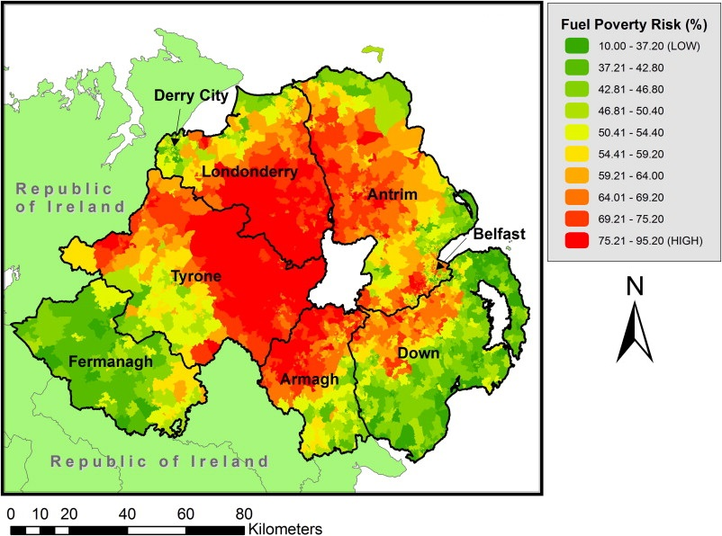

Figure 2: Fuel poverty risk in Northern Ireland, presented in deciles from low (green) to high (red) risk (Adapted from: Walker, McKenzie, Liddell, Morris, 2012).

GIS was not only used to integrate and weight variables but also to identify clusters of fuel poverty risk using Local Moran's I. High-risk clusters were identified when neighbouring COAs exhibited high fuel poverty risk and these clusters of high risk were considered to be fuel poverty ‘hotspots’ (Figure 3). The statistic was also used to identify pockets of risk where a group of high risk COAs are surrounded by low risk COAs. Groups of COAs with low risk can be indicative of ‘coldspots’.

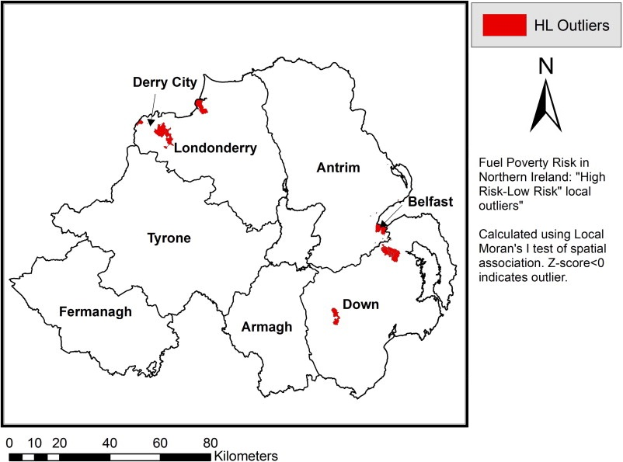

Figure 3: High-risk clusters based on fuel poverty risk using Local Moran's I (Adapted from: Walker, McKenzie, Liddell, Morris, 2012).

The integration of socio-economic, housing and environmental variables at small area scale is an efficient method by which to target areas of greatest need. Through funding from the Office of the First Minister and Deputy First Minister (OFMDFM) and the Department for Social Development (DSDNI), Ulster University partnered with 19 Councils to test the effectiveness of the area-based approach. A total of 2,145 households were surveyed by Council teams to determine actual levels of fuel poverty and eligibility for the Warm Homes scheme. Results from the work suggest that almost 90% of households in target areas were indeed fuel poor, the majority of them in severe fuel poverty. While the model is effective in identifying areas of greatest need, there is variation in need, even along residential streets (Walker, McKenzie, Liddell, Morris, 2014). The use of area-based targeting is an effective first filter by which policy makers can identify those at greatest need of assistance. With fine scale areas detected, it is highly effective to follow up with household questionnaires in order to gain a greater insight into the specific circumstances of the household so that tailored interventions can be provided.

Conclusion
The work presented above has been updated for 2017 based on Census Small Areas (N=4,537). The work continues to the form the basis of identifying those in greatest need of assistance throughout Northern Ireland. Through liaison with Council teams, eligibility for the Affordable Warmth Scheme (AWS) is determined with eligible households receiving assistance. The increase of spatial data has enabled the algorithm to be developed further by using energy efficiency (SAP) data, health data and new fuel data in a GIS to refine the targeting approach. The algorithm is constantly evolving based on the provision of new data that can be used to efficiently target resources to those in greatest need.
References
- Anderson, B, 2008. Creating Small Area Income Deprivation Estimates for Northern Ireland: Spatial Microsimulation Modelling University of Essex, Colchester (2008) (Final report to the Northern Ireland Statistics and Research Agency (NISRA)
- Armstrong, D, Winder, R, Wallis, R, 2006. Impediments to policy implementation: The offer of free installation of central heating to an elderly community has limited uptake, Public Health, 120(2), pp. 161-166.
- Baker, W, Sterling, G, Gordon, D, 2003. Predicting Fuel Poverty at the Local Level: Final Report on the Development of the Fuel Poverty Indicator, Centre for Sustainable Energy, Bristol
- Boardman, B, 1991. Fuel Poverty: From Cold Homes to Affordable Warmth. John Wiley & Sons Ltd
- Crawford, VLS, McCann, M, Stout, RW, 2003. Changes in seasonal deaths from myocardial infarction, QJM - Monthly Journal of the Association of Physicians, 96(1), pp. 45-52.
- Farrell, C, McAvoy, H, Wilde, J, 2008. Tackling Health Inequalities: An All-Ireland Approach to Social Determinants, Combat Poverty Agency, Dublin (2008)
- Healy, JD, 2003. Excess winter mortality in Europe: A cross country analysis identifying key risk factors, Journal of Epidemiology and Community Health, 57(10), pp. 784-789.
- Healy, JD, Clinch, P, 2002. Fuel poverty in Europe: A cross-country analysis using a new composite measure
- Environmental Studies Research Series, University College Dublin.
- Howieson, SG, Hogan, M, 2005. Multiple deprivation and excess winter deaths in Scotland, Perspectives in Public Health, 125(1), pp. 18 – 22.
- Jenkins, DP, 2010. The value of retrofitting carbon-saving measures into fuel poor social housing, Energy Policy, 38(2), pp. 832-839.
- Khanom, L, 2000. Impact of fuel poverty on health in Tower Hamlets. In: J. Rudge, F. Nicol (Eds.), Cutting the Cost of Cold: Affordable warmth for healthier homes, Taylor & Francis, London (2000).
- Lawlor, DA, Maxwell, R, Wheeler, BW, 2002. Rurality, deprivation, and excess winter mortality: An ecological study, Journal of Epidemiology and Community Health, 56(5), pp. 373-374.
- Liddell, C, Morris, C, McKenzie, P, Rae, G, 2011. Defining Fuel Poverty in Northern Ireland: A preliminary review. DSDNI. 164 pp.
- Liddell, C, Morris, C, McKenzie, P, Rae, G, 2012. Measuring and monitoring fuel poverty in the UK: National and regional perspectives, Energy Policy, 49, pp. 27-32.
- Morrison, C, Shortt, N, 2008. Fuel poverty in Scotland: Refining spatial resolution in the Scottish Fuel Poverty Indicator using a GIS-based multiple risk index, Health & Place, 14(4), pp. 702-717.
- NINIS Northern Ireland Neighbourhood Information Service (2011) Available at www.ninis.nisra.gov.uk
- Sefton, T, 2002. Targeting Fuel Poverty in England: Is the Government Getting Warm? Fiscal Studies, 23(3), pp. 369-399.
- Shortt, N, and Rugkåsa, J, 2007. “The walls were so damp and cold” fuel poverty and ill health in Northern Ireland: Results from a housing intervention, Health & Place, 13(1), pp. 99-110.
- Walker, R, McKenzie, P, Liddell, C, Morris, C, 2012. Area-based targeting of fuel poverty in Northern Ireland: An evidence-based approach, Applied Geography, 34, pp. 639-649.
- Walker, R, Liddell, C, McKenzie, P, Morris, C, 2013. Evaluating fuel poverty policy in Northern Ireland using a geographic approach, Energy Policy, 63, pp. 765-774.
- Walker, R, McKenzie, P, Liddell, C, Morris, C, 2014. Estimating fuel poverty at household level: An integrated approach, Energy and Buildings, 80, pp. 469-479.
- WHO, 2007. Housing, Energy and Thermal Comfort, World Health Organization, Copenhagen

