Souradeep Royª, Shalini Nagabooshanamª, Kushagra Krishnaª, Shikha Wadhwa^{a*}, Nidhi Chauhanª, Utkarsh Jainª, Ranjit Kumarª, Ashish Mathur^{a*}, James Davis^{b}

ªAmity Institute of Nanotechnology, Amity University Uttar Pradesh, India 201313
^{b}Nanotechnology and Integrated Bio-Engineering Center, Ulster University Jordanstown, UK BT370QB
*e-mail: amathur@amity.edu; swadhwa@amity.edu

Electroanalytical sensor for diabetic foot ulcer monitoring with integrated electronics for connected health application

Abstract
L-tyrosine is an amino acid, the concentration of which is found to be highly elevated in patients suffering from diabetic foot ulcer (DFU). The latter proves to be fatal when it turns out chronic and may lead to amputation. The conventional clinical diagnostic methods are costly and time consuming, in which case, the condition of patient(s) may deteriorate long before proper treatment commences. Herein, we report the development of smart band-aid for real time monitoring of L-tyrosine by employing enzymatic bio-sensor using α-MnO₂/tyrosinase. The smart band-aid was further integrated with portable electronics capable of wireless data transmission to a personal digital assistant, and its tyrosine sensing performance was evaluated. Anodic current was found to vary linearly with the concentrations of L-tyrosine in the range of 5 nM – 500 μM. The developed sensor displayed a limit of detection and sensitivity of 0.71 nM and 0.67 µA/nM/mm² respectively, with a stability of 25 days. The developed sensor was validated using a commercial impedance analyzer. The impedance response was found to be consistent with the cyclic voltammogram obtained and demonstrated to be a linear function of tyrosine concentration. The developed sensing platform combines early diagnosis with connected health technologies, thus, fitting well into modern healthcare needs.

Keywords: Diabetic foot ulcer, L-tyrosine, manganese dioxide, smart band-aid, electrocatalysis, chemical sensor

1. INTRODUCTION

Chronic wounds are major healthcare challenges that affect a noticeable number of people suffering from diabetes. They exert a severe financial burden and are the leading cause of limb amputation. Smart systems, devices with sensing, responding, or reporting functions, or a combination of these, can address many of the challenges associated with wound healing, particularly for chronic wounds. Diabetic foot ulcer (DFU) can be defined as the inflammation and infection of deep tissues which are associated with neurological abnormalities (neuropathy) and numerous types of vascular disease (angiopathy) at the lower limb of humans [1]. The treatment of DFUs has become a challenge for healthcare providers; due to increasing prevalence of diabetes along with its percentage standing at 7% in India alone [2]. As reported, 25% of these patients are expected to suffer from DFU during their lifetime with 12% of them undergoing major amputations [3,4]. In case of chronic DFUs, among various amino acids, the concentration of L-tyrosine in wound fluid increases abruptly [5].

Corresponding Authors*:
amathur@amity.edu
swadhwa@amity.edu

It has been predicted that the number of patients suffering from diabetes, globally, will surge drastically by 2030 [6], thereby severely burdening the available resources [7]. The increasing health related problems have themselves put a limitation on the time consuming and high cost-based conventional clinical diagnostic protocols. Conventional procedures for monitoring DFUs include Semmes-Weinstein monofilament test, 128 Hz tuning fork and thermal imaging of wound area, to name a few [8]. However, these protocols cannot predict the occurrence of DFUs during its onset due to which the wound is allowed to become chronic and comorbid. Few major disadvantages of these techniques include higher cost and time consumption. On the other hand, existing methodologies for quantifying the concentration of desired biomarker L-tyrosine (tyr) include high-performance liquid chromatography (HPLC) [9], mass spectrometry [10] and capillary electrophoresis [11]. These techniques suffer from major drawbacks such as being expensive, slow response time and lack of portability, the latter being a huge concern from point-of-care scenario [12-14]. Therefore, the need of the hour is to develop fast, efficient and low-cost electronic device which can monitor patient’s condition before it proves fatal.

The exploitation of nanomaterials in electrochemical bio-sensors have been intensively explored owing to enhanced surface to volume ratio, thereby opening prospects of diverse functionalization, and quantum confinement effects [15-20]. Among the vast array of nanomaterials, MnO₂ nanostructures have garnered considerable interest due to its non-toxic nature which makes them potential biocompatible sensing platforms [21-23]. Bai et al. reported the voltammetric detection of choline using choline oxidase (ChOx)/MnO₂/chitosan modified glassy carbon electrode [24]. The electrocatalysis of choline chloride was found to enhance after the deposition of ChOx on α-MnO₂ due to improved redox kinetics at the electrode, owing to high surface area offered by the nanostructure. On the other hand, the catalysis of phenolic specie to its quinoid counterpart by tyrosinase and its application in biosensors is well known [25-26].

Wearable sensor technology is a growing area of research in the field of biomedical instrumentation. The integration of nanomaterials with micro / nano-fluidic based wearable sensors find their use in military applications [27, 28], sports [29] and healthcare [30,31]. Apart from detection of various biochemicals or biomarkers, these smart dressings can also sense changes in physical parameters such as temperature, moisture, blood pH, etc. [32-35]. Large number of studies report sensors developed to monitor body temperature [36], heart rate [37], electrocardiogram [38,39] and blood pressure [40], however, relatively less attention has been given to monitoring of chronic wounds. Farooqui et al. [41] designed a smart bandage comprising of capacitive and resistive sensors for analyzing bleeding / pressure levels and pH of fluids in wound respectively. Mostafalu et al. [42] developed a smart bandage for measuring the presence of oxygen in wounds. The sensor displayed a linear response for oxygen in the concentration range 2-30 % resulting in a sensitivity of 1.5 µA/% and a response time of approximately 20s. Meanwhile, nanomaterials modified smart wound dressings have outperformed their traditional counterparts due to enhanced sensitivity and detection limits within a wide analyte concentration range [43]. For example Mannoor et al. developed a graphene based sensor for detecting the presence of S.Aureus in tooth enamel in the range of 10³-10⁸ CFU/mL with detection limit of 1 bacterium/mL [44]. On the other hand, Lee et al. incorporated graphene doped Au mesh for monitoring glucose and pH in sweat [45]. High sensitivities of 1μA/mM and 71.8 mV/pH were achieved during glucose and pH sensing respectively. Therefore, the urgent requirement of scaling down cost, response time and device dimensions along with scaling up of sensor sensitivity, selectivity, portability and limit of detection for point-of-care applications indicate the importance of developing smart wound dressings as they possess the potential of being the next generation analytical and diagnostic devices in the field of biomedical instrumentation. Application of these bandages will provide insight into wound status and may reduce the frequency at which dressings are changed, allowing for healthcare cost savings and a reduction in patient stress and pain.

In this study, we report the development of a smart band-aid employing tyrosinase/α-MnO₂ hybrid for a specific detection of L-tyrosine. The densely packed fibrous morphology of α-MnO₂, along with high surface area motivated us to envisage that these nanostructures would greatly enable the anchoring of tyrosinase which can then aid in selective recognition of L-tyrosine.

2. Methods and Procedures

2.1. Materials and reagents

All the chemicals used in present work were of analytical grade and did not require further purification. L-tyrosine was obtained from Sisco Research Laboratories Pvt. Ltd, India. Sodium monobasic and dibasic salts, potassium ferrocyanide and potassium ferricyanide were obtained from Fisher Scientific Pvt. Ltd., India. Sodium chloride, potassium permanganate, nitric acid and manganese sulfate hydrate were obtained from Merck Life Science Pvt. Ltd., India. Tyrosinase enzyme was purchased from Sigma Aldrich, St. Louis, USA. 1-N-(3-Dimethylaminopropyl)-N′-ethylcarbodiimide hydrochloride (EDC-HCl) and N-hydroxysuccinimide (NHS) was purchased from Spectrochem Pvt. Ltd.

The commercial band-aids were purchased from Hansaplast India Pvt. Ltd, while the electronic micro-controller was obtained from Smoky Mountains Scientific, USA. The latter is based on a typical three-electrode design but can also be utilized for two-electrode experiments by short circuiting the counter and reference terminals. The micro-controller requires + 5V DC for its operation and possesses an inbuilt Bluetooth module for wireless data transmission to PDAs. The conducting carbon ink (purity ~ 99.9 %) was purchased from Nanoshell Pvt. Ltd. USA. The ink possessed a volume resistivity of ~ 50 kΩ cm and viscosity of 15000-20000 cP.

2.2. Synthesis of α-MnO₂ nanoparticles

α-MnO₂ was synthesized following the redox process as reported by Kumar et al. [46]. A 0.4 M, 225 mL solution of potassium permanganate in deionized (DI) water was mixed with another solution of manganese sulfate hydrate (1.75 M, 67.5 mL) and 6.8 mL concentrated nitric acid to a 500 mL ﬂask ﬁxed to a reﬂux condenser. The dark brownish solute was reﬂuxed for 24 hours and then ﬁltered followed by washing with DI water several times. Finally, the resulting powder was dried overnight at 120ºC before usage.

2.3. Preparation of analyte (tyrosine) solution

An aqueous solution of 100 µM L-tyrosine was prepared in a 10 mL mixture of 0.1 M PBS (phosphate buffer saline), pH 6.4 [2], and 5 mM [Fe(CN)₆]^{3-/4-} electrolyte. L-tyrosine solutions with concentrations ranging from 5 nM - 500 µM were prepared by serial dilutions. Electrolyte solution (200 µL) was dropped precisely on the working electrode for performing electrochemical sensing analyses.

2.4. Characterization of α-MnO₂ nanostructures

The structure of α-MnO₂ has been studied using a Rikagu X-ray diffractometer (XRD). Cu Kα radiation with a beam voltage and current of 40 kV and 30 mA respectively was used to collect the diffraction data. The XRD pattern was matched to the standard cryptomelane manganese oxide. Molecular fingerprint of α-MnO₂ was analyzed using a Perkin Elmer L1250009 FTIR spectrometer within 4000 cm⁻¹ – 400 cm⁻¹. Scanning Electron Micrographs of α-MnO₂ were captured using Zeiss EVO18 at an accelerating energy of 10 keV; while the elemental analysis was performed by using Energy Dispersive X-ray (EDX) Analysis (Oxford Instruments) attached with SEM.

2.5. Sensor fabrication

Carbon conductive ink was screen-printed on commercially available band-aids yielding a typical two-electrode configuration. The working electrode, diameter ~ 1 mm was first coated with 2 μL suspension of α-MnO₂ and was left to dry for 4 hours. The surface was further modified with EDC-HCl (400 mM) and NHS (100 mM), in a ratio of 1:1 to activate COOH groups on the electrode surface. This enables effective binding of tyrosinase via amide linkage [47]. Finally, 2 μL tyrosinase was immobilized on α-MnO₂ modified working electrode using physical adsorption method and was left to stabilize for 24 hours at 4⁰C; which resulted in the development of C/α-MnO₂/tyrosinase based L-tyrosine biosensor. The sensing surface optimization studies are shown in Fig. S2 (SI).

2.6. Electrochemical analyses

The tyrosine sensing performance of smart band-aid was evaluated using cyclic voltammetry (CV). By integrating a portable potentiostat (Smoky Mountains Scientific) onto the wound dressing. Further Electrochemical Impedance Spectroscopy (EIS) using a commercial Wayne-Kerr 6500 B precision impedance analyzer was employed to validate the sensor performance of smart wound dressing. The results from both electrochemical techniques were found to complement each other.

3. Results and discussion

3.1. XRD and SEM analyses

The XRD plot (Fig.1 (A)) confirmed the presence of cryptomelane α-MnO₂ with tetragonal structure with all the corresponding crystal planes associated with it.

FTIR spectrum (Fig.1 (B)) of α-MnO₂ demonstrated a doublet around 400 cm⁻¹ and a singlet peak at 718 cm⁻¹ which can be attributed to the Mn-O bending modes of octahedral MnO₆ structures [48].

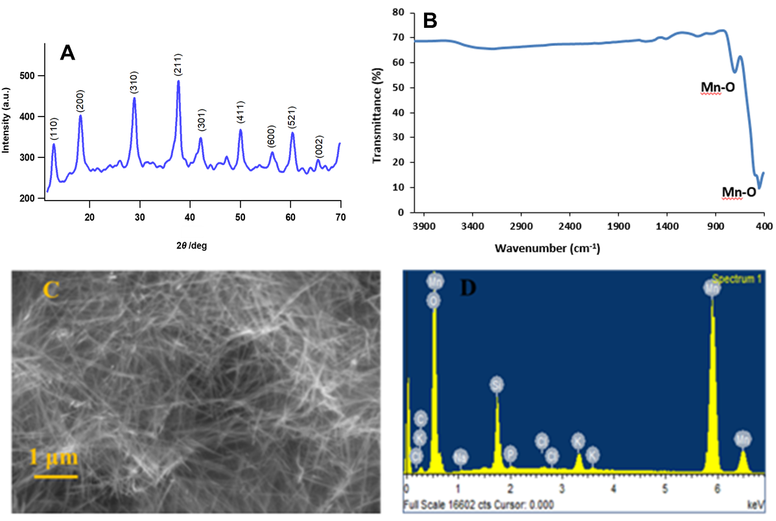

Fig. 1.

The SEM image of α-MnO₂ as shown in Fig.1 (C) indicated the characteristic ﬁbrous morphology, with an average diameter of ~ 45 nm. The phase and morphological results are consistent
with those as reported by Kumar et al. [46]. The EDX spectrum of Fig.1 (D) indicates the abundant availability of Mn and O.

3.2. Tyrosine sensing performance of smart band-aid

The smart band-aid fabrication strategy and impedance response recorded at various stages of construction are highlighted in Fig.2 and Fig.S1 (SI document) respectively. The impedance spectra, at each stage, was obtained within 100 Hz – 1 MHz at 100 mV ac in PBS-[Fe(CN)₆]^{3-/4-} redox probe. It can be observed (Fig.S1, SI document) that the charge transfer resistance R_{ct} (Z’) decreases when carbon electrode is coated with α-MnO₂(C/α-MnO₂), as compared to the unmodified counterpart).

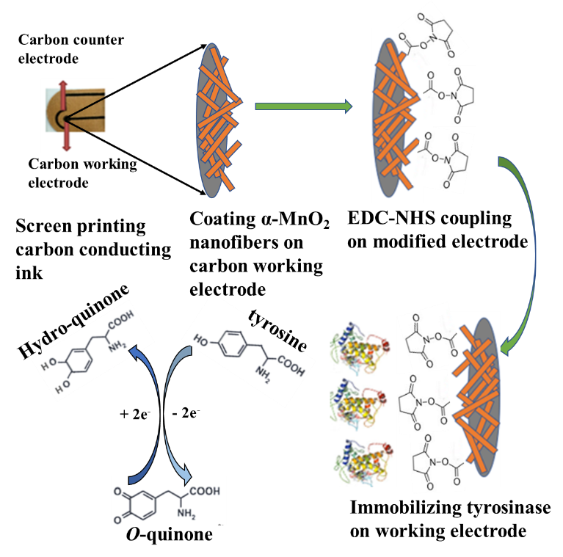
Fig. 2.

This can be attributed to the high surface area of nanofibers which promotes enhanced interfacial electron transfer facilitated by strong local electric field gradient [49,50]. However, R_{ct} gradually increased upon tyrosinase immobilization on the nanofibers (C/α-MnO₂/tyrosinase); which can be attributed to the insulating nature of the enzyme thereby passivating the electrode surface [24].

The C/α-MnO₂/tyrosinase based smart wound dressing was further integrated with portable electronics, as shown in Fig.3. The potentiostat with inbuilt bluetooth microcontroller, capable of transmitting the data to a Personal Digital Assistant (PDA), was sealed to screen printed wound dressing. The current measured by the potentiostat was calibrated and the device was programmed to designate specific concentrations of tyrosine, which gets displayed on the PDA. The latter also possesses the capability to indicate the level of wound severity based on the concentration of tyrosine as shown in Table T1 (SI document) [5]. The current response of the band-aid based smart sensor as a function of tyrosine concentrations (5 nM – 500 µM), was recorded in PBS-[Fe(CN)₆]^{3-/4-} using a portable potentiostat interfaced with a bluetooth module.

The CV was obtained within a potential window of -2 V to 1 V at a scan rate of 100 mV/sec, versus carbon counter/reference electrode (since two-electrode setup is employed). A sharp anodic and depressed cathodic peak at ~ 0.1 V and ~ -1.3 V respectively can be observed as shown in Fig.4 (A). This can be attributed to the fact that tyrosinase oxidises hydroquinone to o-quinone and subsequently releasing more electrons, as has been reported by our previous study [2]. The sensor was therefore calibrated at anodic potential of 0.1 V and the direct proportionality of peak anodic current (I_{pa}) with tyrosine concentration was established (Fig.4 (B)). The sensor generates a low current of ~ 1.5 μA at 5 nM tyrosine and high current value of ~ 4.2 μA at 500 μM. The increase in anodic current with tyrosine concentration can be attributed to enhanced redox cycling, at the electrode-

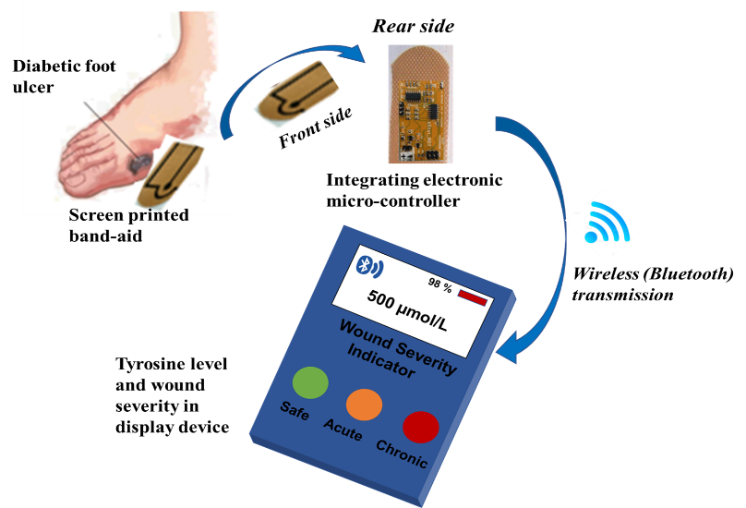
Fig. 3.

electrolyte interface. The electro-catalysis of tyrosine by tyrosinase is shown in Fig.2 [2] and is further elucidated in SI. In order to justify the major impact of tyrosinase towards tyrosine catalysis, a comparison of voltammograms detailing the response of 500 µM tyrosine at various stages of sensor fabrication is shown in Fig. S3 (SI).

Higher tyrosine concentration (500 μM) obviates increased generation of o-quinone, which then leads to rapid electron transfer due to enhanced redox cycling at the interface. This leads to a high current response of ~ 4.2 μA. The regression line equation was measured to be I_{pa} (μA) = 0.532log c(nM) + 1.069 with R² = 0.983. The limit of detection (LoD) and sensitivity were calculated to be 0.71 nM (using the conventional 3σ rule) and 0.67 μA/nM/mm² respectively [23]. Such high sensitivity obtained from CV has also been reported by Monika et.al [51]. In order to assess the stability of current response of smart band-aid based sensor with time, chronoamperometry was performed for various tyrosine concentrations and is detailed in Fig. S4 (SI).

Further, the applicability of the sensor to selectively quantify tyrosine levels in a mixture of various wound exudates as well as in spiked serum were examined. The compounds chosen for this analysis are: Ascorbic Acid (AA), Uric Acid (UA), Glycine (Gly), Histidine (His), Tryptophan (Tryp) and Glutamine (Glu). 500 μM of each compound has been used to perform selectivity studies. The current response, as generated by tyrosine alone (~ 4.2 μA), differed insignificantly when mixed with the chosen wound metabolites (Fig.5 (A)). It can also be observed that tyrosine generates distinct current response when compared with that of potential interfering metabolites in wound exudates (Fig.5 (B)). Further, human serum samples spiked with 500 μM tyrosine also yields almost similar response as obtained in [Fe(CN)₆]^{3-/4-} redox probe (Fig.5 (A)).

The stability of wearable sensor was also monitored for 30 days (Fig.5 (C)). It can be seen that the value of I_{pa}, at 500 μM tyrosine, obtained over 25 days is ~ 4.25 ± 0.05 μA after which a significant decrease in I_{pa} was observed. This indicates the stability of the wearable sensor over 25 days, thereby confirming the reproducibility and shelf-life within the specified period.

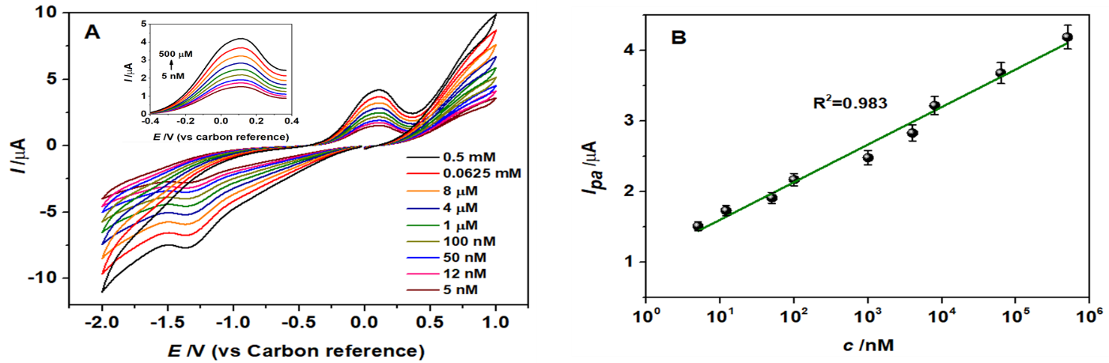

Fig. 4.

4. Validation of the developed smart band-aid
In order to validate the developed tyrosine sensor, the modified band-aid (without potentiostat interfacing) was employed
in a two- electrode setup for performing impedance spectroscopy. Frequency was swept between 100 Hz – 1 MHz at a fixed bias of 100 mV ac, while PBS-[Fe(CN)₆]^{3-/4-} (0.1 M – 5 mM, pH 6.4) was incorporated as the electrolyte.

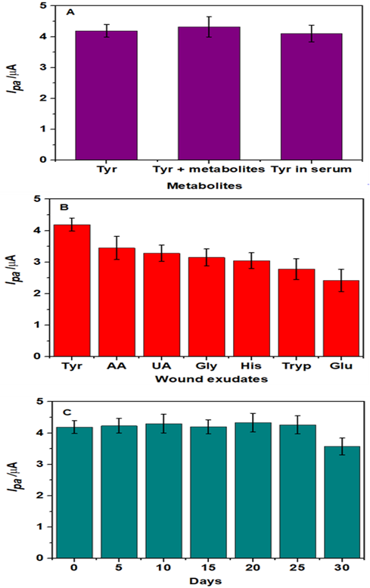
Fig. 5.

The Impedance response (Fig.6 (A) & (B)) obtained from EIS indicates a decrease in sensor impedance as the concentration of tyrosine is increased to 500 μM (0.5 mM). The decrease in impedance is consistent with increased current response at higher tyrosine concentrations (Fig.4 (A)). The Nyquist plot in Fig.6 (A) indicates a semi-circular feature and a straight line 45⁰ to Z’ axis. The semi-circle on left hand side corresponds to the charge transfer at α-MnO₂/tyrosinase surface from PBS-[Fe(CN)₆]^{3-/4-} electrolyte, through the electrical interfacial double layer [26,48]. This is modelled by the elements R_{ct} and C_{dl} respectively in Randel’s circuit depicted in Fig.6 (C). The straight line describes low frequency diffusion kinetics of electrons through tunnels of α-MnO₂ which can be modelled by Warburg impedance W_{s} (Fig.6 (C)) [52]. Further, R_{s} describes the bulk electrode and electrolyte resistance as can be observed by the rightward shifting of Nyquist plot along Z’ axis [26]. The diameter of semi-circle, R_{ct} (Z’), can be observed to decrease at higher tyrosine levels. As already reported earlier [22], the latter releases more electrons at higher concentrations which enables rapid charge transport (low R_{ct}) at C/α-MnO₂/tyrosinase surface from electrolyte. This indicates higher current response (I_{pa}) at elevated tyrosine levels (Fig.4 (A)). The height of the half-semicircle gives a measure of the double layer capacitive impedance Z’’.

The effect of low R_{ct} (high I_{pa}) at higher tyrosine concentration indicates increase in the number of electrons at the interface. In other words, the latter gets filled with charges which leads to increase in C_{dl} and a consequent decrease in Z’’. Finally, the presence of diffusion is a characteristic of porous and tunneled structures [52]. Owing to the tunneled morphology of α-MnO₂ [26], the electrons generated at the interface can easily diffuse through these tunnels. The decrease in the diffusion impedance at high tyrosine levels indicates rapid interfacial electron transfer (low R_{ct}) through the tunnels of α-MnO₂.

The sensor was calibrated at 1.2 kHz, by analyzing Z’ (R_{ct}) as a function of tyrosine concentration (c), while the latter was varied from 5 nM – 500 µM. The calibration graph (Fig.6 (B)) indicates that Z’ was found to be inversely proportional to tyrosine concentration within specified concentration range of analyte, with regression line equation of logZ’(kΩ) = -0.066log c (nM) + 4.781 and R² = 0.982.

Further insights on the redox kinetics at C/α-MnO₂/tyrosinase interface can be gained by calculating the heterogenous electron transfer rate constant (k_{et}) which is given by [47]:

$k_{et}=\frac{RT}{n^{2}F^{2}aR_{ct}[S]}$ (1)

where,

R = universal gas constant = 8.314 J mol⁻¹ K⁻¹
T = environment temperature = 298 K
n = number of electrons transferred = 2
F = Faraday constant = 96500 Coulomb mol⁻¹
a = area of working electrode = 0.785 mm²
[S] = concentration of redox probe = 0.1 M (PBS) + 0.005

M ([Fe(CN)₆]^{3-/4-}) = 0.105 M = 105 mol/m³

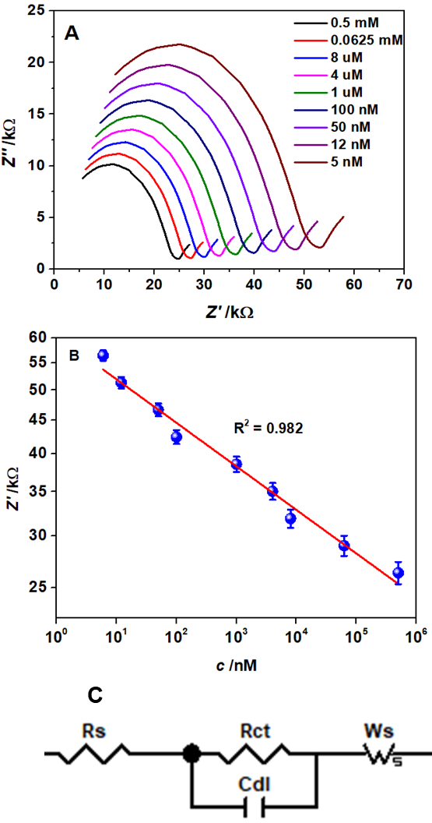

Fig. 6.

The comparison of R_{ct}, I_{pa} and k_{et} at tyrosine concentrations of 5 nM and 500 μM is shown in Table T2 (SI document). The latter indicates that an increase in tyrosine concentration elevates interfacial charge transfer process, as characterized by low R_{ct}, which ultimately leads to faster electron transfer rate (k_{et}). This is clearly supported and complemented by enhanced anodic current response (I_{pa}) from CV, thereby validating the sensing performance of the fabricated smart wound dressing. The calculation k_{et} for analyzing interfacial charge transfer kinetics has also been investigated by Kumar et. al [18] as well as in a study by Chirea [53].

The limit of detection (LoD) and sensitivity of the electrochemical sensor was calculated [54] to be 0.75 nM and 84.52
Ω/nM/mm² respectively. The LoD obtained using screen printed band-aid was found to be superior as compared to those reported in recent studies (Table 1). It is interesting to note that the LoD obtained after integrating micro-controller is approximately equal to that obtained using smart wound dressing with integrated electronics (0.71 nM). Table T3 (SI) indicates a comparison of LoD and sensitivity obtained from CV and EIS techniques.

The operation of portable sensor was further validated by comparing the recovered analyte concentrations with the commercial impedance analyzer. Serum samples were spiked with (500 μM, 4 μM and 50 nM L-tyrosine and the concentrations of tyrosine recovered were calculated as given in Table 2. It is clear that for each concentration of tyrosine spiked, the recovered levels as calculated using portable potentiostat and impedance analyzer does not differ significantly. The percentage recoveries using the smart sensor were then calculated using equation (2), thereby establishing the fact that this sensor could be employed in connected health technology.

$\% recovery=\left(\frac{\begin{aligned}concentration recovered using \\ portable potentiostat\end{aligned}}{\begin{aligned}concentration recovered using \\ commercial impedance analyzer\end{aligned}}\right)x 100$ (2)

Table 1. Comparison of sensing parameters & analytical techniques for various nanomaterial based sensing platforms

S. No | Sensing platform | LoD (M) | Linear range (M) | Method  employed | Reference
1 | Graphene/Chitosan/Pt nanoparticles/tyrosinase on screen printed electrode | 4.75 x 10⁻⁸ | 0.1–100 x 10⁻⁶ | SWV | [55]
2 | Graphene Oxide/ZnO on graphene screen printed electrode | 3.4x10⁻⁷ | 1x10⁻³ - 8x10⁻⁴ | SWV | [56]
3 | B.P. Tyrosinase/M/SN-MPTS on screen printed electrodes | 2.0 x 10⁻⁸ | 5×10⁻⁸ – 6×10⁻⁴ | DPV | [57]
4 | Single wall carbon nano-horns on glassy carbon electrode | 400 x 10⁻⁹ | 2 x10⁻⁶ – 30x10⁻⁶ | LSV | [58]
5 | α-MnO2/tyrosinase electrode on screen printed band-aid | 7.1 x 10⁻¹⁰ | 5x10⁻⁹ – 500x10⁻⁶ | CV | Present work

Table 2. Comparison of recovered tyrosine levels in spiked serum using portable potentiostat and commercial impedance analyzer.

Sl. No | Spiked concentration (M) | Concentration recovered using impedance analyzer (M) | Concentration recovered using portable potentiostat (M) |  | % Recovery using portable potentiostat
1 | 5x10⁻⁴ | 5.2x10⁻⁴ | 5.6x10⁻⁴ |  | 107.62
2 | 4x10⁻⁶ | 5.1x10⁻⁶ | 4.9x10⁻⁶ |  | 96.07
3 | 50x10⁻⁹ | 50.5x10⁻⁹ | 51x10⁻⁹ |  | 100.99

4. CONCLUSION

An electrochemical enzymatic smart wound dressing based on α-MnO₂/tyrosinase hybrid was developed for selective detection of L-tyrosine. A portable potentiostat with in-built bluetooth micro-controller was interfaced with the band-aid. Cyclic voltammetry using portable electronics indicated direct proportionality between I_{pa} and tyrosine levels. The developed sensor platform integrated with portable electronics demonstrated a linear response within a concentration range of 5 nM – 500 µM with detection limit and sensitivity of 0.71 nM and 0.67 µA/nM/mm². Impedimetric analysis validated the sensor response as obtained with integrated electronics. The LoD and sensitivity, using EIS technique, was calculated as 0.75 nM and 84.52 Ω/nM/mm² respectively within a linear range of 5 nM – 500 µM. The sensor response was found to be unaffected in the presence potential interfering agents and was examined in serum samples, along with a stability of 25 days. Owing to impressive percentage recoveries, the smart band-aid thus exhibited capability of sending the data wirelessly to remote device within few minutes thereby opening new avenues towards connected health care application.

ACKNOWLEDGEMENT

This research is supported by DST – UKIERI (DST/INT/UK/P-131/2016) grant.

REFERENCES

[1] Z.S. Kundu, M. Tanwar, K. Singh, B. Singh, J. Foot Ankle Surg. 2017, 4, 35-39.
[2] S. Roy, A. John, S. Nagabooshanam, A. Mishra, S. Wadhwa, A. Mathur, J. Narang, J. Singh, N. Dilawar, J. Davis, Appl. Surf. Sci. 2019, 488, 261-268.
[3] A. McLister, J. Davis, Healthcare 2015, 3, 466-477.
[4] D. Bruen, C. Delaney, L. Florea, D. Diamond, Sensors 2017, 17, 1866.
[5] I. B. J. G. Debats, D. Booi, N. E. P. Deutz, W. A. Buurman, W. D. Boeckx, R. R. W. J. van der Hulst, J. Surg. Res. 2006, 134, 205-214.
[6] D.R. Whiting, L. Guariguata, C. Weil, J. Shaw, Diabetes Res. Clin. Pract. 2011, 94, 311–321.
[7] N. Hex, C. Bartlett, D. Wright, M. Taylor, D. Varley, Diabet. Med. 2012, 29, 855–862.
[8] T. Nagase, H. Sanada, K. Takehara, M. Oe, S. Iizaka, Y. Ohashi, M. Oba, T. Kadowaki, G. Nakagami, J. Plast. Reconstr. Aesthet. Surg. 2011, 64, 860 – 866.
[9] L. Sabine, P.G. Jean, S. Joelle, B. Bernard, J. Chromatogr. B. Biomed. Sci. Appl. 1997, 696, 9–17.
[10] N.M. Felitsyn, G.N. Henderson, M.O. James, P.W. Stacpoole, Clin. Chim. Acta. 2004, 350, 219–230.
[11] Y. Huang, X. Jiang, W. Wang, J. Duan, C. Guonan, Talanta. 2006, 70, 1157-1163.
[12] Q. Ma, S. Ai, H. Yin, Q. Chen, T. Tang, Electrochim. Acta, 2010, 55, 6687–6694.
[13] V. Fejfarová, A. Jirkovská, V. Petkov, P. Bouc̆ek, J. Skibová, J. Diabetes. Complicat. 2004, 18, 108–112.
[14] C. Yates, K. May, T. Hale, B. Allard, N. Rowlings, A. Freeman, J. Harrison, J. McCann, P. Wraight, Diabetes Care 2009, 32, 1907–1909.
[15] F.L. Floch, A. Thauaire, G. Bidan, J.P. Simonato, Nanotechnology 2009, 20, 145705.
[16] Q. Xu, S.F. Wang, Microchim. Acta 2005, 151, 47–52.
[17] L.Q. Liu, F.Q. ZhaO, F. Xiao, B.Z. Zeng, Electronanal. 2008, 20, 2148–2152.
[18] S. Kumar, S. Kumar, S. Augustine, S. Yadav, B.K. Yadav, R.P. Chauhan, A.K. Dewan, B.D. Malhotra, Biosens. Bioelectron. 2018, 102, 247-255.
[19] G. Premaratne, J. Niroula, M.K. Patel, W. Zhong, S.L. Suib, K. Kalkan, S. Krishnan, Anal. Chem. 2018, 90, 12456-12463.
[20] G. Premaratne, S. Farias, S. Krishnan, Anal. Chim. Acta. 2017, 970, 23-29.
[21] G. Boopathy, M. Keerthi, S.M. Chen, M.J. Umapathy, M. Govindasamy, T.W. Chen, M.A. Ali, F.M.A. Al Hemaid, M.S. Elshikh, J. Electrochem. Soc. 2018, 165, B651-B658.
[22] V. Vukojević, S. Djurdjić, M. Ognjanović, M. Fabian, A. Samphao, K. Kalcher, D.M. Stanković, J. Electroanal. Chem. 2018, 823, 610-616.
[23] M. Khanna, S. Roy, R. Kumar, S. Wadhwa, A. Mathur, A.K. Dubey, IEEE sensors J. 2018, 18, 2206-2209.
[24] Y.H. Bai, H. Zhang, J.J. Xu, H.Y. Chen, J. Phys. Chem. 2008, 112, 18984-18990.
[25] F. Fartas, J. Abdullah, N. Yusof, Y. Sulaiman, M. Saiman, Sensors. 2017, 17, 1132.
[26] C.C. Mayorga-Martinez, M. Cadevall, M. Guix, J. Ros, A. Merkoçi, Biosens. Bioelectron. 2013, 40, 57-62.
[27] T. Guinovart, G.V. Ramirez, J.R. Windmiller, F.G. Andrade, J. Wang, Electroanal. 2014, 26, 1345-1353.
[28] S. Park, S. Jayaraman, MRS Bull. 2003, 28, 585–591.
[29] K. Mitsubayashi, M. Suzuki, E. Tamiya, I. Karube, Anal. Chim. Acta. 1994, 289, 27–34.
[30] A. McLister, C. Casimero, A. McConville, C.M. Taylor, C.L. Lawrence, R.B. Smith, A. Mathur, J. Davis, J. Mater. Sci. 2019, 54, 10410-10419.
[31] C. Hegarty, S. McKillop, R.J. McGlynn, R.B. Smith, A. Mathur, J. Davis, J. Mater. Sci. 2019, 54, 10705-10714.
[32] P. Kassal, J. Kim, R. Kumar, W. Araujo, I.M. Steinberg, M.D. Steinberg, J. Wang, Electrochem. Commun. 2015, 56, 6-10.
[33] G. Matzeu, M. Losacco, E. Parducci, A. Pucci, V. Dini, M. Romanelli, F. Di Francesco, IECON 2011-37th Annual Conference on IEEE Industrial Electronics Society 2011, 3533-3535.
[34] Y. Moser, M.A.M Gjis, J. Microelectromech. Syst. 2007, 16, 1349-1354.
[35] D. McColl, B. Cartlidge, P. Connolly, Int. J. Surg. 2007, 5, 316-322.
[36] D. McColl, M. MacDougall, L. Watret, P. Connolly, Wounds UK 2009, 5, 2-6.
[37] W. Honda, S. Harada, T. Arie, S. Akita, K. Takei, Adv. Funct. Mater. 2014, 24, 3299–3304.
[38] M.M. Baig, H. Gholamhosseini, J. Connolly, Med. Biol. Engg. Comput. 2013, 51, 485–495.
[39] E.S. Winokur, M.K. Delano, C.G. Sodini, IEEE Trans. Biomed. Eng. 2012, 60, 189–192.
[40] V. Mihajlovic, B. Grundlehner, R. Vullers, J. Penders, IEEE J. Biomed. Health Inform. 2015, 19, 6–21.
[41] M.F. Farooqui, A. Shamim, Sci. Rep. 2016, 6, 28949.
[42] P. Mostafalu, W. Lenk, M.R. Dokmeci, B. Ziaie, A. Khademhosseini, S.R. Sonkusale, IEEE Trans. Biomed. Circuits Syst. 2015, 9, 670-677.
[43] S. Yao, P. Swetha, Y. Zhu, Adv. Healthcare Mater. 2018, 7, 1700889.
[44] M.S. Mannoor, H. Tao, J.D. Clayton, A. Sengupta, D.L. Kaplan, R.R. Naik, N. Verma, F.G. Omenetto, M.C. McAlpine, Nat. Commun. 2012, 3, 763.
[45] H. Lee, T.K. Choi, Y.B. Lee, H.R. Cho, R. Ghaffari, L. Wang, H.J. Choi, T.D. Chung, N. Lu, T. Hyeon, S.H. Choi, Nat. Nanotechnol, 2016, 11, 566.
[46] R. Kumar, S. Sithambaram, S.L. Suib, J. Catal. 2009, 262, 304-313.
[47] K. Kamil Reza, Md. Azhar Ali, S. Srivastava, V.V. Agrawal, A.M. Biradar, Biosens. Bioelectron. 2015, 74, 644-651.
[48] H. Wang, Z. Lu, D, Qian, Y. Li, W. Zhang, Nanotechnology 2007, 18, 115616.
[49] M. Si, D. Wang, R. Zhao, D. Pan, C. Zhang, C. Yu, X. Lu, H. Zhao, Y. Bai, Adv. Sci. 2020, 7, 1902538.
[50] P.R. Bueno, C. Gabrielli, Electrochemistry, Nanomaterials, and Nanostructures, Springer, Boston, MA, 2009.
[51] M. Srivastava, N.R. Nirala, S.K. Srivastava, R. Prakash, Sci. Rep. 2018, 8, 1-11.
[52] E. Katz, I. Willner, Electroanal. 2003, 15, 913-947.
[53] M. Chirea, Catalysts, 2013, 3, 288-309.
[54] S.R. Balakrishnan, U. Hashim, S.C.B. Gopinath, P. Poopalan, H.R. Ramayya, M. Iqbal Omar, R. Haarindraprasad, P. Veeradasan, PLOS ONE 2015, 10, 1-17.
[55] I. M. Apetrei, C. Apetrei, Materials. 2019, 12, 1009.
[56] H. Beitollahi, F. G. Nejad, Electroanal. 2016, 28, 1–9.
[57] M. Rahimi-Mohseni, J.B. Raoof, R. Ojani, T.A. Aghajanzadeh, A. Bagheri Hashkavayi, Int. J. Biol. Macromol. 2018, 113, 648–654.
[58] S. Zhu, J. Zhang, X. Zhao, H. Wang, G. Xu, J. You, Microchim. Acta. 2014, 181, 445–451.
.

Captions to Figures

Fig. 1. (A) XRD plot. (B) FTIR spectrum. (C) SEM micrograph. (D) EDX spectrum of α-MnO₂ nanostructures.

Fig. 2. Fabrication of smart band-aid based on α-MnO₂/tyrosinase hybrid.

Fig. 3. Integration of modified band-aid with portable potentiostat.

Fig. 4. (A) CV demonstrating variation of peak currents with tyrosine concentration. (B) Calibration of portable wound monitoring device at 0.1 V.

Fig. 5. Peak anodic current response of (A) tyrosine, mixture of wound exudates and tyrosine and spiked analyte in serum. (B) tyrosine and individual wound exudates. (C) stability of smart band-aid based sensor over 25 days. (Tyrosine and wound exudates concentration = 500 μM, and response was recorded at 0.097 V).

Fig. 6. (A) Nyquist plot at various tyrosine concentrations in the range 100 Hz – 1 MHz. (B) Sensor calibration from 5 nM – 500 μM, at 1.2 kHz. (C) Randel’s equivalent circuit corresponding to sensor – electrolyte interface.

