Ultra-sensitive detection of L-tyrosine using molecularly imprinted electrochemical sensor towards diabetic foot ulcer detection
Souradeep Roy¹, Shalini Nagabooshanam¹, Shikha Wadhwa¹, Nidhi Chauhan¹, Ashish Mathur¹, Saif.A. Khan² and James Davis³
¹Amity Institute of Nanotechnology, Amity University, Noida, 201313, India
²Inter-University Accelerator Center, Vasant Kunj, New Delhi, 110067, India
³NIBEC, Ulster University, Jordanstown Campus, Northern Ireland, BT370QB, UK
*Email- james.davis@ulster.ac.uk

Abstract:

It has been found that the concentration of L-tyrosine is greatly elevated within infected ulcers and thus there is a pressing need for sensors that can aid the point of care monitoring of this potential biomarker. In this work, a templated over-oxidised polypyrrole film on indium tin oxide is exploited as a sensitive sensing system, for the detection of tyrosine. The sensor has been characterised using a variety of surface techniques (contact angle, FTIR, SEM) and the electrochemical properties explored using cyclic voltammetry (CV) and electrochemical impedance spectroscopy (EIS). The sensor was found to exhibit a substantial linear range (100 fM-1 mM) with limits of detection of 1.73 pM (CV) and 6.63 pM (EIS). The sensor demonstrated rapid response characteristics (less than 1 minute) and high stability (up to 3 months).

Keywords: - Infection; tyrosine; molecularly imprinted polymer; sensor; point of care.

1.0 Introduction
Diabetes is a pernicious disease with a global reach and predicted to rise significantly in the future [1]. In India, it has been estimated that some 7% of the population suffer from the disease with the day-to-day management of the condition and its complications placing a severe burden on healthcare resources [1]. In particular, the lifetime risk of people with diabetes to develop a foot ulcer is 34% of which more than half become infected. This can be attributed to the slow healing nature of the wound and leads to limb amputation or life-threatening events [2-5]. The availability of diagnostic tools that can monitor the condition of the wound in situ or be employed as point of care (POC) tests during consultations or dressing changes would clearly be of tremendous clinical value with early detection of infection enabling much more timely interventions which could lead to more positive outcomes for the patient. While systemic inflammatory markers (i.e. C-reactive protein) are used extensively in clinical practice, their specificity for wound infection can be ambiguous in the complex scenarios common to diabetic patients. As such, there has been an extensive search for other, more local indicators of infection. Among the numerous metabolites present in wound fluid, the concentration of tyrosine (TYR) has long been known to become elevated in patients suffering from Diabetic Foot Ulcers (DFUs) with on-going infection [1]. Hence, early monitoring of TYR concentrations could ultimately serve as a potential indicator for predicting the early occurrence of infection within foot ulcers.
Electroanalytical approaches to the measurement of TYR have traditionally been hindered by the lack of selectivity and sensitivity achievable through its direct oxidation at unmodified electrodes. Various approaches have been taken to counter such issues and include: tyrosinase enzyme electrodes [6,7] and organic/inorganic electrocatalysts based on copper oxide[8,9], iron oxide-zinc oxide-zinc hexacyanoferrate [10], manganese heterostructures, [11], graphene [12-14], carbon nanotubes [15,16], and gold nanoparticles [17]. The use of molecularly imprinted polymer (MIP) templates have also been investigated as a mean of capturing TYR and improving the voltammetric detection performance [8, 14, 17-19]. In principle, the MIP approach can offer numerous benefits such as low cost synthesis, enhanced shelf life, durability over a wide range of pH and temperature and reversible analyte binding using non-covalent interactions [20,21]. The latter could be significant where there is a need for periodic measurements of a wound status without having to change the dressing and disrupt the healing processes. In this work, we report an electrochemically synthesised molecularly imprinted poly-pyrrole (MIPPy) sensor based on an Indium Tin Oxide (ITO) substrate for the detection of TYR employing electrochemical impedance spectroscopy (EIS) as the detection methodology. The core rationale being to exploit both the selectivity offered by the MIP – TYR templating and the sensitivity of the EIS.

2.0 Materials and Methods
2.1 Chemicals and Reagents
Reagents were of analytical grade and used without further purification. Sodium acetate, potassium chloride and ethylene glycol were purchased from Merck Pvt. Ltd, India. Acetic acid, potassium ferrocyanide, potassium ferricyanide and ethanol were obtained from Fisher Scientific India, while pyrrole and L-tyrosine were purchased from Sigma Aldrich (USA) and Sisco Research Laboratories Pvt. Ltd. (India).
2.2 Fabrication and Characterisation of Polymer Modified Electrodes
The non-imprinted polymer (NIP) were fabricated on ITO substrates. The ITO coated glass slides (1.5 cm x 1 cm) served as the working electrode (delineated electrode area : 1 cm²) and were cleaned using a RCA-1 protocol prior to use [22]. Electro-polymerisation of pyrrole (0.01 M, 0.25 M acetate buffer, pH 5) was conducted through employing repetitive scan cyclic voltammetry (-0.4 V to +2 V, 50 mV/s) using a conventional three electrode configuration with a Pt counter and a Ag/AgCl (3 M Cl⁻) reference electrode. The oxidation of the pyrrole was observed at +1.3 V as a well defined peak with the continuation of the scan to more positive potentials leading to overoxidation of the film resulting in a thin non-conductive barrier. Templating of polypyrrole to yield the MIPPy sensors was achieved through employing similar conditions but with different ratios of PY: TYR (1:1, 1:2, 1:3 and 1:4). The electrodes were removed, rinsed and dried. Thereafter, removal of the TYR from the MIPPy electrodes was achieved through repeated immersing within 50% (v/v) aqueous ethanol.

3.0 Results and Discussion
The voltammetric properties of the MIPPy functionalised electrode toward TYR was initially assessed using ferrocyanide (2 mM, 0.1 M KCl) as a redox probe with the responses detailed in Figure 1A. The over-oxidised nature of the polypyrrole film was found to be sufficiently porous as to allow the transport of ferrocyanide (as indicated by the defined redox peaks on the blank scan). As the concentration of TYR was increased (100 fM to 1 mM), the peak heights of the ferrocyanide were also found to increase with a log linear response (Figure 1B). This behaviour contrasts that traditionally observed with antibody systems employing ferrocyanide probes where the peak current is found to decrease with increasing concentration of antigen.
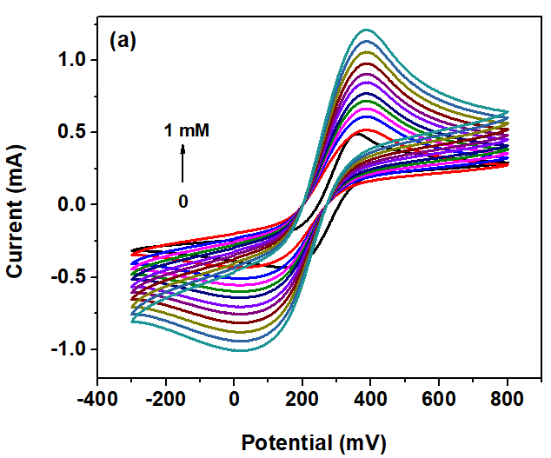
Fig.1 (a) Cyclic voltammograms highlighting the influence of L-tyrosine on a MIPPy-Ferrocyanide based sensor. (b) Variation of anodic peak height (at +0.42 V) with tyrosine concentration (The error bars indicate standard deviation obtained after 11 consecutive scans, N = 11).
A direct proportionality was established between peak anodic current (I_{pa}) and tyrosine levels (pM) with regression line equation I_{pa} (mA) = 0.069 log c (pM) + 0.576 and R² = 0.997. The limit of detection (LoD), employing the conventional 3σ rule [23], and sensitivity of the MIPPy sensor was calculated to be 1.73 pM and 0.69 μA/pM/mm². The non-imprinted polymer (NIP), in contrast, did not exhibit any cumulative increase in the height of the ferrocyanide peak with increasing concentrations of L-tyrosine. This highlights the role of the templating process in enhancing the sensitivity towards tyrosine.

The over-oxidised film contains an abundance of carboxyl groups (corroborated by FTIR and in agreement with previous reports[19]) which would normally serve to hinder the transport of anionic species and hence its use as an anti-interferent film against ascorbate. In this case, it is possible to speculate that the insertion of the tyrosine into the film results in electrostatic coordination at these carboxyl sites (via hydrogen bonding and/or electrostatic interaction via the protonated alpha amino group) and thus reduces their influence on the ferrocyanide. In doing so, access of the ferrocyanide is facilitated and the response increases with tyrosine concentration.
Further insights into the tyrosine binding phenomena were obtained using electrochemical impedance spectroscopy (EIS). The latter was performed using a conventional three electrode setup within a frequency range of 100 Hz-1 MHz with an ac bias of 100 mV. The MIP surface was found to exhibit a low charge transfer resistance (R_{ct}) ~ 1.5 kΩ which is attributed to the over-oxidised nature of the polypyrrole where charge transfer, particularly at surfaces with high wettability, can be enhanced due to the presence of polar functional groups (i.e. carboxyl) [24-26]. Contact angle studies of the polymer confirmed that the NIP surfaces, absent of any tyrosine templating, are highly hydrophilic yielding a moderately higher surface energy than that of the MIP samples (86.52 vs. 39.85 mJ/m²). The NIP surface, examined with both water and ethylene glycol, gave contact angles of 10.01º and 5.10º respectively. This contrasts those obtained for the MIP surfaces where the respective contact angles were found to be 66.96º and 64.39º for water and ethylene glycol. This could be associated with the formation of tyrosine-specific cavities in the former, resulting in roughening of the poly-pyrrole surface [24-26].
The behaviour of the electrode-electrolyte interface at various tyrosine concentrations has been studied by circuit simulation of Nyquist plots (Inset Fig. 2). The Randel’s equivalent circuit indicates the presence of two current conducting pathways – through a resistor (charge transfer resistance) and a capacitor (double layer capacitance) arranged in a parallel combination [25]. A decrease in charge transfer resistance Z’ (diameter of semi-circle) is observed as tyrosine levels are scaled up from 100 fM to 1 mM, simultaneously decreasing the double layer impedance Z’’ which indicates an increase in interfacial capacitance [1]. In the circuit model, R_{s} and R_{ct} correspond to bulk electrolyte and charge transfer resistances respectively, while CPE (constant phase element) refers to a double layer capacitor formed at the vicinity of a rough surface. Table 1 shows the approximate values of various interfacial parameters involved in the tyrosine re-binding process.
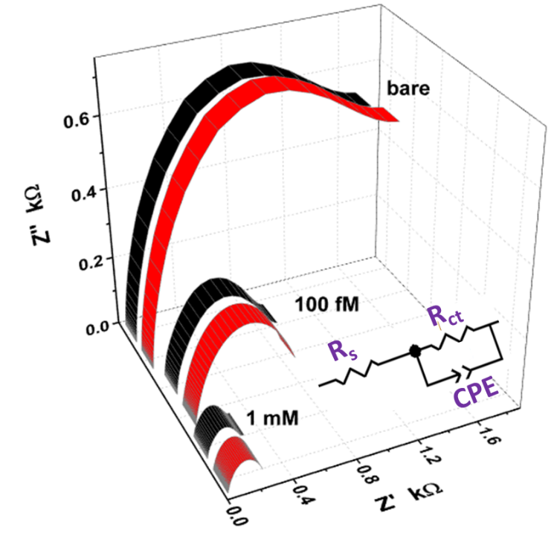
Fig.2 Curve fitting of Nyquist plot at bare MIP and after exposure to tyrosine (red = experimental data, black = simulated data). Inset: Randel’s equivalent circuit employed for simulation.

Table. 1 Approximate quantification of circuit elements used to model
the electrode-electrolyte interface.

Sl. No | Tyrosine concentration (M) | R_{s} (Ω) | R_{ct} (Ω) | CPE (F)
1 | 0 | 76 | 1600 | 1x10⁻⁶
1 | 100x10⁻¹⁵ | 74 | 720 | 5x10⁻⁶
2 | 1x10⁻³ | 25 | 240 | 35x10⁻³

Calibration data relating to the EIS response of the MIP electrode towards increasing concentration of tyrosine in pH 7 PBS buffer are shown in Fig 3. A linear relationship was observed using the log-log plot (Fig. 3(b)), and is given as (log Z' (kOhm) = -0.045 log c (pM) - 0.20; R² = 0.991; N=11) with the limit of detection calculated to be 6.63 pM [23]. A comparison of the system sensitivity relative to recent published work is highlighted in Table 2.
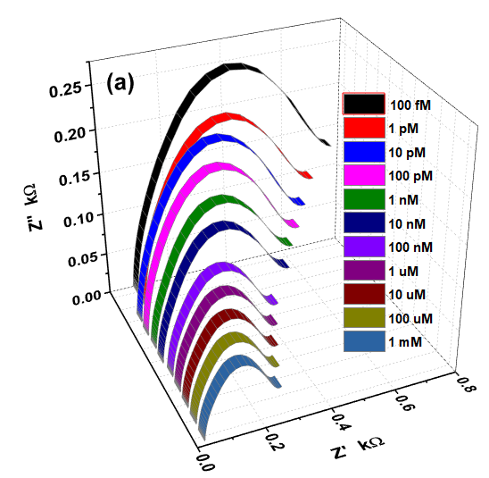

Fig.3 (a) Impedance spectra detailing the response of the templated polypyrrole (MIPPy) response to increasing tyrosine. (b) Corresponding calibration data.

Table.2 Performance comparison of sensors for the detection of tyrosine.
Methodology | Electrode Modifier | Sample Type | Limit of Detection  /nM | Ref
Enzyme, DPV | Tyrosinase / Si nps | P | 20 | 6
Enzyme, SQW | Tyrosinase / Graphene / Chitosan / Pt nps | P | 48 | 7
MIP, DPV | PP, CuO | U | 4 | 8
AMP | CuO / b-cyclodextrin / nafion | S / U | 8 | 9
DPV | ErVO₄ / MnWO₄ | S | 7.7 | 11.
DPV | Graphene / L-aspartic acid | S | 310 | 12
DPV | Nd₂O₃ / Graphene | S / U | 40 | 13
MIP DPV | 2-amino-5-mercapto-1, 3, 4-thiadiazole / Graphene Oxide | S / U | 46 | 14
DPV | MWCNT/Nafion | S | 800 | 15
DPV | Crown ether / polyhydroquinone / CNT | S | 1.3 | 16
MIP, DPV | polyaniline / polythionine/ Au nps @zeolitic imidazolate framework-67 | S | 0.8 | 17
MIP, CV | PP, Ni | NS | NS | 18
MIP, SQW | PP | P | 2.5 | 19
MIP, CV | PP-Ferrocyanide | SWF | 0.00173 | This work
MIP, EIS | PP-Ferrocyanide | SWF | 0.0063 | This work
Where: MIP = Molecularly imprinted polymer; DPV = Differential Pulse Voltammetry; SQW = Square wave voltammetry; CV = Cyclic voltammetry; AMP = Chronoamperometry; EIS = Electrochemical Impedance Spectroscopy; PP = Polypyrrole; MWCNT = multiwall carbon nanotube; S = Serum ; U = Urine; P = Plasma; SWF = Simulated wound fluid; NS = Not Specified.

Wound fluid, as a consequence of extensive cellular remodelling, will consist of a large variety of molecular species which will normally pose considerable issues to any electrochemical sensing system [5]. The selectivity of the MIPPy system was studied through comparing the response to tyrosine in the presence of common components – valine (VAL), tryptophan (TRYP), L-phenylalanine (PHE) and cysteine (CYS). TRYP and CYS are electroactive and could be expected to interfere when considering voltammetric detection but the application of the EIS detection protocol deftly avoids their interaction. This is evidenced in Fig 4 where the EIS response to equimolar concentrations (1 mM, pH 7 PBS) are compared. Moreover, the response was found to be stable over a period of 90 days – which is far in excess of the expected lifetime of the sensor when placed in situ within the dressing. The wound environment will be highly variable and it could be anticipated that protective permselective layers (i.e. cellulose acetate) could be employed to screen out large proteinaceous species or other macromolecular debris emanating from tissue remodelling.

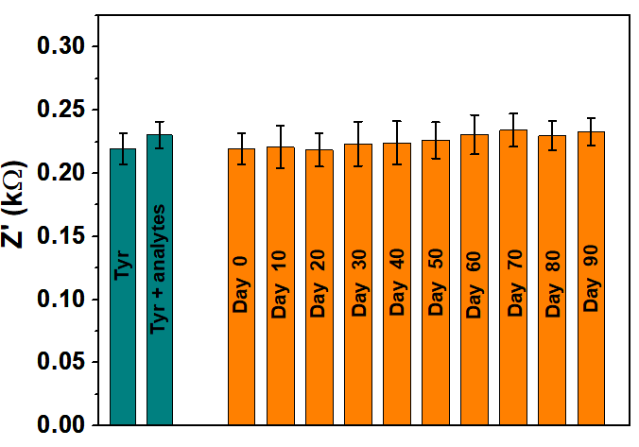
Fig. 4 Detection of Tyrosine in the presence of potential interfering metabolites in wound exudates and the sensor response over a period of 3 months (The error bars indicate standard deviation obtained after 11 consecutive scans, N = 11).
Conclusions
The relatively facile production of templated polypyrrole in combination with EIS detection has been shown to yield a highly sensitive, selective and stable detection system for the quantification of tyrosine. In principle, the approach is transferrable to other electrode substrates providing that the ferrocyanide electron transfer kinetics are fast and thereby provide sharp unambiguous peak profiles through which to gauge the influence of tyrosine-MIPPy interaction. While the clinical efficacy of the device has yet to be proven, the underpinning methodology clearly meets many of the criteria needed for commercial exploration with inexpensive construction and device stability being among the more pertinent factors.

Acknowledgements
This research is supported by funding obtained from DST – UKIERI project number DST/INT/UK/P-131/2016.

Conflicts of Interest
The authors declare no conflict of interest.

References

1. S. Roy, A. John, S. Nagabooshanam, A. Mishra, S. Wadhwa, A. Mathur, J. Narang, J. Singh, N. Dilawar, J. Davis, Self-aligned TiO2-Photo reduced graphene oxide hybrid surface for smart bandage application. Appl. Surf. Sci. 488 (2019) 261-268
2. Z.S. Kundu, M. Tanwar, K. Singh, B. Singh, Clinical assessment, risk factors and classification of diabetic foot: An overview. J. Foot Ankle Surg 4 (2017) 35-39
3. S.O. Oyibo, E.B. Jude, I. Tarawneh, H.C. Nguyen, D.G. Armstrong, L.B. Harkless, A.J.M.; Boulton, The effects of ulcer size and site, patient's age, sex and type and duration of diabetes on the outcome of diabetic foot ulcers. Diabet. Med. 18 (2001) 133-138
4. J. Larsson, J. Apelquist, Towards less amputations in diabetic patients: Incidence, cause, cost, treatment and prevention - a review. Acta Orthop Scand. 66 (1995) 181-192
5. J. Davis, A. McLister, J. Cundell, D. Finlay, Smart Bandage Technologies: Design and Applications, Academic Press, Elsevier: UK, (2016).
6. M. Rahimi-Mohseni, J.B. Raoof, R. Ojani, T.A. Aghajanzadeh, A.B. Hashkavayi, Development of a new paper based nano-biosensor using the co-catalytic effect of tyrosinase from banana peel tissue (Musa Cavendish) and functionalized silica nanoparticles for voltammetric determination of L-tyrosine. Int. J. Biol. Macromol. 113 (2018) 648-654
7. I.M. Apetrei, C. Apetrei, Development of a novel biosensor based on tyrosinase/platinum nanoparticles/chitosan/graphene nanostructured layer with applicability in bioanalysis. Materials, 12 (2019) 1009
8. V. Saumya, K.P. Prathish, T.P. Rao, In-situ copper oxide modified molecularly imprinted poly-pyrrole film based voltammetric sensor for selective recognition of tyrosine. Talanta 85 (2011) 1056-1062
9. A. Karthikaa, D.R. Rosaline, S.S.R. Inbanathan, A. Suganthi, M. Rajarajan, Fabrication of Cupric oxide decorated β-cyclodextrin nanocomposite solubilized Nafion as a high performance electrochemical sensor for L-tyrosine detection, J. Phys. Chem. Solids. 136 (2020) 109145
10 J. Narang, N. Chauhan, S. Pundir, C.S. Pundir, A magnetic nanoparticles-zinc oxide/zinc hexacyanoferrate hybrid ﬁlm for amperometric determination of tyrosine. Bioprocess Biosyst. Eng. 36 (2013) 1545-1554
11. A. Khoobi, F. Shahdost-fard, M. Arbabi, M. Akbari, H. Mirzaei, M. Nejati, M. Lotfinia, A. Sobhani-Nasab, H.R. Banafshe, Sonochemical synthesis of ErVO4/MnWO4 heterostructures: Application as a novel nanostructured surface for electrochemical determination of tyrosine in biological samples, Polyhedron 177 ( 2020) 114302
12. Y. Luo, Y. Zhang, L. Lu, H. Luo, A flexible CVD graphene platform electrode modified with L-aspartic acid for the simultaneous determination of acetaminophen, epinephrine and tyrosine, J. Electroanal. Chem., 856 (2020) 113737
13. S. Biswas, H. Naskar, S. Pradhan, Y. Wang, R. Bandyopadhyay, P. Pramanik, Simultaneous voltammetric determination of Adrenaline and Tyrosine in real samples by neodymium oxide nanoparticles grafted graphene, Talanta, 206 (2020) 120176
14. W. Zheng, M. Zhao, W. Liu, S. Yu, L. Niu, G. Li, H. Li, W. Liu, Electrochemical sensor based on molecularly imprinted polymer/reduced graphene oxide composite for simultaneous determination of uric acid and tyrosine. J. Electroanal. Chem. 813 (2018) 75-82.
15. Z-Y. Li, D-Y. Gao, Z-Y. Wu, S. Zhao, Simultaneous electrochemical detection of levodapa, paracetamol and L-tyrosine based on multi-walled carbon nanotubes , RSC Advances 10 (2020) 14218-14224
16. N.F. Atta, A. Galal, A.R. El-Gohary, Crown ether modified poly(hydroquinone)/carbon nanotubes based electrochemical sensor for simultaneous determination of levodopa, uric acid, tyrosine and ascorbic acid in biological fluids, J. Electroanal. Chem. 863 (2020) 114032
17. N. Chen, Y. Zhang, L. Lin, H. Chen, M. Zhao, Au nanoparticles @metal organic framework/polythionine loaded with molecularly imprinted polymer sensor: Preparation, characterization, and electrochemical detection of tyrosine, J. Electroanal. Chem., 863 (2020) 114052
18. H.J. Liang, T.R. Ling, J.F. Rick, T.C. Chou, Molecularly imprinted electrochemical sensor able to enantroselectivly recognize D and L-tyrosine. Anal. Chim. Acta 542 (2005) 83–89
19. N. Ermiş, N. Tınkılıç, Preparation of molecularly imprınted polypyrrole modified gold electrode for determination of tyrosine in biological samples. Int. J. Electrochem. Sci. 13 (2018) 2286 – 2298
20. S.W. Lee, T. Kunitake, T. Handbook of Molecular Imprinting: Advanced Sensor Applications, CRC Press, Taylor & Francis: US, 2012)
21. T.S. Rebelo, R. Costa, A.T. Brandão, A.F. Silva, M.G.F. Sales, C.M. Pereira, C.M. Molecularly imprinted polymer SPE sensor for analysis of CA-125 on serum. Anal. Chim. Acta 1082 (2019) 126-135
22. R. Gupta, S. Wadhwa, A. Mathur, A.K. Dubey, Designing of a microelectrode sensor based label free milk adulteration testing system (MATS). IEEE Sens. J. 17 (2017) 6050-6055
23 S. Roy, S. Nagabooshanam, K. Krishna, S. Wadhwa, N. Chauhan, U. Jain, R. Kumar, A. Mathur, J. Davis, Electroanalytical sensor for diabetic foot ulcer monitoring with integrated electronics for connected health application. Electroanal. (2020), https://doi.org/10.1002/elan.201900665
24. Q. Zhang, T. Li, J. Liang, N. Wang, X. Kong, J. Wang, H. Qian, Y. Zhou, F. Liu, C. Wei, Y. Zhao, Highly wettable and metallic NiFe-phosphate/phosphide catalyst synthesized by plasma for highly efficient oxygen evolution reaction. J. Mater. Chem. A 6 (2018) 7509-7516.
25. E. Katz, I. Willner, Probing biomolecular interactions at conductive and semiconductive surfaces by impedance spectroscopy: routes to impedimetric immunosensors, DNA‐sensors, and enzyme biosensors. Electroanal. 15 (2003) 913-947
26. T.N. Chatterjee, D. Das, R.B. Roy, B. Tudu, S. Sabhapondit, P. Tamuly, P. Pramanik, R. Bandyopadhyay, Molecular imprinted polymer based electrode for sensing catechin (+ C) in green tea. IEEE Sens. J. 18 (2018) 2236-2244

