Food Insecurity and Covid-19
Summary Results to Department for Communities, Northern Ireland

Report prepared by:
Sinéad Furey, Ulster University
Martin Caraher, City, University of London
Ellen Finlay, Children in Northern Ireland
Pauline Leeson, Children in Northern Ireland
Gary McFarlane, Chartered Institute of Environmental Health
Anna Taylor, Food Foundation

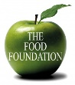

Acknowledgements
Alan Anderson, Department for Communities
Peter Martin, Department for Communities
Sharon Polson, Department for Communities
Ricky Raichura, YouGov
Charlotte Smith, YouGov
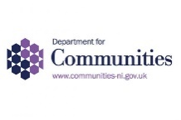

December 2020

Summary of Results
The following results are a summary analysis of a YouGov poll of 503 respondents (profile presented below) between 3 and 7 September 2020, adapting Food Foundation UK research.

Table 1 Sample characteristics
 |  |  | N  (unweighted) | % *  (weighted)
Gender
Male |  |  | 234 | 48.0
Female |  |  | 269 | 52.0
Age Profile
18 – 24 years  25 – 34 years  35 – 44 years  45 – 54 years  55 + years |  |  | 28  77  105  99  194 | 14.0  15.0  20.0  18.0  32.0
Social Grade  ABC1  C2DE |  |  | 342  161 |  | 65.0  35.0
Working Status  Working full time  Working part time  Full time student  Retired  Unemployed  Not working / other |  |  | 233  72  12  111  23  52  250  59  46  16  132 |  | 46.0  17.0  4.0  19.0  4.0  10.0  46.0  12.0  9.0  3.0  31.0
Marital Status
Married / civil partnership
Living as married
Separated / divorced
Widowed
Never married
Household composition
1 person  2 people  3 people  4 people  5 people  6 people  7 people  8+ people  Prefer not to say  No answer |  |  | 99  172  89  79  29  11  1  1  10  12 | 18.0  33.0  18.0  19.0  7.0  2.0  <1.0  <1.0  2.0  2.0
Dependents  A child or children  A person with a disability  A dependent elderly person  None of these |  |  | 144  26  37  318 | 28.0  6.0  6.0  64.0
Dependent Children
None |  |  | 343 | 64.0
1 child |  |  | 63 | 14.0
2 children |  |  | 60 | 12.0
3 + children  No answer |  |  | 27  10 | 7.0  2.0
Health status
Daily activities limited a lot  Daily activities limited a little |  |  | 46  92 | 10.0  18.0
Daily activities not limited  No answer  Urban / Rural  Urban  Rural  Don’t know |  |  | 352  13  285  207  11 | 73.0  2.6  53.0  44.0  3.0
* Numbers may not add up to 100% due to rounding
Covid-19 and self-isolation
Six per cent of the Northern Ireland sample reported self-isolating and 3% reported having been advised to self-isolate but being unable to do so because they need to go out for food / medical appointments and other essential reasons.

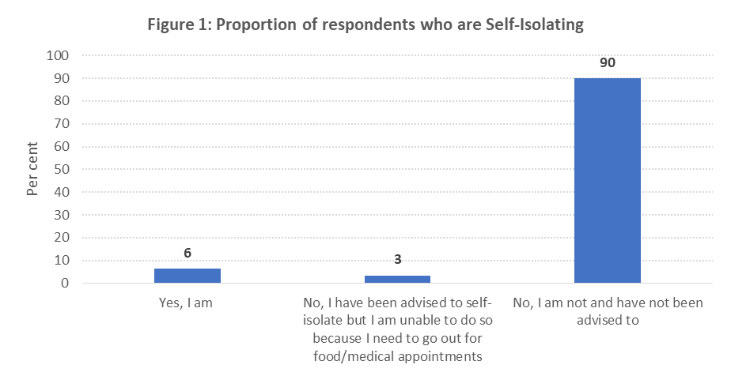
Employment Status
More than half (53%) of the sample reported working full (43%) or part time (10%) (down from 57% before lockdown); 4% reported being self-employed but not currently working; and 2% were furloughed full-time workers and 1% were furloughed part-time workers. Unemployment figures currently stand at 4% for this sample.

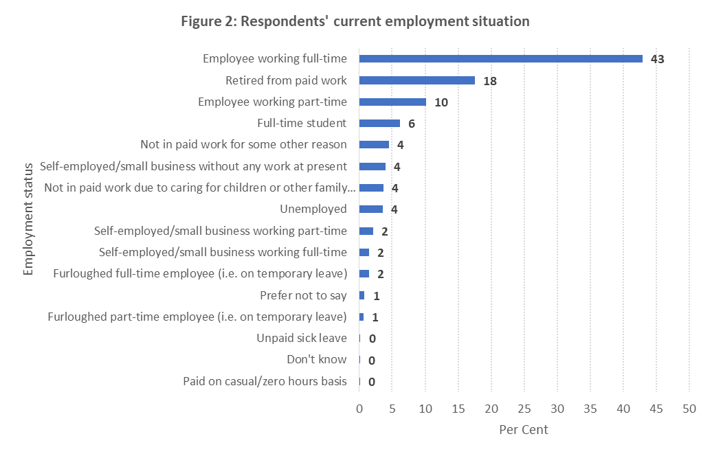

Income Status
For three-fifths (62%) of the sample, their income had remained constant; this was the case for significantly fewer (p<001) C2DE households (53%) than ABC1 households (67%). Younger respondents (18 – 24 years) were significantly less likely (p<0.01) to say their incomes had remained constant. Ten per cent of the total sample experienced an up to 24% decrease in their income; five per cent had experienced an income decrease of between 25% and 49%; three per cent had experienced an income decrease of between 50% and 74%; one per cent had experienced an income decrease of between 75% to 99%; and one per cent had lost all their income. Among those who had lost some/all of their income, 28% reported managing without replacing the loss of income.

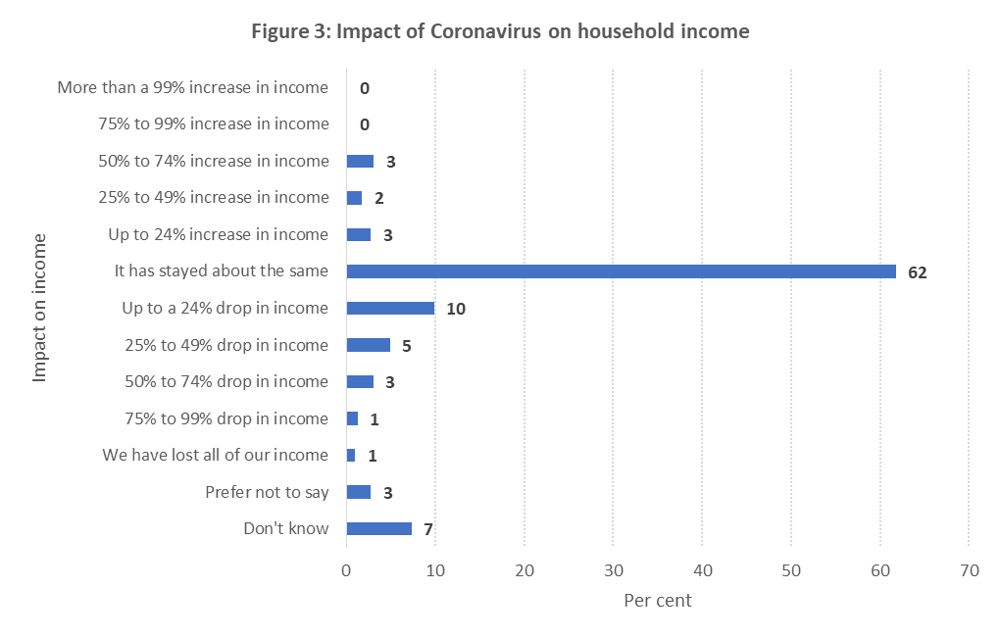
Shopping for food during Covid-19
Four-fifths (79%) of respondents reported going to the shops when they need to get food; one in four (23%) reported using home delivery of food - ordering on website/app; one in ten (11%) are using up food stocks at home (e.g. larder, freezer etc.); neighbours, family, friends and/or volunteers are helping four per cent of households to get food; two per cent are using home delivery of food – ordering by phone call and reflecting a different make up of and reliance on convenience shops in NI with more local connections, in contrast to GB; two per cent reported receiving food parcels from government, the council or charitable services; and one per cent reported not currently managing to get the food they need.

One in eight (13%; n=64) respondents reported being fairly or very worried currently about having the essential foods their household needs. Of these, 28 (43.5%) had their daily activities limited a little or a lot due to a persistent health condition; 15 respondents are currently self-isolating; 36 (55.3%) lived in an urban area; 31 (48.8%) had no children living at home and 43.7% had children entitled to free school meals; 43 (66.3%) were in some form of employment and 24 (37.5%) had lost some of their income, with two (3.9%) having lost all of his/her income.
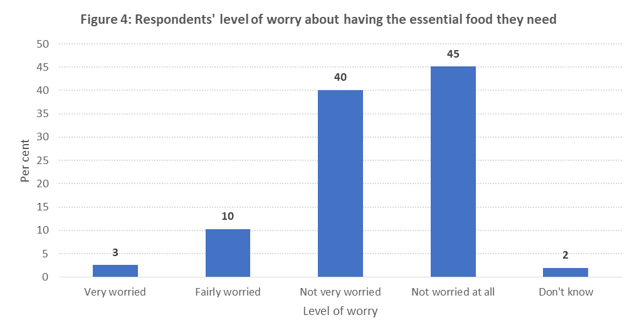
Food Security Status
One in twelve (7.95%; n=40) respondents answered affirmatively to experiencing at least one food poverty symptom before the Covid-19 pandemic increasing to one in five respondents (20.48%; n=103) experiencing a symptom of food poverty at some point before, during the early lockdown period or during the past month. More than one in ten (10.74%; n=54) confirmed that they experienced food impoverishment during the past month.

Table 2: Percentage of respondents answering >1 affirmative response(s) out of five food poverty questions
Percentage of respondents answering >1 affirmative response(s) out of five food poverty questions | %
Before NI went into official lockdown (i.e. February 2020) | 7.95%
During the early weeks of the NI official lockdown (i.e. April 2020) | 17.30%
During this past month | 10.74%
At any point before, during early lockdown or during the past month | 20.48%

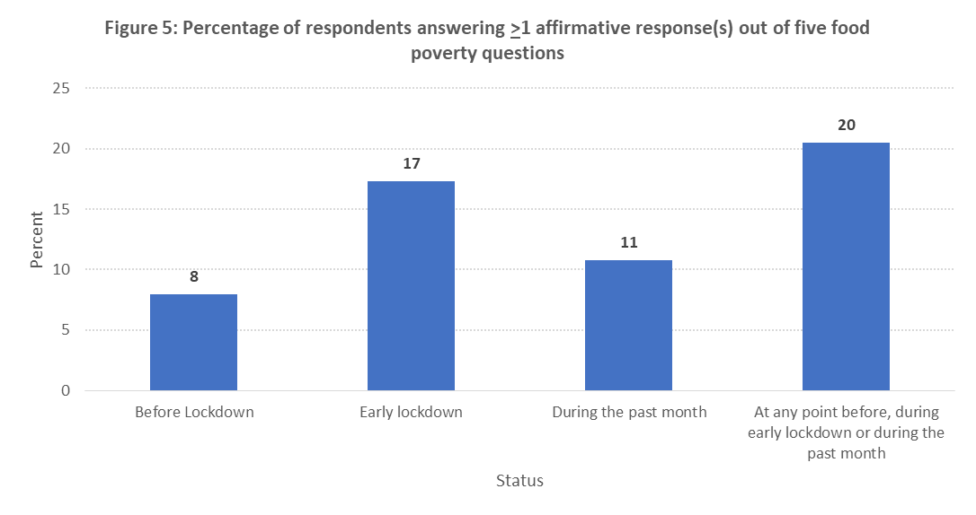

Table 3: Percentage of respondents experiencing each food poverty symptom

Food poverty symptom | % experiencing this symptom
 | Before lockdown | Early lockdown | Past month
Did you/anyone else in your household have smaller meals than usual or skip meals because you couldn't afford or get access to food? | 1% | 9% | 6%
Did you/anyone else in your household ever not eat for a whole day because you couldn't afford or get access to food? | 2% | 2% | 2%
Did you/anyone else in your household ever been hungry but not eaten because you couldn't afford or get access to food? | 4% | 3% | 3%
Did you/anyone else in your household ever rely on only a few kinds of low-cost food because you couldn't afford or get access to food? | 6% | 11% | 8%
Did you/anyone else in your household ever rely on support from others to enable you to afford or get access to food? | 4% | 9% | 4%

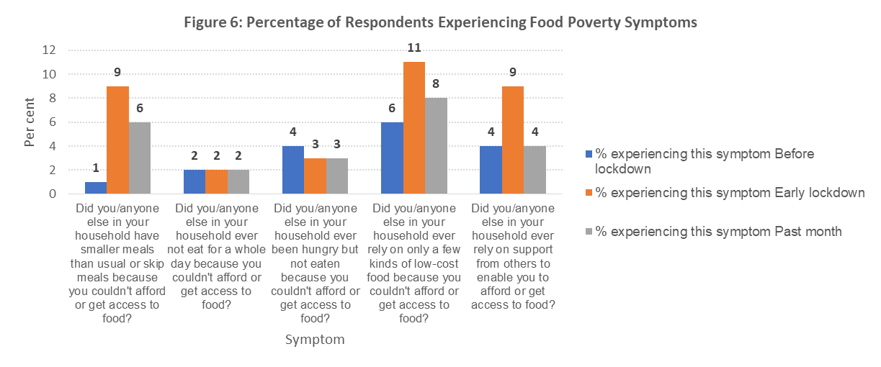

The Food Foundation survey used three food poverty symptoms, and excluded questions related to relying on a few kinds of low-cost food or relying on support from others. In comparing only the data from the equivalent three questions asked in both the NI and Food Foundation surveys, then one in eight (12.13%; n=61) respondents had experienced one or more symptoms of food poverty at some point before, during the early lockdown period or during the past month. In total, one in 31 (3.18%; n=16) had answered affirmatively to experiencing at least one food poverty symptom before the Covid-19 pandemic; one in 11 (9.15%; n=46) had reported difficulty in accessing or affording food during the early weeks of lockdown; and one in 17 (5.96%; n=30) confirmed that they experienced food impoverishment during the past month.

Table 4: Percentage of respondents answering >1 affirmative response(s) out of three food poverty questions

Percentage of respondents answering >1 affirmative response(s) out of three food poverty questions | NI Study
Before NI went into official lockdown (i.e. February 2020) | 3.18%
During the early weeks of the NI official lockdown (i.e. April 2020) | 9.15%
During this past month | 5.96%
At any point before, during early lockdown or during the past month | 12.13%
* Caution is urged when interpreting these data as the current Covid-19 and Food Insecurity survey extended the food insecurity questions to ask if the food insecurity arose because the respondent couldn't afford or get access to food (regular food insecurity questions do not consider inability to access food).

A small number (n=15) preferred not to answer some of the food insecurity questions. The ‘prefer not to say’ answer was provided most notably for the questions relating to the more severe end of the food insecurity spectrum: ‘Eating smaller meals or skipping meals’ (eight respondents reported experiencing this phenomenon during the early lockdown period); Not eating for a full day (eight respondents reported experiencing this phenomenon during the past month); and ‘Being hungry but being unable to eat’ (eight respondents reported experiencing this phenomenon during the early lockdown period).

Free School Meals Support
NI families with school-aged children eligible for free school meals received a substitute (for example, food vouchers, food parcels, direct payments) during the period when schools were closed. Three in ten respondents reported not receiving or not knowing if they had received the direct payment intended as a substitute for free school meals during lockdown.

Seeking Help
Of those requiring help, three in ten (29%) reported having sought and secured help (principally from family members / friends (59%), food banks (31%), social supermarket (10%); government food parcels (9%), volunteers (8%) and church/faith groups (7%)), while 8% reported trying but failing to find help.

Not Looking for Help
Of those who had not looked for help (n=58), three in five (60%) stated that they did not believe they would be eligible for help, almost half (47%) reported that they would feel bad asking for help and one in three (35%) did not want to ask for help. An equal proportion (35%) did not know where to go for help.

Affording food during the pandemic by other means
Respondents were asked if they had taken out any form of loan to be able to buy food due to the impact of Coronavirus: approximately equal proportions has used a credit card (5%) or borrowed money from friends or relatives (4%) in order to afford food during the pandemic. Slightly fewer had taken out an overdraft (3%), payday loan (2%) or used a pawnbroker’s services (1%) to find the money to buy food.

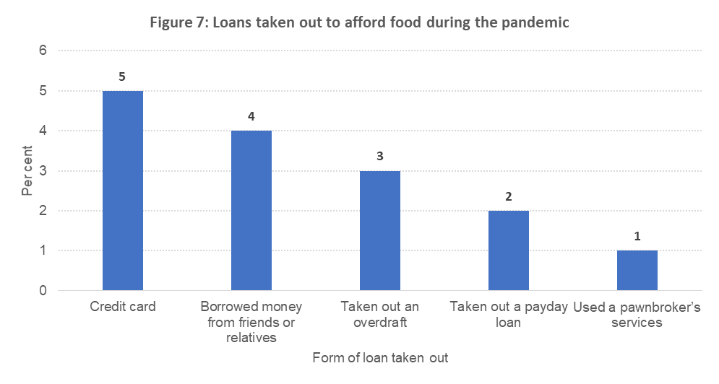

Appendix

Food Security (Pre-Covid-19)
Food security in Northern Ireland has been measured via the EU-SILC in the regional Health Survey for Northern Ireland - a Department of Health survey that runs annually on a continuous basis since 2010 with a respondent base of approximately 3,000. EU-SILC comprises four food deprivation measures: inability to afford a meal with meat or vegetarian equivalent every second day; inability to afford a roast or vegetarian equivalent once a week; whether during the last fortnight, there was at least one day (i.e. from getting up to going to bed) when the respondent did not have a substantial meal due to lack of money; and inability to have family or friends for a meal or drink once a month. For the purposes of reporting food insecurity prevalence, the Health Survey relies on one or more affirmative answers to the former three questions and excludes the inability to have family or friends for a meal/drink from analysis. However, the EU-SILC measures have only been asked in 2013/14 – 2017/18.

Northern Ireland households showing signs of food poverty
Five per cent of households reported experiencing some symptom of food insecurity for reasons of unaffordability of food in 2017-18. This increases to 9% for the most deprived 20% (quintile) of Northern Ireland households.

Overall rates of food poverty in Northern Ireland

 | 2017/18 | 95% confidence intervals
No | 95% | 94.6 | to | 96.2
Yes | 5% | 3.8 | to | 5.4
Total | 100%
Unweighted base | 2607

Households showing signs of food poverty by deprivation quintile

Deprivation quintile | 2017/18
 | % | Unweighted base | 95% confidence intervals
Most deprived | 9% | 487 | 6.8 | to | 12.0
Quintile 2 | 5% | 504 | 3.2 | to | 7.0
Quintile 3 | 3% | 537 | 1.2 | to | 3.9
Quintile 4 | 4% | 583 | 2.8 | to | 6.1
Least deprived | 2% | 496 | 0.5 | to | 2.7
Total | 5% | 2607 | 3.8 | to | 5.4
[Source: Health Survey Northern Ireland: Trend Tables]

In 2015/16, food insecurity was evaluated in Northern Ireland using the Household Food Security Survey Module (HFSSM), again within the Northern Ireland Health Survey wherein respondents self-report their food insecurity status ranging from worry about running out of food, the quality and quantity of the food they eat; reduced adult food intake; and reduced food intake by children. Results are categorised as food secure, low food security or very low food security, dependent on the number of food insecure conditions and behaviours self-reported. In the Northern Ireland Health Survey (2015/16) a small proportion of households (4%) indicated that there had been at least one day in the last fortnight that they did not have a substantial meal due to a lack of money. Respondents’ views on the food eaten in their household in the past 12 months indicated that while 85% always had enough of the kinds of food they want to eat, approximately 3% often or sometimes did not have enough to eat, while 13% had enough to eat but not always the kinds of foods they wanted.
Source: Department of Health (2016)

Department of Health. (2019) Health survey trend tables. Available from: https://www.health-ni.gov.uk/sites/default/files/publications/health/hsni-trend-tables_0.xlsx
Department of Health. (2016) Health survey Northern Ireland first results 2015/16 (page 14) available from: https://www.health-ni.gov.uk/sites/default/files/publications/health/hsni-first-results-15-16.pdf

