“The Certificate in Religious Education (CRE) and matters relating to the Fair Employment (FETO) exemption for schools.”

Written presentation to the Committee for Education

Dr Matthew Milliken (Ulster University)

3rd March 2021

The UNESCO Centre
Working out of the School of Education and based at the Coleraine Campus of Ulster University, the UNESCO Centre has become a leading voice in the field of education research. Founded in 2001, and home to the longest continually operating UNESCO Chair in the United Kingdom, over the years we have built a national and international reputation. On the island of Ireland, our work focuses on improving educational practice and policy, integrated education, and academic selection. In the international sphere, we have partnered with major international institutions to deliver projects examining the role of education in peacebuilding, international development and conflict.

Dr Matthew Milliken
Matthew Milliken joined the staff of the UNESCO Centre on the completion of his PhD at Ulster University in 2018. Prior to that he had worked for more than two decades as a youth worker, youth officer and education officer with the SEELB. In this capacity Matthew managed and delivered award winning cross-community, good relations, cross border and international projects with local young people. He also developed innovative educational initiatives to support the building of inter-community relations in Germany, Southern Africa and the Caucasus. Matthew was part of the panel that developed guidelines for the Community Relations Equality and Diversity policy.
Matthew is currently engaged in three initiatives:
- the Transforming Education project which uses evidence from academic research to illuminate issues that sustain the separation of schooling in Northern Ireland (funded by IEF, CFni and IrelandFunds);
- Future Schools which aims to support communities to find local solutions to address the problems of sustainability facing primary schools in rural areas;
- The creation of resources to enable history teachers to make best use of the Conflict Archive on the Internet (CAIN).

Summary
- The education system in Northern Ireland reflects the pattern of deep division between the two dominant communities here.
- Catholic pupils make up the overwhelming majority of those attending Maintained schools, while Protestant pupils attend mainly Controlled schools.
- Although there is recent evidence of greater sectoral permeability for teachers – particularly for those employed in grammar schools – community consistent patterns of teacher deployment mean that pupils are unlikely to be taught by someone from the ‘other side’.
- The movement of teachers between community defined sectors is inhibited by several factors including a requirement that all teachers in Maintained primary schools must have obtained a Certificate in Religious Education (CRE) approved by the Catholic bishops and the exception of teachers from protection under Fair Employment legislation (FETO).
- The courses of RE offered to teaching students at St Mary’s and Ulster have been approved as meeting the criteria for CRE.
- Since 2019 the St Mary’s CRE course has been available on-site to students at Stranmillis.
- Research undertaken through UU identified that Protestant teachers who have completed the CRE course did not feel that it equipped them adequately to provide Catholic religious instruction.
- A similar course to the CRE is offered to prospective teachers in a number of English teaching colleges – around half of the teachers employed in Catholic schools in England are non-Catholic.
- NI has wide ranging and effective Fair Employment laws; teachers are, however, excluded from their protection – this is known as the FETO exception.
- This means that schools are legally entitled to use religious belief as grounds on which to discriminate between candidates for teaching posts.
- It has been argued that the FETO exception acts a counterbalance to the CRE requirement in Maintained schools.
- There is little evidence of the exception being actively called upon in appointment decisions.
- 38% of teachers in Controlled primaries and 48% in Maintained primaries have been identified as being culturally encapsulated – having had no engagement with ‘the other side’ at any stage of their education or career.
- A small proportion of teachers have crossed between the community-defined sectors – their experiences have been varied, from highly negative (suffering sectarian victimisation) to highly positive (using their ‘otherness’ to provide their students with new insights).
- It is recommended that CRE and the FETO exception be considered in the review of education.

Introduction
The division of Ireland in 1922 necessitated the establishing of educational structures for the new northern state. A common management system for schools attended by both Protestant and Catholic pupils was proposed. This was resisted by the churches on both sides. Amendments were made to address the perceived secularism of this model; these brought the Protestant churches on-board, but the Catholic church and most of the grammar schools remained unmoved. Thus, three classes of school emerged: (state) Controlled, (Catholic) Maintained, and Voluntary (grammar schools: both Catholic and non-denominational). Today, the community separation evident in the profiles of the pupils that attend schools in each of the various sectors remains a striking and pervasive feature of education. The 2019-20 school census identified that 93% of pupils attended these three school types. Of the pupils attending schools under Catholic management 96% were Catholic as opposed to 7% of those who attended Controlled and non-denominational schools. In 1981, the first planned Integrated school was established in Northern Ireland. Today around 7% of pupils attend a school that has been designated as Integrated – 37% of the pupils who attend these schools are Catholic.

1.1 The Sector-specific Deployment of Teachers
Research published in 1977 and 2004 had indicated that the community separation of schools was mirrored in the identity profile of the staff employed to teach within them. Work undertaken by the UNESCO centre in 2015 proposed that the exception of teachers from protection under the 1998 NI Fair Employment and Treatment Order (FETO) and the occupational requirement for those seeking employment in Maintained primary schools to be in possession of a Certificate in Religious Education endorsed by the Catholic Schools’ Trustee Service effectively maintained this separation. More recent research has however indicated that the ‘chill factor’ identified in previous investigations may have thawed slightly. Whilst community consistency in the deployment of teachers was still very evident in Maintained and Controlled primaries, the profile of post-primaries – and particularly grammar schools – was more mixed than had been observed in earlier investigations.
Year | Primary | Post Primary (non-grammar) | Grammar
1977 | < 1% | 2% | 1%
2004 | 2% | 2% | 1%
2019 | 2% | 8% | 17%
  - Table 1: Protestant teachers employed in schools with a Catholic ethos.
Year | Primary | Post Primary (non-grammar) | Grammar
1977 | < 1% | 2% | 1%
2004 | 5% | 5% | 1%
2019 | 7% | 17% | 23%
  - Table 2: Catholic teachers employed in Controlled and non-denominational schools.

The Certificate in Religious Education

2.1 Why does the Certificate exist?
2.1.1 The Education and Libraries (Northern Ireland) Order 1986, Section 21 stipulates that all schools in NI must provide a daily act of collective worship and include Religious Education based upon the “Holy Scriptures” in line with a core syllabus (formulated by the four largest Christian denominations in NI) for all pupils from Foundation to Key Stage 4.
2.1.2 Those schools under Catholic management require that any teacher who has been employed to teach RE must be able to do so in line with the ethos of the school – this capability is demonstrated by the possession of a Certificate in Religious Education (CRE) that has been completed at an institution approved by the Catholic trustees.
2.1.3 Unlike the subject-specific teachers employed in post-primary schools, primary school teachers are generalists who are required to teach across the full curriculum – it follows that all primary school teachers will be required to teach RE.
2.1.4 Following a review in 2013, the Department of Education accepted that the CRE was a legitimate occupational requirement for primary school teachers, post-primary teachers of RE and those teachers with designated responsibility for pastoral care in Catholic schools.

Who does the Certificate?
2.2.1 Stranmillis University College, St Mary’s University College and Ulster University provide courses specifically for those wishing to teach in primary schools. The St Mary’s website states that the university college “exists to ensure that there will be an adequate supply of Catholic teachers”, who can educate children “according to the principles of Catholic education”. St Mary’s is attended almost exclusively by Catholic students. It is recognised as an awarding body for the CRE and the course is available to all BEd and PGCE students. Ulster (where the student body is more mixed) is also a recognised awarding body and the CRE is provided as an integral, ecumenical element of the primary school teaching course. Until very recently, those Stranmillis students who wished to complete the CRE could only do so by distance-learning. From September 2019 student teachers enrolling at Stranmillis have been able to access a course on-site. The course is optional, is taught by Stranmillis staff and validated through St Mary’s.
2.2.2 Initial Teacher Education institutions are heavily oversubscribed in NI – particularly for primary school teaching. A number of prospective teachers therefore elect to attend teaching colleges in GB (and, to a lesser extent, RoI). Around a quarter of those currently teaching in NI have undertaken ITE outside NI.
2.2.3 One-in-ten state-funded schools in England and Wales are managed by Catholic church authorities. Thirty-three Catholic Higher Education institutions in England and Wales provide courses that lead to the award of the Catholic Certificate in Religious Studies (CCRS). The CCRS was re-designed in 1992 to provide teachers with a basic understanding of the central beliefs of the Catholic faith, “its teachings and way of life” in order to enable them “to contribute to the maintenance of the ethos of the Catholic school”. The course description explicitly specifies that it may be completed by non-Catholics. Around half of the teachers employed in English Catholic primary schools are Catholic.
2.2.4 The institutions attended by teaching students from NI who attend colleges in GB are broadly reflective of the community divide: it seems that Catholic students choose predominantly to attend those teaching colleges which have a Catholic ethos and offer the CCRS – Protestant students, on the whole, attend different institutions (Figure 1).
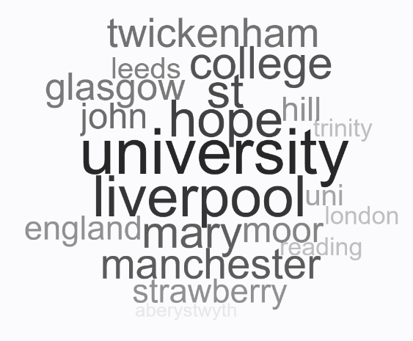A | 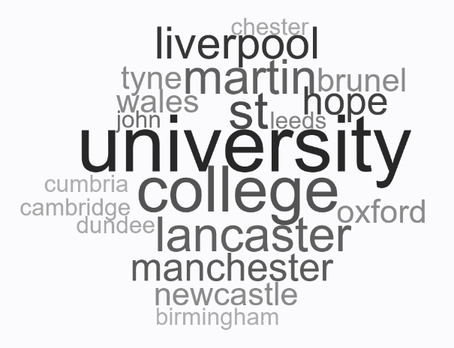  B
Figure 1. ITE institutions in GB that were attended by Catholic teachers from NI (A) Protestant teachers from NI (B)

2.3 What do teachers think about the Certificate?
2.3.1 A study undertaken by the UNESCO Centre and published in 2020 interviewed a sample of 30 teachers who had followed an atypical career path and were teaching in a school that was not associated with their own community identity. They were asked about the factors that they saw as maintaining this separation.
2.3.2 Some interviewees identified the Certificate as creating a barrier for Protestant teachers seeking employment in Maintained schools. It was suggested by one teacher that the Certificate requirement may be concealing an ulterior motive.
When you are in a Catholic school and you are advertising for a teacher you have to put that thing in about the Catholic certificate so it’s highly unlikely you will get any non-Catholics applying for the job. There is a hidden agenda there.
2.3.3 It was noted by another teacher that the requirement only applies to those who seek permanent posts. This teacher had not completed the Certificate but had been able to gain employment as a teacher in a series of short-term posts in Maintained primary schools. When these posts were later advertised as permanent positions, she was unable to demonstrate that she met the essential criteria.
2.3.4 All of the Protestant interviewees who had been employed in Maintained primary schools expressed scepticism about the value of the Certificate. They suggested that, as it currently exists, the qualification does not adequately prepare a non-Catholic teacher to support pupils to follow the Catholic religious practices and rituals. One teacher, who had completed the Certificate course by distance learning, was particularly scathing.
The Catholic Certificate of religion was absolutely, hopelessly, useless to teach RE – it was completely useless.
2.3.5 The Certificate was seen by another respondent as an obstacle without educational merit or practical justification.
The Certificate does not teach you anything that will help you teach in school – it will not give me more information to teach Catholic education than I already have. I know what I need to know – it’s just a piece of paper that prevents me from teaching in that school… I can’t see how having that certificate is going to make me a better teacher to those pupils.
2.3.6 One local teacher of RE who had undertaken ITE in England commented:
In [teaching college] in England… ones on the course who were Sikhs did it, just to widen their opportunities.

3. The FETO Exception

3.1 What is it?
3.1.1 The introduction of effective fair employment and anti-discrimination laws was among the demands made by the NI Civil Rights movement in the years immediately preceding the Troubles. By way of response, Part 3 of the Northern Ireland Constitution Act (NICA) 1973 prohibited religious and political discrimination by the state. This was extended in the 1976, Fair Employment (Northern Ireland) Act but Section 37 of this Act excepted “employment as a teacher in a school”. The Act also required the Fair Employment Authority to keep this exception under review “with a view to considering whether… it is appropriate that any steps should be taken to further equality of opportunity in the employment of such teachers”. The Act was revised in 1989. Compulsory workforce monitoring was introduced for those organisations employing more than ten employees. The teacher exception was, however, left in place.
3.1.2 In 1998, the Fair Employment and Treatment (Northern Ireland) Order (FETO), was brought into being following the Belfast Agreement. It consolidated existing fair employment law. Part 8: Article 71: Paragraph (1) states categorically that “this Order does not apply to or in relation to employment as a teacher in a school”.
3.1.3 The teacher exception has also been justified in European Law, “in order to maintain equality of opportunity in employment for teachers in Northern Ireland and reconcile the historical divisions between the two main religious communities” (Article 15(2), Treaty of Amsterdam, 1999).
3.1.4 Schools are consequently legally entitled to use religious belief as grounds on which to discriminate between candidates for teaching posts. The exception has rarely been tested in law but a tribunal in 2007 confirmed that employing authorities are entitled to consider an applicant’s faith with regard to both the initial recruitment of teachers and to promotion within a school (Debast and Flynn v Dr Malcolmson, Laurelhill Community College and SEELB). However, a 2010 Religious Discrimination case ruled in favour of a teacher whose religion had been used as a factor in selecting her for redundancy (Brudell v Board of Governors, Ballykelly Primary School & WELB).

3.2 What do teachers think about the FETO exception?
3.2.1 It has been suggested that teachers had originally been exempted from the protection afforded by Fair Employment legislation to appease Protestant teachers’ concerns that whilst Catholic teachers (with the Certificate) could apply for a job in both the Maintained and Controlled sectors, Protestant teachers (without the Certificate) would be unable to apply for posts in Maintained schools. There was some evidence from the interviews with cross-over teachers that, although some may have been made aware of the teacher exception to FETO during their initial teacher education, their interpretation of its origins may lack nuance:
In teacher training you were told that schools had the right to employ their staff to reflect their student body. So, you were told that, if it’s a 100% Catholic school they have the right to – or they can fight to – have 100% Catholic teachers. I know in those days it was simply – well you don’t have much hope of getting in there.
3.2.2 There was evidence that some schools (particularly in the grammar sector) may consider a candidate’s community identity to be irrelevant for most posts.
I think the great thing about the principal is she picks best person for the job you know. The principal who hired me I think on the day she just went with the risk, “Let’s go for it, it's a new thing!”
There is an intimation in this remark that, even where employment practices are more inclusive, the engaging of a community outsider may still be judged as carrying with it an element of ‘risk’.
3.2.3 None of those interviewed could recall a case in which the FETO exception had been specifically called upon to justify (or block) an appointment.

4. Conclusions

4.1 Cultural Encapsulation
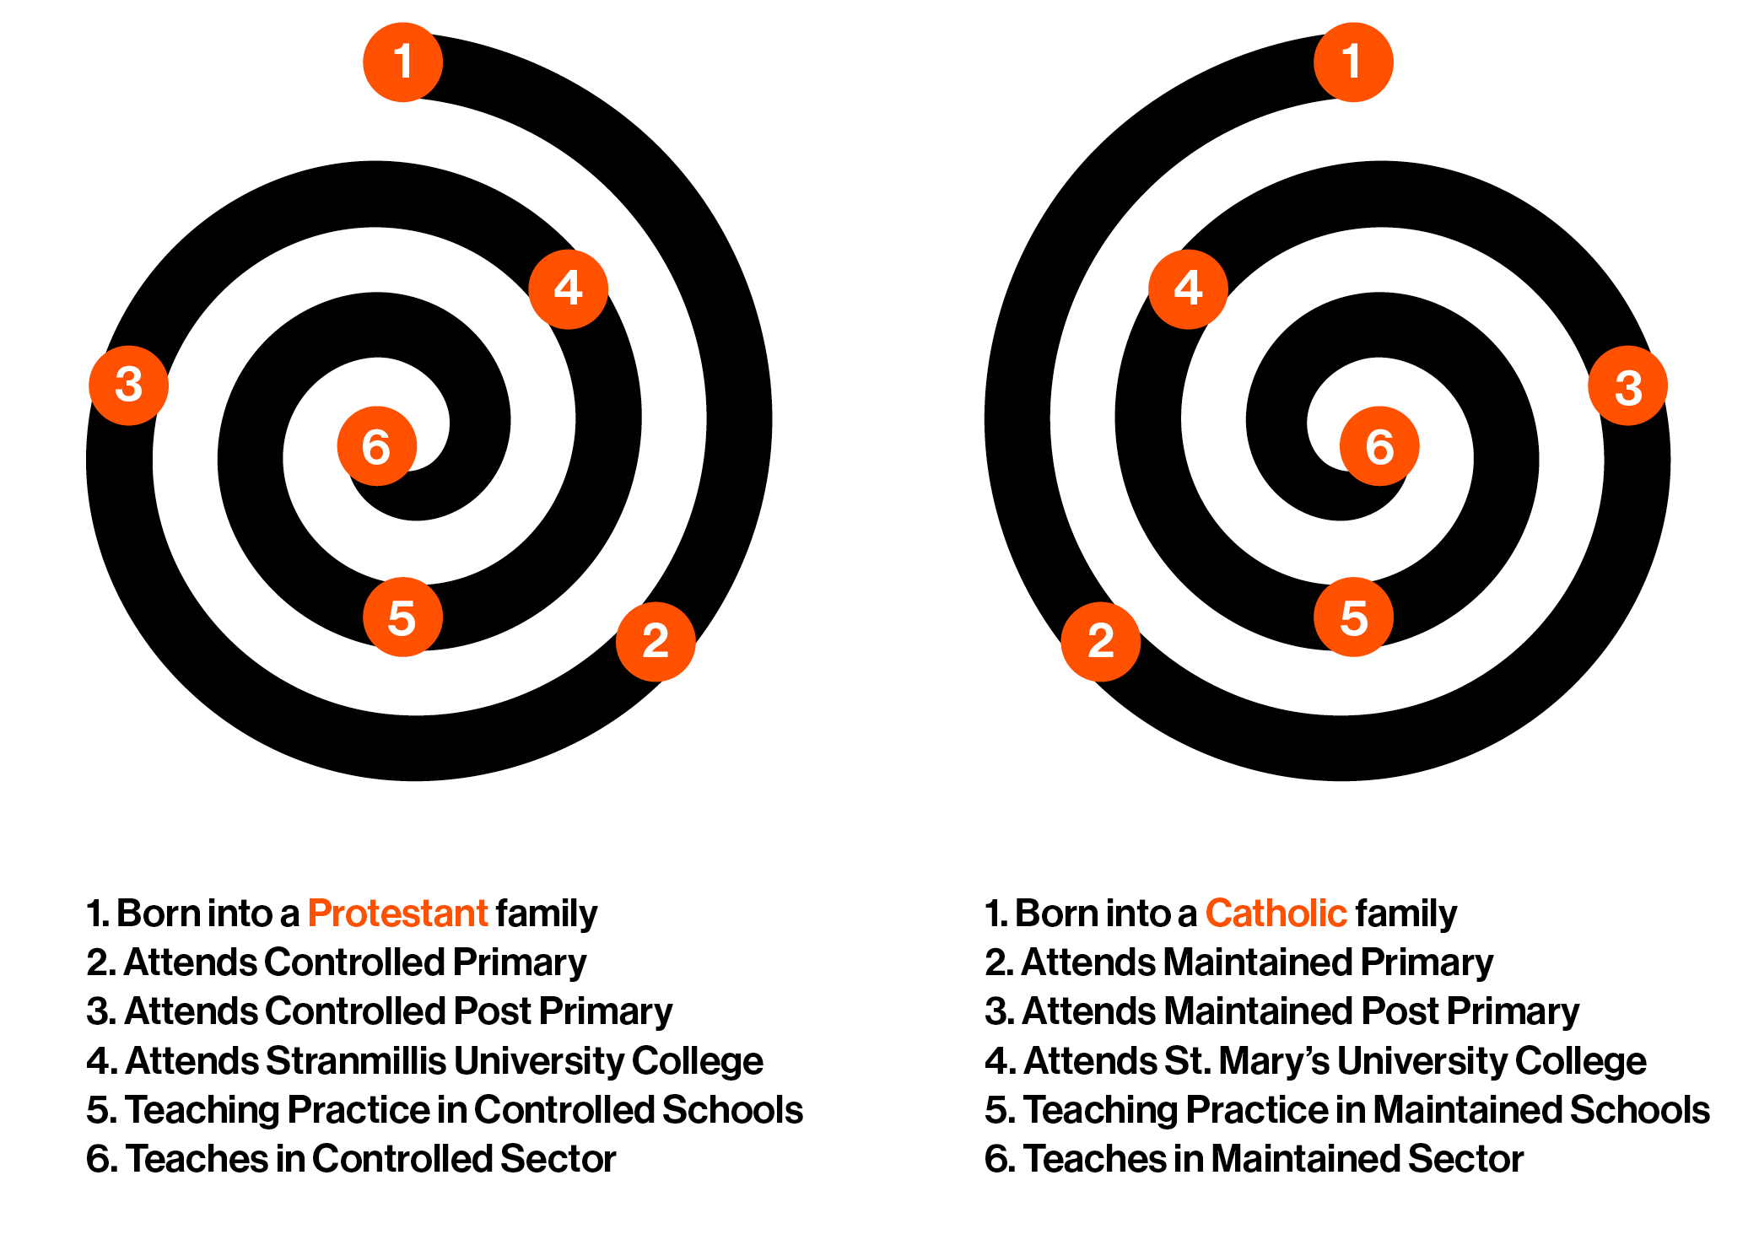
  - Figure 2. The Cycle of Community Consistency and Cultural Encapsulation.
4.1.1 Many of those teaching in NI will have had their formative educational experiences in a primary school that was consistent with their community identity and will have transferred to a post-primary school in the same sector. From here they may have progressed to Initial Teacher Education in a University College where they would be amongst peers who share their community identity and where they will have been prepared to teach in a school on ‘their own side’ (Figure 2).
4.1.2 Research conducted among black and white teachers in the USA identified that, where similar ‘cultural encapsulation’ had occurred, teachers displayed both a lack of understanding of those who did not share their identity and an absence of awareness of how their own identity may be perceived by others.
4.1.3 UNESCO conducted an on-line survey which was completed by more than 1,000 teachers across all sectors in NI. Of the 398 teachers who completed the survey and were working in Controlled schools and non-denominational grammars: 77% had been educated in Controlled primary schools, 75% had also attended a Controlled post-primary school or non-denominational voluntary grammar, 34% had also attended Stranmillis University College, 28% had also undertaken teaching practice only in Controlled schools or non-denominational grammars, 22% had also only ever taught in Controlled schools or non-denominational grammars - 79% of these were teaching in Controlled primary schools and 21% were teaching in Controlled post-primary or non-denominational grammar schools. Thus, 22% of teachers employed in Controlled schools and non-denominational grammars (including 38% of teachers in primary schools and 9% of teachers in post-primary schools) could be considered to be culturally encapsulated.
4.1.4 A further 407 teachers who completed the online survey were working in Maintained schools and Catholic voluntary grammars: 85% of these teachers had been educated in Maintained primary schools in NI, 82% had also attended Maintained post-primary or Catholic voluntary grammar schools, 40% had also attended St Mary’s University College, 39% had also undertaken teaching practice only in Maintained schools or Catholic voluntary grammars, 33% had also only ever taught in Maintained schools or Catholic voluntary grammars - 67% of these were teaching in primary schools and 33% were teaching in post-primary schools. It was determined that 33% of teachers in Catholic schools (including 48% of teachers in primary schools and 19% of teachers in post-primary and grammar schools) could be considered as being culturally encapsulated.
4.1.5 Consequently, it seems likely that the plumber who comes to fix the primary school toilets (who will have qualified from a mixed FE college) may well have had more experience of being educated and working alongside colleagues from the other community than the teacher who the system asks to work towards reconciliation through Shared Education initiatives.

4.2 Cross-over Teachers
4.2.1 Inevitably personal elements of a teacher’s identity will affect their professional persona and their teaching. To be wholly effective a teacher needs the confidence and capacity to engage the wider dimensions of their identity in the classroom.
4.2.2 Our research has shown that, where a cross-over teacher perceived that the school environment could be potentially hostile to their community identity, they were seen to have endeavoured to hide that dimension from their pupils or, in the most extreme examples, from both pupils and other staff members. In such cases, teachers carefully and consciously tried to adapt to fit within the prevailing culture. Such a strategy is fraught with difficulties and inevitably involves a degree of subterfuge and deception. The ‘disguised’ teacher may be anxious about their otherness being found out – they must maintain a consistent mask. Deception has the potential to backfire and word-of-mouth quickly spreads.
4.2.3 It was also seen that a cross-over teacher may, out of habit or convention, attempt to obscure their identity, or, alternatively, to believe, probably naïvely, that it is unknown. Such an approach is only possible where the teacher’s other identity is not seen as a threat within the school – this was seen to be the case where the teacher was well-established in the school and when they teach a subject with comparatively limited potential for engaging with controversial issues (e.g. Mathematics).
4.2.4 In marked contrast, some cross-over teachers were seen to have actively brought their ethnicity into both their teaching in the classroom and their interactions with colleagues – for these teachers, their outsider status had become a defining aspect of their identity within the school. Support from leaders within the school was identified as having been instrumental where the teacher reported that this approach as having proved effective.
4.2.5 It has however also been observed that there can be significant problems where a cross-over teacher attempts to act in a manner that challenges established practices and attitudes. This was seen to be at its most extreme in school communities that were inexperienced, unwilling and/or unprepared to engage with alternative perspectives. In all such instances the situation was seen to have deteriorated into sectarian bullying.
4.2.6 A small number of teachers who had returned to NI following a period teaching elsewhere took up a cross-over position in the assumption that society had progressed beyond historical sectarianism. Those who had entered an Integrated school found a culture within which the various dimensions of their identity were accepted or accommodated. However, two teachers who had stepped across the ethnic divide in education had experienced a less welcoming situation. Their identity tested the culture of their host in ways for which it was not prepared, and they found themselves exposed in a hostile school environment. Neither received effective support from either the school leadership or sectoral management. The sectarian attitudes displayed by pupils, parents and other staff members went unchallenged and, as such, were effectively reinforced. Both have since left their posts and are seeking employment in community consistent schools.
4.2.7 Cross-over teachers were characterised in line with the different approaches that they had adopted within these four possible permutations: the Ostrich, the Peacock, the Chameleon and the Hedgehog (Figure 3).
4.2.8 The apocryphal story of the Ostrich that sticks his head in the sand in the face of a perceived threat provides an illustration of the cross-over teacher who attempts to disguise, or distance themselves from, their community identity, even though it may be widely known within the school. The Ostrich does not only not use this dimension of their identity in any aspect of their teaching but does not see it as having relevance to their role. Their professional persona is incomplete, they are consequently unable to achieve agency and there is no impact from their otherness on the school culture.
4.2.9 The Chameleon is a cross-over teacher who adopts to the culture of the host community so effectively that they assimilate completely, and their otherness effectively disappears. The chameleon teacher is accepted as ‘one of us’; their ethnic identity is assumed by all (bar perhaps a small number of individuals) to be consistent with that of the school. They can however work as an insider to create change from within, though their potential capacity to achieve agency is compromised by their lack of engagement with their identity. Their position is vulnerable and maintaining the pretence may prove difficult in the longer term.
4.2.10 The Peacock flamboyantly displays their identity and, where the school authorities accept and accommodate this display, they are able to engage their ethnic identity in their teaching – thereby opening opportunities for pupils to encounter and engage with issues that might otherwise remain unexplored. In order to be able to act in this way, the peacock needs to have critically reflected on their own identity and to feel confident in using it in their current practice. Such displays may be unsettling to more conservatively-minded colleagues and the wider school community – the support of school management is therefore crucial. Where that support has been assumed by the teacher but has failed to materialise, the cross-over teacher can become exposed and isolated and they must fall back on their own defences. The peacock can become a hedgehog.
Figure 3. Cross-over Teachers
4.2.11 The archetypal hedgehog is wary in the present and ultrasensitive to the potential of future threats. The hedgehog teacher has engaged their ethnicity – its otherness is known to everyone else in the school. They see hostility everywhere and readily retreat into a prickly, defensive carapace. This becomes the dominant feature of their identity to the detriment of everything else. Clearly this is not conducive to a healthy working situation.
 | Identity Hidden | Identity Open
Otherness Supported

Otherness Contested

Recommendations

5.1 Context
5.1.1 In 2019 the NI Affairs Committee in Westminster observed that, “the complicated structure of education in Northern Ireland meant that money was not being spent in the most efficient way”.
5.1.2 The webpages of DE’s Education Transformation Programme state, “We will work together to deliver an education system which meets the needs of all our children and young people… This requires an ambitious and radical programme of change... We want to bring significant improvements in where and how our children and young people are educated…By doing this, we will improve outcomes and transform lives”.
5.1.3 In 2020 the New Decade New Approach (NDNA) agreement stated that, “the Executive will establish an external, independent review of education provision, with a focus on securing greater efficiency in delivery costs, raising standards, access to the curriculum for all pupils, and the prospects of moving towards a single education system”.
5.1.4 The NDNA agreement went on to say the diversity of school types is “not sustainable”, that there was a desire to improve “the quality, equity and sustainability of the system” and that, in response, “the Executive will commission and oversee an independent fundamental review with a focus on quality and sustainability”.

5.2 Recommendations arising from this research brief.
5.2.1 It is recommended, in light of the evidence presented here, in order to ensure a diverse workforce and employment opportunity for under-represented groups, that the CRE requirement for all teachers in Maintained primary schools should be included in this review.
5.2.2 This review could consider whether the CRE, in the form that it is currently delivered by St Mary’s and at Stranmillis, should be revised in line with the more inclusive model that used in Ulster University.
5.2.3 There may also be benefit in encouraging those responsible for the design and delivery of the CRE to reflect on the course content to make it of greater practical benefit to non-Catholics.
5.2.4 It is recognised that such changes may not be within the authority of the Department – it is therefore also suggested that the review should consider if the place currently afforded to the three transferor Protestant denominations and the Catholic church in the development of the RE curriculum and in the governance of schools is consistent with the creation a more pluralistic and inclusive system.
5.2.5 Given the pattern and likely impact of Cultural Encapsulation observed the composition of the student bodies in the two university colleges could be audited to identify any under-represented groups. Consideration could then be given to the revision of admittance policies to ensure greater access and inclusion.
5.2.6 Active consideration could be given to providing opportunities for all student teachers to gain practical experience of working in an unfamiliar education setting – preferably one with a community identity that is not the same as their own.
5.2.7 The FETO Exception is an anachronism in a society striving for inclusion and equality – it should also be included in the remit of the fundamental review in anticipation of its repeal.

5.3 Final comments
5.3.1 FETO and CRE are not the only issues affecting the sustainability of our education system, a range of these are explored in other Transforming Education papers. Taken together, these expose how a costly pattern of duplication is the inevitable outcome of the state funding a multitude of sectoral bodies and subsidising the separation of teacher education; of policy that determines that Boards of Governors in each of the sectors may be so composed that they may have an entirely community consistent composition; and of the role played by clerics from four denominations in drafting and inspecting the RE syllabus.
5.3.2 In effect, the state is both bankrolling the community separation that it is endemic in education and investing additional money in expensive solutions to ameliorate the problems that the system itself has created. Nothing is more iniquitous and less sustainable than a business model that creates the very problem that it finds impossible to solve – pouring good money after bad. Powerful vested interests profit from the complexity current system; these bodies are unlikely to welcome change. Radical root and branch reform is however essential if there is to be a move towards a single education system and away from the financially and socially expensive out-workings of a system that perpetuates division.

Milliken, M., Bates, J. & Smith, A. (2019) Education policies and teacher deployment in Northern Ireland: ethnic separation, cultural encapsulation and community cross-over, British Journal of Educational Studies
Milliken, M., Bates, J. & Smith, A. (2020) Teaching across the divide: perceived barriers to the movement of teachers across the traditional sectors in Northern Ireland, British Journal of Educational Studies,
Milliken, M., Bates, J. & Smith, A. (2021) Teaching on the Other Side: how identity affects the capacity for agency of teachers who have crossed the community divide in the Northern Ireland educational system, Oxford Review of Education
Northern Ireland Affairs Committee, Ninth Report of Session 2017–19, Education funding in Northern Ireland, HC1497
https://www.education-ni.gov.uk/topics/education-transformation-programme
https://assets.publishing.service.gov.uk/government/uploads/system/uploads/attachment_data/file/856998/2020-01-08_a_new_decade__a_new_approach.pdf
All papers in this series may be found here: https://www.ulster.ac.uk/research/topic/education/unesco-centre/research/transforming-education

